**HANOI UNIVERSITY OF SCIENCE AND TECHNOLOGY**

**SCHOOL OF INFORMATION AND COMMUNICATION TECHNOLOGY**



**REPORT**

**Graduation Research 1**

**Topic: Building a sales website**

**Instructors: MSc.Nguyen Hong Phuong**

**Class code: *135469***

**Students:  *Nguyen Hop Phu 20205165***

**Ha Noi – 2023**

**Acknowledgements**

GR1 specializing in information technology with the topic of building an e-commerce website is the result of my relentless effort and the dedicated guidance of Mr. Nguyen Hong Phuong, as well as my colleagues and friends. Through this, I would like to sincerely express my gratitude to those who have helped me complete this project.

I would like to express my deep respect and gratitude to the teachers who directly guided this project. They provided me with the necessary documents for my project.

Once again, I sincerely thank you!

………………………………………………………………………………………………………………………………………………………………………………………………………………………………………………………………………………………………………………………………………………………………………………………………………………………………………………………………………………………………………………………………………………………………………………

……………………………………………………………………………………………

……………………………………………………………………………………………

……………………………………………………………………………………………

……………………………………………………………………………………………

……………………………………………………………………………………………

**INTRODUCTION**

In the era of industrialization and modernization, society demands a quality workforce with complete skills. Especially in the field of information technology, it requires solid knowledge, sufficient experience, teamwork abilities, and creativity in work. Along with the explosive growth of information technology and websites in recent years, creating, designing, and managing a website is a necessary skill for a programmer, in particular, and IT students in general.

At the hottest moment, everything is just a click away, and the whole world can come close instantly. These are the undeniable benefits that websites bring. Starting from building static web pages with only a few black and white lines of text, websites have evolved to become more visual and lively with sound. As programmers create more functions to meet the "supply-demand" cycle, websites have become even more successful today.

Applications that connect with practical life make it more convenient for users, and businesses have started to introduce, advertise, and work more on the web. From companies investing in development to diverse food, health, and lifestyle websites, the web has become a part of the digital transformation and e-government. Technology is difficult to predict, but websites will undoubtedly continue to exist and develop in the years to come.

Building a website now has many instructional materials, but the easiest way to access them is probably through news and e-commerce websites. This is partly why I chose this topic to learn about how to build a website. Although the topic is familiar, it is an opportunity for me to apply the knowledge accumulated from previous studies and this semester. From here, I will equip myself with the necessary skills and get acquainted with the direction for future projects.

1. **Project title**

Research and design of an e-commerce website

1. **Objectives**

* Research on various technologies, programming languages and frameworks
* Develop an e-commerce website for managing computer store sales.

1. **Scope of the project**

Scope of the project implementation: Individual.

1. **Research subjects**

* Technology research orientation:

+) Front end: html, css, javascript, bootstrap, jquery.

+) Back end: php, Laravel, database management systems MYSQL, PGSQL.

+) Source code editor: Visual Studio Code.

+) Usage model: MVC.

1. **Overview of chapters in the report:**

+) Chapter 1: Introduction to technology.

+) Chapter 2: Design analysis, application.

+) Chapter 3: Results testing.

+) Chapter 4: Conclusion.

+) Chapter 5: References.

**TABLE OF CONTENTS**

Chapter I: LEARNING ABOUT TECHNOLOGY 6

1.1 Web 6

1.1.1 What is the web and an overview of its development? 7

1.1.2 Pure code and using framework 7

1.2 HTML 8

1.3 CSS 9

1.4 JS 9

1.5 The relationship between HTML, CSS, JS 10

1.6 DBMS, Database, Web 11

1.6.1 DBMS 11

1.6.2 Relationship between web and database 11

1.6.3 MySQL 11

1.7 PHP 12

1.8 XAMPP 12

1.9 MVC 13

1.10 Laravel Framework 14

1.10.1 Laravel 14

Chapter II: Design analysis, apply 16

2.1 Functional analysis 16

2.1.1 Customer 16

2.1.2 Administrator 17

2.2 Database design 17

2.2.1 ERD 17

2.2.2 Table schema mapping 18

Chapter III : Result verification 19

3.1 Install enviroment 19

3.2 Demo interface of some main pages 21

Chapter IV: Conclusion 27

4.1 Conclusion 27

4.2 Evaluation 27

Chapter V: REFERENCES 28

# 

# CHAPTER I: LEARNING ABOUT TECHNOLOGY

## Web

### 1.1.1 What is the web and an overview of its development?

The web (World Wide Web) is a system of internet-based documents that are linked together by hyperlinks and URLs (Uniform Resource Locators). It allows users to access and share information, documents, images, audio, and video on a global network platform. Websites are created using web programming languages such as HTML (Hypertext Markup Language), CSS (Cascading Style Sheets), and JavaScript.

The web was developed by Tim Berners-Lee in the 1980s at CERN (European Organization for Nuclear Research), a scientific research organization in Switzerland. Initially, the web was used as a tool to help CERN scientists access internal documents of the organization. However, with the development of the web, it became a global tool for transmitting information and communication between individuals, organizations, and countries.

The web has gone through several stages of development. The first stage of the web is called Web 1.0, in which websites were created to display static information and often had no interaction with users. The next stage is Web 2.0, in which websites have high interactivity with users, allowing them to participate in content creation and sharing information. Currently, the web is developing towards Web 3.0, a new stage with many applications such as artificial intelligence, blockchain, and virtual reality.

The web has become an important part of modern life and has changed the way we communicate, learn, shop, search for information, and work.

### 1.1.2 Pure code and using framework

Vanilla code (or pure code) is the act of writing HTML, CSS, and JavaScript code without using any frameworks or libraries. This means you have to write all the code yourself to create the user interface, handle events, and interact with the server.

Using a framework is a way to speed up web application development by using libraries and tools provided by the framework. Some popular frameworks include:

* React: a JavaScript library used to build user interfaces (UI) for web applications.
* Angular: a JavaScript framework used to build high-end dynamic web applications.
* Vue: a simple yet powerful JavaScript framework used to build single-page applications (SPAs).
* Laravel: a PHP framework used to build complex dynamic web applications.

Frameworks typically provide features and functions optimized for creating complex web applications. Using a framework also helps with faster application development, high scalability, and easier maintenance. However, using a framework may limit the flexibility and customization of the application and sometimes may make the code harder to understand.

## 1.2 HTML

HTML stands for Hypertext Markup Language. It is a markup language used to create and design web pages, websites and web applications. HTML provides the basic structure and content of a web page, including text, images, audio, video, links, and other elements that can be displayed in a web browser.

HTML uses markup tags to describe and define the content of a web page, such as headings, paragraphs, lists, tables, and forms. These tags are enclosed in angle brackets, like <tagname>, and can have attributes to specify additional information about the content, such as its size, color, or location on the page.

Web browsers use HTML to display web pages, interpreting the markup tags and rendering the content in a way that can be viewed and interacted with by users. While HTML is the foundation of most web pages, it is often used in conjunction with other technologies such as Cascading Style Sheets (CSS) and JavaScript to create more complex and dynamic web applications.

**HTML** is a powerful language for creating web pages and web applications. Here are some of the key features and benefits of HTML:

* Universal Accessibility: HTML is supported by all modern web browsers, making it an ideal choice for creating content that can be accessed by a wide range of users on different devices and platforms.
* Structure and Organization: HTML provides a clear and structured way to organize content on a web page, making it easier for users to navigate and understand the information presented.
* Compatibility with Other Technologies: HTML can be combined with other technologies like CSS and JavaScript to create dynamic and engaging web experiences.
* SEO-Friendly: HTML provides a way to add important information to web pages that search engines use to index and rank them. This means that properly structured HTML can improve a website's visibility and search engine ranking.
* Cross-Platform Compatibility: HTML is designed to work across different platforms, devices, and operating systems, making it easy to create content that is accessible to a broad audience.
* Flexibility and Customizability: HTML allows developers and designers to create custom web pages and applications that meet their specific needs and requirements.

Overall, HTML is a foundational technology that plays an essential role in the creation of modern websites and web applications. Its simplicity, versatility, and wide compatibility make it an ideal choice for developers and content creators alike.

## CSS

CSS stands for Cascading Style Sheets, which is a language used for describing the presentation and style of web pages. CSS is used to control the layout, formatting, and visual appearance of HTML elements on a web page, such as fonts, colors, spacing, borders, and backgrounds.

CSS works by selecting HTML elements and applying styles to them through a set of rules. These rules can be written directly into an HTML document, but are typically stored in a separate CSS file that is linked to the HTML document.

CSS provides a number of benefits for web developers and designers, including:

* Separation of Content and Presentation: CSS allows developers to separate the content of a web page from its presentation, making it easier to manage and maintain web pages.
* Consistency: CSS provides a way to apply consistent styles across multiple web pages, ensuring that the look and feel of a website is cohesive and professional.
* Flexibility and Customizability: CSS allows developers to create custom styles and layouts for web pages, making it possible to create unique and visually appealing designs.
* Responsive Design: CSS can be used to create responsive web designs that adapt to different screen sizes and devices, ensuring that websites look and function well on desktops, tablets, and smartphones.

Overall, CSS is a powerful tool for web developers and designers that helps them create visually appealing and functional web pages. By separating content and presentation, CSS makes it easier to maintain and update web pages, while also providing a way to create unique and engaging designs.

## JS

JS stands for JavaScript, which is a high-level programming language used to create dynamic and interactive web pages and web applications. JavaScript is a client-side language, meaning it runs in the browser and can interact with HTML and CSS to manipulate web page elements and provide interactivity.

JavaScript can be used to add a wide range of interactive features to web pages, such as form validation, animations, responsive menus, pop-up windows, and more. JavaScript can also be used to create complex web applications, such as social networks, online games, and productivity tools.

JavaScript works by adding scripts to HTML documents, which are executed in the browser when the web page loads. JavaScript code can also be loaded asynchronously, allowing it to interact with web page elements and user input in real-time.

Some of the benefits of using JavaScript in web development include:

* Interactivity: JavaScript allows web developers to create interactive and dynamic user interfaces that respond to user input, improving the user experience and engagement.
* Compatibility: JavaScript is supported by all modern web browsers, making it a versatile and reliable tool for creating web pages and web applications.
* Flexibility: JavaScript is a flexible language that can be used for a wide range of applications, from simple form validation to complex web applications.
* Community: JavaScript has a large and active community of developers, which means there are many resources and tools available for learning and using the language effectively.

Overall, JavaScript is a powerful and essential tool for creating dynamic and interactive web pages and web applications. Its versatility, flexibility, and compatibility make it a popular choice among web developers and designers.

## The relationship between HTML, CSS, JS

HTML, CSS, and JavaScript are three essential technologies used in web development to create and design interactive and visually appealing web pages and web applications. Here's a brief explanation of how they work together:

HTML: HTML is used to create the structure and content of a web page. It defines the various elements that make up a web page, such as headings, paragraphs, images, links, and forms. HTML provides a basic framework for a web page, but it does not control the visual appearance or layout of the page.

CSS: CSS is used to add styles and visual formatting to HTML elements. It defines how the content of a web page should look, such as font size, color, spacing, and layout. CSS provides a way to create visually appealing designs for web pages, and it allows developers to apply consistent styles across multiple web pages.

JavaScript: JavaScript is used to add interactivity and dynamic behavior to web pages. It can be used to manipulate HTML and CSS elements in real-time, allowing web pages to respond to user input and update their content dynamically. JavaScript can also be used to create complex web applications that can run entirely within the browser.

## DBMS, Database, Web

### 1.6.1 DBMS

DBMS stands for Database Management System, which is software that allows users to manage and manipulate data in a database. A DBMS provides an interface for users to interact with a database, allowing them to perform tasks such as creating, updating, and deleting data.

Some popular DBMS used in web development include MySQL, PostgreSQL, MongoDB, and Oracle. Each DBMS has its own unique features and capabilities, and choosing the right one depends on the specific needs of the application.

### 1.6.2 Relationship between web and database

Web applications often require a database to store and manage large amounts of data that need to be accessed and manipulated by the application.

A database is an organized collection of data that can be accessed, managed, and updated. It can be thought of as a digital filing cabinet, where data is stored in a structured format, allowing it to be easily retrieved and manipulated. Databases are used in a wide range of applications, including web development, finance, healthcare, and more.

In web development, databases are used to store data such as user profiles, product catalogs, transaction records, and more. Web applications use a database management system (DBMS) to access and manipulate the data stored in the database. Popular DBMS used in web development include MySQL, PostgreSQL, MongoDB, and Oracle.

### 1.6.3 MySQL

MySQL is a popular open-source relational database management system (RDBMS) that is widely used in web development. It is a powerful and reliable database system that is easy to use and offers excellent performance and scalability.

MySQL is a type of RDBMS, which means that it organizes data into tables that are related to one another through common fields or keys. Each table in a MySQL database contains rows of data, with each row representing a unique record or entry.

MySQL supports a wide range of features, including:

* SQL language support: MySQL supports the standard SQL language, allowing developers to write queries and manipulate data in a familiar syntax.
* High-performance: MySQL is designed for high-performance, with features such as caching, indexing, and optimized query execution.
* Scalability: MySQL can handle large amounts of data and can be scaled up or down to meet the needs of the application.
* Security: MySQL offers robust security features, such as user authentication and access controls, to protect data from unauthorized access or tampering.

MySQL is commonly used in web development to store and manage data for web applications, such as user profiles, product catalogs, and transaction records. It is also used in a wide range of other applications, such as finance, healthcare, and more.

## PHP

PHP (Hypertext Preprocessor) is a popular server-side scripting language that is widely used in web development. It is a powerful and flexible language that allows developers to create dynamic and interactive web applications.

PHP is primarily used to generate dynamic web pages by embedding PHP code within HTML pages. When a user requests a PHP page from a web server, the server processes the PHP code and generates HTML code, which is then sent back to the user's web browser.

Some key features of PHP include:

* Server-side scripting: PHP is a server-side scripting language, which means that the code is executed on the web server, not on the user's computer.
* Database integration: PHP has built-in support for database integration, making it easy to connect to and manipulate data in a database.
* Cross-platform compatibility: PHP is compatible with a wide range of platforms, including Windows, Linux, and macOS.
* Open-source: PHP is open-source software, which means that it is freely available for use and modification by anyone.

PHP is commonly used in web development to create a wide range of applications, such as content management systems, e-commerce websites, and social networking platforms. It is also frequently used in conjunction with other technologies, such as MySQL and JavaScript, to create powerful and dynamic web applications.

## XAMPP

XAMPP is a free, open-source software package that provides a local web server environment for developers to test and develop web applications on their own computers. It includes several components, such as Apache, MySQL, PHP, and Perl, that are commonly used in web development.

The name XAMPP is an acronym for the components included in the package:

* X: Cross-platform (works on multiple operating systems)
* A: Apache HTTP Server
* M: MySQL database server
* P: PHP programming language
* P: Perl programming language

In addition to these core components, XAMPP also includes other useful tools and utilities, such as phpMyAdmin for managing MySQL databases, FileZilla FTP client, and Mercury Mail Transport System.

By installing XAMPP, developers can create a local web server environment on their own computer, which enables them to test and debug their applications before deploying them to a production server. This allows for faster and more efficient development, as developers can make changes and see the results immediately without having to upload files to a remote server.

XAMPP is available for Windows, Linux, and macOS, and can be downloaded for free from the official website.

## MVC

MVC stands for Model-View-Controller, which is a software design pattern used in web development to separate an application's data (model), user interface (view), and control logic (controller) into distinct components.

The Model**(M)** represents the application's data and handles all database-related operations, such as querying the database and updating records.

The View**(V)** is responsible for presenting the data to the user in a clear and organized way. It includes the HTML templates, CSS stylesheets, and JavaScript scripts that make up the user interface.

The Controller **(C)** handles user requests and serves as an intermediary between the Model and View. It receives input from the user and interacts with the Model to retrieve and update data, and then passes the data to the View for display.

The separation of these components allows for better code organization, easier maintenance and updates, and improved scalability of the application. It also enables multiple developers to work on different parts of the application simultaneously without interfering with each other's code.

MVC is a widely used pattern in web development, and many popular web frameworks, such as Ruby on Rails, Laravel, and Django, are built around it. By following the MVC pattern, developers can create well-structured and maintainable web applications that are flexible and adaptable to changing requirements.

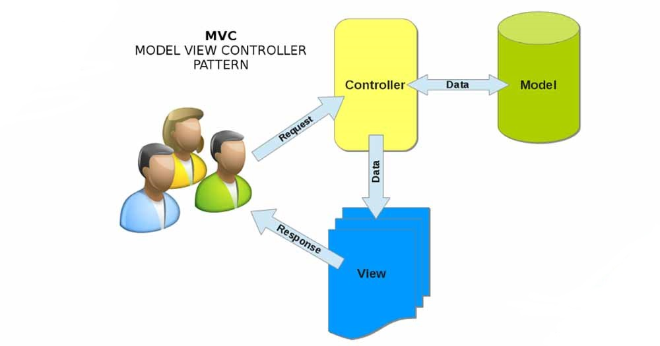

## Laravel Framework

## 1.10.1 Laravel

Laravel is a popular open-source PHP web application framework used for building robust and scalable web applications. It follows the Model-View-Controller (MVC) architecture and provides a range of tools and features to make web development easier and more efficient.

Some of the key features of Laravel include:

* Blade templating engine: Laravel provides a powerful and lightweight templating engine called Blade, which allows developers to easily create and manage dynamic views for their web applications.
* Eloquent ORM: Laravel's built-in Object-Relational Mapping (ORM) system, called Eloquent, makes it easy to work with databases by providing a simple and intuitive syntax for querying and updating data.
* Artisan CLI: Laravel comes with a command-line interface called Artisan, which provides a range of useful tools for automating common development tasks, such as generating code, running tests, and managing migrations.
* Authentication and Authorization: Laravel provides built-in support for user authentication and authorization, making it easy to implement secure login systems and control access to different parts of your application.
* Routing: Laravel's routing system makes it easy to define and manage application routes, allowing you to easily map URLs to controller actions and manage redirects.

Laravel is widely used in web development for building a wide range of applications, including content management systems, e-commerce platforms, and social networking sites. Its active and supportive community and comprehensive documentation make it a popular choice for developers who want to create high-quality, scalable, and maintainable web applications.

**1.10.2 Advantages and disadvantages**

Laravel is a powerful and popular PHP web application framework that offers a range of features and tools for building robust and scalable web applications. However, like any technology, it has its advantages and disadvantages, especially for new developers. Here are some of the pros and cons of using Laravel for newbies:

**Advantages**:

* *Rapid development: Laravel's built-in features, such as routing, authentication, and database management, can help new developers build web applications quickly and efficiently.*
* *Community support: Laravel has a large and active community of developers who contribute to its development, provide support, and share resources, making it easier for new developers to learn and get help.*
* *Modern and intuitive syntax: Laravel's syntax is modern and intuitive, making it easier for new developers to write and understand code.*
* *MVC architecture: Laravel follows the Model-View-Controller (MVC) architecture, which separates the presentation layer, business logic, and data storage, making it easier to maintain and scale applications over time.*

**Disadvantages:**

* *Steep learning curve: Laravel has a lot of features and tools, which can make it overwhelming for new developers to learn and understand all of its components.*
* *Limited backward compatibility: Laravel updates regularly, and sometimes, new versions of the framework may not be backward compatible, which can make it difficult for new developers to keep their applications up to date.*
* *Performance overhead: Some of Laravel's features, such as routing and middleware, can add some performance overhead, which may affect the speed of applications.*
* *Dependency management: Laravel has a lot of dependencies, which can make it difficult for new developers to manage and update them.*

# CHAPTER II: DESIGN ANALYSIS, APPLY

## 2.1 Functional analysis

### 2.1.1 Customer

**Account management function:**

* Register
* Login
* Account management

**Update information**: Email, name, phone number, address, shipping address, profile picture, update password.

**Product search function**

Search for products by name, category.

**Product detail view function**

Users can directly select products on the homepage, view detailed information about prices, reviews, images, product features, detailed descriptions, ... of the product.

**News view function**

Users can view news or advertisements about the store such as promotional products, promotional information, technology information, ...

News articles are displayed as a list on the slider and sidebar.

**Cart, order function**

Users can select products directly on the homepage or search for desired products and add them to the cart.

### 2.1.2 Administrator

**Category management function:**

Admin can add, edit, and delete product categories.

**Product management function:**

Admin can add, edit, and delete products.

For each product, they can update: name, description, content, category, price, promotions, quantity, display image, product specifications, etc.

**News management function:**

Admin can add, edit, and delete news about related products or content.

**Settings management function:**

Admin can add, edit, and delete website settings.

**Order management function:**

Admin can delete, view details, and update order status.

**Statistical function:**

On the home page, admin can view statistics on the number of products remaining in stock, number of orders, administrators, and product categories.

Admin can also view sales and profits within a specific time period entered by the admin.

## 2.2 Database design

## 2.2.1 ERD

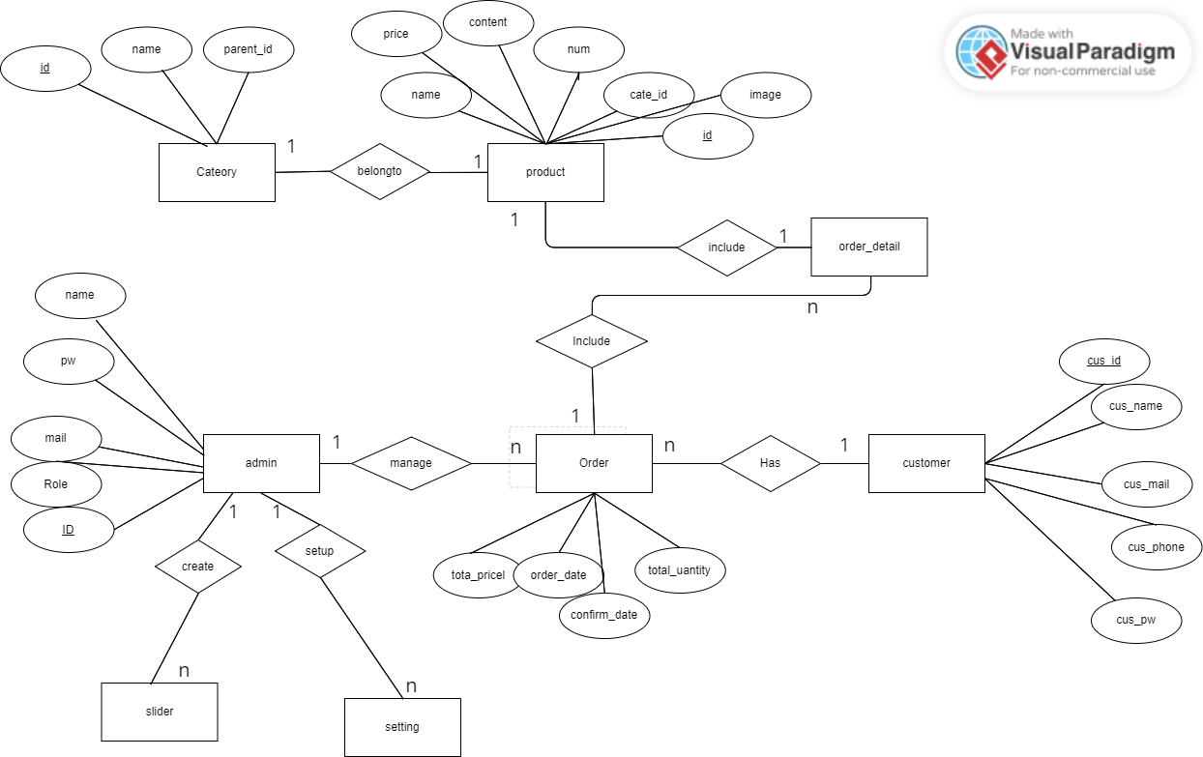

### 2.2.2 Table schema mapping

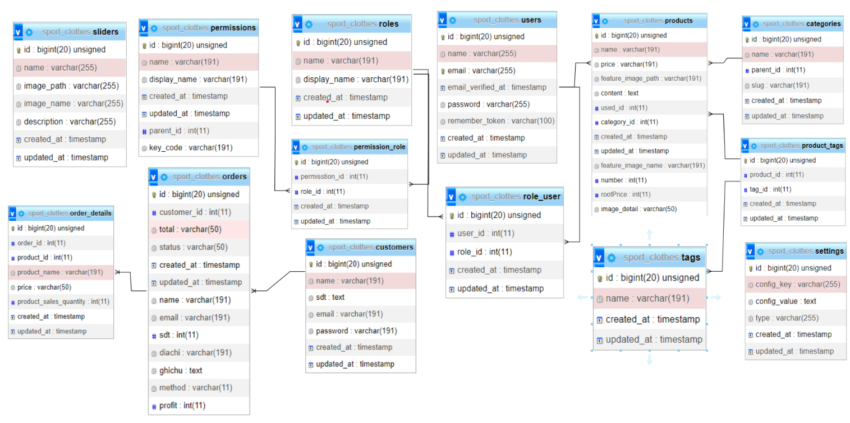

# CHAPTER III : RESULT VERIFICATION

## 3.1 Install enviroment

**Minimum requirements for installing Laravel environment**

PHP >= 7.4.1

OpenSSL PHP Extension

PDO PHP Extension

Mbstring PHP Extension

Tokenizer PHP Extension

XML PHP Extension

Ctype PHP Extension

JSON PHP Extension

BCMath PHP Extension

The necessary extensions may not be of much concern, but there are 3 minimum requirements:

* *PHP version requirement is 7.4.*, as this version has significantly improved performance compared to previous versions.*
* *OpenSSL PHP Extension: The requirement to switch from HTTP to HTTPS protocol is mandatory for improved security and safer data transfer, and it is a plus point for optimizing search engine rankings (SEO).*
* *JSON PHP Extension: JSON is a simple and highly efficient data format that is gradually replacing XML, a dominant data format in the past. JSON is now present everywhere, especially in current API application architectures.*

**Installing Laravel**

One tool that we need to get familiar with when developing PHP applications is Composer, a tool for managing software package dependencies in a PHP project.

**Installing Xampp**

Access the following link:

<https://sourceforge.net/projects/xampp/files/XAMPP%20Windows/7.4.15/>

**Run project by using artisan**

To run PHP applications in general and Laravel in particular, if a web server application such as Apache is already installed on the local machine, we just need to start these applications. However, if web servers have not been installed yet, Laravel also provides an alternative way to execute applications through the Artisan tool.****

In that case, the project can be accessed via the browser at http://127.0.0.1:8000/. The drawback of using Artisan to run the application is that you always have to keep the console window open, and the second disadvantage is that if we are developing multiple projects simultaneously, it is better to install web server software.

**IDE, code editor**

We need to write code, and of course we need an application that can be used to edit it. The simplest one could be Nodepad, nano... But these applications do not highlight the code, making it difficult to read. Text editors can be categorized as follows:

* Code editors: Sublime Text, Visual Studio Code, Notepad++, Atom...
* IDE (Integrated Development Environment): PHPStorm, Eclipse, NetBean, ZendStudio...

If the computer configuration is not strong, we should choose a source code editor as it runs very smoothly and can also meet up to 98% of project development tasks.

**Development environment**

The development environment includes applications such as a web server, database, PHP compiler... There are currently 3 ways to create a development environment:

Traditional method: Installing each component separately, such as the Apache or Nginx web server, PHP compiler, MySQL, PostgreSQL database.

Using all-in-one software such as XAMPP, WAMPP, LEMP, LAMP... And the latest software, if you use Windows, Laragon is one of the best-rated options.

Using virtual technology with Laravel Homestead: Virtualization helps isolate the development environment completely from the environment on your daily working computer. It also installs a series of necessary applications so that you can focus on development. However, your personal computer requires a relatively high configuration if you choose this option.

For this project, I chose XAMPP.

## 3.2 Demo interface of some main pages

**Home page:**

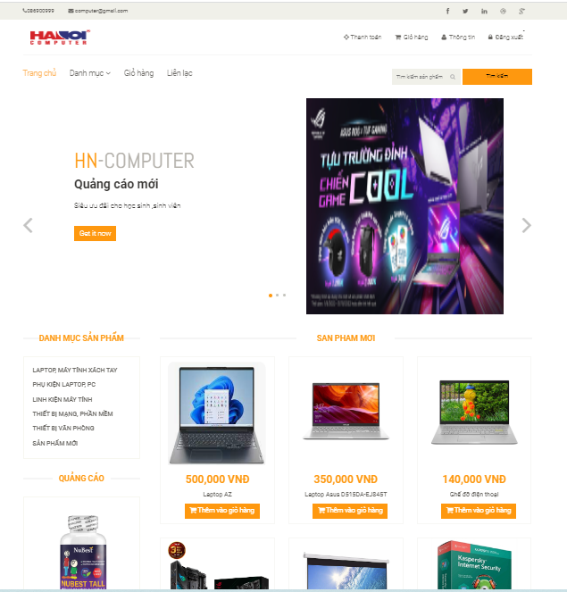

**Product detail:**



**Search product:**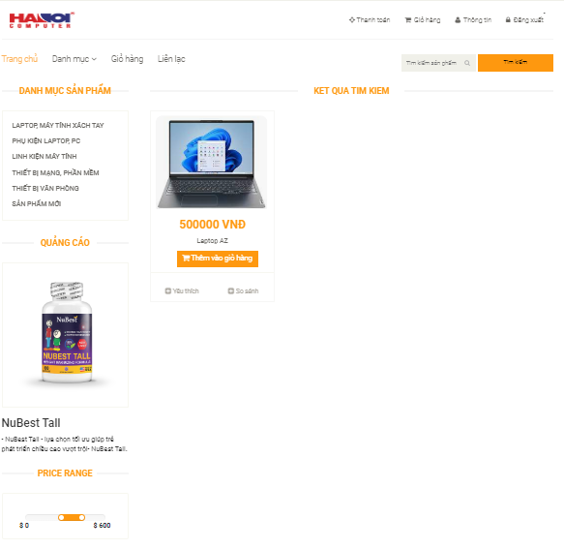

**Login admin:**

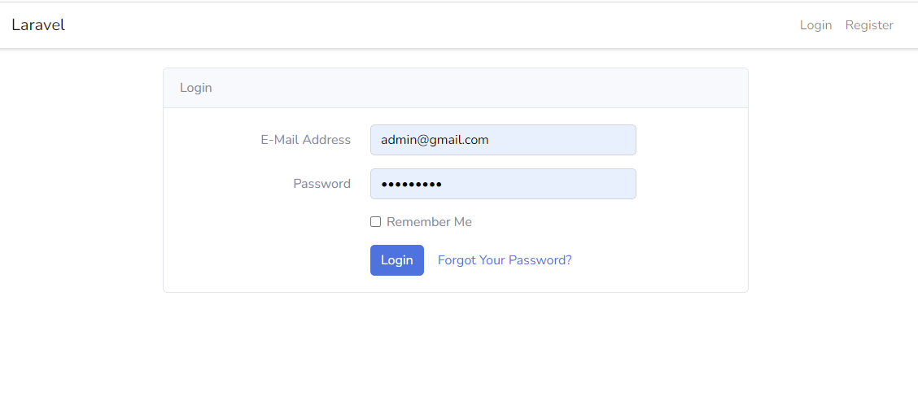

**Register:**

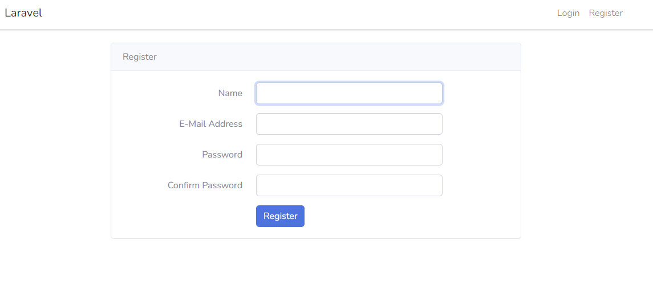

**Forget password:**

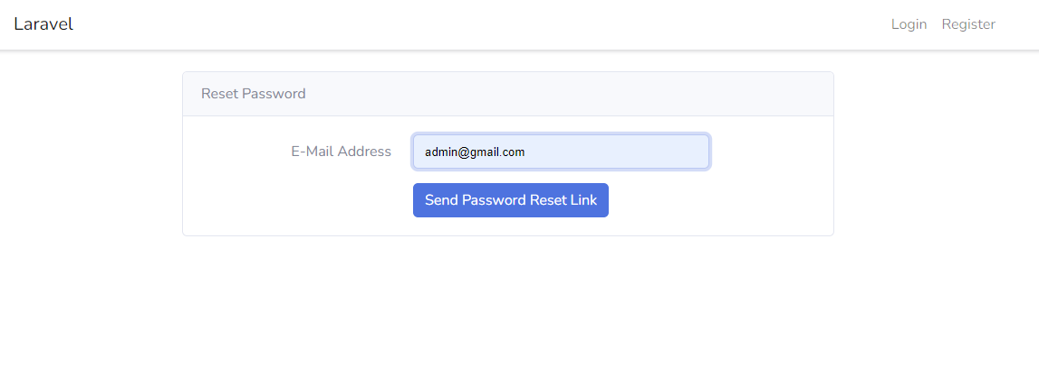

**Admin home page:**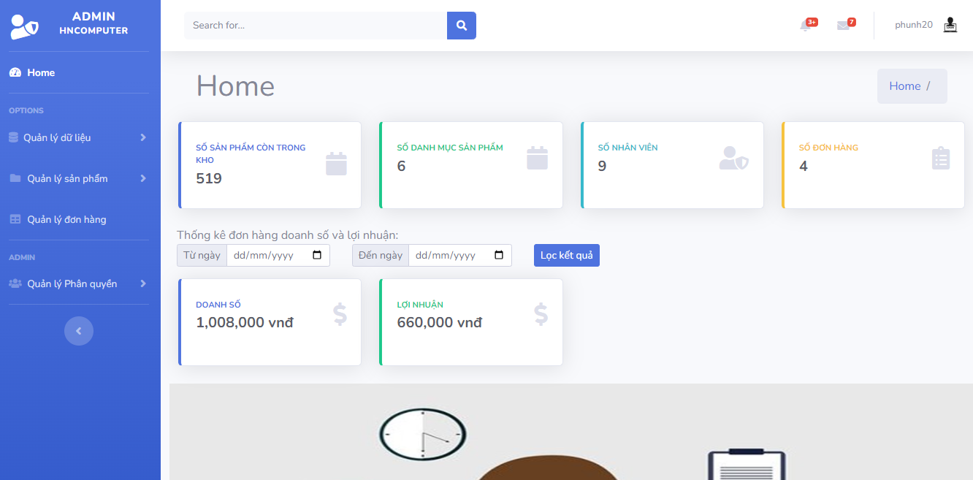

**Interface product management:**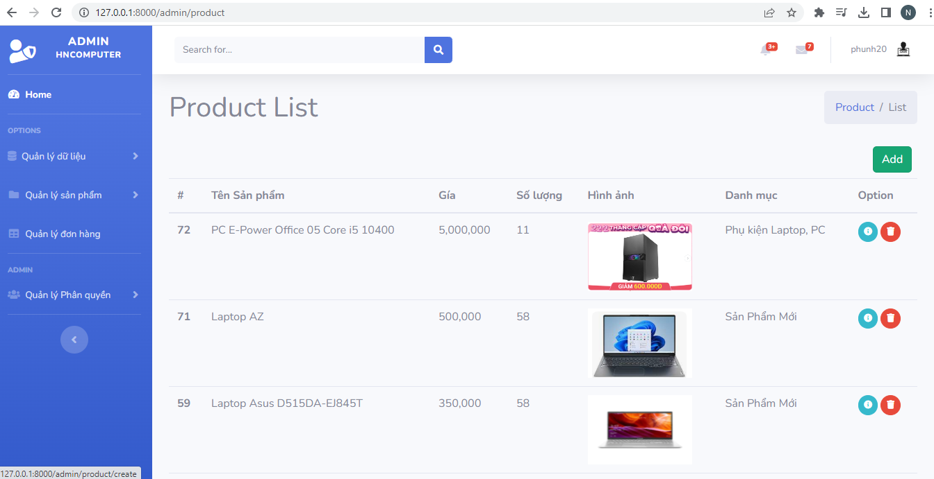

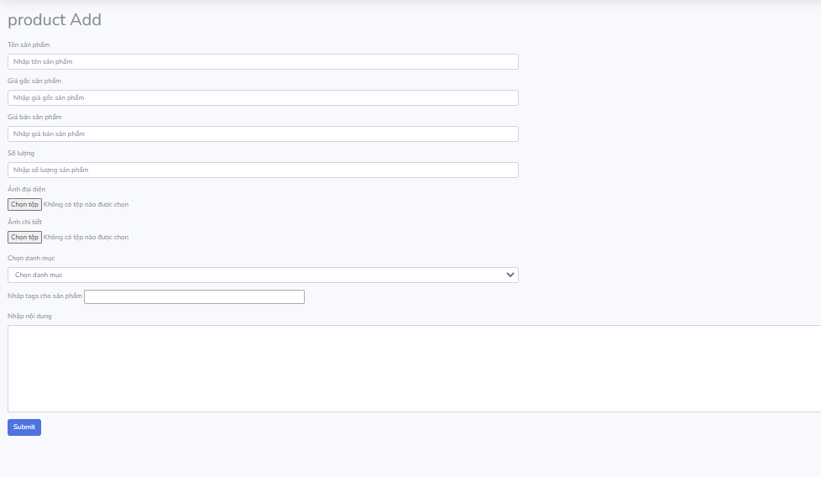

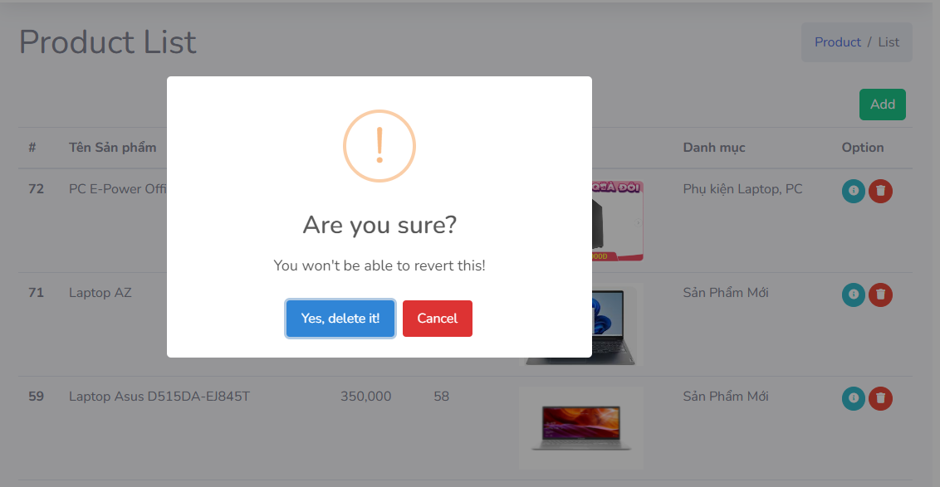

**Category:**

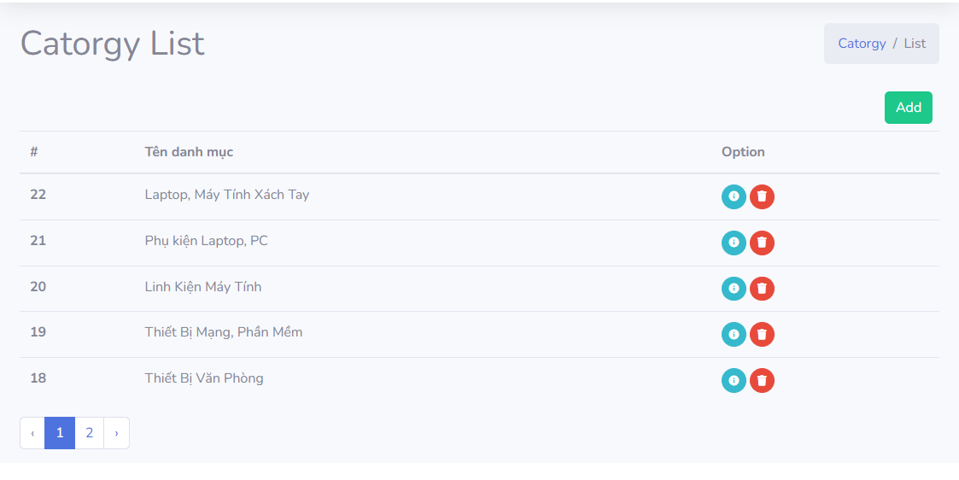

**Order management:**

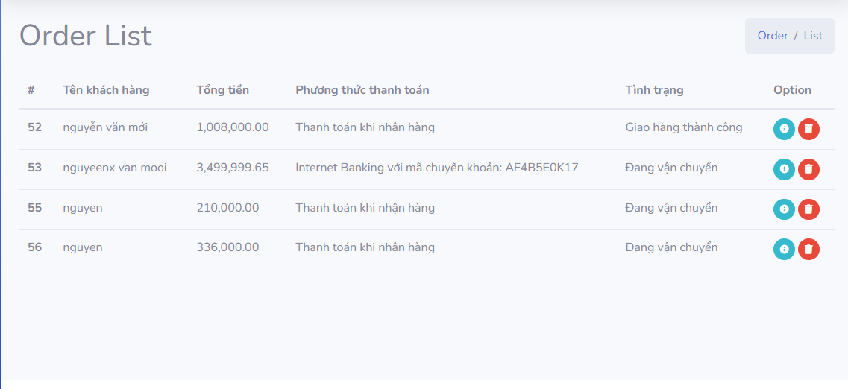

# Chapter IV: Conclusion

## 4.1 Conclusion

**Result:**

Learn about web, pure web code, use framework to do basic CRUD.

**Accumulated knowledge:**

* Database design
* Interface design
* Learn some packages of the Laravel framework
* Ability to study documents to solve problems
* Debug

## 4.2 Evaluation

**Overall:**

The main content of this project is still to learn about technology, and then apply that technology to create interfaces and basic functions. Through this, there is a basic understanding of web and web design.

The output product still has many deficiencies and cannot be considered complete.

**Desire:**

Complete the functions, control the input data, and have a usable web application in practice. Furthermore, integrating AI-related technologies to predict and suggest products would be a future goal.

I would like to express my gratitude once more to MSc. Nguyen Hong Phuong for helping me with this project. Although there were some errors in the project, I am hopeful that I can receive additional guidance from you to enhance my future projects.

Thank you with sincerity!

# Chapter V: REFERENCES

1. https://packagist.org/packages/bumbummen99/shoppingcart

2. Laravel Framework : https://laravel.com/ .

3. Trang web: https://shopee.vn/ : Website của Shopee.

4. Khóa học Laravel : <https://www.youtube.com/watch?v=sMXkSWFlV28&list=PL8y3hWbcppt2nWBglaxrQm_A5sRjstdnK>

5. https://www.w3schools.com/