|  |  |  |  |
| --- | --- | --- | --- |
| **Lecturers:** | **Francisco Javier Calle Gomez, Daniel Esteban Villamil Sierra** | | |
| **Group:** | **283** | **Lab User** | **fsdb283** |
| **Student:** | **Antonio Nicolas Lemus Yeguas** | **NIA:** | **100522110** |
| **Student:** | **Denis Loren Moldovan** | **NIA:** | **100522240** |
| **Student:** | **Jorge Adrian Saghin Dudulea** | **NIA:** | **100522257** |

# Introduction

The Foundation for the Diffusion of Culture (Foundicu Org.) requires an updated database system to efficiently manage its bibliographic collections and mobile library services. The current database is inadequate, containing only three disjointed tables with limited constraints, leading to poor data integrity and insufficient semantic coverage. This project aims to design a new relational database that meets the foundation’s operational needs, implements necessary constraints, and facilitates seamless data migration. The accompanying files, create-tables.sql and migration.sql, contain the implementation of the new schema and data migration procedures, respectively.

In this document will be present a diagram of the followed database structure, with the primary keys and the foreign keys, accompanied with tables that define the before mentioned structure.

# Relational Design

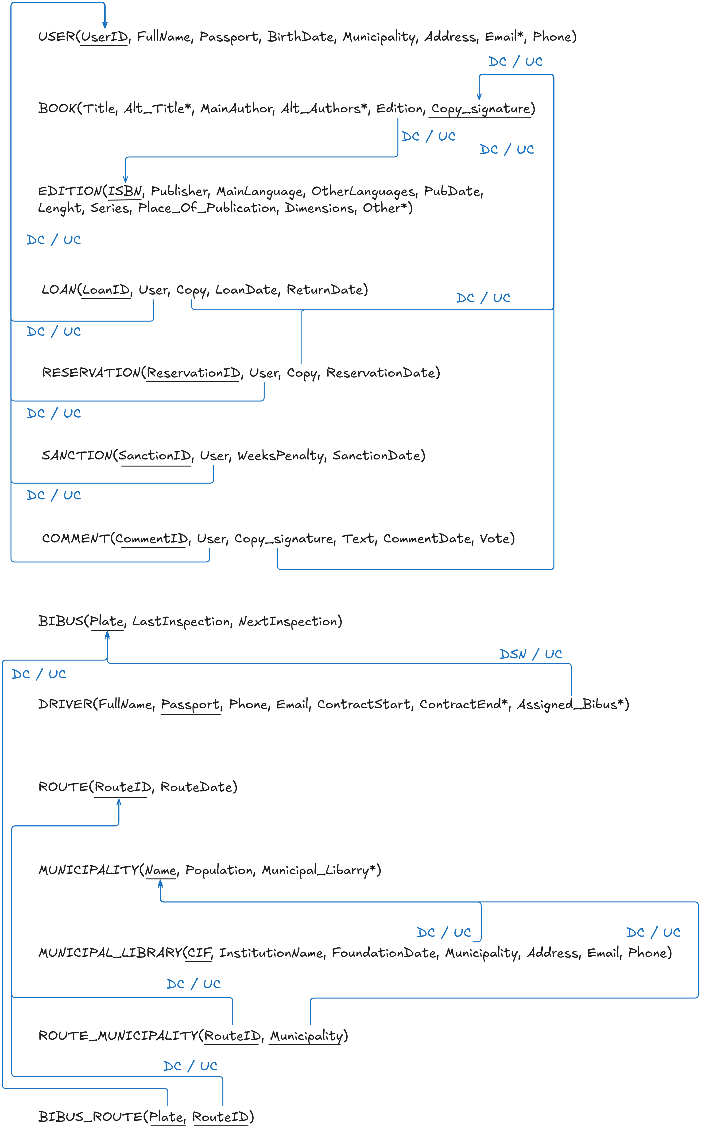

* Implicit semantics:

|  |  |  |  |
| --- | --- | --- | --- |
| **Presp_id** | **Stage** | **Mechanism** | **Description** |
| I1 | Design | Primary key | Users are identified by their user ID. |
| I2 | Design | Primary key | Books are identified by their own copy signature |
| I3 | Design | Primary key | Each edition of a book is identified by its ISBN |
| I4 | Design | Primary key | Loans are identified by their ID |
| I5 | Design | Primary key | Each reservation of a book has its own ID |
| I6 | Design | Primary key | Sanctions are identified also by their ID |
| I7 | Design | Primary key | Each comment has its own ID |
| I8 | Design | Primary key | Bibuses are identified by their plates |
| I9 | Design | Primary key | Drivers are uniquely identified by their passports |
| I10 | Design | Primary key | Each route can be found by their ID |
| I11 | Design | Primary key | Each municipality has its own unique name |
| I12 | Design | Primary key | Each municipal library has its own CIF |
| I13 | Design | Primary key | Each route passing through a municipality is identified by its route ID and the municipality it goes to |
| I14 | Design | Primary key | The routes that a bibus will take its identified by the plate of the assigned bibus and the route ID. |

Table 1: Implicit semantics incorporated into the relational graph

* Non-observed explicit semantics:

|  |  |
| --- | --- |
| **Presp_id** | **Description** |
| S1 | Phone numbers have 9 digits (at least, at most) |
| S2 | Passports follow the format of the corresponding country standard, with checks that validate it before uploading to the database. |
| S3 | ISBNs have 13 digits |
| S4 | Plates have 4 digits, followed by 3 letters |
| S5 |  |
| S6 |  |
| S7 |  |
| S8 |  |
| S9 |  |
| S10 |  |
| S11 |  |
| S12 |  |
| S13 |  |
| S14 |  |

Table 2: Non-observed explicit semantics

# Relational Statics Implementation in SQL (DDL)

This section must include the creation of each table. In addition to the code (*NEWcreation.sql* script) for creating tables (valid syntax in PL/SQL), you should include the correspondent subsections referring to the excluded semantics that are re-incorporated, the newly incorporated implicit semantics, and the explicit semantics that were observed but are now excluded. All these sections will be accomplishing by fulfilling the correspondent table (see tables 3, 4 and 5). Any of these tables is empty (in case), the table should be omitted and replaced by a phrase such as "Has not been reported."

Re-incorporated semantics: (identifiers referred to those assigned in table 1)

|  |  |
| --- | --- |
| **Presp_id** | **Solution Description** |
| S1 | field size is 9; a constraint (*constraint_name*) CHECK (phone³100000000) is added to the table *<table_name>* |
| … | … |

Table 3: re-incorporated explicit semantics

Incorporated implicit semantics: (numbering continues where ended in table 2)

|  |  |  |  |
| --- | --- | --- | --- |
| **Presp_id** | **Stage** | **Mechanism** | **Description** |
| In+1 | Implem. | Check | There is no *age* greater than 120 years old |
| … |  |  | … |

Table 1(cont.): implicit semantics incorporated in the definition of each table

Excluded semantics:

|  |  |  |  |
| --- | --- | --- | --- |
| **Presp_id** | **Description** | **Cause** | **Explicit/Implicit** |
| E1 | Contracts are automatically updated with the company’s update (integrity option UC on the FK referencing *Companies*). | PL/SQL does not observe this integrity option | Implicit |
| … | … | … |  |

Table 5: explicit semantics excluded in the creation of each table

# Workload (DML)

This section will describe the uploading of the workload (*NEWload.sql* script) from the tables provided (and described in the statement). To this end, we will analyze the problem of populating the tables with the workload. The solution will be described, with emphasis on:

* The specific order of tables to dump data into them (reasoned).
* The problems that arise (obligatory field value, inconsistencies in the original data, etc...) and the solutions adopted to overcome them.