|  |
| --- |
| Computing Technology Inquiry Project |
| Assignment 1 Report  COS10026  Darren Chong Kai Chen| 104406534 |
| Bachelor of Computer Science (Honours) |
|  |
|  |

School of Engineering, Computer Science

Swinburne University of Technology

Sarawak Campus

# TABLE OF CONTENTS

TABLE OF CONTENTS 1

1.0 Introduction 2

2.0 Website Content 3

2.1 Sitemap 3

2.2 Products Page (Menu Page) 3

2.2.1 Products 1-4 5

3.0 Website Style 6

3.1 Products 6

3.1.1 Drink Name Section (.prd-drink-name) 7

3.1.2 Category Toggle Section (.prd-toggle-wrapper, .prd-menu-toggle, .prd-menu-btn, .prd-menu) 7

3.1.3 Product Grid Section (.prd-content-container, .prd-product-list, .prd-product-item) 8

3.1.4 Drink Info Block (.prd-name, .prd-description, .prd-price) 8

3.1.5 Full Table Menu (.full-menu, .menu-table, .menu-table-wrapper, .prd-menu-category) 8

3.1.6 Product Explainer (.product-explainer) 9

4.0 Conclusion 10

4.1 Future Improvements and Recommendations: 10

# Introduction

The *Brew & Go* website was developed as a marketing-oriented platform with two core objectives: to act as a digital storefront that promotes the brand and its offerings, and to provide existing and potential customers with an engaging and informative user experience. It serves both as a presentation tool for marketing purposes and as a self-introduction for the Brew & Go brand.

For existing customers, the site allows members to sign in, browse the latest drinks and promotions, collect points, and stay updated with current activities and events. For new visitors, it introduces the brand’s identity, culture, and product philosophy in an accessible and visually appealing format.

This project holds deep personal meaning to us. It represents the most time, energy, and creative effort We’ve ever invested in any assignment so far. From structuring the content and developing forms to fine-tuning the CSS animations and layout details — every line of code reflects hours of dedication. While I acknowledge that the submission deadline marks the current limit, I view this site as one of my most complete and polished works to date.

This report will provide a breakdown of the website’s structure and purpose, an overview of the design and styling techniques used, and a review of the key features and enhancements implemented throughout the project.

# Website Content

## Sitemap

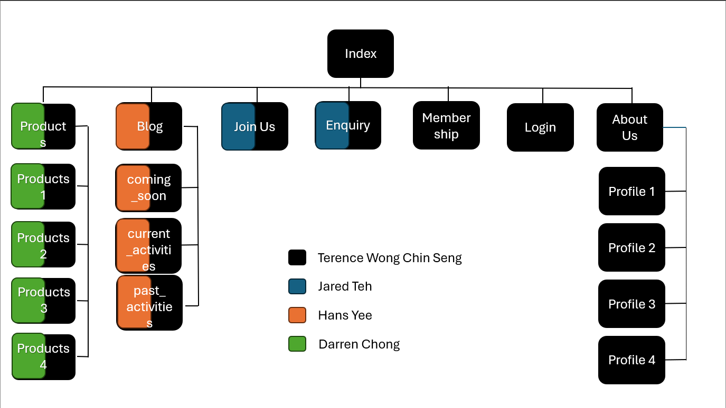

## Products Page (Menu Page)

The *Product Pages* are split across four individual HTML files: product1.html (Basic Brew), product2.html (Artisan Brew), product3.html (Non-Coffee), and product4.html (Seasonal). Each page categorizes Brew & Go's drink offerings for better user navigation and focuses on clarity, consistency, and visual hierarchy.

Each product is presented using a <figure> element that wraps the product image, name, description, and pricing details. The accompanying <figcaption> ensures semantic accuracy while also improving accessibility and screen reader compatibility. To enhance visual clarity and maintain alignment across rows, products are displayed within a grid layout managed through CSS Flexbox.

Beneath each item:

* **Two pricing tiers** are shown — Member and Non-Member — helping reinforce the value of membership.
* Interactive **hover effects** are applied to product cards, subtly highlighting the entire row or enlarging the image to create a dynamic browsing experience.

Every page also includes additional HTML5 semantic elements:

* <ol> lists are used for recommendations and drink highlights.
* <dl> (definition list) tags define unique drink ingredients or brewing methods.
* <aside> elements are occasionally used for fun facts, seasonal highlights, or ingredient notes — improving both structure and search engine readability.

To ensure visual consistency, all product pages share a unified structure, navigation menu, cart toggle, and footer. CSS class naming conventions (e.g., .prd-product-item, .prd-price, .prd-description) were maintained across all four pages, making styling predictable and maintainable.

These pages collectively offer a clean, responsive digital menu system — and provide the user with an organized, visually appealing experience when exploring Brew & Go’s beverage offerings.

### Products 1-4

The Products Page section comprises four dedicated HTML files — product1.html, product2.html, product3.html, and product4.html — each representing a unique beverage category: Basic Brew, Artisan Brew, Non-Coffee, and Hot Beverage respectively. All four pages follow a unified layout structure, ensuring brand consistency and seamless navigation across the site. These product pages serve as categorized digital menus that help users explore the full range of Brew & Go's offerings in a clear, organized format.

Each product is structured using semantic HTML elements for accessibility and clarity. Every drink is enclosed within a <figure> element, accompanied by an image, product name, description, and tiered pricing shown in the <figcaption>. The dual pricing system highlights both Member and Non-Member prices, reinforcing the value of membership benefits. Lists of featured drinks and highlights are provided through <ol> tags, while <dl> elements are used to define ingredients or brewing methods. Additionally, <aside> sections are included on select pages to provide contextual side content such as seasonal notes or drink facts.

Despite the separation into different HTML files, the codebase across all four remains predictable and maintainable through standardized class naming conventions. Collectively, these pages establish a structured, user-friendly environment for exploring Brew & Go’s beverage range in detail.

# Website Style

## Products

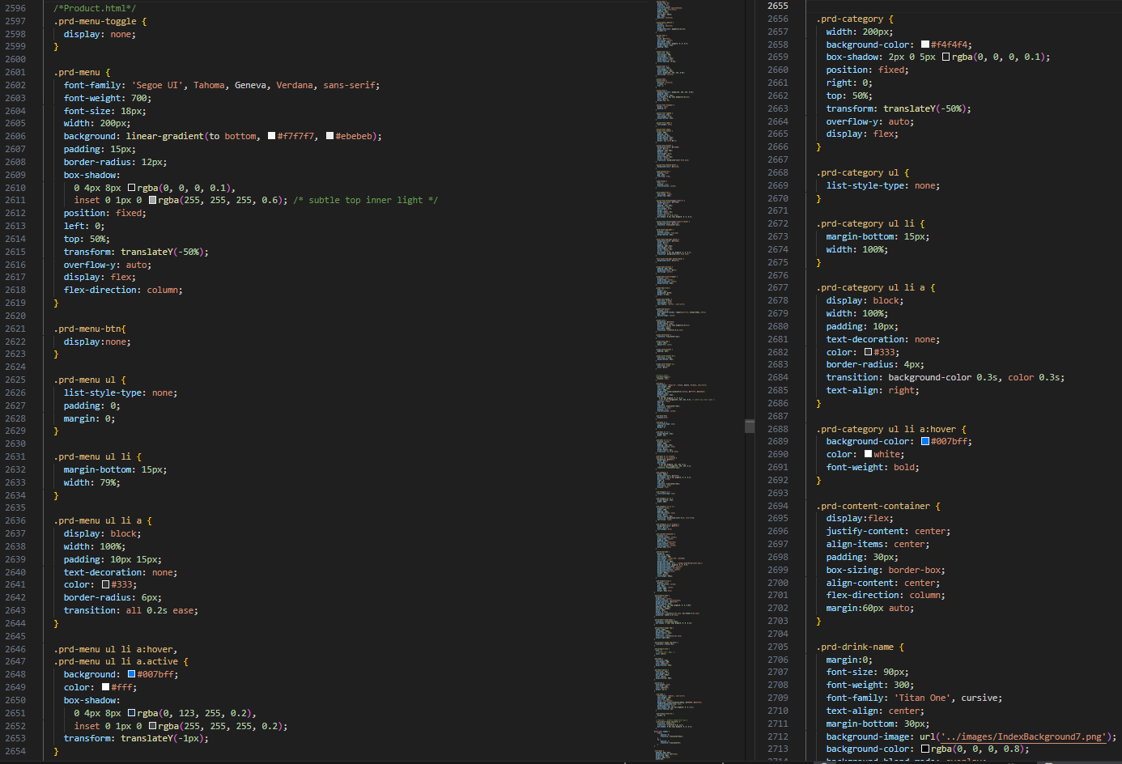

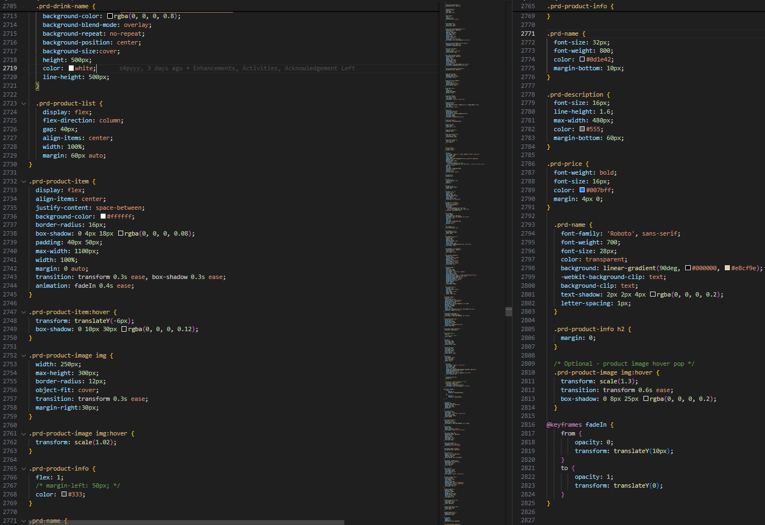

### Drink Name Section (.prd-drink-name)

The product page begins with a prominent header that clearly displays the current drink category (e.g., "Basic Brew", "Artisan Brew"). Styled using the .prd-drink-name class, it features bold typography and a full-width darkened background image that enhances contrast and readability. The text is center-aligned both horizontally and vertically, creating an engaging visual introduction to each category.

### Category Toggle Section (.prd-toggle-wrapper, .prd-menu-toggle, .prd-menu-btn, .prd-menu)

This section implements a responsive toggle menu that allows users to quickly switch between different drink categories. A checkbox input (.prd-menu-toggle) controls the visibility of the dropdown menu. The toggle button (.prd-menu-btn) is designed as a wide, blue-highlighted clickable label with clear, bold white text. When activated, the .prd-menu becomes visible with a smooth transition, presenting drink category links as list items styled for visual clarity and easy navigation. The entire section improves user experience on mobile by using a JavaScript-free toggling mechanism with just CSS selectors.

### Product Grid Section (.prd-content-container, .prd-product-list, .prd-product-item)

The core of the page lies in the product display grid, where beverages under the selected category are showcased. The .prd-content-container centers the entire layout and maintains consistent padding. Inside it, .prd-product-list uses a column-based flex layout with a comfortable gap between each item. Every individual drink is presented as a .prd-product-item, a styled figure with a shadowed card-like appearance. Each item displays an image on the left and drink details on the right, creating a clean and scannable layout ideal for both desktop and mobile.

### Drink Info Block (.prd-name, .prd-description, .prd-price)

Each product card includes detailed information broken down into multiple elements. The .prd-name class renders the drink title in a bold, modern typeface, often enhanced with a gradient or subtle color contrast for emphasis. Descriptions under .prd-description provide brief but enticing summaries in a lighter font for easy reading. Prices are displayed using .prd-price, styled in blue tones to draw attention to both member and non-member pricing. This clear distinction makes it easy for users to understand the value offered through membership.

### Full Table Menu (.full-menu, .menu-table, .menu-table-wrapper, .prd-menu-category)

Below the product grid, a comprehensive .full-menu section provides a full drink listing in tabular form. The .menu-table-wrapper centers the content within a visually padded box, while the .menu-table presents data in structured rows and columns. Each product category is grouped using the .prd-menu-category class to separate drinks by type. The table alternates row colors for readability and uses hover effects for interactivity. It includes headings for category, drink name, member price (MP), and non-member price (NP), ensuring transparent pricing and full menu visibility.

### Product Explainer (.product-explainer)

Concluding the page is a descriptive section meant to provide additional context and product storytelling. The .product-explainer class defines a neatly styled section with rounded borders and soft background, containing definition lists (<dl>) and ordered lists (<ol>). Each <dt> highlights the drink name while <dd> provides an informative description about its flavor profile or ingredients. This is followed by a Top 3 Picks list using an <ol>, guiding customers toward the most popular or recommended items. It adds a personal touch and enhances the shopping experience through curated suggestions.

# Conclusion

This project involved the development of a multi-page website for **Brew & Go**, showcasing products, membership programs, ongoing activities, and interactive content. The site was built using HTML and CSS only, following semantic and responsive design principles. Pages such as index.html, product1~4.html, joinus.html, enquiry.html, membership.html, and profile1.html were carefully structured to ensure consistency in branding and usability. Key features implemented include a mobile-responsive navigation bar, animated carousel, collapsible content cards, embedded Google Maps, membership flip cards, and various hover-based enhancements.

Throughout the development process, we gained hands-on experience with layout design, media responsiveness, semantic structuring, and user interface interactivity—all while working within the limitations of HTML and CSS. This exercise not only strengthened our frontend design skills but also reinforced the importance of accessibility and user experience design.

## Future Improvements and Recommendations:

1. **Cleaner and More Modular Codebase**:

Refactoring the code to improve naming conventions, segment reusable styles, and reduce redundancy would make the project more scalable and easier for future collaboration.

1. **JavaScript Integration**

With JavaScript, we can greatly enhance interactivity. For example, making the embedded map clickable with real-time location filtering or allowing users to interact with dynamic form validation and animations would elevate the user experience.

1. **Expanded Media Queries for Diverse Devices**

While the current responsive layout works well for common screen sizes, introducing more @media breakpoints (e.g., for tablets, ultra-wide monitors, or foldable phones) would ensure an even more seamless experience across a wider range of devices.

1. **Backend Implementation**:

Introducing a backend (e.g., using PHP, Node.js, or Firebase) could allow for persistent data storage, user authentication, dynamic product listings, and admin content management—transforming this static website into a fully functional web application.

1. **Framework Usage**:

Future iterations could benefit from adopting frontend frameworks like Bootstrap or Tailwind CSS for faster styling, or even React.js or Laravel for modular component-based development to enhance maintainability and performance.

Looking back, I feel there’s still much more that could be achieved. This project was a meaningful step forward, and I’m proud of what we’ve built—but I also look forward to future opportunities where I can push the boundaries even further, refine my skills, and deliver something even better.