|  |
| --- |
| Computing Technology Inquiry Project |
| Assignment 1 Report  COS10026  Terence Wong Chin Seng| 104404059,  Darren Chong Kai Chen| 104406534,  Hans Yee xxx xxx| 104404059,  Jared Teh xxx xxx| 104404059 |
| Bachelor of Computer Science (Honours) |
|  |
|  |

School of Engineering, Computer Science

Swinburne University of Technology

Sarawak Campus

# TABLE OF CONTENTS

TABLE OF CONTENTS 1

1.0 Introduction 2

2.0 Website Content 3

2.1 Sitemap 3

2.2 Form Pages (Join Us, Enquiry, Registration, Login Pages) 3

2.2.1 Join Us 3

2.2.2 Enquiry 5

2.3 Enhancements 6

3.0 Website Style 8

3.1 Join Us & Enquiry 8

3.2 Membership 11

3.3 Profile Page 13

3.4 Enhancements 15

4.0 Conclusion 17

4.1 Future Improvements and Recommendations: 17

# Introduction

The *Brew & Go* website was developed as a marketing-oriented platform with two core objectives: to act as a digital storefront that promotes the brand and its offerings, and to provide existing and potential customers with an engaging and informative user experience. It serves both as a presentation tool for marketing purposes and as a self-introduction for the Brew & Go brand.

For existing customers, the site allows members to sign in, browse the latest drinks and promotions, collect points, and stay updated with current activities and events. For new visitors, it introduces the brand’s identity, culture, and product philosophy in an accessible and visually appealing format.

This project holds deep personal meaning to us. It represents the most time, energy, and creative effort We’ve ever invested in any assignment so far. From structuring the content and developing forms to fine-tuning the CSS animations and layout details — every line of code reflects hours of dedication. While I acknowledge that the submission deadline marks the current limit, I view this site as one of my most complete and polished works to date.

This report will provide a breakdown of the website’s structure and purpose, an overview of the design and styling techniques used, and a review of the key features and enhancements implemented throughout the project.

# Website Content

## Sitemap

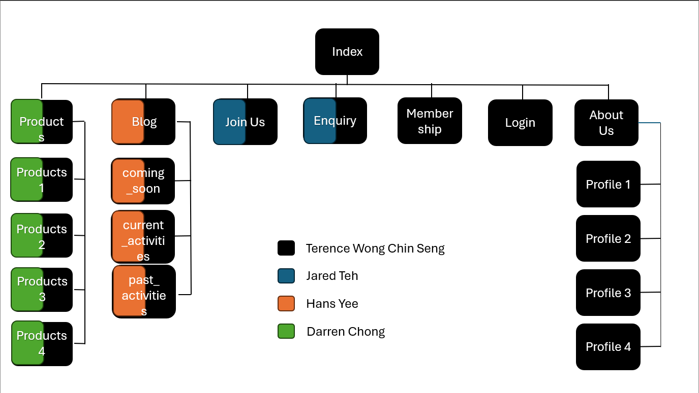

## Form Pages (Join Us, Enquiry, Registration, Login Pages)

The *Form Pages* are designed to collect essential user information for various functions, ranging from job applications to customer enquiries and membership registration. All four forms are structured with semantic HTML5 tags, clearly labeled fields, and built-in validation to ensure accuracy, accessibility, and responsiveness across devices.

### Join Us

**Crew Application Form**

This page allows potential baristas or cashiers to apply to join Brew & Go’s crew. The form uses <fieldset> and <legend> for structure, along with labels for each field to support screen reader accessibility. Input types include text fields, radio buttons (for preferred shifts), checkboxes (for position choices), a file upload input, and a textarea for applicant messages. All fields are marked as required, and constraints like maxlength and proper patterns are applied.

### Enquiry

**Customer Enquiry Form**

This form is designed in a A4 size way that looks like a letter format, enables customers to submit feedback or questions. It includes a dropdown menu for Malaysian states, a pattern-validated 5-digit postcode input, a reason selector using <select>, and textarea for detailed enquiries. Input validation ensures consistent formatting and improves user experience. All field labels are clearly aligned, and tab order is logical.

### Enhancements

The enhancements.html page highlights twelve custom enhancements implemented throughout the Brew & Go website. This page serves as both a functional documentation hub and a creative showcase, presenting each enhancement with a brief description, preview image, and a direct link to the page where the enhancement is used. All enhancements were built using HTML and CSS exclusively, without the use of JavaScript, in accordance with the project’s technical constraints.

Among the most prominent enhancements is the responsive **dropdown navigation menu**, which includes hover underline animations and category-based submenus under "Products" and "Blog". The **floating shopping cart icon** is another core feature — present on every page — allowing users to toggle a sliding cart sidebar using only an input checkbox and label interaction. On mobile devices, the site dynamically transforms into a **mobile-optimized layout** featuring a hamburger menu, reflowed sections, and scroll-friendly components. These responsive behaviors are powered by media queries and Flexbox layout techniques.

The homepage features a horizontally scrolling **product carousel** that pauses on hover and uses card hover effects to animate images and text. Further down, the **membership section** incorporates CSS-based **flip cards** to display information on both customers and crew recruitment. Below that, an additional row of perk cards reveals content on hover through scaling and overlay effects. These animated cards offer both interactivity and visual depth.

The **store locator section** embeds two responsive **Google Maps** iframes, each paired with store details and contact information. The embedded maps support zoom and scroll, enhancing the physical connection to the brand. At the bottom of the homepage, a **video section** plays two looping barista clips flanking a central "Join Us" button — reinforcing the brand culture and human touch.

On the content side, the **blog slideshow** on blog.html automatically rotates through upcoming and past events, with clickable images and hover-revealed descriptions. The **product pages** implement a variety of semantic enhancements, including <figure>, <ol>, <dl>, and <aside> to structure detailed drink menus and promotional callouts. Even individual profile pages feature **expandable <details> sections**, custom icons, and floating image enhancements that meet both the functional and aesthetic goals of the project.

Each enhancement contributes to a smoother, more engaging user experience, and collectively they reflect a high level of effort, attention to detail, and front-end development fluency.

# Website Style

## Join Us & Enquiry

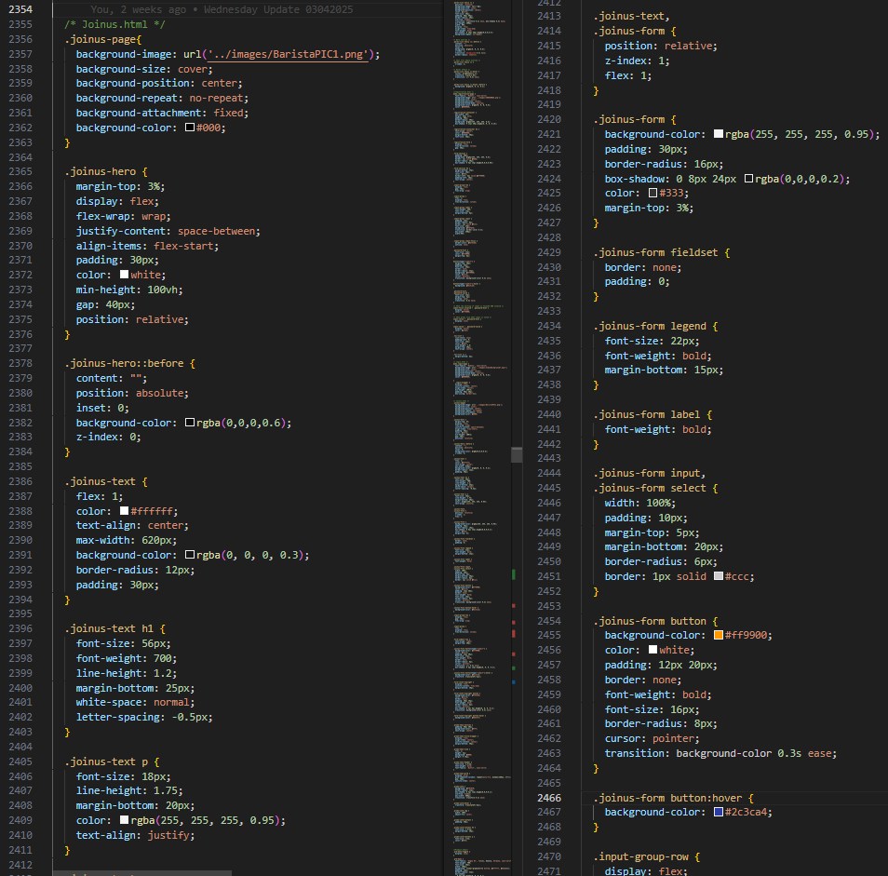

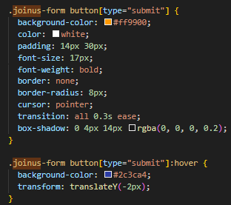

**▸ Page Structure & Layout**

Both the joinus.html and enquiry.html pages follow a consistent and professional layout that aligns with the overall theme of the Brew & Go website. Each begins with a full <header> section containing the navigation bar, logo, and shopping cart functionality. This is followed by a hero banner with a centered page title and introduction. The main content of both pages is vertically stacked, with the form section placed inside a styled container (joinus-form or enquiry-form) that visually separates it from the background using padding, rounded borders, and controlled width to maintain focus and readability.

**▸ Form Containers & Input Design**

Each form is wrapped in a specific class—joinus-form or enquiry-form—which governs styling like form width, background color, margin spacing, and padding. The input fields inside both forms are uniformly styled using CSS, ensuring consistent spacing, font size, and input height. Labels are aligned with their respective fields for accessibility and clarity. Buttons for **Submit** and **Reset** are positioned vertically, one on top of the other, for both pages as per user experience design consistency.

**▸ Join Us Specific Features**

The joinus.html form includes a radio button group for selecting the preferred working shift and a file upload input field for resume submissions. These inputs are laid out cleanly within fieldset and legend elements to semantically group related fields. All entries are validated with HTML5 features such as required attributes and appropriate input types (e.g., email, text, file). Additionally, a brief paragraph at the top introduces the form’s purpose—recruiting new team members to the Brew & Go family.

**▸ Enquiry Specific Features**

The enquiry.html page is designed for customer communication and feedback. It uses similar form elements but is structured to capture messages, contact info, and topics of concern. A textarea is included for open-ended feedback or detailed questions, styled to visually match other inputs. The design retains the same look-and-feel as joinus.html, ensuring consistency in layout, font choices, and mobile responsiveness.

## Membership

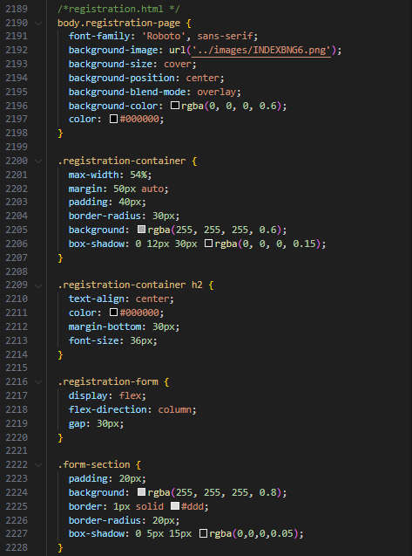

**▸ Page Structure & Layout**

The membership.html page adopts the same structural template as joinus.html and enquiry.html, ensuring design consistency across all form-based pages. The layout is vertically oriented with a full navigation <header> at the top, followed by a prominently styled banner area and main content container that divides the page into **membership information** (top half) and **registration form** (bottom half). This split layout allows visitors to first understand the benefits and requirements before filling out the form.

**▸ Membership Information Section**

The top half of the page is wrapped in a membership-info-section container (or equivalent), showcasing key details about the membership program. This includes headings such as “Member Perks” or “Why Join?”, short paragraphs that describe the lifetime perks, and sometimes an image or QR code on the side. This section also features horizontal lines or borders (like .membership-line-title-wrapper) to emphasize headers, giving the page a polished visual hierarchy. The typography and spacing mirror the styling of similar sections in the homepage and membership promo banners, reinforcing visual consistency.

**▸ Membership Registration Form**

The bottom half consists of the actual registration form, encapsulated within the registration-form class. This form mirrors the styling logic of joinus-form and enquiry-form but uses its own class naming convention for CSS separation. The form fields include name, email, IC/passport number, top-up amount selection (possibly via dropdown), and other personal details. Each input is spaced evenly and clearly labeled. The submit and reset buttons are vertically aligned, following the same UX pattern across all forms on the website.

**▸ Design Consistency & Validation**

The registration.html form implements HTML5 validation, using required fields, appropriate input types, and length restrictions to ensure correct data entry. The container uses consistent padding, border-radius, and margin values that match joinus.html, while maintaining its own unique identity through registration- prefixed classes. This separation allows the page to inherit the same user experience while remaining modular in its styling.

## Profile Page

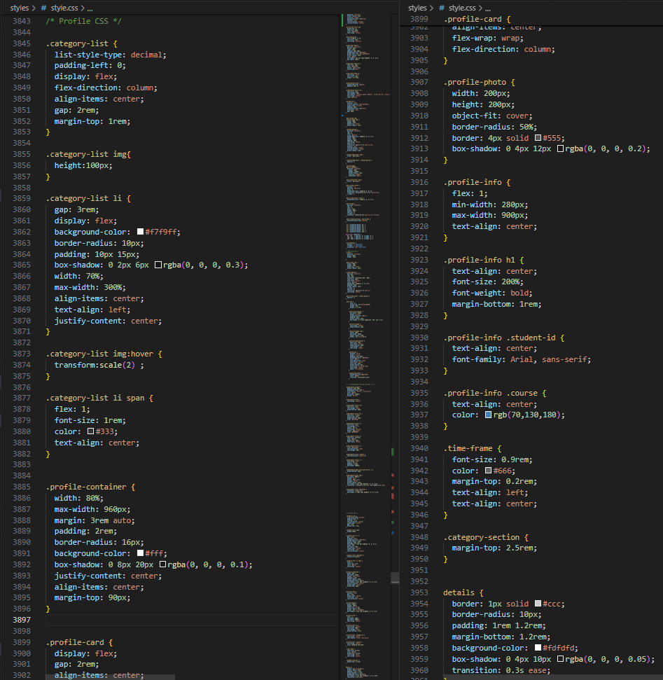

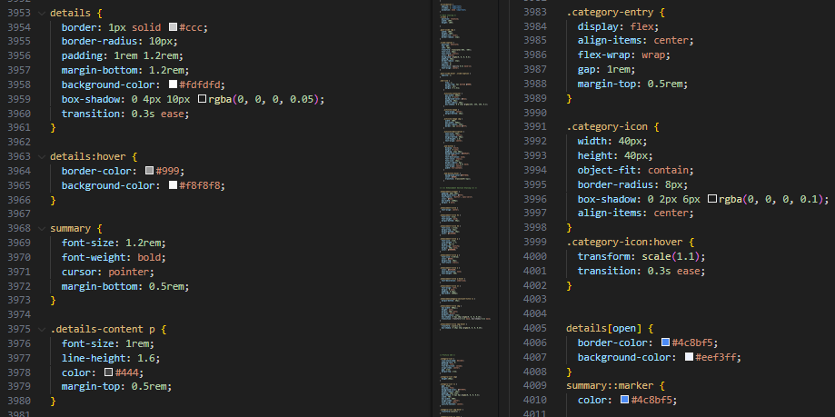

The profile page layout is meticulously structured using multiple CSS components to achieve a centered, clean, and responsive design. It begins with .profile-container, which sets the maximum width to 960px and centers the content both horizontally and vertically using margin: 3rem auto and align-items: center. This container is visually separated using a white background with a soft box-shadow to enhance readability and visual focus. Inside the container, .profile-card uses a flexible column layout to stack profile photo and details. The .profile-photo class sets a circular image frame using border-radius: 50% along with a subtle shadow effect. Beside it, .profile-info contains textual elements like the user’s name (h1), student ID, and course, all center-aligned and styled with varying font weights and colors to differentiate hierarchy and function.

Moving below the profile header, the .category-section introduces organized sections of categorized information using lists and interactive <details> blocks. The .category-list employs flex-direction: column and displays list items (li) in a card-like manner, each with a shadow and background color (#f9f9ff) for a soft, modern touch. Each list item scales slightly on hover, adding a responsive feel. Inside these list items, <span> tags are used for titles, and embedded <img> elements ensure iconography or illustrative support.

The <details> and <summary> elements are styled to resemble collapsible FAQ-style cards. The container itself has padding, rounded corners, and a light background (#fdfdfd). On hover, it subtly changes color and shadow for a dynamic interaction cue. When expanded, the [open] attribute changes border and background colors for clear visibility. Typography across the section is balanced with appropriate sizing (1.2rem for summary, 1rem for paragraphs), line heights, and muted tones (#666, #444) to ensure readability.

Finally, .category-entry and .category-icon contribute to a responsive icon grid section. Icons are rounded, visually elevated with shadows, and slightly scale on hover using transform and transition properties. The result is a profile page that feels personal, interactive, and well-structured — reflecting both aesthetic and usability principles in modern UI design.

## Enhancements

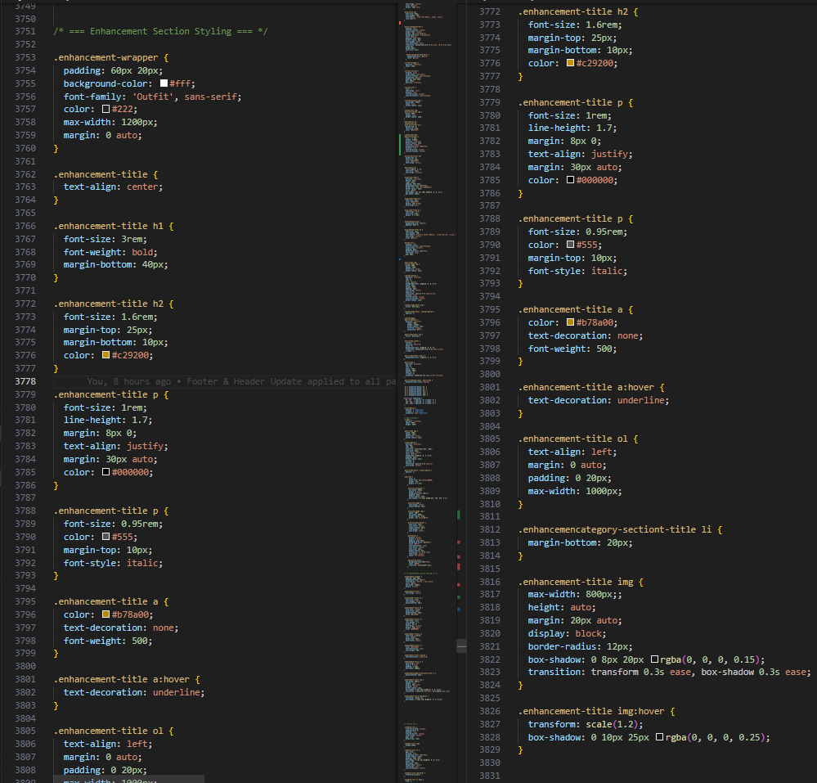

The **Website Style** section focuses on the overall aesthetics, consistency, and branding experience of the Brew & Go website. Through custom CSS and layout design, we aimed to deliver a visually appealing, modern, and user-friendly interface that reflects the identity of a premium coffee brand.

**✦ Custom Typography & Color Scheme**

We utilized the **Outfit** and **Roboto** fonts via Google Fonts to create a clean, contemporary look. These fonts were selected to ensure high readability while projecting a modern café identity. The color scheme (black, white, golden yellow, and accent blues) was carefully chosen to maintain harmony across all pages while drawing attention to interactive elements like buttons and hover states.

**✦ Consistent Layout with Reusable CSS**

Each page of the website uses a consistent grid layout defined in style.css. Classes such as .navbar, .footer, .product-page, and .blog-page allow uniform styling across various sections. This consistency improves user navigation and visual coherence.

**✦ Responsive Design with Media Queries**

Media queries were implemented to ensure the site adapts to different screen sizes, particularly for mobile and tablet devices. Elements such as the hamburger menu, stacked buttons, and scaled images maintain usability on devices ranging from desktops to phones.

**✦ Hover Effects for Interactivity**

Subtle hover effects were applied across navigation links, buttons, product cards, and activity slides. These include **scaling, shadow expansion, and color changes**, enhancing the interactive experience without overwhelming the user.

**✦ Semantic HTML and Accessibility**

Semantic HTML elements such as <section>, <nav>, <footer>, <ol>, and <details> were used to provide structure and meaning to the content. This improves accessibility for users using screen readers and also helps with SEO.

# Conclusion

This project involved the development of a multi-page website for **Brew & Go**, showcasing products, membership programs, ongoing activities, and interactive content. The site was built using HTML and CSS only, following semantic and responsive design principles. Pages such as index.html, product1~4.html, joinus.html, enquiry.html, membership.html, and profile1.html were carefully structured to ensure consistency in branding and usability. Key features implemented include a mobile-responsive navigation bar, animated carousel, collapsible content cards, embedded Google Maps, membership flip cards, and various hover-based enhancements.

Throughout the development process, we gained hands-on experience with layout design, media responsiveness, semantic structuring, and user interface interactivity—all while working within the limitations of HTML and CSS. This exercise not only strengthened our frontend design skills but also reinforced the importance of accessibility and user experience design.

## Future Improvements and Recommendations:

1. **Cleaner and More Modular Codebase**:

Refactoring the code to improve naming conventions, segment reusable styles, and reduce redundancy would make the project more scalable and easier for future collaboration.

1. **JavaScript Integration**

With JavaScript, we can greatly enhance interactivity. For example, making the embedded map clickable with real-time location filtering or allowing users to interact with dynamic form validation and animations would elevate the user experience.

1. **Expanded Media Queries for Diverse Devices**

While the current responsive layout works well for common screen sizes, introducing more @media breakpoints (e.g., for tablets, ultra-wide monitors, or foldable phones) would ensure an even more seamless experience across a wider range of devices.

1. **Backend Implementation**:

Introducing a backend (e.g., using PHP, Node.js, or Firebase) could allow for persistent data storage, user authentication, dynamic product listings, and admin content management—transforming this static website into a fully functional web application.

1. **Framework Usage**:

Future iterations could benefit from adopting frontend frameworks like Bootstrap or Tailwind CSS for faster styling, or even React.js or Laravel for modular component-based development to enhance maintainability and performance.

Looking back, I feel there’s still much more that could be achieved. This project was a meaningful step forward, and I’m proud of what we’ve built—but I also look forward to future opportunities where I can push the boundaries even further, refine my skills, and deliver something even better.