**Assignment**

**NOTE: Screenshots attached for reference each step. Also separately Images added in Repository for better view.**

**Swagger URL :** <http://localhost:8080/swagger-ui/index.html#/>

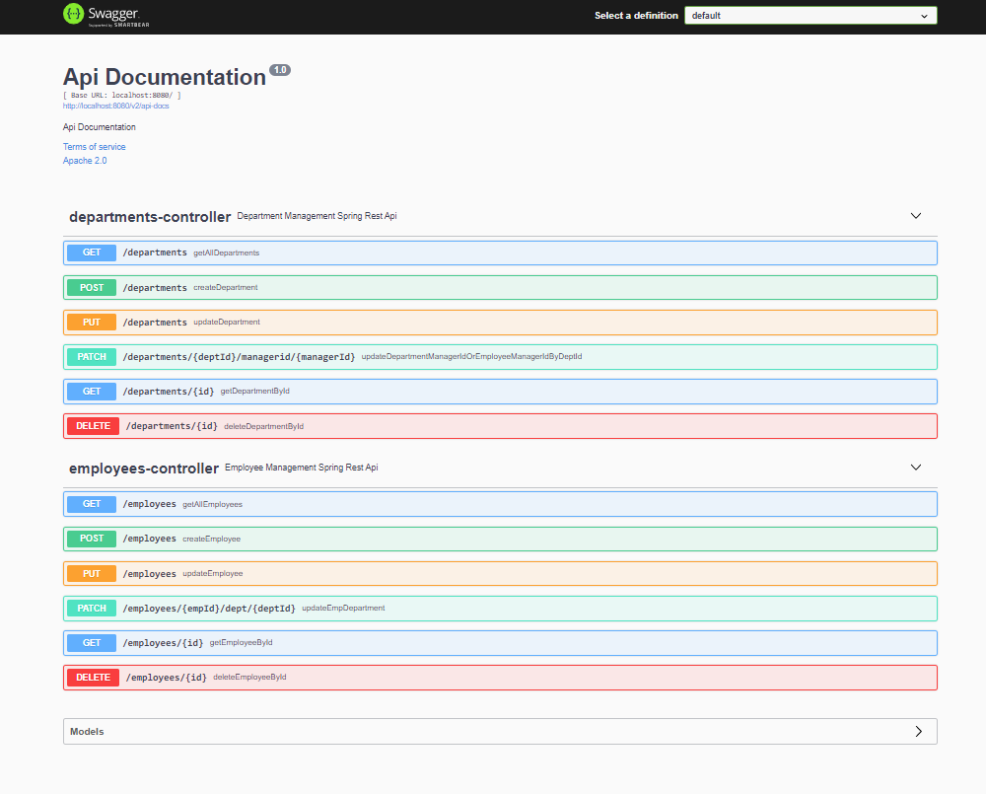

**H2 URL** : <http://localhost:8080/h2-console/login.do?jsessionid=a89806ddcdded94583e1033f36b5cc44>

**DB USER NAME : “sa” and DB USER NAME : “admin”**

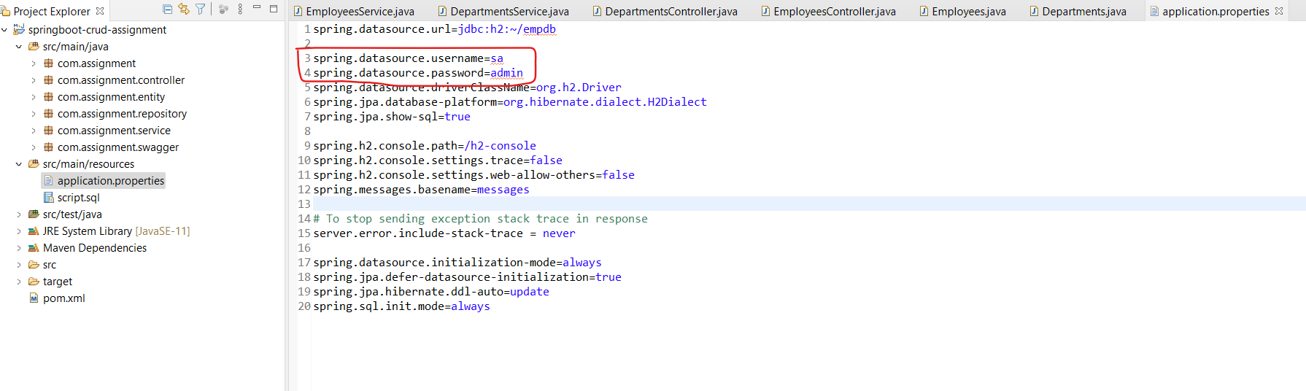

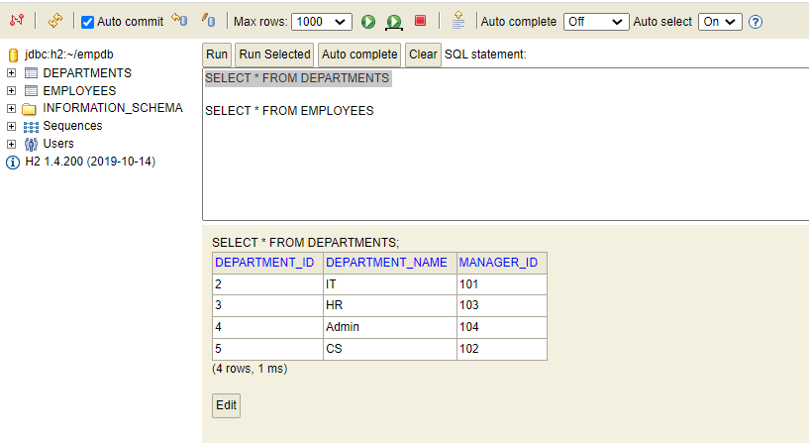

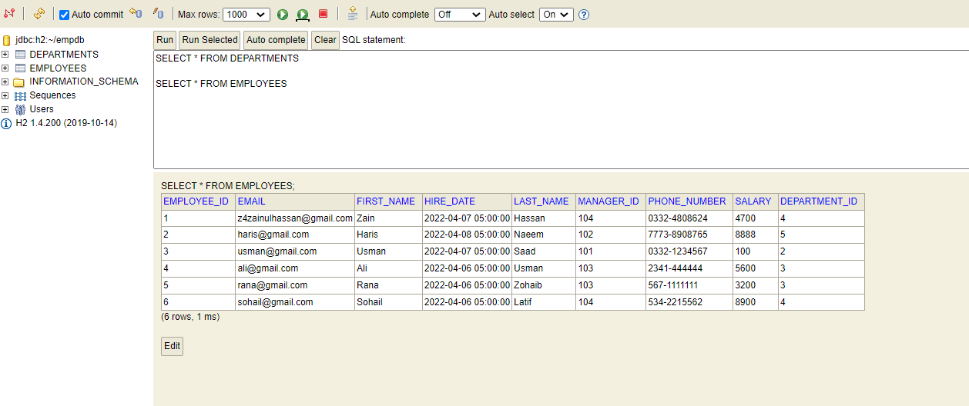

*************************************************************

**Employee API's :**

**Get Request Pagination** : http://localhost:8080/employees?pageNo=0&pageSize=2&sortBy=employeeId

**Get Request By Id** : http://localhost:8080/employees/1

**Post Request** : http://localhost:8080/employees

**PUT Request** : http://localhost:8080/employees

**DELETE Request** : http://localhost:8080/employees/1

**PATCH Request** : http://localhost:8080/employees/3/dept/1

**JSON REQUEST Example for Employee:**

{

"firstName": "Zain",

"lastName": "Hassan",

"email": "z4zainulhassan@gmail.com",

"phoneNumber": "0332-4808624",

"hireDate": "2022-04-07",

"salary": 1000

}

*************************************************************

**Department API's :**

**Get Request Pagination**: http://localhost:8080/departments?pageNo=0&pageSize=3&sortBy=departmentId

**Get Request By Id** : http://localhost:8080/department/1

**Post Request**  : http://localhost:8080/department

**PUT Request** : http://localhost:8080/department

**DELETE Request** : <http://localhost:8080/department/1>

**PATCH Request** : http://localhost:8080/departments/1/managerid/101

**JSON REQUEST Example for Employee**:

{

"departmentName": "IT",

"managerId": 101

}

*************************************************************

**STEPS**  
In this project Employee data CRUD operations will be added separately or Department data CRUD operations will be added separately.

(Note: It’s your choice to perform any operations randomly like [to add department data first or either add employee data first]).

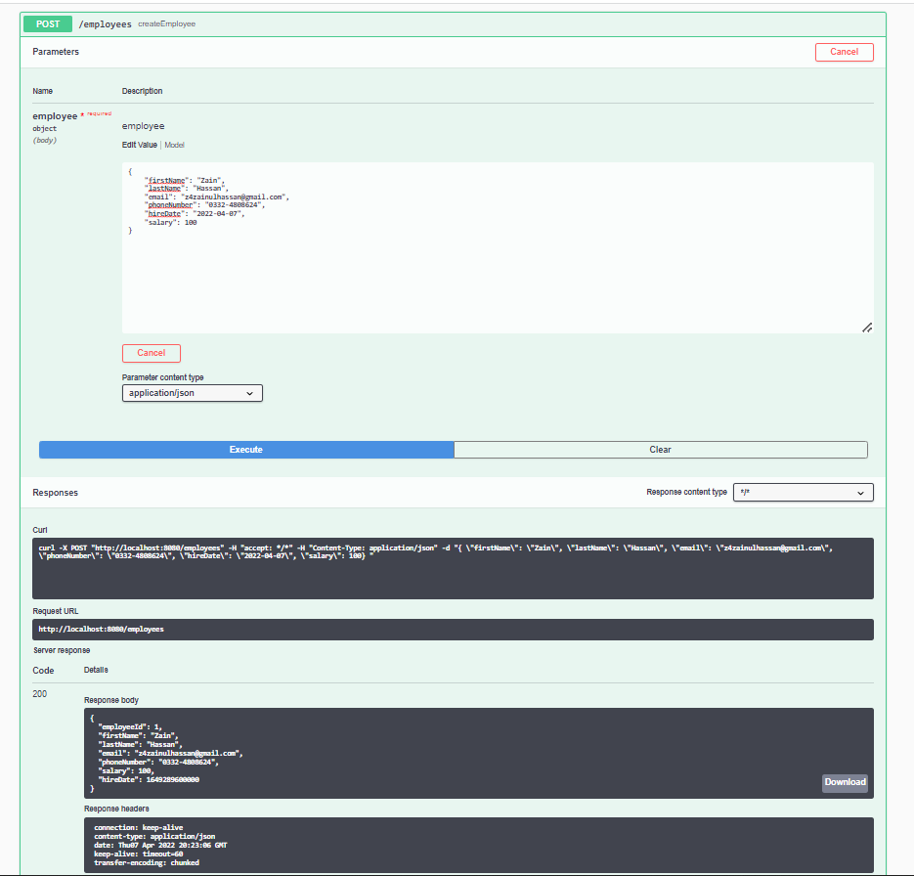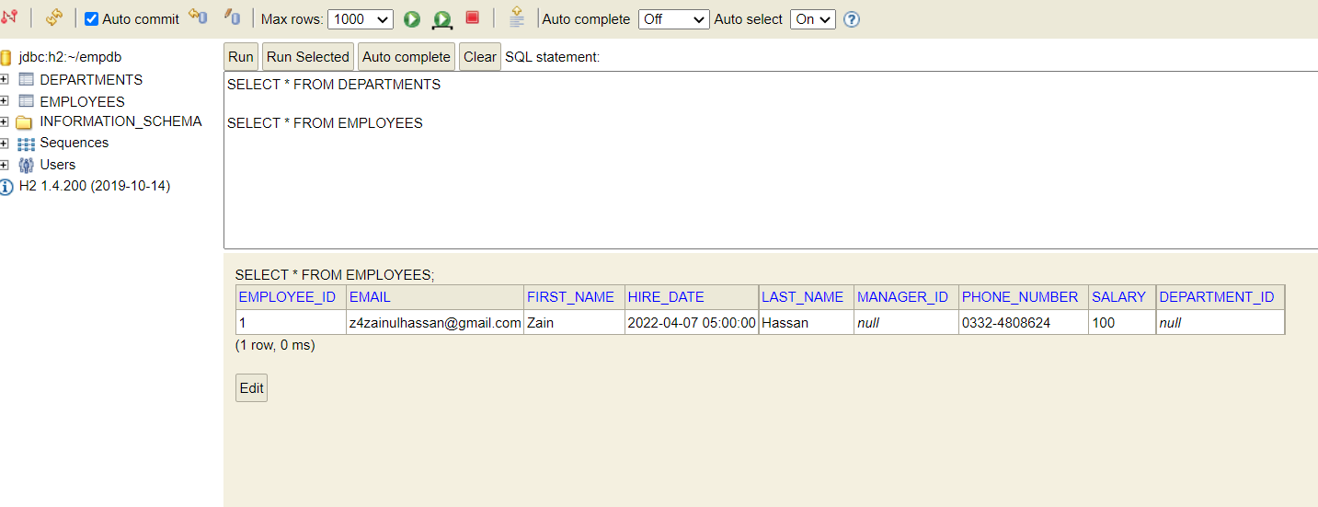

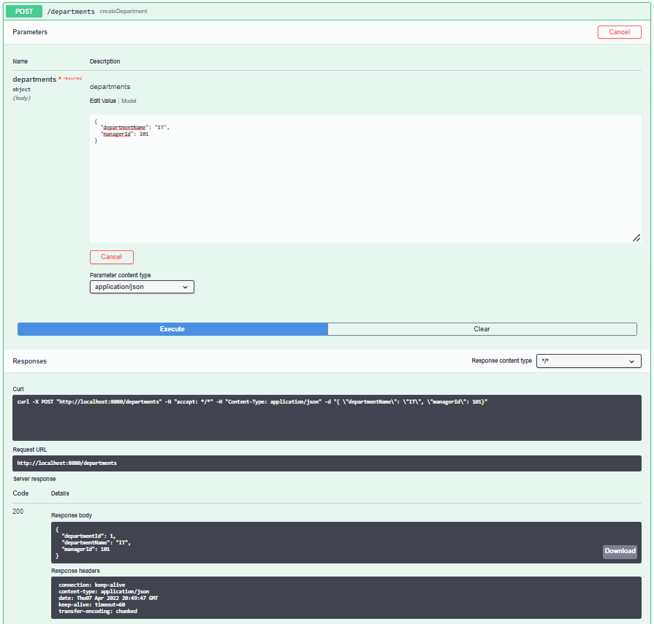



Suppose Employee and Department data is added successfully after all validations as mentioned in (provided REQUIRMENT file)

-> first_name and last_name should be not be null and more than 2 chars each

-> validate that salary is greater than 0

-> validate phone_number contain only digits and dashes

SEE Images blow

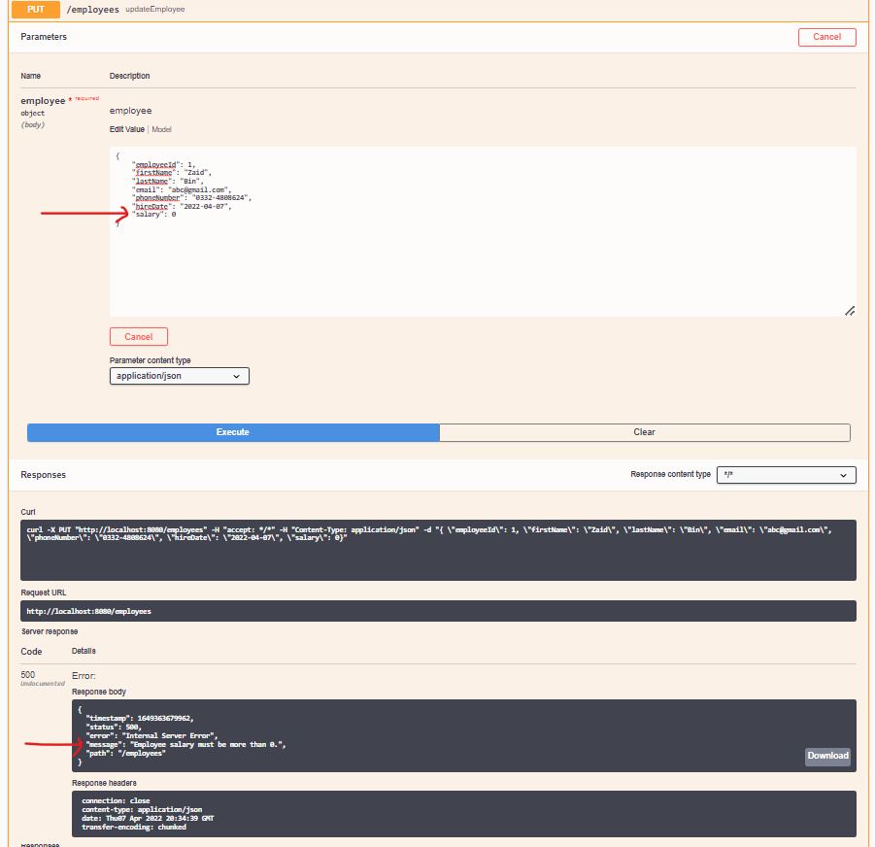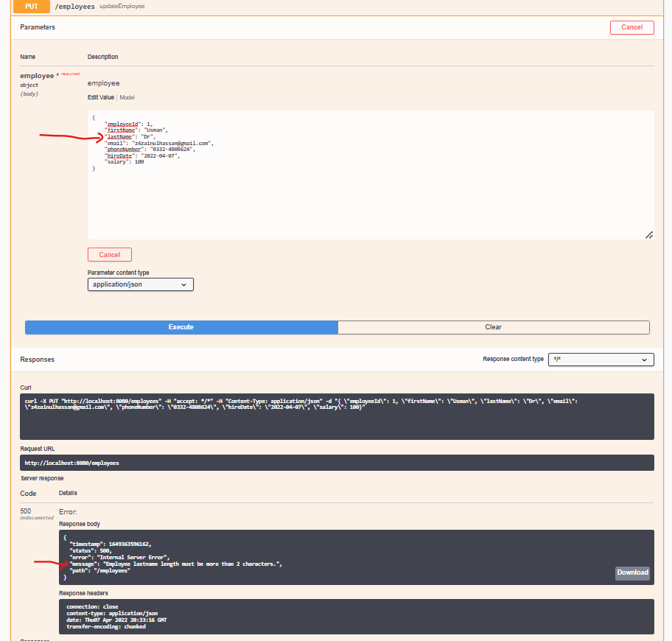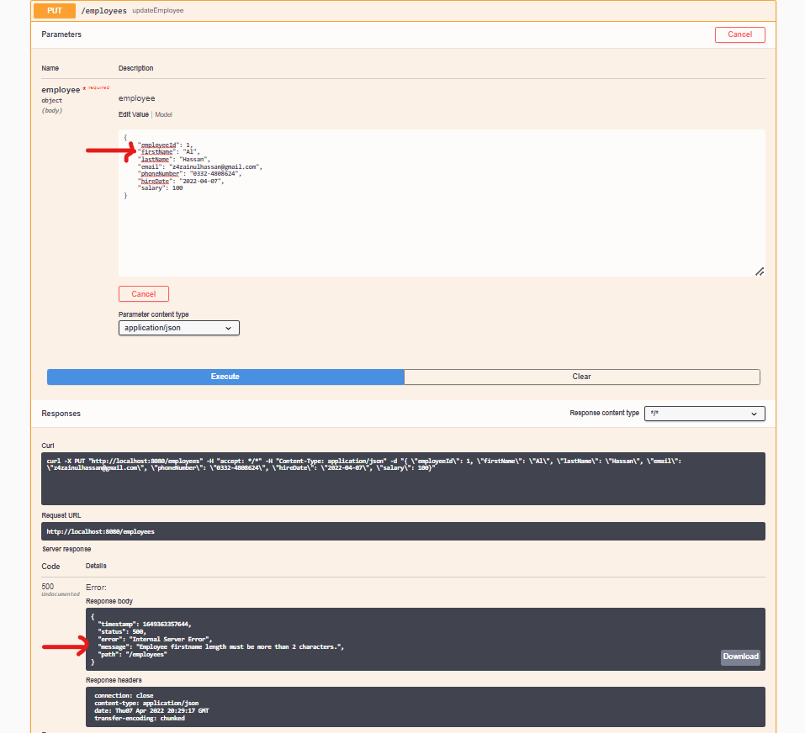

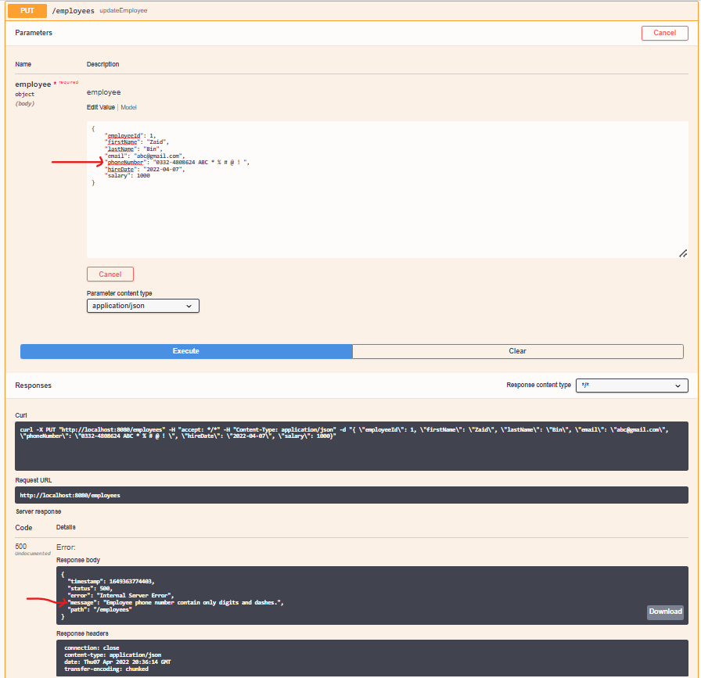

Now, we want to assign an employee a Manager ID call this API (Mapping type is PATCH-MAPPING) http://localhost:8080/employees/3/dept/1 (Note: 3 is an employee id or 1 is a department id)

Hit Request: manager_id or department_id will be updated in Employee Table successfully and get all specific fields record from Department Table.

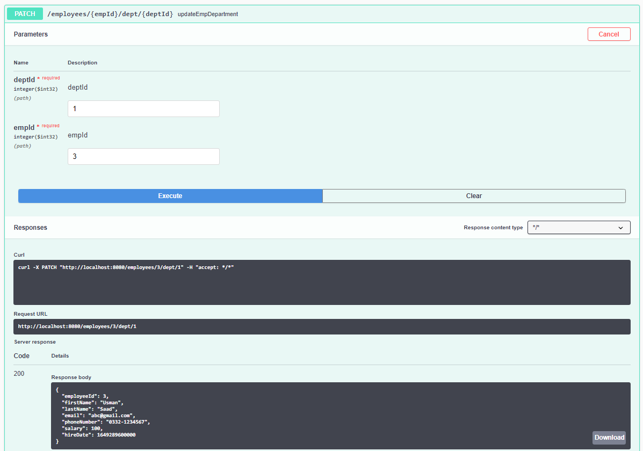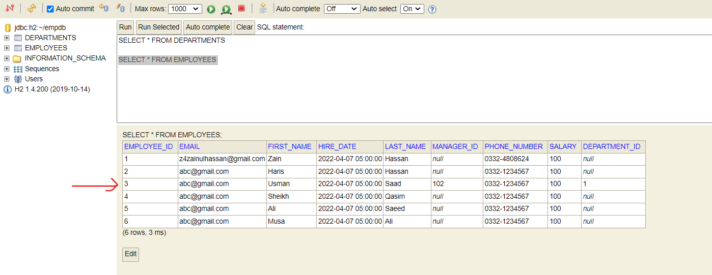

Suppose in Department Table department_name or manager_id is already existing and user want to (create or update) new Department Name, error message will be shown like

"Department name already exists. Please try another name."

"Department Manager Id already exists. Please try another name."

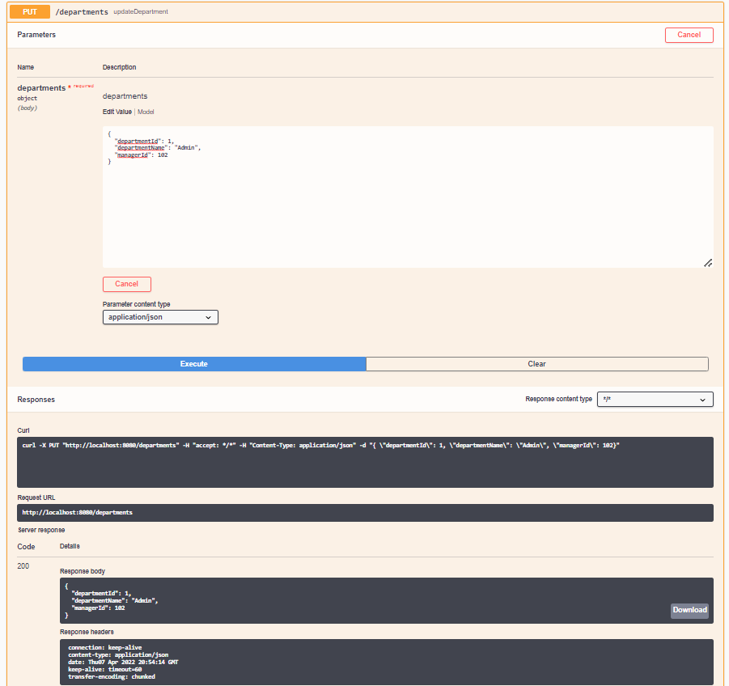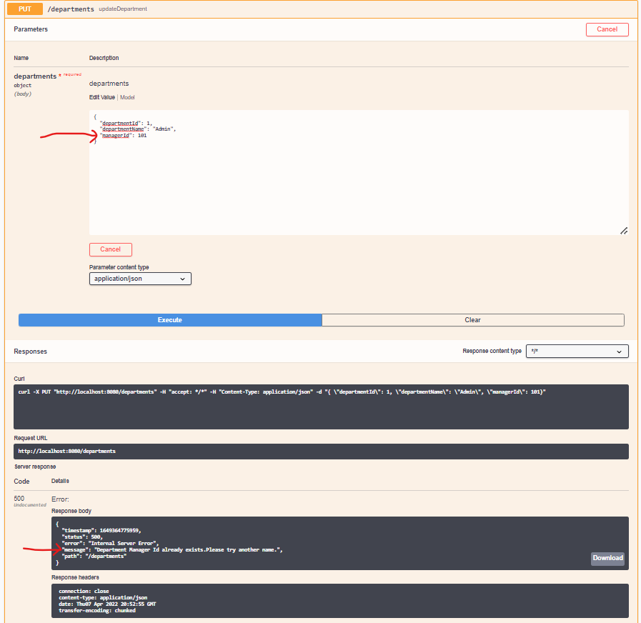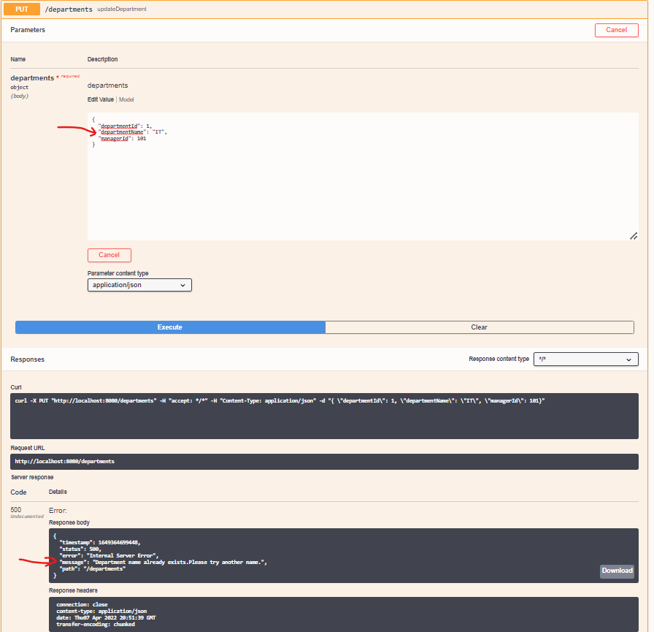

If user wants to update only manager_id field in Department Table separate API will be call API (Mapping type is PATCH-MAPPING) http://localhost:8080/departments/1/managerid/109

(Note: 1 is department id or 109 is a new manager id).

Hit Request: manager_id will be updated in Department Table or Employee Table and value set in both tables against specific department id.

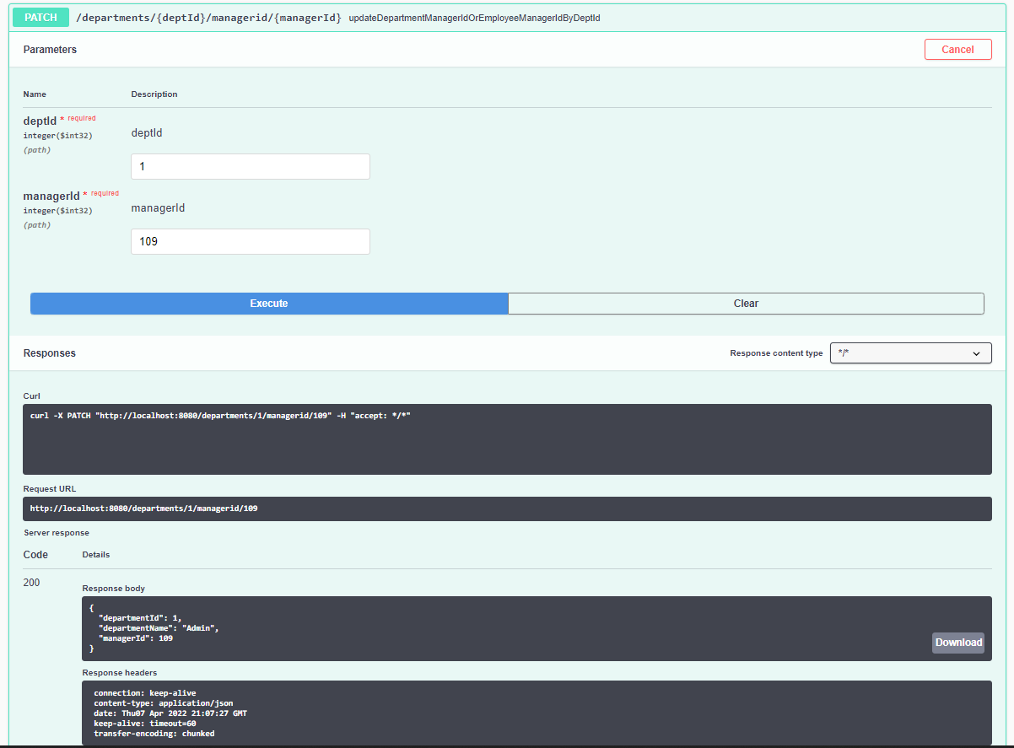

Suppose we want to delete any department record but it's value is assigned to Employee Table as well will be updated and all values update into 0 and null

(For Example: manager_id = 0 and department_id = null).

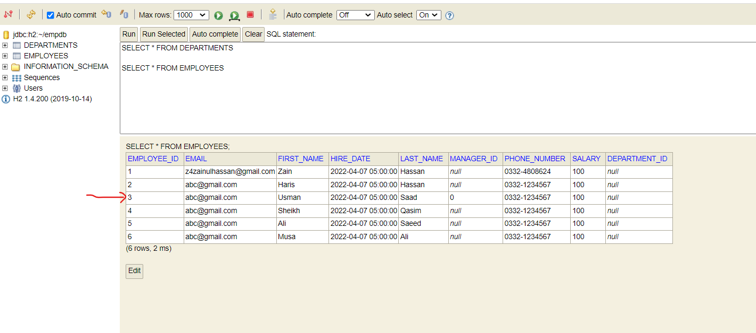

**Pagination added and also set default values can be seen in Swagger Employee.**

**Requests.**  
Employee requests (Get Pagination , Get By Id , DELETE)  
Attach below;

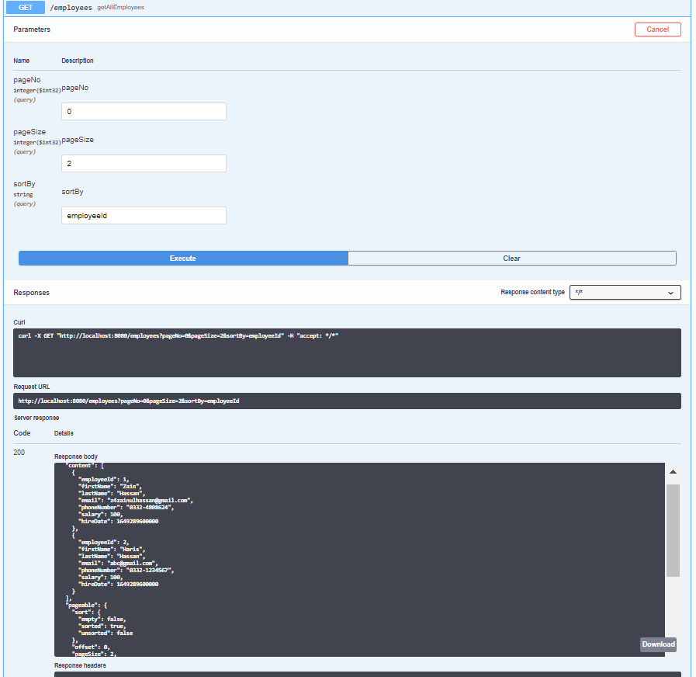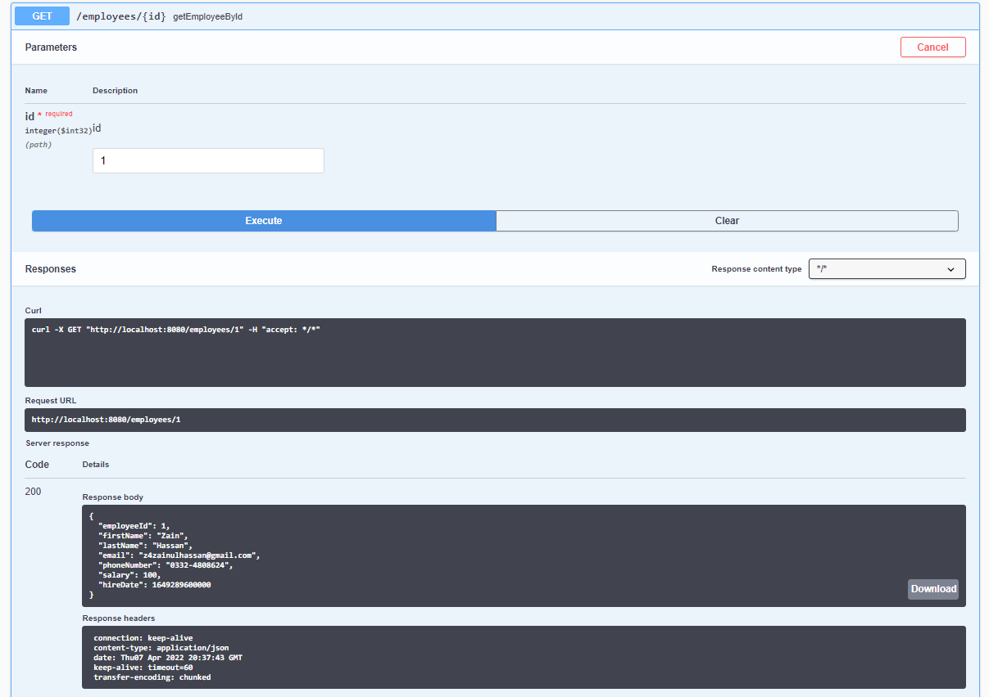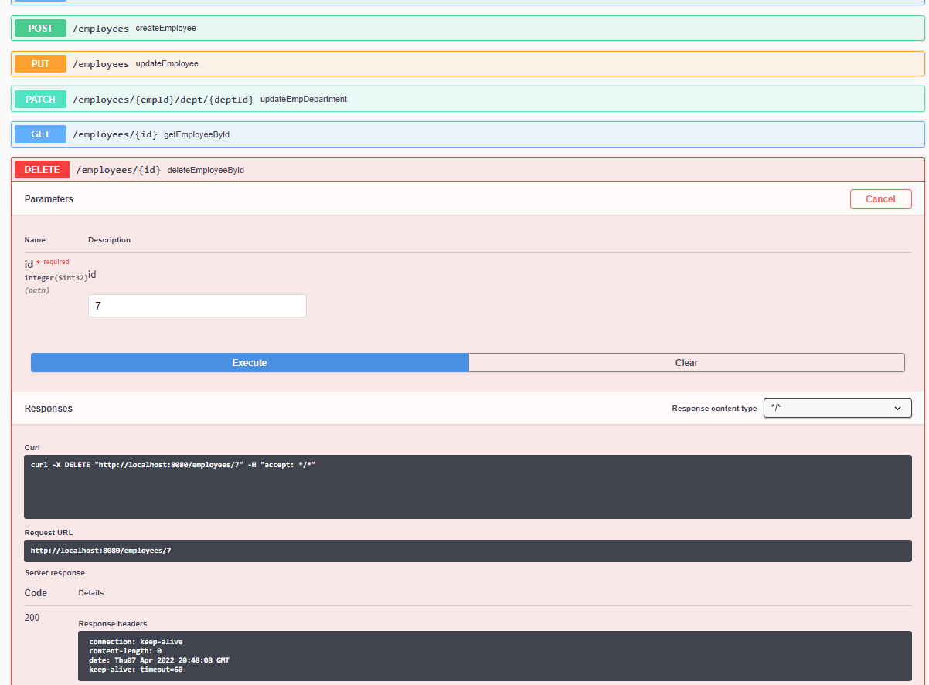

**Pagination added and also set default values can be seen in Swagger Department.**

**Requests.**  
Department requests (Get Pagination , Get By Id , DELETE)  
Attach below;

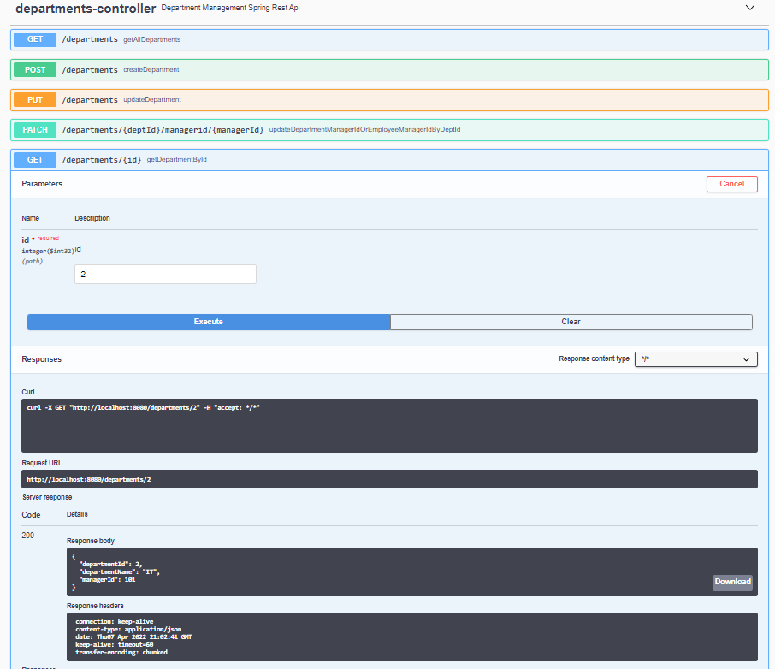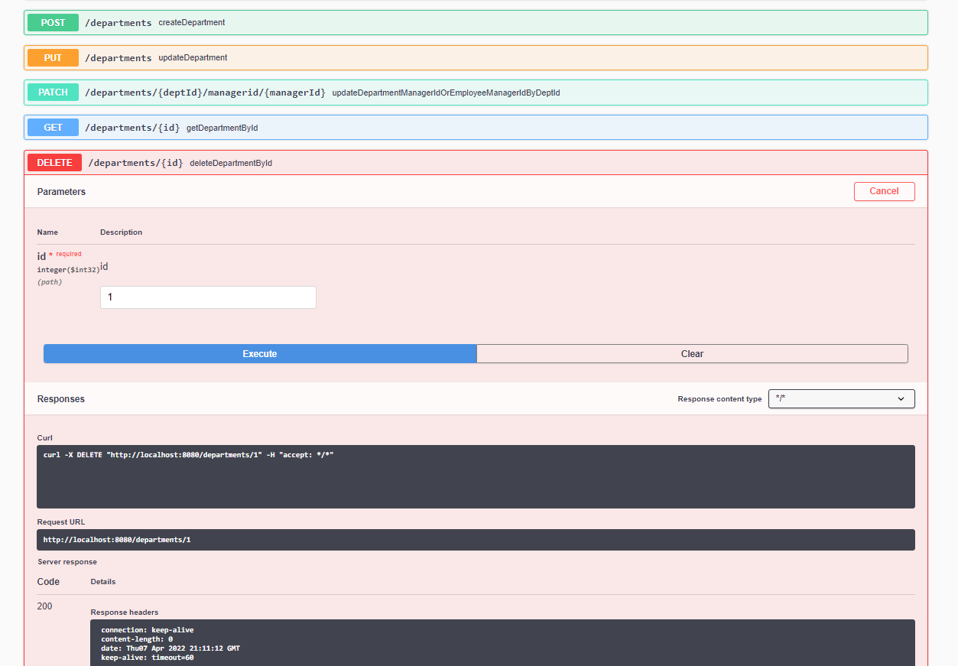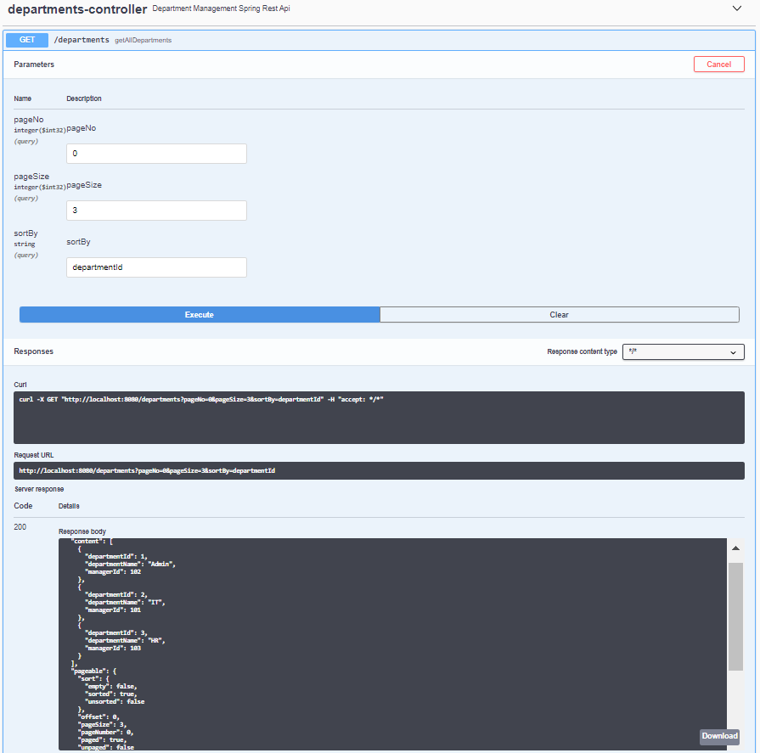

**All other possible exceptions or checks are handled properly.**

Test all these Api's on postman as well.

