Fast-q

Ziyad Algunaid
230208721 | Section 0
March 2026

1. Project Overview
Project Name: Fast-q
Objective: Fast-q is a full-stack web application for creating, sharing, and taking interactive quizzes with real-time collaborative features. It allows educators to build customizable quizzes with multiple question types, share them via unique codes, host live quiz sessions, and track participant performance through analytics and leaderboards.
Problem Statement: Traditional quiz tools lack real-time interaction capabilities. Fast-q
solves this by combining quiz management with live session hosting, instant auto-grading, and real-time leaderboard updates using WebSocket technology.

Technology Stack
Layer | Technology | Details
Frontend | React 18 + TypeScript + Vite | shadcn/ui, Tailwind CSS, TanStack Query, Framer Motion, Recharts
Backend API | PHP 8.2+ (PDO) | Firebase JWT, Ramsey UUID, Custom MVC
Realtime | Node.js + Socket.io | WebSocket for live quiz sessions, leaderboards, notifications
Database | MySQL 8+ | 8 tables, UUID keys, JSON columns, ENUM types
Architecture: Layered MVC (Controller-Model with Middleware/Helpers). Three-service architecture: REST API (PHP), Realtime Server (Node.js), SPA Frontend (React).

2. Module Definitions
The system is organized into six core modules:
# | Module Name | Description
1 | Authentication | User registration, JWT access tokens (15 min) + refresh tokens (7 days), token rotation, bcrypt password hashing, session invalidation. Supports required and optional authentication.
2 | Quiz Management | CRUD operations for quizzes. Supports 4 question types (multiple choice, multiple select, true/false, fill-in-the-blank), quiz duplication, share code generation, draft/published status, configurable timer/shuffle/access settings.
3 | Attempt & Grading | Quiz submissions with automatic server-side grading. Tracks per-question answers and timing, calculates scores/percentages, generates leaderboard rankings (by percentage, then time).
4 | Analytics | Per-quiz statistics: total attempts, average/highest/lowest scores, average time, per-question correctness rates. Global platform statistics.
5 | Real-Time | Socket.io with 3 namespaces: /quiz-session (live hosted sessions), /leaderboard (real-time updates), /notifications (push delivery). Supports guest participants.
6 | Notifications | Attempt completion alerts, quiz sharing notifications, unread count tracking, mark-as-read, real-time push via WebSocket.

3. Class Structure
The backend follows an MVC pattern with Models, Controllers, Middleware, and Helpers.

3.1 Model Classes
User
- $db: PDO
+ findByEmail(email: string): ?array
+ findById(id: string): ?array
+ create(email, name, passwordHash): array
+ storeRefreshToken(userId, tokenHash, lifetime): string
+ findRefreshToken(tokenHash): ?array
+ deleteRefreshToken(id): void
+ deleteAllRefreshTokens(userId): void

Quiz
- $db: PDO
+ findByCreator(creatorId): array
+ findById(id): ?array
+ findByShareCode(code): ?array
+ findWithQuestions(id): ?array
+ create(data, creatorId): array
+ update(id, data): array
+ delete(id): void
+ countAll(): int
- saveQuestions(quizId, questions): void
- generateShareCode(): string

Attempt
- $db: PDO
+ create(quizId, data): array
+ findById(id): ?array
+ findByQuiz(quizId): array
+ findByParticipant(participantId): array
+ leaderboard(quizId): array
+ statsForQuiz(quizId): ?array
+ countAll(): int

Notification
- $db: PDO
+ create(data): array
+ findByUser(userId, limit): array
+ markRead(id, userId): bool
+ unreadCount(userId): int

3.2 Controller Classes
AuthController
- $userModel: User
+ register(data): void
+ login(data): void
+ refresh(data): void
+ logout(data): void
+ me(): void
- issueTokens(user): array

QuizController
- $quizModel: Quiz
+ list(): void
+ create(data): void
+ get(id): void
+ getByShareCode(code): void
+ update(id, data): void
+ delete(id): void
+ duplicate(id): void

AttemptController
- $attemptModel: Attempt
- $notificationModel: Notification
+ submit(quizId, data): void
+ listForQuiz(quizId): void
+ stats(quizId): void
+ leaderboard(quizId): void
+ myAttempts(): void

3.3 Helper & Middleware
JWT (Helper)
+ static createAccessToken(payload): string
+ static createRefreshToken(): string
+ static decode(token): ?object
+ static hashRefreshToken(token): string

AuthMiddleware
+ authenticate(): object
+ optionalAuth(): ?object

3.4 Class Diagram
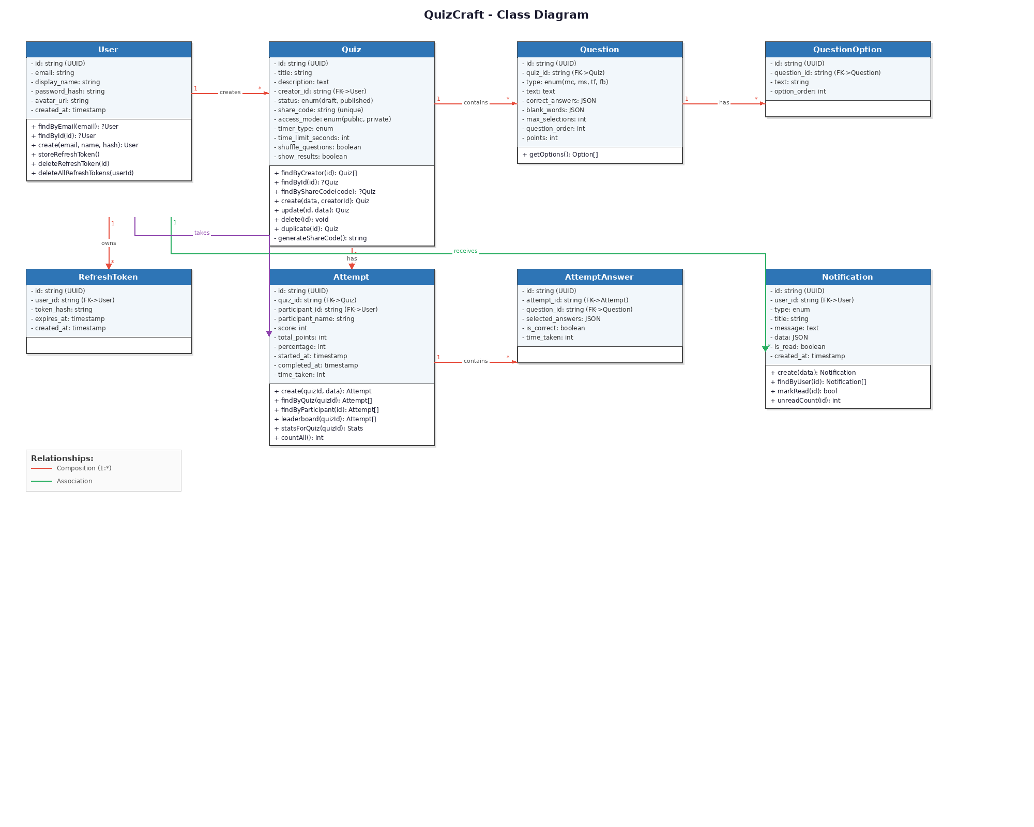

4. UML Diagrams

4.1 Use Case Diagram
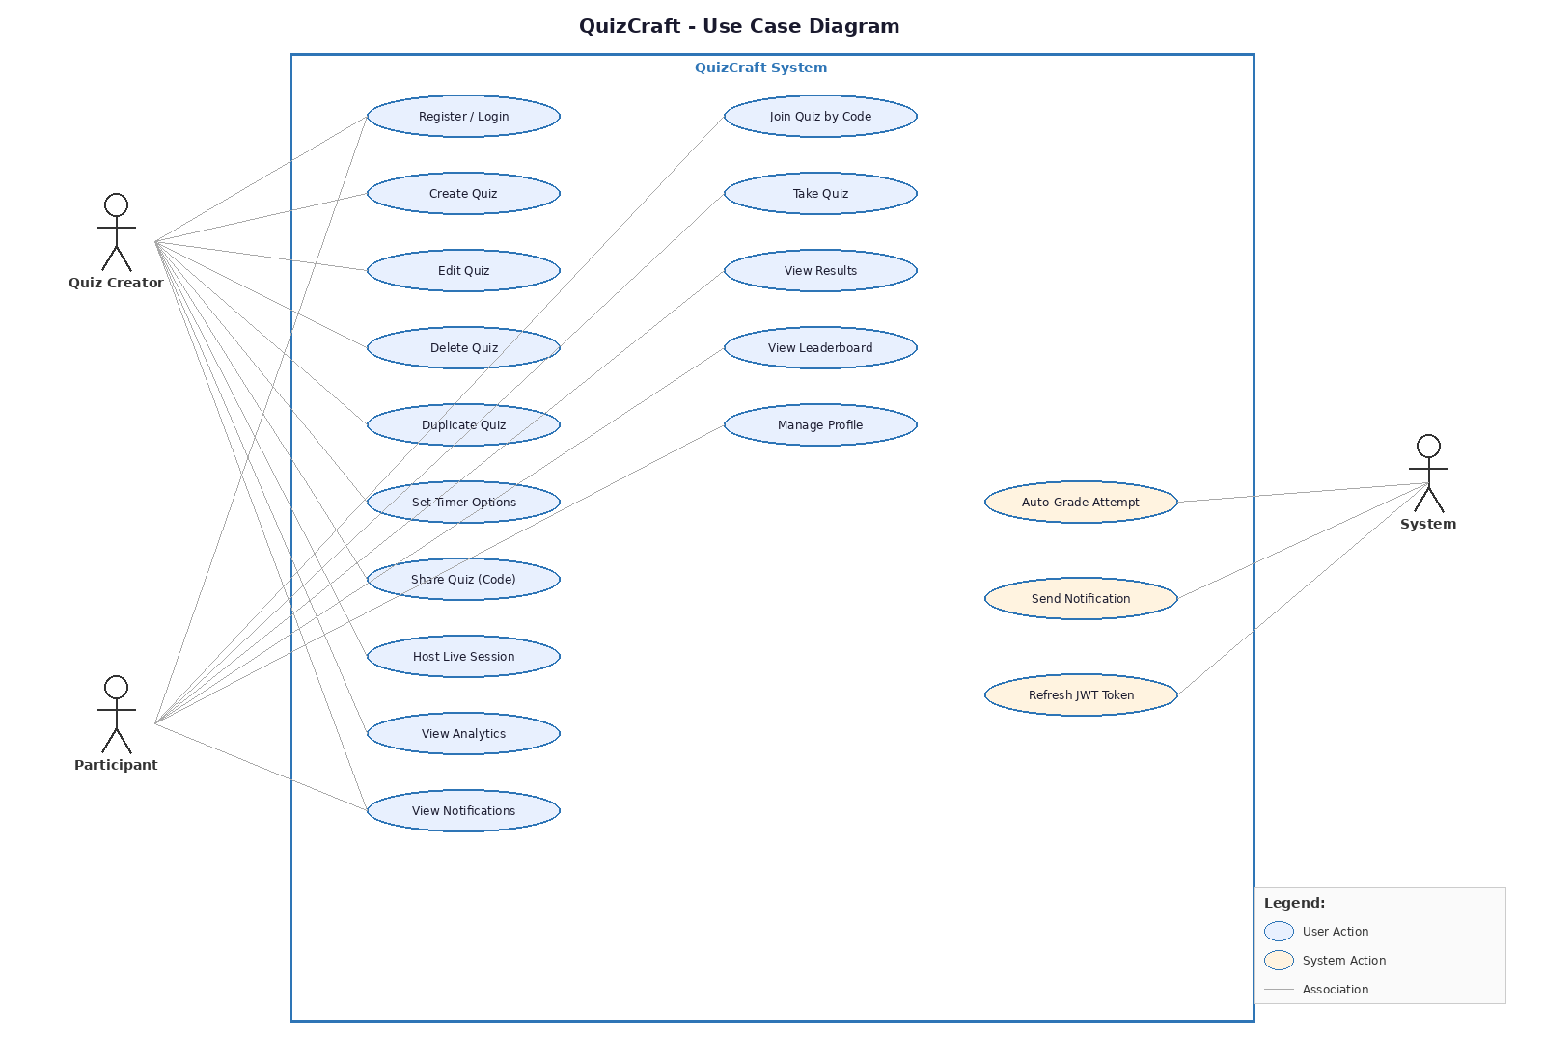

4.2 API Endpoints

Authentication
Method | Endpoint | Description
POST | /api/auth/register | Create new account
POST | /api/auth/login | Sign in, receive JWT + refresh token
POST | /api/auth/refresh | Rotate tokens
POST | /api/auth/logout | Invalidate refresh token
GET | /api/auth/me | Current user profile

Quizzes
Method | Endpoint | Description
GET | /api/quizzes | List user's quizzes
POST | /api/quizzes | Create quiz with questions
GET | /api/quizzes/:id | Get quiz (strips answers if not owner)
PUT | /api/quizzes/:id | Update quiz (owner only)
DELETE | /api/quizzes/:id | Delete quiz (owner only)
POST | /api/quizzes/:id/duplicate | Duplicate quiz
GET | /api/quizzes/join/:code | Get quiz by share code (public)

Attempts & Stats
Method | Endpoint | Description
POST | /api/quizzes/:id/attempts | Submit attempt (auto-graded)
GET | /api/quizzes/:id/attempts | List attempts (owner only)
GET | /api/quizzes/:id/stats | Quiz analytics (owner only)
GET | /api/quizzes/:id/leaderboard | Public leaderboard
GET | /api/attempts/me | User's all attempts
GET | /api/stats/global | Global platform statistics

5. UI Mockups
The following sections show the key interface screens of the Fast-q application.

5.1 Dashboard

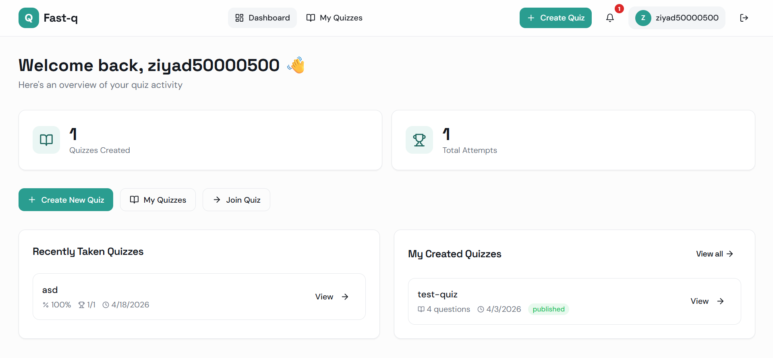

5.2 Create Quiz

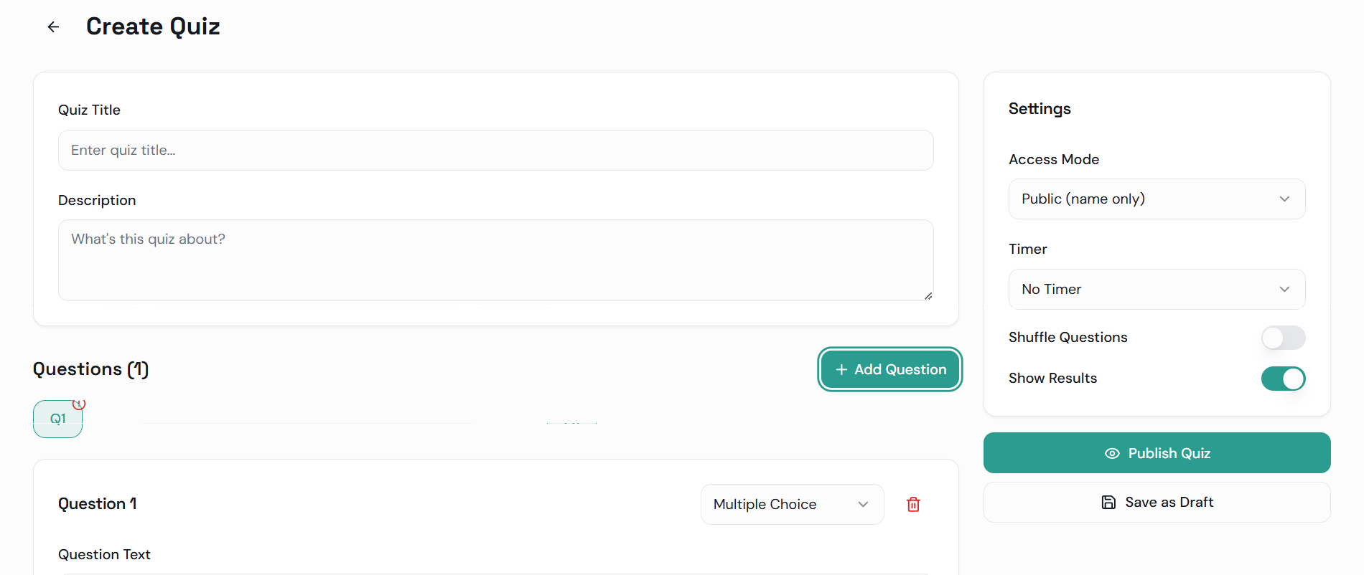

5.3 Take Quiz

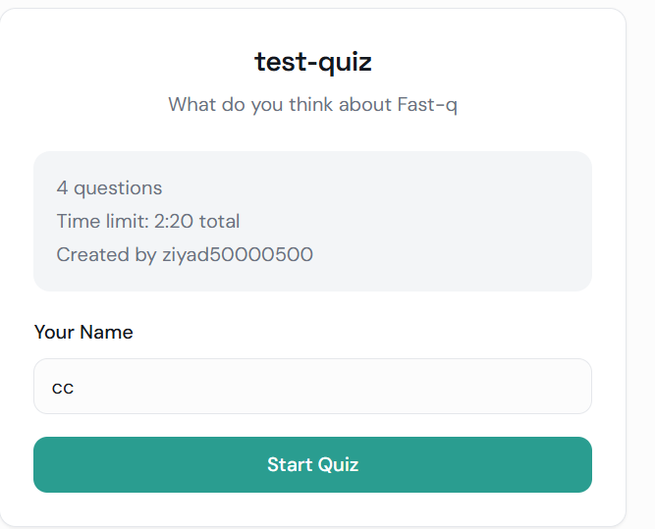

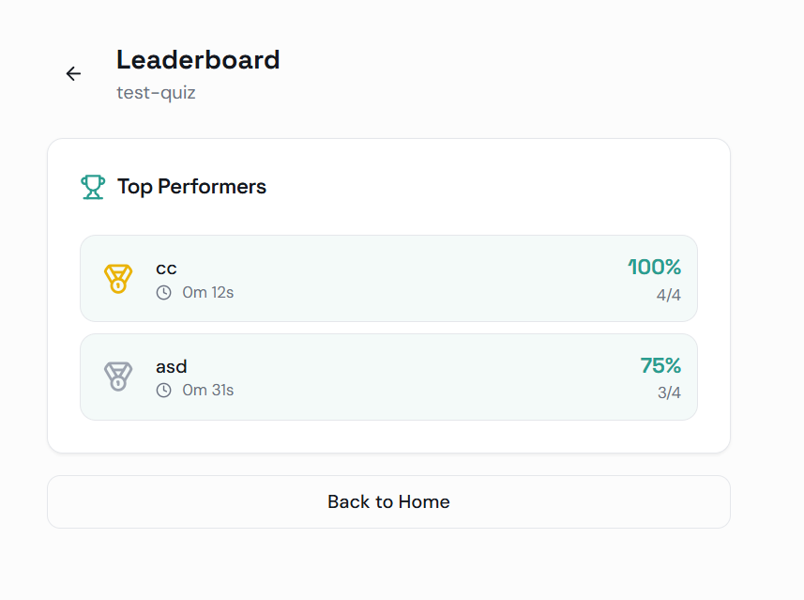
5.4 Leaderboard

5.5 Quiz Analytics

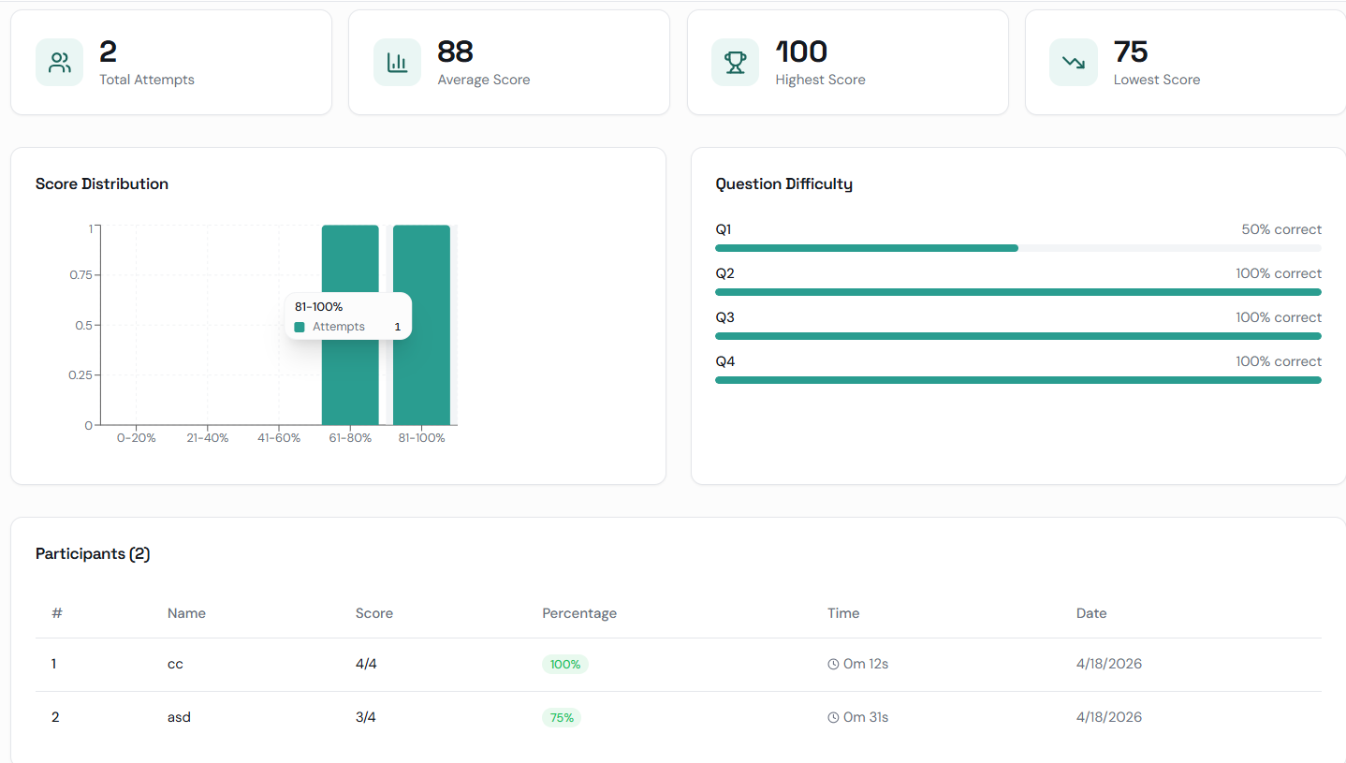

5.6 Login / Register
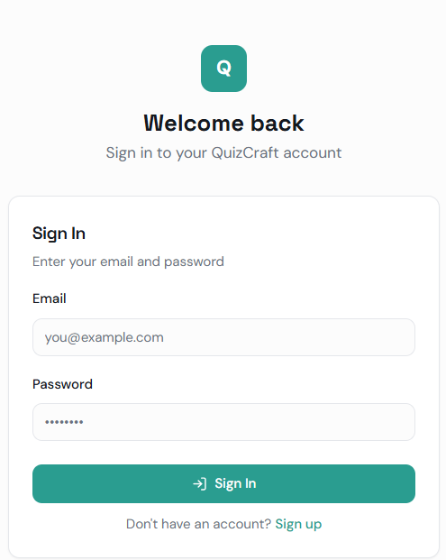
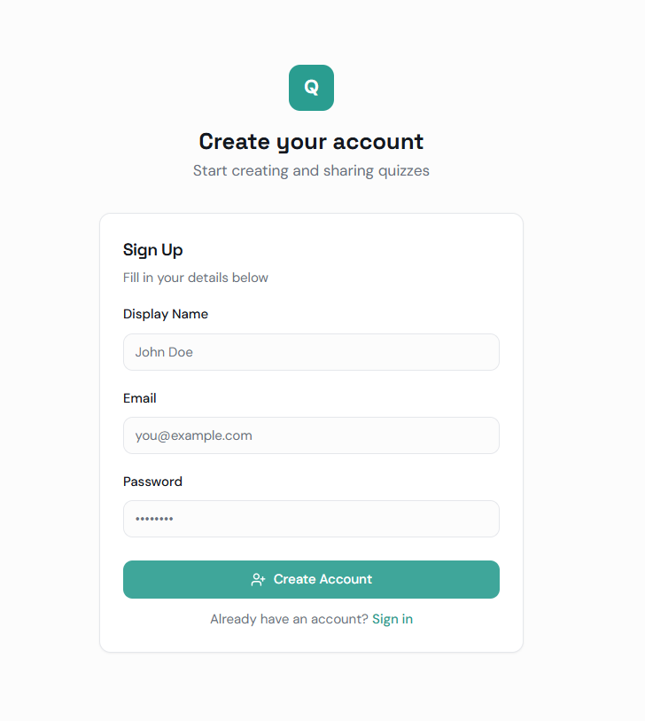

6. Database Design
The database consists of 8 relational tables using MySQL 8+. All primary keys use UUID (CHAR(36)). JSON columns store flexible answer data, and ENUM types constrain categorical fields.

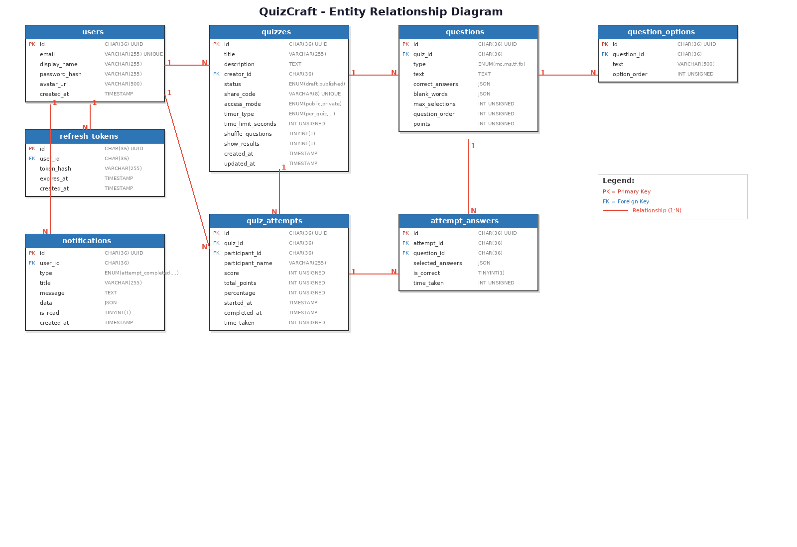
6.1 Entity Relationship Diagram

6.2 Table Definitions
users
Column | Data Type | Constraint | PK | FK Reference
id | CHAR(36) | UUID, NOT NULL | PK
email | VARCHAR(255) | UNIQUE, NOT NULL
display_name | VARCHAR(255) | NOT NULL
password_hash | VARCHAR(255) | NOT NULL
avatar_url | VARCHAR(500) | NULLABLE
created_at | TIMESTAMP | DEFAULT NOW()

refresh_tokens
Column | Data Type | Constraint | PK | FK Reference
id | CHAR(36) | UUID, NOT NULL | PK
user_id | CHAR(36) | NOT NULL |  | users.id
token_hash | VARCHAR(255) | INDEX
expires_at | TIMESTAMP | NOT NULL
created_at | TIMESTAMP | DEFAULT NOW()
quizzes
Column | Data Type | Constraint | PK | FK Reference
id | CHAR(36) | UUID, NOT NULL | PK
title | VARCHAR(255) | NOT NULL
description | TEXT
creator_id | CHAR(36) | NOT NULL |  | users.id
status | ENUM | DEFAULT 'draft'
share_code | VARCHAR(8) | UNIQUE
access_mode | ENUM | DEFAULT 'public'
timer_type | ENUM | DEFAULT 'none'
time_limit_seconds | INT UNSIGNED | NULLABLE
shuffle_questions | TINYINT(1) | DEFAULT 0
show_results | TINYINT(1) | DEFAULT 1
created_at | TIMESTAMP | DEFAULT NOW()
updated_at | TIMESTAMP | ON UPDATE

questions
Column | Data Type | Constraint | PK | FK Reference
id | CHAR(36) | UUID, NOT NULL | PK
quiz_id | CHAR(36) | NOT NULL |  | quizzes.id
type | ENUM | NOT NULL
text | TEXT | NOT NULL
correct_answers | JSON | NOT NULL
blank_words | JSON | NULLABLE
max_selections | INT UNSIGNED | NULLABLE
question_order | INT UNSIGNED | NOT NULL
points | INT UNSIGNED | DEFAULT 1
question_options
Column | Data Type | Constraint | PK | FK Reference
id | CHAR(36) | UUID, NOT NULL | PK
question_id | CHAR(36) | NOT NULL |  | questions.id
text | VARCHAR(500) | NOT NULL
option_order | INT UNSIGNED | NOT NULL
quiz_attempts
Column | Data Type | Constraint | PK | FK Reference
id | CHAR(36) | UUID, NOT NULL | PK
quiz_id | CHAR(36) | NOT NULL |  | quizzes.id
participant_id | CHAR(36) | NULLABLE |  | users.id
participant_name | VARCHAR(255) | NOT NULL
score | INT UNSIGNED | DEFAULT 0
total_points | INT UNSIGNED | DEFAULT 0
percentage | INT UNSIGNED | DEFAULT 0
started_at | TIMESTAMP | DEFAULT NOW()
completed_at | TIMESTAMP | NULLABLE
time_taken | INT UNSIGNED | NULLABLE

attempt_answers
Column | Data Type | Constraint | PK | FK Reference
id | CHAR(36) | UUID, NOT NULL | PK
attempt_id | CHAR(36) | NOT NULL |  | quiz_attempts.id
question_id | CHAR(36) | NOT NULL |  | questions.id
selected_answers | JSON | NOT NULL
is_correct | TINYINT(1) | DEFAULT 0
time_taken | INT UNSIGNED | NULLABLE
notifications
Column | Data Type | Constraint | PK | FK Reference
id | CHAR(36) | UUID, NOT NULL | PK
user_id | CHAR(36) | NOT NULL |  | users.id
type | ENUM | NOT NULL
title | VARCHAR(255) | NOT NULL
message | TEXT | NULLABLE
data | JSON | NULLABLE
is_read | TINYINT(1) | DEFAULT 0
created_at | TIMESTAMP | DEFAULT NOW()

7. Development Rules & Standards
- MVC Architecture: Controller-Model pattern with Middleware and Helper layers.
- Stateless Auth: JWT access tokens (15 min) with refresh token rotation (7 days).
- Database Transactions: PDO transactions for multi-table operations.
- UUID Primary Keys: CHAR(36) UUIDs via Ramsey UUID for all tables.
- Input Validation: Custom fluent Validator class with clear error responses.
- CORS: CorsMiddleware handles cross-origin between frontend (8080), API (8000), realtime (3001).
- TypeScript: Full type safety on frontend with TanStack Query for server state management.
- Real-Time: Socket.io namespaces (/quiz-session, /leaderboard, /notifications).
- Security: Bcrypt password hashing, correct answers stripped for non-owners, owner-only access checks.
- Testing: Vitest for unit tests, Playwright for end-to-end tests.

