Manual

Brief Introduction
This document is a guide for users to get touch with our tool ‘autoBioSeqpy’ for modeling and analysis of Protein, DNA and RNA data, including a brief introduction to installation, quick start and standalone modules (a jupyter notebook example provided).
Our tool autoBioSeqpy’ is a self-made python tool which can transfer the sequence into matrix, and then use it for deep learning. In this document, users can find the data format, the internal mechanism of encoding and figure out how to use this tool.

Installation
All the code of autoBioSeqpy’ is wrote in Python, and no mixture code (e.g. C/C++) is used in this project, so the installation is very easy. Once the dependencies are resolved, the only thing to do is to make the path as a working path or put the code into the search path.

2.1 Dependence
Some python modules are necessary for autoBioSeqpy, which are re, numpy, importlib, sklearn and keras. Since all modules are included in anaconda3, users could resolve module dependencies by installing anaconda3 (2 is not suggested) on their official website https://www.anaconda.com/. Alternatively, the users can install the module manually, for example using pip or another installer. If using pip to install the dependent modules, the command is:
pip install numpy
or
pip install numpy --user

2.2 Set Search Path
After installing the dependent modules, if the working path is the root directory of the extracted folder (that is, the folder where the manual is located), users can use autoBioSeqpy directly in the command line window (CMD window).
If users want to use it in their own python script, there are two ways to add modules to the search path:
- If autoBioSeqpy is already in the python search path, adding a line to the python script is sufficient:
import autoBioSeqpy
or
from autoBioSeqpy import *
- Otherwise, users could add the location into sys.path:
import sys
libPath = /the/path/of/the/folder
sys.path.append(libPath)
Then all modules are available. An example in jupyter notebook is provided, which uses the provided module for data processing and users can get it in ‘notebook/tutorial in jupyter notebook.html’, or see the section ‘Using autoBioSeqpy in Other Work’.

3 Quick Start
There are two ways to use autoBioSeqpy, one is to use the script running.py as a standalone application, and the other is to integrate it into a python script as a module. We will introduce both ways in separated sections.

3.1 Using autoBioSeqpy as Standalone Application

3.1.1 Training and predict
If the dependent modules are installed (in section 2.1), a standalone script running.py is available. To test it, just open a command line window (or terminal in Linux) and make the working path (i.e. current folder) to the location of autoBioSeqpy. Then test:
python running.py –help
if the help document is showed without error, it’s available. Users can then perform a shot test:

python running.py --dataType protein --dataEncodingType dict --dataTrainFilePaths examples/typeIIIsecretedeffectors/data/train_pos.txt examples/typeIIIsecretedeffectors/data/train_neg.txt --dataTrainLabel 1 0 --dataTestFilePaths examples/typeIIIsecretedeffectors/data/test_pos.txt examples/typeIIIsecretedeffectors/data/test_neg.txt --dataTestLabel 1 0 --modelLoadFile examples/typeIIIsecretedeffectors/model/protein_CNN1D_model.py --verbose 1 --outSaveFolderPath tmpOut --savePrediction 1 --saveFig 1 --batch_size 60 --epochs 20 --spcLen 100 --shuffleDataTrain 1 --modelSaveName tmpMod.json --weightSaveName tmpWeight.bin --noGPU 1 --paraSaveName parameters.txt

The use of parameters is in “parameters” section or in the help document generated by ‘--help’.
Since there are too many parameters to write on the command line, an alternative way is to write the parameters to a text file, for example the file parameters.txt contains the details information (All spaces below can be changed to line breaks):
--useKMer None
--batch_size 60
--shuffleDataTrain True
--dataTestLabel 1 0
--dataType protein
--dataSplitScale None
--noGPU True
--epochs 20
--verbose True
--figDPI 300
--paraFile None
--shuffleDataTest False
--loss binary_crossentropy
--modelSaveName tmpMod.json
--paraSaveName parameters.txt
--dataTrainLabel 1 0
--outSaveFolderPath tmpOut
--spcLen 100
--optimizer optimizers.Adam()
--weightSaveName tmpWeight.bin
--inputLength None
--firstKernelSize
--modelLoadFile examples/typeIIIsecretedeffectors/model/protein_CNN1D_model.py
--KMerNum 3
--weightLoadFile None
--dataTrainFilePaths examples/typeIIIsecretedeffectors/data/train_pos.txt examples/typeIIIsecretedeffectors/data/train_neg.txt
--showFig True
--metrics acc
--saveFig True
--dataEncodingType dict
--savePrediction True
--dataTestFilePaths examples/typeIIIsecretedeffectors/data/test_pos.txt examples/typeIIIsecretedeffectors/data/test_neg.txt

This file can then be used as a command line:
python running.py –paraFile parameters.txt

3.1.2 Predict using the built model
Sometimes users will want to use the built model to predict the new data, and predicting.py is available. Since the data encoding during training depends on the parameters, few parameters are required during training. Using the same example as in section 3.1.1, the command line becomes:
python running.py --dataType protein --dataEncodingType dict --dataTrainFilePaths examples/typeIIIsecretedeffectors/data/train_pos.txt examples/typeIIIsecretedeffectors/data/train_neg.txt --dataTrainLabel 1 0 --dataTestFilePaths examples/typeIIIsecretedeffectors/data/test_pos.txt examples/typeIIIsecretedeffectors/data/test_neg.txt --dataTestLabel 1 0 --modelLoadFile examples/typeIIIsecretedeffectors/model/protein_CNN1D_model.py --verbose 1 --outSaveFolderPath tmpOut --savePrediction 1 --saveFig 1 --batch_size 60 --epochs 20 --spcLen 100 --shuffleDataTrain 1 --modelSaveName tmpMod.json --weightSaveName tmpWeight.bin --noGPU 1 --paraSaveName parameters.txt

The three parameters highlighted above are necessary for making predictions, where ‘--modelSaveName’ and ‘--weightSaveName’ are the keras model files and related weights, and ‘--paraSaveName’ are the parameters used when training. Then, for prediction, the command line will become:
Python predicting.py --paraFile tmpOut/parameters.txt --dataTestFilePaths examples/typeIIIsecretedeffectors/data/test_pos.txt --predictionSavePath tmpout/indPredictions.txt
That is, if the test data and parameters are sufficient (because the module and weight are recorded in parameters.txt), if the user wants to print the output to STDOUT, you can ignore --predictionSavePath.

3.2 Using autoBioSeqpy in Other Work
Because autoBioSeqpy can encode FASTA sequences into matrices, sometimes users may just want to use feature encoding instead of modeling. The autoBioSeqpy can be used as a module, so it can be used for other tasks. We provided a jupyter notebook to explain how to use it, so please open the file in ‘notebook/ tutorial in jupyter notebook.ipynb’ in jupyter notebook. If the jupyter notebook is not installed, users could use the HTML and PDF version alternatively (but only for reading, no interaction included in pure HTML and PDF files).

Descriptions and usages
The autoBioSeqpy contains several parts to support automatic data transferring and modeling. Therefore, this section will introduce the framework, parameters and some important mechanisms.

4.1 Design
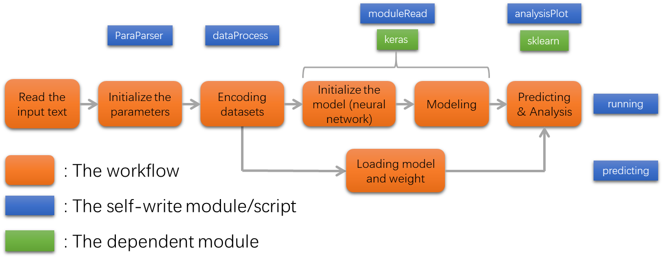
Figure 1: the design of autoBioSeqpy
The construction is listed in fig. 1, which is consisted of 6 parts (5 parts for prediction) and is supported by 4+2 modules. The workflow is very simple, so the functions of the modules are completely different. If users want to use the components of autoBioSeqpy, usually the ‘dataProcess’ and ‘analysisPlot’ are used, and sometimes ‘moduleRead’ is used. But the paraParser will be ignored unless the workflow be used directly.

4.2 Parameters
Because autoBioSeqpy can be modeled using keras, not only the encoding parameters, but also keras parameters will be explained here. Please note that all parameters in this section are for the standalone version, the usage of the modules are in the file ‘notebook/tutorial in jupyter notebook.ipynb’.

4.2.1 Basic information
The information in this section could be got in command line window by typing:
python running.py --help
The details are as follows:
Parameter Name | Must be used | Default Value | Format
--dataType | Yes | None | List of units in  {protein, dna, rna, other}
The type of the data, should be protein, dna, rna or other (upper case is supported either), where 'other' means a matrix which contain some manual features, please see our template in folder 'examples' or the next section in the manual for details.

For example, if we have two models for rna and matrix, the values are:
--dataType rna other
--dataEncodingType | No | None | List of units in {onehot, dict}
the type for encoding the data, if dict choosed, a character (e.g. A/G/C/T for DNA) is represented as a number (such as A:1 T:2 C:3 T:4), and if onehot choosed, a character will be represented as an array (such as A:[1,0,0,0] G:[0,1,0,0] C:[0,0,1,0] T[0,0,0,1])
--spcLen | No | [100,100,100,..]  Length is the same as  --modelLoadFile | List of int
The length of the input sequence which will be used for enconding. If the length of an input sequence is larger than the 'spcLen', the exceed part will be ignored, and if the length is less than 'spcLen', zeros (or zero arrays) will be added to make the length to 100.

Since different model would have different spcLen, the number of models and spcLen are the same.
--dataTrainFilePaths | Yes | None | List of paths:  [path1,path2,…]
The inputs are separated by space. FASTA data should be provided in separated files according to the labels, if two labels provided, there should be at least two FASTA files. For example, there are two files containing positive and negative samples separately, the inputs are:

--dataTrainFilePaths the/path/of/the/positive/file1.fasta the/path/of/the/negative/file2.fasta
--dataTrainLabel | Yes | None | List of labels:  [1, 0, 1, 2, …]
The label of each file, and the length should be the same as --dataTrainFilePaths. As the example above, two FASTA file provided, so the label could be:

--dataTrainLabel 1 0
--dataTrainModelInd | No | None | list of int
No default value, should be provided by user. The length should be the same as --dataTrainModelInd

The index for the model of each file, and the length should be the same as --dataTrainFilePaths, and the values should be not larger than --modelLoadFile. As the example, if three FASTA files and two models (model_0, model_1 for example) provided, so the index could be:
--dataTrainModelInd 1 1 0
Here the '1 1 0' means the first two data will be train by model_1 and the 3rd model will be trained by model_0
--dataTestFilePaths | No | None | List of paths:  [path1,path2,…]
Conflicting: --dataSplitScale

The data for independent test. The format and usage are the same as --dataTrainFilePaths.

NOTE: if no independent data provided, this parameter could be ignored, the dataset for testing will be generated from the training data by spliting it according to '--dataSplitScale'
--dataTestLabel | No | None | List of labels:  [1, 0, 1, 2, …]
Conflicting: --dataSplitScale
The format is the same as --dataTrainLabel but for the test data. The length should be the same as --dataTestFilePaths
--dataTestModelInd | No | None | list of int
No default value, should be provided by user. The length shoud be the same as len(--dataTestLabel)

The index for the model of each test file if provided. The other explanations are the same with --dataTrainModelInd
--outSaveFolderPath | No | None | string
A folder path for saving the outputs, if not provide, only STDOUT will be generated.
--showFig | No | True | bool
Switch to show the figures
--saveFig | No | True | bool
Switch to save the figures to '--outSaveFolderPath'
--figDPI | No | 300 | int
The dpi of the figure
--savePrediction | No | True | bool
Switch to save the predictions to '--outSaveFolderPath'
--dataSplitScale | No | 0.8 | Float in (0,1)
Conflicting: --dataTestFilePaths, --dataTestLabel
A scale for spliting the training data into two piece, one is for training and the other for independent test.
For example, if the '--dataTestLabel' is 0.8, then the training data-set is 80% and the test data-set is 20% from the provided data.
--modelLoadFile | Yes | None | List of string
Load the Keras model for modeling. Both user made model (in .py file) and keras model (in .json file) are supported. Few templates in python script (e.g. .py file) are provided in folder 'models'.
--weightLoadFile | No | None | List of string
Relating: --modelLoadFile

A built Keras model could save weight file as well, thus the weight file could be loaded when loading the model
--shuffleDataTrain | No | True | bool
shuffle the sequence of training data
--shuffleDataTest | No | False | bool
shuffle the sequence of test dataset. The default is False because the sequence will not change the modeling performance.
--batch_size | No | 40 | int
The parameter for keras to decide the size of batch (e.g. the number of used data) when training
--epochs | No | 100 | int
The parameter for keras to decide the number of iteration of training
--useKMer | No | False | bool
To considering the environment of a residue. For example, if a sequence is ATTACT, and '--KMerNum' is 3, then the first A will be considered as 'ATT' and the shape of dataset will be expanded accordingly (see section ‘kmer’ for more details).
--KMerNum | No | 3 | int
The length of the sequence which will be taken as environment, please see the details of '--UseKMer'
--inputLength | No | None | int
A parameter for 2D layer. This parameter is added to modify the size of the built model before compiling. The "batch_input_shape" and "input_length" will be changed according to this parameter. If not provided, program will change the size to the current shape automaticly if a 2D convolution layer is used as the first layer.
--firstKernelSize | No | None | int
A parameter for changing the kernel size of the first layer. Since the shape of input dataset might be not fit for the first layer, this parameter is added to modify the size of the built model before compiling. The "kernel_size" will be changed according to this parameter. If not provided, program will change the size to the current shape automaticly.
--reshapeSize | No | None | list or matrix
If not provided, autoBioSeqpy will try to generate it automatically.

Since the model provided in separated file, and the data will change all the time, to make the input shape of the model be compatible with the data shape, a reshape layer might be necessary.

Since the layer size would be more than 1-dim, the input template could be :
--reshapeSize [[10,20,1],[30,13,1]]
More details could be found in the next section ‘about --reshapeSize’.
--loss | No | binary_crossentropy | string
Keras parameter, available candidates are 'mean_squared_error', 'mean_absolute_error', 'mean_absolute_percentage_error', 'mean_squared_logarithmic_error', 'squared_hinge', 'hinge', 'categorical_hinge', 'logcosh', 'categorical_crossentropy', 'sparse_categorical_crossentropy', 'binary_crossentropy', 'kullback_leibler_divergence', 'poisson', 'cosine_proximity'
(reference https://keras.io/losses/)
--metrics | No | ['acc'] | list of the metrics [‘acc’,’mae’,…]
Keras parameters. Available candidates are 'acc', 'mae', 'binary_accuracy', 'categorical_accuracy', 'sparse_categorical_accuracy', 'top_k_categorical_accuracy', 'sparse_top_k_categorical_accuracy'.
Note: The loss function is available here.
reference https://keras.io/metrics/
--modelSaveName | No | None | string
Save the built model in json format.
--weightSaveName | No | None | string
Save the weights of built model in binary format.
--noGPU | No | None | bool
Only using CPU for modeling, sometimes is useful for debugging
--paraFile | No | None | string
Sometimes using command line is not easy for use, write the parameters into file is better for modification. The parameters in the paraFile is the same as writen in command line, such as '--noGPU 1 --figDPI 600 ...'
--paraSaveName | No | None | string
Save used parameters into file. Sometimes saving the parameters into a file will make the model easier for prediction.
--labelToMat | No | False | bool
Change the label into matrix as follows:
[0,1,2,1,1] => [1,0,0]
[0,1,0]
[0,0,1]
[0,1,0]
[0,1,0]
The change of the label could be useful for some kind of CNN with multilabel training.
--colorText | No | auto | 0, 1 or ‘auto’
Using different color for the text to make the message easier for figure out. 'auto' means this function will be used in linux and disabled in windows.
--verbose | No | False | bool
See a detailed output when the script running.

We provide as many parameters as possible to build the model explicitly, but usually few parameters are sufficient.
In the table above, the parameter ‘--useKMer’ and ‘--modelLoadFile’ will be described in the next sections.

4.2.2 Sequence Encoding and KMer
In this section, we will introduce the way of sequence encoding and the mechanism of KMer. KMer is not a new concept in sequence data processing, which means using the environment for modeling, but the implementation can be misunderstood, so we have written a description of such content.
Consider that we have a 6 base DNA sequence, such as ‘ATTACG’. In autoBioSeqpy, ‘dict’ and ‘onehot’ are used for encoding. If we do not use kmer, the sequence ‘ATTACG’ will be encoded separately as 122134 for ‘dict’ with the hash table (or dict) {A:1, T:2, C:3, T:4} and as $\left[\begin{matrix}1 & 0 & 0 & 0 \\ 0 & 1 & 0 & 0 \\ 0 & 1 & 0 & 0 \\ 1 & 0 & 0 & 0 \\ 0 & 0 & 1 & 0 \\ 0 & 0 & 0 & 1\end{matrix}\right]$ for ‘onehot’ with the hash table {A:[1,0,0,0],T:[0,1,0,0],C:[0,0,1,0],T:[0,0,0,1]}. The two encoding methods are very easy to understand, and each base in the hash table is unique. However, if we consider using 2-Mer, the ‘ATTACG’ will become 5 (6-2+1) pieces: ‘AT’, ‘TT’, ‘TA’, ‘AC’, ‘CG’, but it is currently an element increased from 4 to 16 in the hash table. If ‘dict’ is used to encode the 2-Mer case, the result is still an array containing 5 elements ranging from 1 to 16, but if ‘onehot’ is used, the shape of the matrix becomes 5x16 and each row has only one and fifteen zeros such as:
$\left[\begin{matrix}0 & 1 & 0 & 0 & 0 & 0 & 0 & 0 & 0 & 0 & 0 & 0 & 0 & 0 & 0 & 0 \\ 0 & 0 & 0 & 0 & 0 & 1 & 0 & 0 & 0 & 0 & 0 & 0 & 0 & 0 & 0 & 0 \\ 0 & 0 & 0 & 0 & 1 & 0 & 0 & 0 & 0 & 0 & 0 & 0 & 0 & 0 & 0 & 0 \\ 0 & 0 & 1 & 0 & 0 & 0 & 0 & 0 & 0 & 0 & 0 & 0 & 0 & 0 & 0 & 0 \\ 0 & 0 & 0 & 0 & 0 & 0 & 0 & 0 & 0 & 0 & 0 & 1 & 0 & 0 & 0 & 0\end{matrix}\right]$. The positions are determined in this way:
- We have $positionDict=\left\{A:1,T:2,C:3,T:4\right\}$ for a single base and 4 for the length
- When 2 bases ‘$XY$’ used, the following formula is used for find the position of 1:
$$\left(positionDict\left[x\right]-1\right)*4+\left(positionDict\left[y\right]-1\right)+1 \\ =\left(positionDict\left[x\right]-1\right)*4+positionDict\left[y\right]$$
- Similarly, in kmer case: ‘$X_{1}X_{2}…X_{k}$’, the position of ‘1’ becomes:
$$\left(\sum_{i=1}^{k}{\left(positionDict\left[x_{i}\right]-1\right)*4^{k-i}}\right)+1$$
Using these formulas, you will find that “onehot” may not be a good idea for encoding proteins because the encoded matrix is too sparse.

4.2.3 The template of keras models
In autoBioSeqpy, keras is used for deep learning, but users still have to build neural networks manually because there is no “universal” neural network for any type of data. But to make modeling (especially the construction of the framework) more simplicity, we provide some templates in .py script. Users can use them directly by using parameter ‘-- modelLoadFile’ or create model scripts based on them.
Alternatively, if a neural network is built, the parameter ‘--modelSaveName’ and ‘--weightSaveName’ are provided to save the model as JSON and the weights in binary format. Users can use them in the next experiments with ‘--modelLoadFile’ and ‘--weightLoadFile’.

4.2.4 About the ‘--reshapeSize’
In version 1.0, the –inputLength and –kernelSize were provided to confirm the input size be fit for the encoded data. However, this approach will change the model somehow. Therefore, a new way for reshaping the encoded sequences is generated. With the reshape layer, the data shape could be fit for the input layer without change the kernel of the convolution layer.
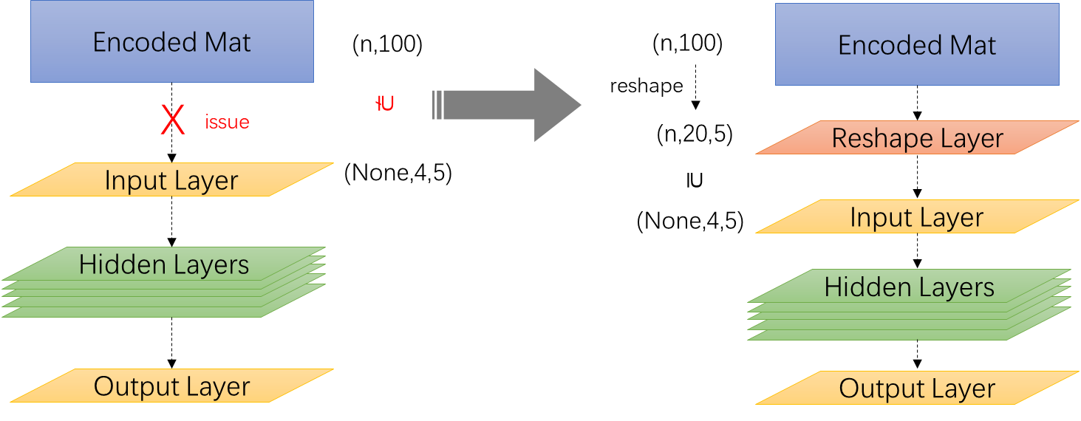
At the same time, another question is raised: How to decide the shape of the reshape layer? As in the figure above, the shape of the added reshape layer is $20×5$, but 4$×25$ will also be available in this case, which has indicated that the size could be decided by users, and the parameter ‘--reshapeSize’ will do the such things.
If users do not want to provide the size, autoBioSeqpy will do the followings:
- Check the size of the input data, if the size is not fit for the input layer, will try to add a reshape layer.
- A prime factorizing will be used for the data shape, as the example in the figure above, 100 will be factorized to $2×2×5×5$, then will use the prime factors for generating the new shape from small to large.
  - That is, using the minimal factors ‘2’, but the first dimension of the input shape is ‘4’, which is large than ‘2’. Then the searching will continue by multiply the second minimal factor ‘2’, the production is ‘4’, which is not smaller than the first dimension ‘4’ in the input layer. Then we found the first dimension of the reshape layer, it is 4.
  - The rest factors are ‘5’ and ‘5’, this time the second dimension of the input shape is ‘5’, thus ‘5’ will be used as the second value of the reshape layer.
  - Now we have found a shape (4,5) for the reshape layer, but still there is a ‘5’ not used, this time it will be multiplied to the first dimension, then it becomes to (20,5).

The steps above is the way for generating the shape of the reshape layer, but some times it will be not usable. For example, if the length of the input data is 97, a prime, the prime factorizing will tell you the answer is just 97 (and 1), then the next steps are unable to be used. In this situation, users have to change the parameter ‘–spcLen’ or the construction of the model manually.

4.3 Merging the output layer of the models
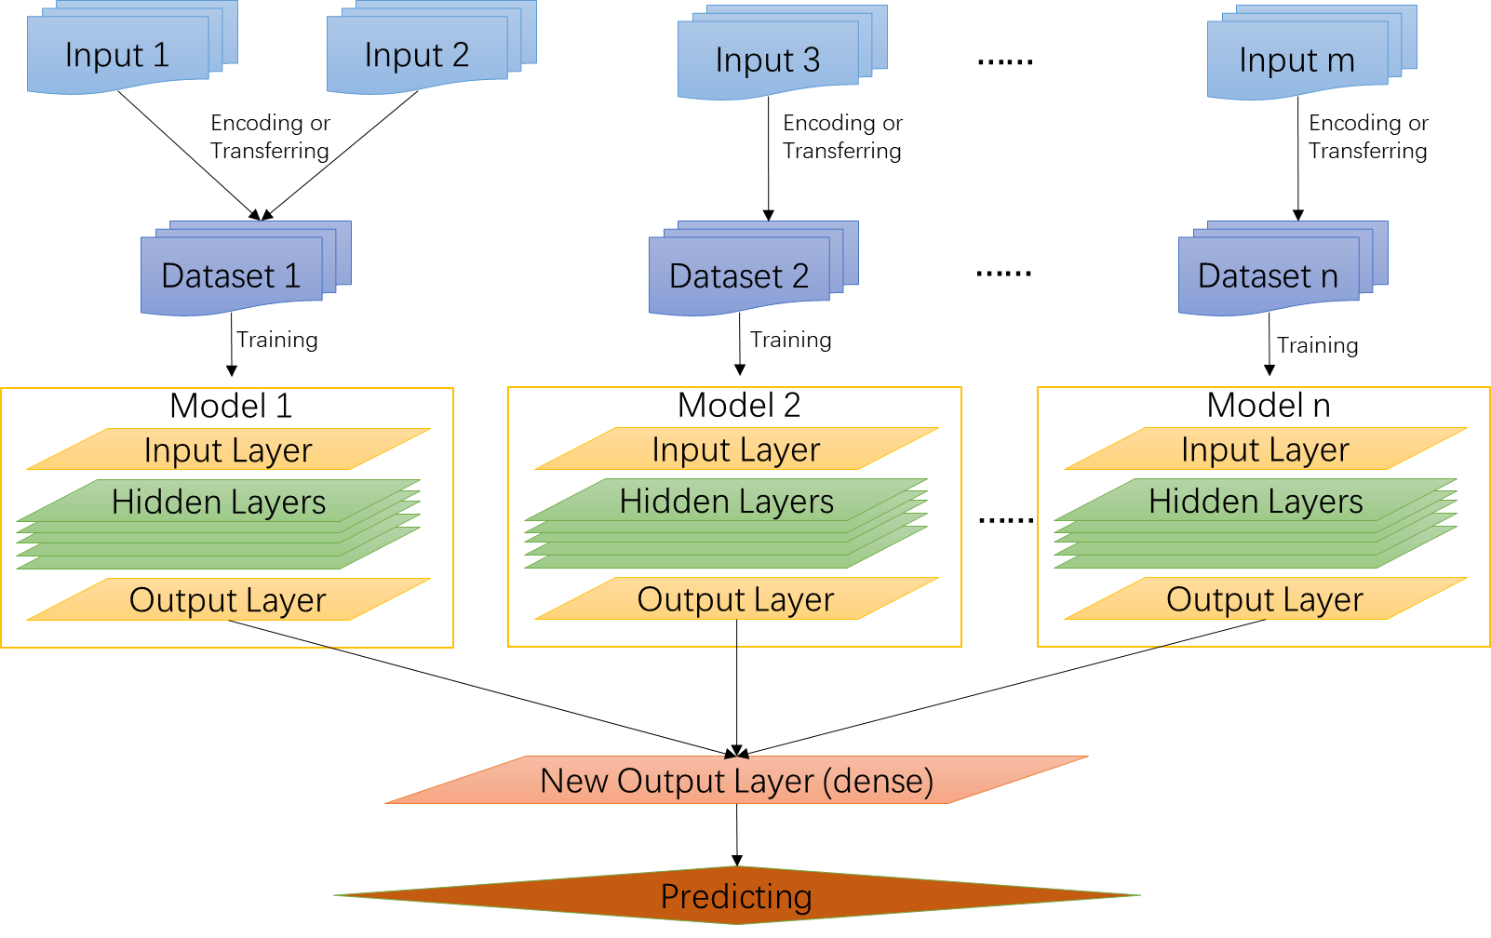
With version $≥$2.0, autoBioSeqpy support using multiple models for different (and same) kinds of data due to the features could achieve better performance with specific network construction. The output layer will be merged by a dense layer as the new output layer. To use this new function, users should provide more than 1 models, related datasets, and parameters. As an example, there are two models:
‘examples/CRISPRCas9guideefficiency/model/ DNA_CNN2D_model.py’
and
‘examples/CRISPRCas9guideefficiency/model/ DNA_2mer_CNN2D_model.py’
in the example folder, where both of the modules are designed for modeling the sequence data by using 2D convolution neural network, the different is only the kernel size of the first convolution layer. For both models, two examples provided:
`python running.py --dataType dna --dataEncodingType onehot --dataTrainFilePaths examples/CRISPRCas9guideefficiency/data/Doench_high_activity_sgRNA.txt examples/CRISPRCas9guideefficiency/data/Doench_low_activity_sgRNA.txt --dataTrainLabel 1 0 --dataSplitScale 0.8 --modelLoadFile examples/CRISPRCas9guideefficiency/model/DNA_CNN2D_model.py --verbose 1 --outSaveFolderPath tmpOut --savePrediction 1 --saveFig 1 --batch_size 25 --epochs 40 --shuffleDataTrain 1 --spcLen 30 --firstKernelSize 4 5 --modelSaveName tmpMod.json --weightSaveName tmpWeight.bin --noGPU 0 --paraSaveName parameters.txt`
and
`python running.py --dataType dna --dataEncodingType onehot --dataTrainFilePaths examples/CRISPRCas9guideefficiency/data/Doench_high_activity_sgRNA.txt examples/CRISPRCas9guideefficiency/data/Doench_low_activity_sgRNA.txt --dataTrainLabel 1 0 --dataSplitScale 0.8 --modelLoadFile examples/CRISPRCas9guideefficiency/model/DNA_2mer_CNN2D_model.py --verbose 1 --outSaveFolderPath tmpOut --savePrediction 1 --saveFig 1 --batch_size 25 --epochs 40 --shuffleDataTrain 1 --spcLen 30 --firstKernelSize 16 5 --useKMer 1 --KMerNum 2 --modelSaveName tmpMod.json --weightSaveName tmpWeight.bin --noGPU 0 --paraSaveName parameters.txt`
Users could find the two examples in the file ‘examples\CRISPRCas9guideefficiency\testRecords.txt’.
If users want to merge the two models, the example becomes:
` python running.py --dataType dna dna --dataEncodingType onehot onehot --dataTrainFilePaths examples/CRISPRCas9guideefficiency/data/Doench_high_activity_sgRNA.txt examples/CRISPRCas9guideefficiency/data/Doench_low_activity_sgRNA.txt examples/CRISPRCas9guideefficiency/data/Doench_high_activity_sgRNA.txt examples/CRISPRCas9guideefficiency/data/Doench_low_activity_sgRNA.txt --dataTrainLabel 1 0 1 0 --dataSplitScale 0.8 --modelLoadFile examples/CRISPRCas9guideefficiency/model/DNA_CNN2D_model.py examples/CRISPRCas9guideefficiency/model/DNA_2mer_CNN2D_model.py --verbose 1 --outSaveFolderPath tmpOut --savePrediction 1 --saveFig 1 --batch_size 25 --epochs 40 --shuffleDataTrain 1 --spcLen 30 30 --modelSaveName tmpMod.json --weightSaveName tmpWeight.bin --noGPU 0 --paraSaveName parameters.txt --dataTrainModelInd 0 0 1 1 --useKMer 0 1 --KMerNum 0 2 --showFig 1`
In the example above, several of the parameters’ numbers were doubled, for example, the ‘—dataType’ becomes to ‘dna dna’ from single ‘dna’. In fact, the number of parameters depends on the number of datasets and used models if used:
Parameter | Number should be same as
--dataType | --modelLoadFile
--dataTrainLabel
--spcLen
--dataEncodingType
--useKMer
--KMerNum
--inputLength
--firstKernelSize
--reshapeSize
--weightLoadFile
--dataTrainModelInd | --dataTrainFilePaths
--dataTestModelInd | --dataTestFilePaths
The parameter ‘--dataTrainModelInd’ and ‘--dataTestModelInd’ are designed to tell program which model the dataset belongs to, and thus the values should not be larger than the index of the models. As the example above, the ‘--dataTrainModelInd’ was ‘0 0 1 1’, which means the first two dataset will be used by the first model ‘examples/CRISPRCas9guideefficiency/model/DNA_CNN2D_model.py’ (the index is 0 in the inputs), and the rest for the second model ‘examples/CRISPRCas9guideefficiency/model/DNA_2mer_CNN2D_model.py’ (the index is 1 in the inputs).
According to the table above, it is clear that most of the parameters are used to adjust the model instead of the dataset, a model could train multiple dataset, but should have a certain parameter. Since the command becomes too long, the script input would be a good choice.

4.4 Using 3rd matrix as input
Since some times users will want to add extra features to the sequence, but the provided encoder is designed to encoding the sequence, together with output layer merging, additional matrix has been supported with version $≥2.0$. The implementation is easy that using a dense network for the matrix and merge it to others (see figure below).
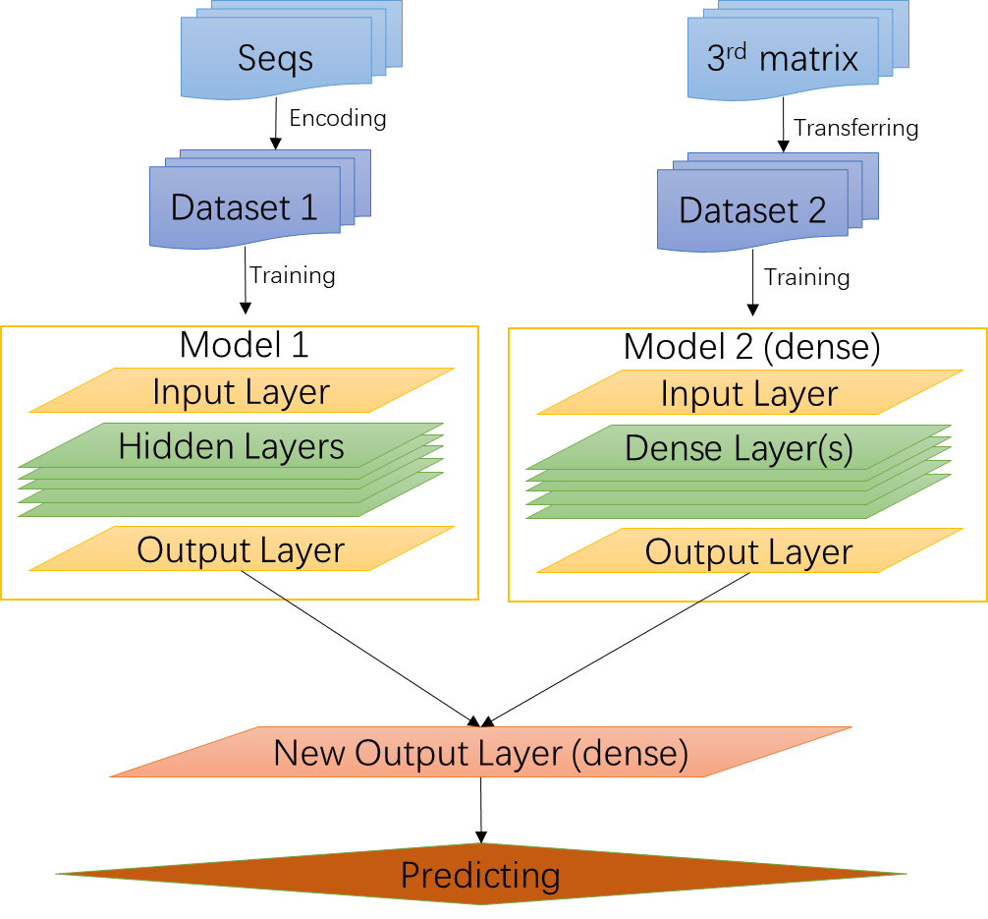
Since 3rd matrix is not needed to be encoded, but the sample should be the same as the sequences, the format of the matrix should be as follows:
- The file which contain the sequence should not be the same:
For example, ‘path1/seqs_1.fasta’ and ‘path/seqs_2.fasta’ are supported, but ‘path1/seqs.fasta’ and ‘path2/seqs.fasta’ are not.
- Suppose the input files are ‘path1/seqs_1.fasta’ and ‘path/seqs_2.fasta’, in which the sequences are named by number, such as ‘>1’, ‘>2’, …. The name will be generated as ‘seqs_1.fasta_1’, ‘seqs_1.fasta_2’, …, ‘seqs_2.fasta_1’, ‘seqs_2.fasta_2’, …, respectively.
- Thus in the 3rd matrix, the first column should be the names, such as (if a line start with a #, this line will be ignored):
#name,fea1,fea2
seqs_1.fasta_1, 3, 1
seqs_1.fasta_2, 4, 2
…
seqs_2.fasta_1, 1, 0
seqs_2.fasta_2, 5, 2
- Prepared the matrix as above, set the ‘--datatype’ to ‘other’ in the correct position, then program will read the matrix and align the rows according to the names of the sequence.
- Note that ‘--useKmer’ and ‘--KmerNum’ will not be functioned to 3rd matrix, thus set it to any value (including None) is OK.

4.5 Layer output visualization
Sometimes users would like to know the output from the hidden layer and see the manifold. Here we provided a script ‘layerPlot.py’ in folder ‘tools’, using the script could be able to make the output trained by UMAP (https://github.com/lmcinnes/umap) and yield few figures according to the parameters.
However, the function of this script is limited since the neural network could be very complex, thus we recommend using the jupyter notebook for the implement. Please see ‘notebook/Tutorial of layer visualization.ipynb’ for details.

5. Conclusion
This document is provided for users to know autoBioSeqpy. As an open source tool, we have documented all the code and function, but this document is still a better way to understand the framework.
We looking forward to receiving any bug reports and suggestions, please feel free to contact us anytime (ljs@swmu.edu.cn)

