SignalHarbor: Systematic Multi-Asset Funds with News Sentiment
FINS3645 Part B Report | z5516421

Executive Summary
SignalHarbor is an investor-facing prototype designed to compare systematic equity funds, cryptocurrency funds and combined multi-asset funds. This report focuses not on the code itself, but on a more practical investment question: after considering return, volatility, maximum drawdown, turnover and signal reliability together, which funds are more suitable as products for financially literate retail investors? The report uses out-of-sample fund results, portfolio exposures, fact sheets and sector sentiment evidence to make this comparison. The central judgement is that high terminal wealth alone does not make a fund a better investment product. If the path to that return involves extreme losses, unstable allocations or excessive trading intensity, the product may be unattractive for real investors.
The OOS results show that raw return and investability are not the same. Crypto funds achieved the highest terminal wealth and annualised returns. Crypto Risk Parity, for example, grew $1 to $2.50 and produced an annualised return of 35.8%. However, these returns came with volatility close to 80% and maximum drawdowns above 80%, making pure crypto funds difficult to justify as default core holdings. By contrast, Equity Equal Weight achieved the highest Sharpe ratio across all 12 funds, at 0.82. Combined Risk Parity was the strongest risk-adjusted fund within the combined universe, with a Sharpe ratio of 0.79. This result suggests that SignalHarbor should not rank funds only by terminal wealth. Instead, it should help investors judge whether they can tolerate the volatility, drawdowns and rebalancing burden required to earn those returns.
SignalHarbor is therefore positioned as a fund comparison and portfolio allocation tool rather than a return-chasing crypto product or a pure sentiment-timing strategy. It helps financially literate retail investors compare return, risk, drawdown and implementation burden before allocating capital.
The main extension in this report is a coverage-aware sector sentiment signal. Specifically, I first use finance-augmented VADER to score equity news headlines, so that the sentiment scores better reflect market language. I then adjust the lagged sector sentiment z-score using the previous day’s news coverage ratio. The logic is that if a sector sentiment signal is based on news from only a small number of stocks, it should not receive too much weight. If news coverage is broader, the signal is more credible. The out-of-sample test does not support using this signal directly as a trading engine. The sentiment overlay changed portfolio weights and increased turnover, but it did not improve the Sharpe ratio or downside protection. Therefore, the value of this extension is not that it proves sentiment is already a mature alpha source. Its value is that it provides an explainable, look-ahead-safe and out-of-sample-tested research signal, and presents that signal transparently in the app.

Funds and Backtest Design
SignalHarbor builds 12 funds by combining three asset universes with four portfolio-construction methods. The equity universe uses 50 listed US stocks, the crypto universe uses 10 cryptocurrencies, and the combined universe puts both groups into one tradable multi-asset setting. Each universe-method pair is treated as a separate fund. This means, for example, that Combined Risk Parity, Crypto Equal Weight and Equity Tangency are different products, but they can still be judged using the same out-of-sample performance framework.
The four methods were chosen because they make different trade-offs between simplicity, risk control and forecasting (Markowitz, 1952). Equal Weight is the clearest benchmark because it spreads capital evenly and makes very few forecasts (DeMiguel et al., 2009). It gives up the chance to use estimated expected returns, while also avoiding the damage caused by poor estimates. Minimum Variance uses the covariance matrix to target lower volatility, so it is more model-based but still avoids expected-return forecasts. Tangency is the most forecast-dependent method because it uses estimated returns and covariances to target the highest expected excess return per unit of risk. This makes it theoretically attractive, but also fragile when expected returns are noisy in short samples. Risk Parity also uses covariance information, although its focus is risk balance rather than return prediction (Maillard et al., 2010). This setup lets the report test whether extra optimisation improves out-of-sample investor outcomes, or whether simpler diversification produces a more robust fund.
The comparison therefore tests whether additional optimisation complexity improves realised investor outcomes after considering weight stability, turnover and drawdown. Performance is measured with a walk-forward OOS backtest. The initial estimation window is calendar year 2020. At each monthly rebalance, weights are estimated using only information available before the live month, and those weights are then applied to the following month of returns. This expanding-window design reduces look-ahead bias. The first live date is 4 January 2021 for Equity and Combined funds, which use equity trading days, and 1 January 2021 for Crypto funds, which use calendar days. For the Combined universe, crypto returns are first computed on the crypto calendar and then aligned to equity trading dates, so weekend-only crypto returns are not rolled into Monday. Each fund completed 36 monthly rebalances during the 2021–2023 OOS period. Equity and Combined funds were annualised using 252 trading days, while Crypto funds were annualised using 365 calendar days.
All portfolios are long-only and fully invested, so weights are non-negative and sum to one. The baseline risk-free rate is 0%. Equity and Combined results are annualised using 252 trading days, while Crypto results use 365 calendar days because crypto trades continuously. The Sharpe ratio is calculated from the mean daily excess return divided by daily return volatility, multiplied by the square root of the relevant annualisation factor. CAGR is reported separately as annualised return and is not used as the Sharpe numerator.
Turnover is measured from the drifted pre-rebalance weights to the new target weights. Transaction costs and management fees are set to zero in the baseline results. Turnover is reported separately to show trading intensity and implementation burden. News sentiment is used only in the equity overlay experiment and is lagged before trading. Equal Weight uses $w_{i}$= 1/N. Minimum Variance minimizes $w'Σw$. Tangency maximises expected excess return per unit of portfolio volatility. Risk Parity aims to equalise each asset’s contribution to total portfolio risk.
Table 1. Fund construction and backtest design
Design choice | SignalHarbor setting
Universes | Equity-only, Crypto-only, Combined
Methods | Equal Weight, Minimum Variance, Tangency, Risk Parity
Constraint | Long-only and fully invested: $w_{i}≥$0 and $Σ_{i}w_{i}$= 1
Rebalancing | Monthly
Backtest | Walk-forward out-of-sample, 2021-2023
Estimation | Expanding window, 2020 initial estimation period, past data only
Risk-free rate | 0%
Transaction costs | 0% baseline, turnover reported separately
Annualisation | Equity/Combined: 252 trading days; Crypto: 365 calendar days
Sentiment use | Equity overlay only, one-day lag before trading
Source: SignalHarbor design settings and results/tables/backtest_audit.csv.
This design measures the performance that an investor could plausibly have earned under fixed rules, monthly rebalancing and past data only weight formation. This design keeps the 2021 to 2023 evaluation genuinely out of sample because portfolio weights are formed without using future returns. The report therefore evaluates not only portfolio performance, but also drawdown, turnover and holdings to assess whether each fund is practical for investors.
The calendar treatment is also product relevant. Equity and Combined portfolios use trading days and 252-day annualisation, while Crypto portfolios use calendar days and 365-day annualisation. This preserves the different trading schedules and annualisation conventions of the two asset classes.

Out-of-Sample Results and Fact Sheets
Table 2 in Appendix A shows that the highest-return funds are not necessarily the most suitable products. Crypto Risk Parity and Crypto Equal Weight produced the strongest annualised returns, at 35.8% and 34.2%, but both came with volatility above 78% and maximum drawdowns above 80%. These figures make them difficult to recommend as stand-alone core holdings, even though their returns are attractive. Within the Combined universe, Risk Parity had the strongest Sharpe ratio at 0.79, while Equal Weight had the highest annualised return at 15.0%. This split is useful for product design. Equal Weight is the transparent return-building benchmark, while Risk Parity is the more balanced combined-fund candidate after risk is considered.
A key interpretation is that the same return number can have different product quality depending on how it is earned. A high-return fund with an 80% drawdown requires investors to tolerate losses large enough to change behaviour, force liquidation or destroy confidence in the strategy. This is why maximum drawdown is not just a risk statistic. It is also a behavioural and commercial constraint. A fund can report a high annualised return, but if many investors would abandon it during the drawdown, the backtest overstates the practical value of the strategy.
Turnover gives a second implementation lens. The baseline metrics assume zero transaction costs, so turnover is the main warning sign for costs that are not yet charged in the headline results. Combined Tangency’s 15.5% average monthly turnover is therefore a weakness even before explicit costs are added. In a live fund, trading creates bid-ask costs, market impact, tax effects and operational complexity. Lower-turnover funds such as Equity Equal Weight, Equity Risk Parity and Combined Risk Parity are more believable products because their results depend less on frictionless implementation.
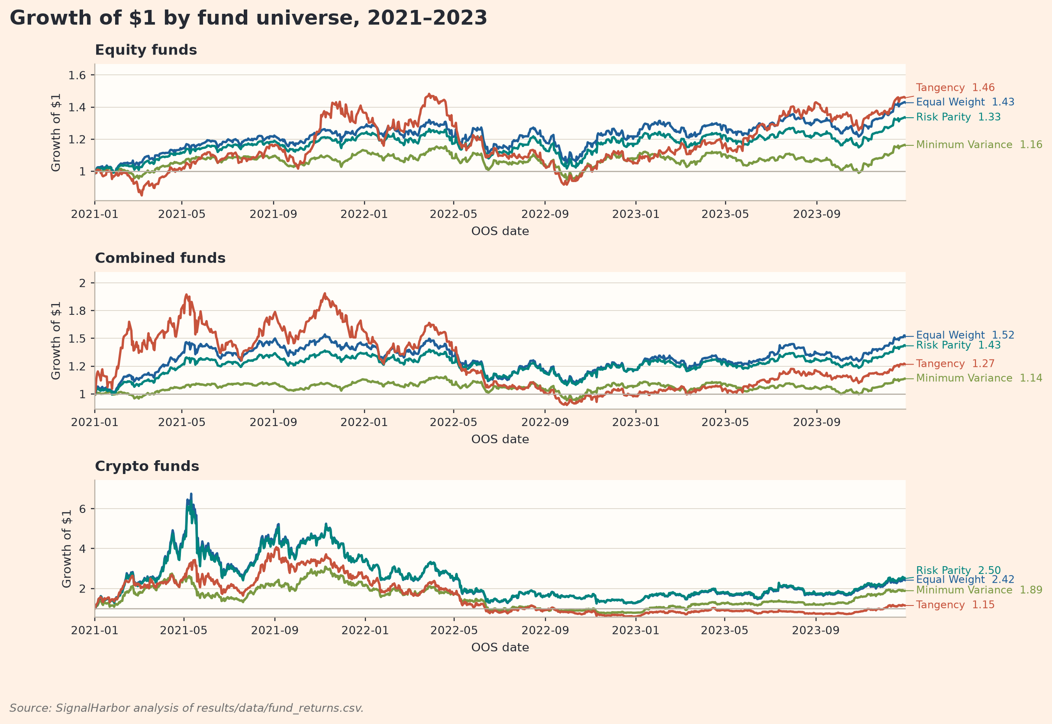
Figure 1. Growth of $1 by fund universe, 2021-2023
Figure 1 adds path information to the static performance metrics in Table 2. In the equity universe, Tangency finished at $1.46, only slightly above Equal Weight at $1.43, so its higher terminal value does not show persistent dominance. Minimum Variance ended at $1.16, which is consistent with a defensive design that reduced volatility but sacrificed return. The combined universe shows a different ordering. Combined Equal Weight finished highest at $1.52, followed by Combined Risk Parity at $1.43. The important point is that no method dominates in every universe, so the app should help users compare trade-offs rather than present a single universal winner.
The crypto panel shows why terminal wealth alone is insufficient. Crypto Risk Parity and Crypto Equal Weight ended much higher, at $2.50 and $2.42, but those gains were earned through a far more unstable path, including the 2021 crypto boom and the large 2022 reversal. This supports treating crypto as a separate risk regime rather than simply another equity-like sector. For SignalHarbor users, crypto exposure is therefore better understood as a high-risk return sleeve. It may improve upside in some regimes, but the path instability and drawdown evidence mean it should be sized deliberately rather than treated as a default core allocation. Figure 1 does not directly measure the severity of interim losses, so Figure 2 examines the same trade-off through drawdown.
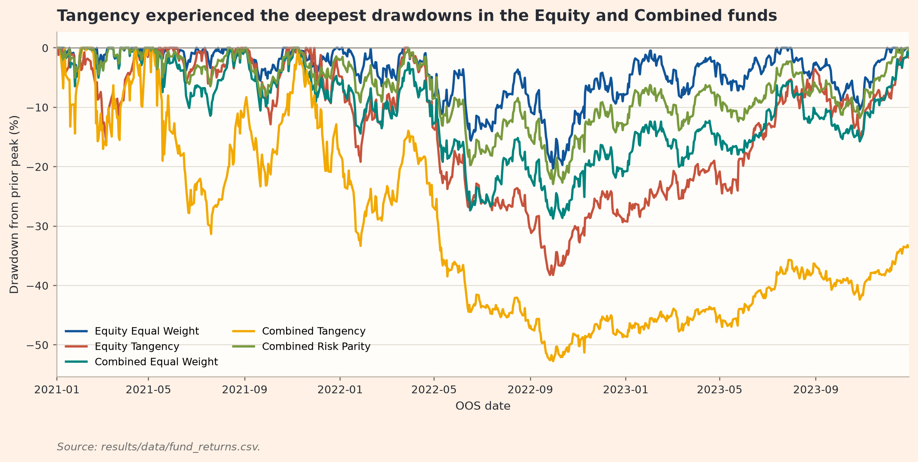
Figure 2. Selected equity and combined drawdown paths; crypto-only funds are excluded
Table 2 in Appendix A and Figure 2 together show clear differences in downside losses across portfolio methods. Equity Tangency reached a 38.2% maximum drawdown, almost twice the 20.3% drawdown of Equity Equal Weight. The combined result is more severe. Combined Tangency fell 52.7% from its previous peak, compared with 28.7% for Combined Equal Weight and 22.9% for Combined Risk Parity. The chart also shows persistence, because Combined Tangency remained well below its earlier peak for much of the later OOS period. For an investor, this is not a small cosmetic difference. A fund that compounds strongly but spends long periods far below its previous peak may be difficult to hold through market stress.
This matters because drawdown measures the loss an investor must tolerate after a fund has already accumulated wealth. Tangency is designed to maximize expected excess return per unit of risk, but it relies heavily on estimated expected returns, which are difficult to estimate from short daily samples. In this project, that estimation risk appears in the OOS results through deeper drawdowns and higher turnover. Combined Tangency had both the worst drawdown in Table 2 and the highest average monthly turnover at 15.5%. Extra optimisation complexity therefore did not translate into a more usable product during 2021 to 2023.
Tangency’s weak OOS performance is one of the useful findings in the report. In theory, Tangency should target the highest expected Sharpe ratio. In practice, small differences in estimated expected returns can lead to large differences in weights. When the estimated return of one asset or group of assets is temporarily high, the optimiser may concentrate exposure in a way that looks reasonable in the estimation window but fragile in the live month. This is the gap between theory and implementation that a systematic fund product needs to address.
The stronger performance of Equal Weight and Risk Parity helps explain why simpler strategies remain competitive. Equal Weight benefits from broad diversification without return forecasting. Risk Parity still uses estimated risk and covariance, but these inputs are usually more stable than expected returns. The evidence in this project is consistent with that hierarchy. Methods that relied less on expected-return prediction produced more investable OOS profiles.
Figure 3 in Appendix A shows that the strongest out-of-sample Sharpe ratios came from simpler or risk-balanced methods. Equity Equal Weight ranked first with a Sharpe ratio of 0.82. Crypto Risk Parity and Combined Risk Parity were close behind at 0.79, while Crypto Equal Weight and Combined Equal Weight also stayed above the median fund. By contrast, all three Tangency funds ranked below the median Sharpe ratio of 0.69. This is important because Tangency is the method most directly designed to improve risk-adjusted return. If it still falls below the median fund out of sample, then the issue is not only that Tangency failed to rank first. The deeper issue is that its optimisation objective did not translate into reliable realised performance.
This result suggests that optimisation only helps when the inputs are reliable. Tangency depends heavily on estimated expected returns, and those estimates can be noisy in a short sample. Combined Tangency had a Sharpe ratio of only 0.40, which was well below the median, and Equity Tangency was also below the median at 0.65. Equal Weight and Risk Parity were more robust and rely less on expected-return forecasts. Equal Weight gets diversification without forecasting returns. Risk Parity still uses estimated volatility and covariance, but those inputs are usually more stable than expected returns. In this sample, the methods that relied less on return prediction produced more investable out-of-sample profiles.
For the app, this means the fund ranking should not be shown as a simple leaderboard with one winner. A conservative investor may prefer Equity Equal Weight because it had the best Sharpe ratio and a relatively shallow drawdown. A balanced investor may prefer Combined Risk Parity because it includes crypto exposure without letting crypto dominate total risk. An aggressive investor may still inspect Crypto Risk Parity as a satellite sleeve, but the app should make the drawdown cost clear. This is why the fact sheet design matters. The same fund can look attractive in a return table and much less attractive once the user sees the drawdown path.
Figure 4 in Appendix A explains how portfolio construction translated into exposures inside the same Combined universe. Equal Weight is mechanically stable, holding the crypto sleeve at 16.7% and distributing the remaining capital broadly across equity sectors. Minimum Variance is more defensive. By the final rebalance, its crypto exposure is only 0.3%, and the largest sector exposures are Healthcare, Communication and Utilities. Tangency is the least stable allocation. Its crypto sleeve ranges from 12.6% to 76.4% during the OOS period, and Table 2 reports the highest Combined-fund average monthly turnover at 15.5%. Risk Parity is more balanced, keeping crypto between 8.4% and 11.8% and avoiding the extreme sector shifts seen in Tangency. The mechanism is therefore visible. Tangency's unstable sector and crypto weights are consistent with its higher turnover and weaker OOS downside profile, while Risk Parity maintained a more stable allocation.

Sentiment Index and Coverage-Aware Signal
I retained the original headline wording, including casing and punctuation, because VADER uses linguistic cues such as emphasis and punctuation when interpreting sentiment (Hutto and Gilbert, 2014). The sentiment component is designed as an explainable extension, not as a black-box return forecast. The project uses headlines rather than full articles, so sentiment is an imperfect proxy for information. A zero sentiment score may reflect neutral wording, a lexicon miss or finance-specific language that standard VADER does not understand, while a day with no observed headline is treated as missing rather than neutral. To reduce this problem, I use a finance-augmented VADER lexicon as a transparent adjustment for financial language. Market terms such as downgrades, impairments, buybacks, guidance changes and bankruptcy receive more appropriate treatment. The adjusted sentiment scores then provide the input for the coverage-aware sector signal used in the portfolio experiment. I do not claim that every headline score is correct. The value is that the scoring process remains transparent, auditable and easy to explain inside the app.
The signal is built from raw headlines to an investable sector input. Headline scores are averaged to ticker-day sentiment, and sector-day sentiment is then calculated as an equal-weight average across news-active tickers in the same sector. I do not force no-news ticker-days to zero or blindly carry them forward. Instead, no-news observations affect a separate coverage measure, which records how much of the sector had observable headline information. This distinction matters because zero sentiment and missing sentiment are not the same economic object. A quiet day with no relevant news should not be treated as strongly neutral evidence in the same way as a broad set of genuinely neutral headlines.
The underlying research hypothesis is deliberately modest. If sector news sentiment captures changes in investor attention, risk appetite or perceived fundamentals, then a lagged sector sentiment tilt may improve the OOS risk-adjusted performance of an equity portfolio (Tetlock, 2007). The hypothesis does not assume that every headline contains tradable information. It only assumes that aggregated sector tone may contain a small timing signal after lagging and coverage controls.
This is why the project avoids treating sentiment as a magic score. Text data are messy: headlines are short, sometimes promotional, sometimes delayed, and often written for attention rather than precise valuation. A lexicon model such as VADER is useful because it is transparent and auditable, but it cannot fully understand sarcasm, context, earnings expectations or whether good news is already priced. The financial question is therefore not whether the sentiment score is perfect; it is whether a simple, explainable signal survives an OOS portfolio test.
The main original extension beyond the baseline is the coverage-aware lagged sector sentiment signal. A raw sector score can be misleading when it is driven by only one or two news-active stocks. To reduce this problem, I scale the lagged sector sentiment z-score by the previous day’s news coverage ratio.
The coverage-aware sentiment signal used for trading is:
$$S_{s,t}^{CA}=z_{s,t-1}^{F}×c_{s,t-1}$$
The coverage ratio is：
$$c_{s,t-1}=\frac{n_{s,t-1}^{news}}{N_{s}}$$
In these equations, $z_{s,t-1}^{F}$ is the past-only expanding-window finance-augmented VADER z-score for sector$s$ , lagged by one trading day. $C_{s,t-1}$is the prior-day news coverage ratio. $n_{s,t-1}^{news}$ is the number of stocks in sector with observed headlines on the prior trading day, and $N_{s}$ is the total number of stocks in that sector. This design reduces the strength of sentiment signals based on sparse stock-level news coverage, while preserving stronger signals when news is broad across the sector.
The report uses two related sentiment measures for different purposes. The standalone 0 to 100 sector sentiment index is designed for investor interpretation, while the lagged and coverage adjusted z score is used in the portfolio fusion test. Keeping them separate means that the visual index is not treated as a trading rule. The standalone index makes sector news tone easier to compare, while the trading signal also accounts for timing and the amount of news available.
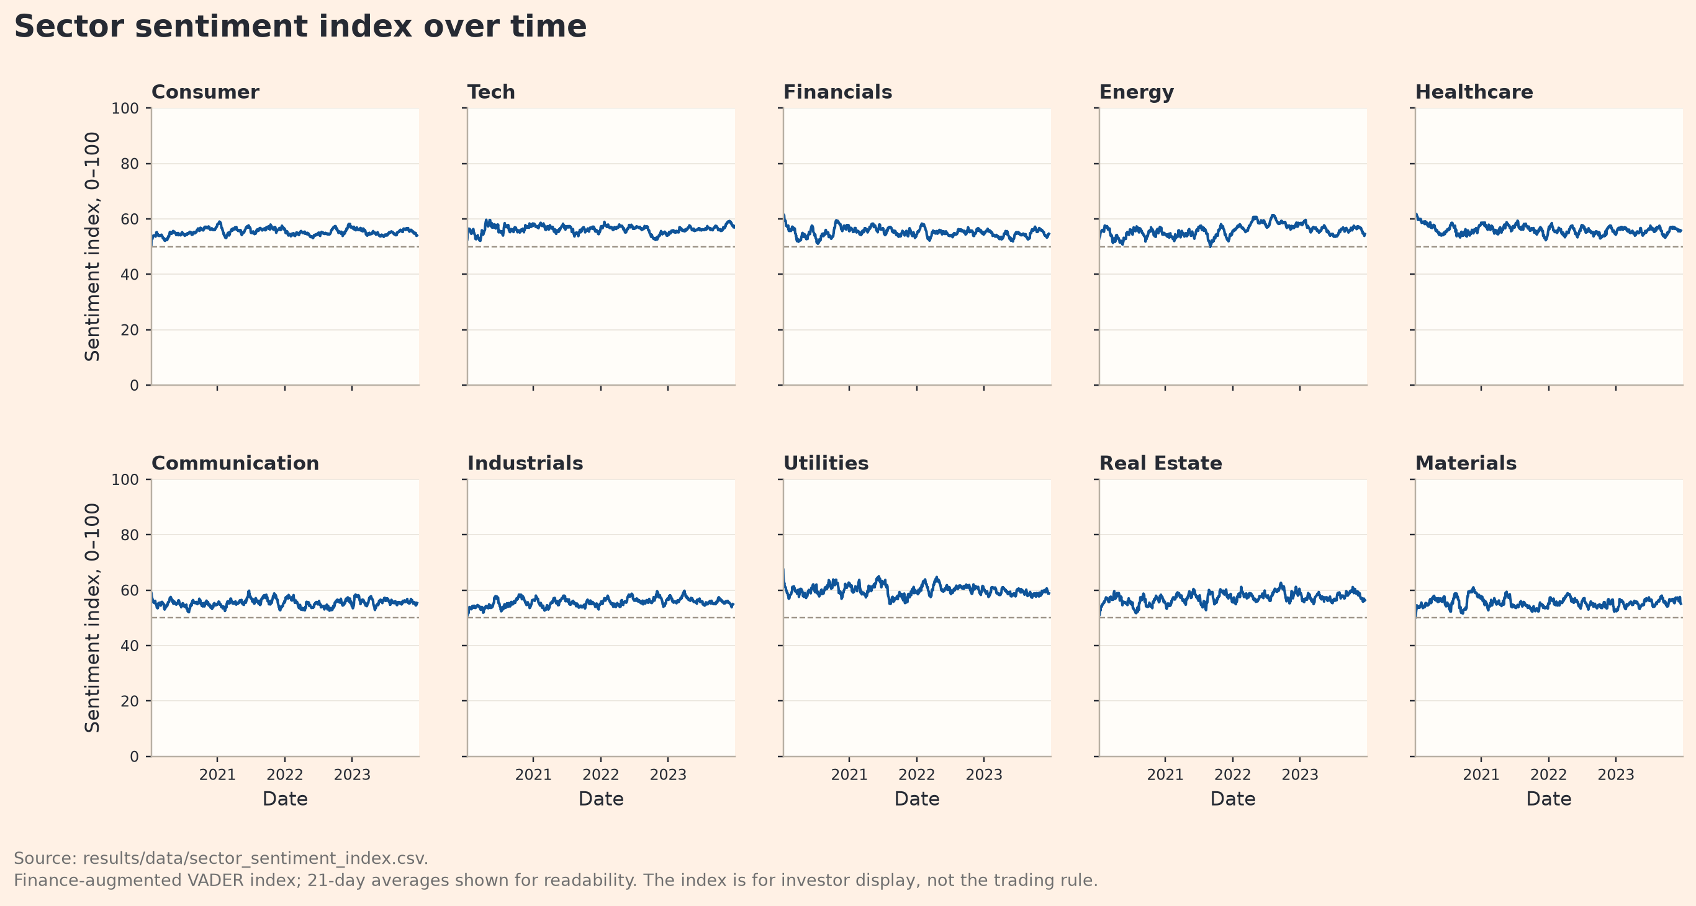
Figure 5. Standalone sector sentiment index over time, 2020 to 2023
Figure 5 shows the standalone sentiment index across the ten equity sectors. Most sectors remain close to the middle of the 0 to 100 scale, although temporary differences appear over time. Energy becomes relatively stronger during 2022, while most other sectors stay closer to their usual ranges. The 21-day averages make these movements easier to compare across sectors. This index is used as an investor facing view of sector news tone and is not used directly to change portfolio weights.
For the portfolio experiment, I use the lagged and coverage-adjusted sector signal described above. The signal reduces the influence of sector sentiment when only a small share of stocks has observable news and uses only information available before each portfolio decision. The resulting coverage-aware signals are shown in Figure A5. Figure 6 then tests whether using this signal improves out-of-sample portfolio performance.

Portfolio Test of the Sentiment Overlay
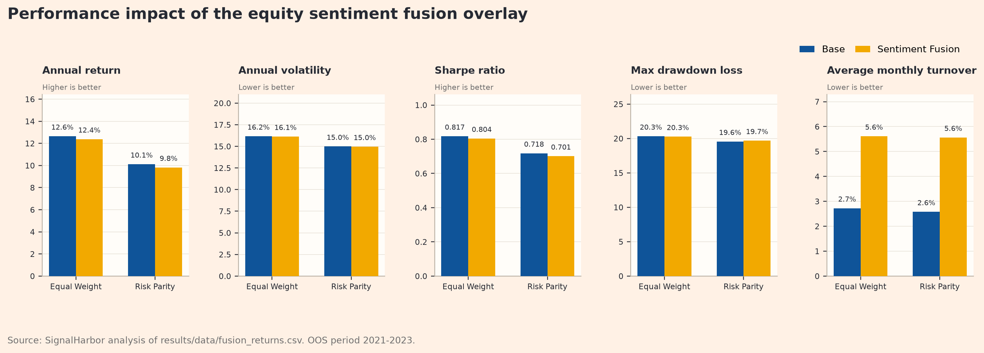
Figure 6. Performance impact of the equity sentiment fusion overlay
Table 3. OOS fusion comparison for equity funds, 2021-2023
Fund | Experiment | Ann. ret. | Ann. vol. | Sharpe | Max DD | Avg. monthly turnover
Equity Equal Weight | Base | 12.64% | 16.17% | 0.817 | -20.32% | 2.72%
Equity Equal Weight | Sentiment fusion | 12.38% | 16.13% | 0.804 | -20.27% | 5.61%
Equity Risk Parity | Base | 10.12% | 14.99% | 0.718 | -19.56% | 2.58%
Equity Risk Parity | Sentiment fusion | 9.82% | 14.96% | 0.701 | -19.68% | 5.56%
Source: results/tables/fusion_comparison.csv. Drawdown is shown as a negative loss.
Figure 6 shows that the coverage-aware sentiment overlay did not improve risk-adjusted performance over the 2021 to 2023 OOS period. For Equal Weight, annual return fell slightly from 12.6% to 12.4%, the Sharpe ratio declined from 0.817 to 0.804, and average monthly turnover rose from 2.7% to 5.6%. For Risk Parity, annual return fell from 10.1% to 9.8%, the Sharpe ratio declined from 0.718 to 0.701, and turnover increased from 2.6% to 5.6%. Drawdown protection also did not materially improve. This means the sentiment signal changed portfolio weights and created more trading activity, but it did not improve realised risk-adjusted performance.
The turnover result is the clearest economic warning. The baseline test uses zero explicit transaction costs, so the reported Sharpe ratios are already generous to the sentiment overlay. If realistic trading costs were added, the fusion strategy would likely look weaker unless the signal produced a larger return benefit. In its current form, the additional turnover is difficult to justify because it was not accompanied by better risk-adjusted performance.
There are several plausible reasons for this result. Sector-level headline sentiment may be too coarse because news affecting individual companies does not necessarily contain information about the whole sector. The one-day lag prevents look-ahead bias, but it may also mean the market has already incorporated part of the information. The 2021 to 2023 OOS period also includes unusual market conditions, including the post-COVID rebound, inflation pressure, rising interest rates and large sector rotations. These forces may have overwhelmed a simple headline-based sector tilt.
This result is still useful for evaluating the innovation because the signal was tested out of sample rather than assumed to improve performance. The coverage adjustment provides a transparent way to deal with differences in news availability, but the OOS evidence suggests that the sentiment signal needs further refinement before it can be justified as a portfolio overlay.

App and Investor Journey
The Streamlit app turns the backtest results into an investor workflow. In Fund Explorer, users can compare the 12 funds by universe and method using the same OOS metrics reported in Table 2. After that, they can open a Fact Sheet for a chosen fund and inspect its growth of one dollar path, drawdown path, performance metrics, latest holdings and audit checks. A fund product should not only report performance. It should also show what the fund currently holds and how that performance was earned.
The user journey follows four decisions. First, the user compares funds. Next, the user inspects a selected fund through the Fact Sheet. They can then blend funds in Portfolio Builder and apply a simple management fee assumption. Finally, the user can check whether the sentiment evidence changes the interpretation of the equity funds. This sequence makes the app more than a display of charts. It helps the user move from comparison to inspection, then from allocation to signal interpretation.
The sentiment layer is included as an analytics feature rather than a return promise. Sentiment Analytics shows the coverage-aware trading signal, the 0 to 100 display index and the base-versus-fusion test. That design choice matters because the report finds that the sentiment overlay did not improve OOS risk-adjusted performance. Instead of presenting sentiment as a signal to follow automatically, the app presents it as evidence that users can interpret alongside the fund results.
The deployment design also supports reliability. The app reads only precomputed CSV files under results. It does not download raw data, rerun optimisation or rescore headlines at runtime. As a result, the app remains reproducible and lightweight, while the report, app and submitted repository all use the same results. The Methodology page explains the OOS design, calendar treatment, lagged sentiment, long-only constraints and the warning that historical backtests are not return promises.

Critical Reflection and Recommendations
The evidence leads to three practical recommendations. First, conservative investors should start with Equity Equal Weight or Equity Risk Parity. Equity Equal Weight had the highest Sharpe ratio across all 12 funds, and both equity funds avoided the extreme drawdowns seen in the higher-risk crypto funds. The main lesson is that the strongest product candidate was not necessarily the most complex one. In this sample, broad diversification and lower dependence on return forecasts worked better than trying to optimise every input.
Second, investors who want crypto exposure should use it carefully inside a combined fund rather than treat a crypto-only fund as the core product. The strongest-return crypto strategies produced the highest terminal wealth, but they also came with very high volatility and drawdowns around or above 80%. Combined Risk Parity is a better product candidate because it kept crypto exposure limited while still allowing some upside. Its Sharpe ratio was 0.79, and its latest crypto sleeve was around 8.6%. This makes crypto more suitable as a satellite allocation than as the centre of the product.
Third, the sentiment overlay should remain an experimental analytics feature for now. The design is transparent, lagged and coverage-aware, but Figure 6 shows that it reduced the Sharpe ratio and increased turnover. I would not remove the sentiment feature because it still makes the app more informative and gives users a clearer view of sector news tone. However, before live use, future tests should try different lag lengths, coverage thresholds, tilt strengths and transaction cost assumptions. In this sample, sentiment analysis made the product more informative, but it did not improve OOS investment performance.
These results also have limitations. The OOS window is relatively short and covers the unusual period from 2021 to 2023, when markets experienced large swings, inflation pressure and monetary tightening. Fund rankings may look different in a calmer period. In addition, the baseline assumes zero transaction costs and fees. This helps isolate the behaviour of each strategy, but it is too generous for a live fund. A real fund would also need to consider transaction costs, fee drag, liquidity filters and tax effects. The sentiment signal is based on news headlines rather than full articles, so it only captures a narrow and noisy part of market information.
The most important conclusion is that SignalHarbor should be built around evidence, transparency and risk tolerance, not around the most exciting model. Equal Weight and Risk Parity produced stronger OOS profiles in this sample, consistent with their lower reliance on noisy expected-return estimates. Cryptocurrency can add upside, but only if investors understand the drawdown risk and size it carefully. Market sentiment can be useful as product insight, but it should not be promoted as alpha unless it improves net OOS performance after turnover and costs.
Product recommendations should be segmented according to investor risk budgets. Conservative users should choose diversified equity funds, balanced users should choose Combined Risk Parity, and aggressive users should treat cryptocurrency exposure only as a satellite allocation. The app should also make clear that the sentiment overlay is currently an analytical experiment, not the default trading engine.
Table 4. Final SignalHarbor product recommendation by investor use case
Investor use case | Recommended product | Reason
Conservative core | Equity Equal Weight / Equity Risk Parity | Best fit for investors who prioritise diversification, lower drawdown and low dependence on noisy expected-return forecasts.
Balanced multi-asset | Combined Risk Parity | Uses crypto as a controlled sleeve rather than allowing it to dominate total portfolio risk.
Aggressive satellite | Crypto Risk Parity | Highest upside in the sample, but only suitable as a satellite because volatility and drawdown are extreme.
Not default | Tangency / current sentiment fusion | Tangency is unstable out of sample; sentiment fusion increases turnover without improving Sharpe in this test.

Appendix A: Supporting Required Exhibits
This appendix contains the full performance table and supporting required exhibits not shown in the main narrative.
Table 2. Out-of-sample performance metrics across all funds
Fund | Universe | Method | Ann. ret. | Ann. vol. | Sharpe | Max DD | Turnover
Combined Equal Weight | Combined | Equal Weight | 15.0% | 21.3% | 0.76 | -28.7% | 3.9%
Combined Minimum Variance | Combined | Minimum Variance | 4.4% | 13.4% | 0.39 | -18.6% | 4.2%
Combined Risk Parity | Combined | Risk Parity | 12.8% | 17.2% | 0.79 | -22.9% | 3.2%
Combined Tangency | Combined | Tangency | 8.2% | 34.8% | 0.40 | -52.7% | 15.5%
Crypto Equal Weight | Crypto | Equal Weight | 34.2% | 80.4% | 0.77 | -81.6% | 5.9%
Crypto Minimum Variance | Crypto | Minimum Variance | 23.6% | 64.1% | 0.65 | -75.9% | 10.4%
Crypto Risk Parity | Crypto | Risk Parity | 35.8% | 78.7% | 0.79 | -80.4% | 6.0%
Crypto Tangency | Crypto | Tangency | 4.7% | 79.0% | 0.46 | -85.7% | 7.0%
Equity Equal Weight | Equity | Equal Weight | 12.6% | 16.2% | 0.82 | -20.3% | 2.7%
Equity Minimum Variance | Equity | Minimum Variance | 5.1% | 13.4% | 0.44 | -18.0% | 5.3%
Equity Risk Parity | Equity | Risk Parity | 10.1% | 15.0% | 0.72 | -19.6% | 2.6%
Equity Tangency | Equity | Tangency | 13.5% | 23.7% | 0.65 | -38.2% | 13.7%
Source: results/tables/performance_metrics.csv.
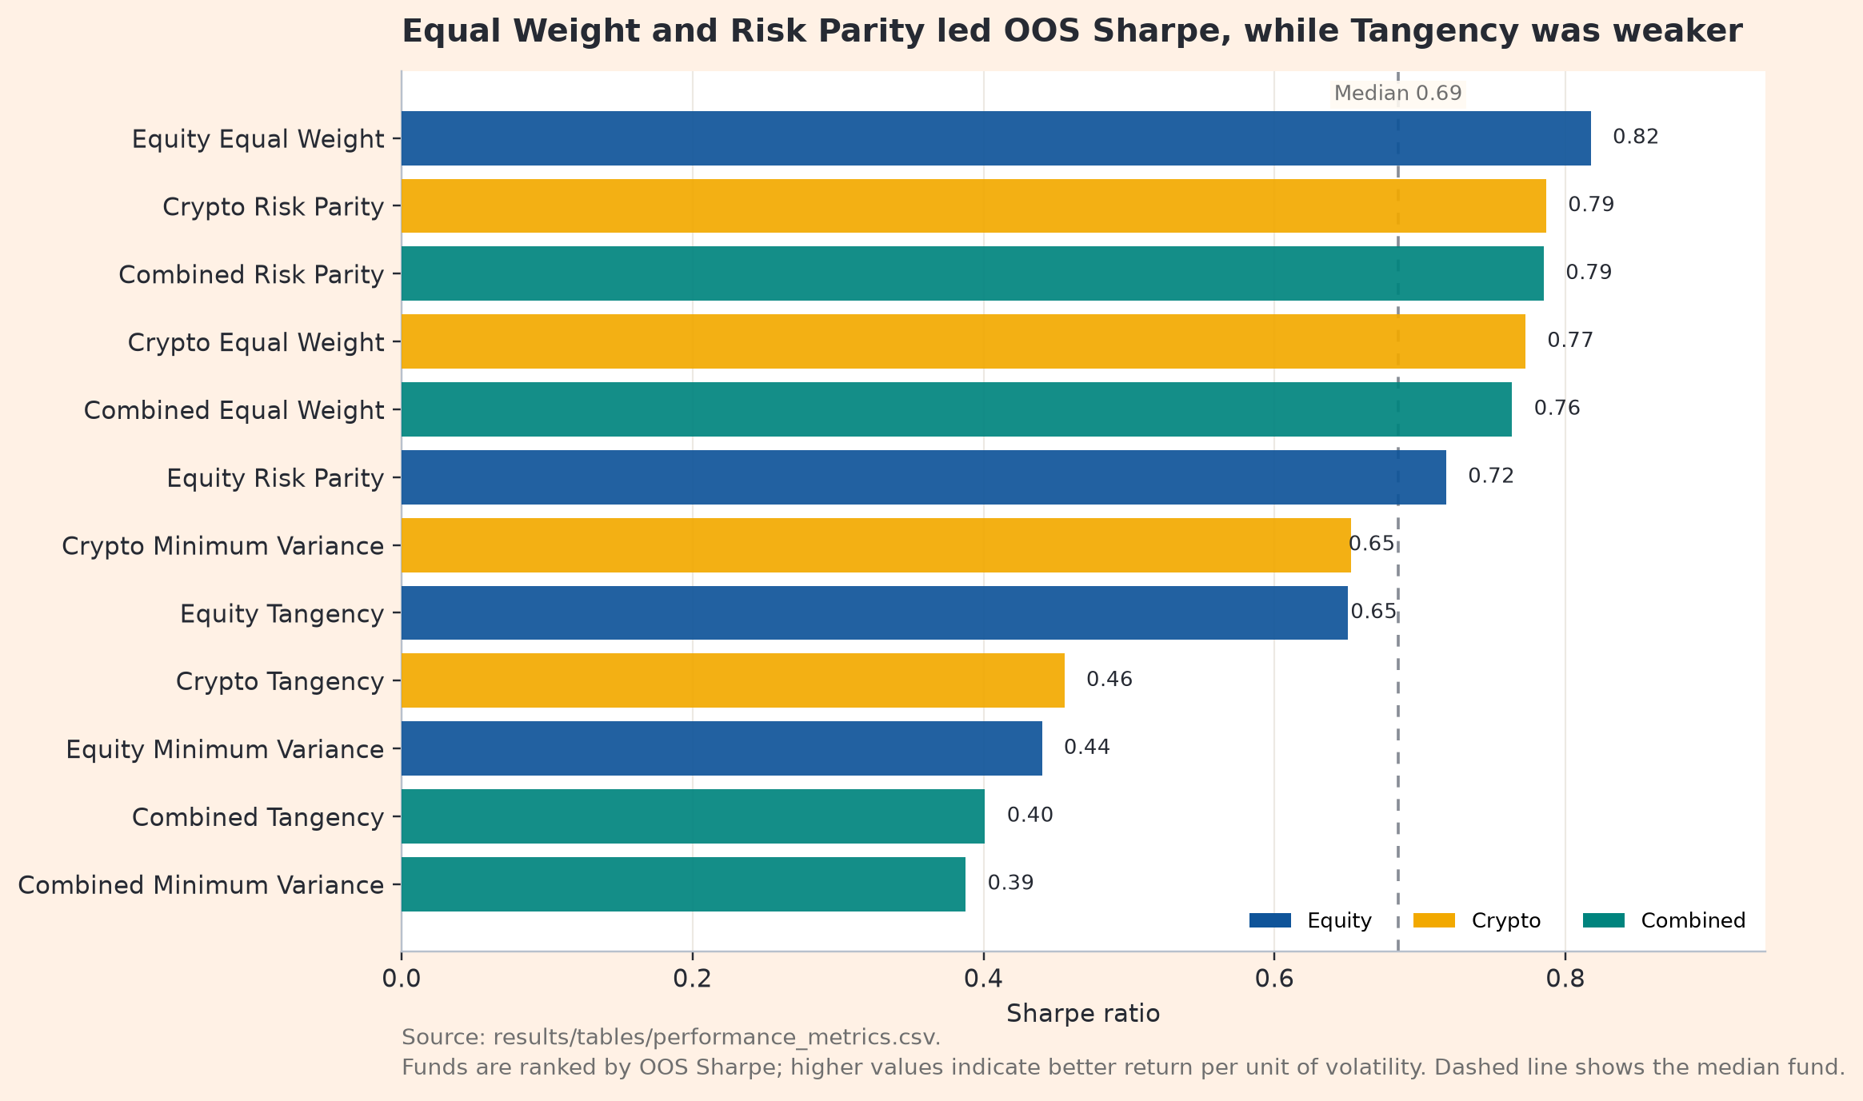
Figure 3. Funds ranked by OOS Sharpe ratio
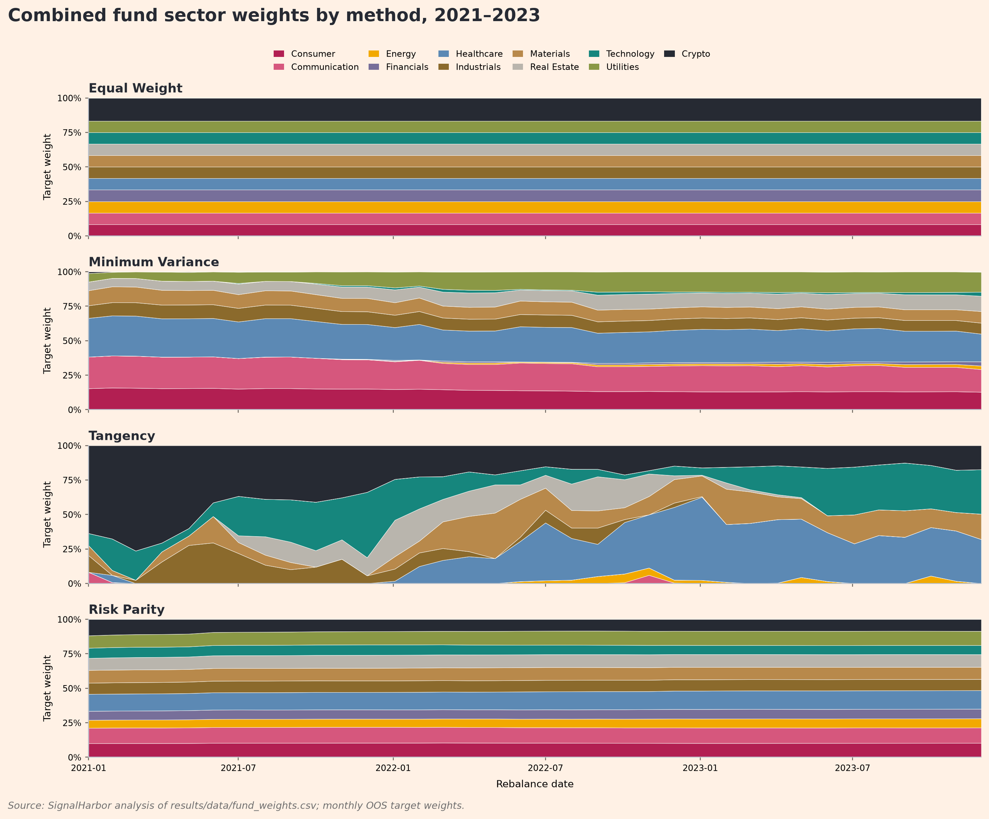
Figure 4. Combined fund sector and crypto weights by method, 2021-2023
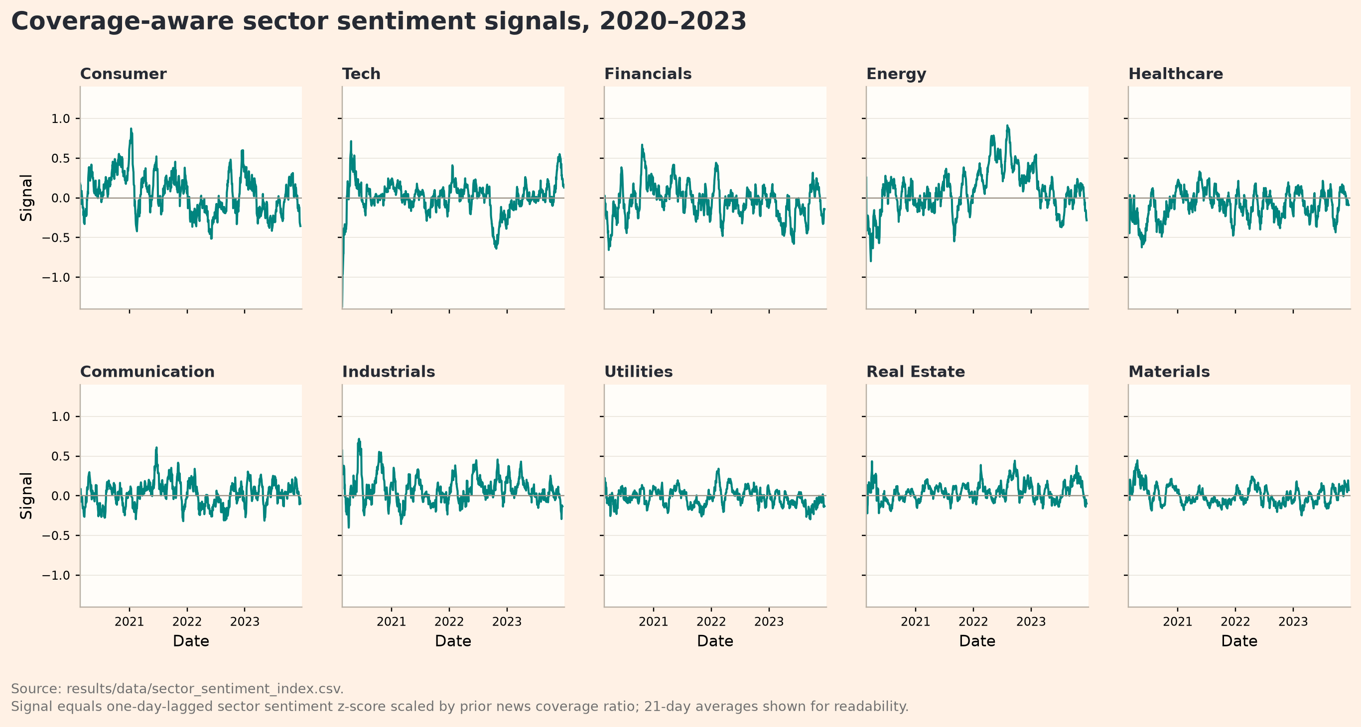
Figure A5. Coverage-aware sector sentiment signals, 2020-2023

Current Holdings Example
Table A1. Top current holdings for Combined Risk Parity at the latest rebalance.
Ticker | Weight
WMT | 3.17%
GILD | 3.10%
MRK | 2.98%
NEM | 2.89%
ABBV | 2.80%
EA | 2.77%
AMGN | 2.52%
KO | 2.39%
Source: results/data/current_holdings.csv.

Appendix B: Streamlit App Evidence
Figure B1. SignalHarbor fund fact sheet interface.
The app allows investors to select a fund and view its OOS return, volatility, Sharpe ratio, maximum drawdown, Growth of $1 path, drawdown path, current holdings and audit checks. This supports the brief's investor journey because a user can compare funds, inspect a fact sheet, build a blended allocation and view sentiment analytics without seeing code or rerunning the model.
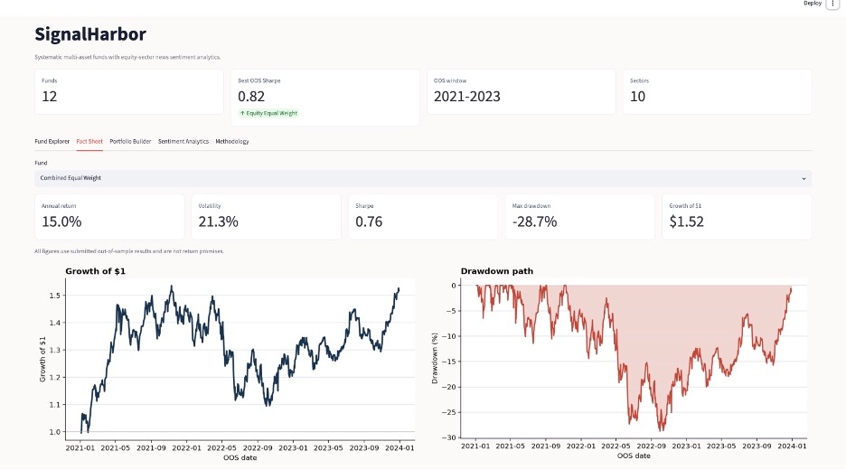
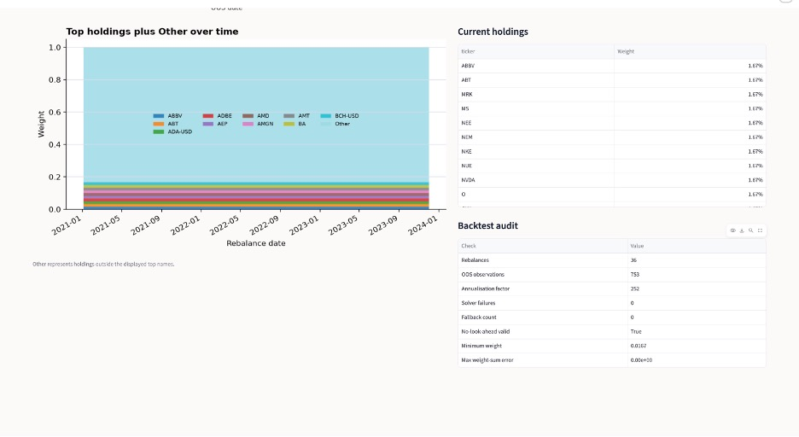

Figure B2. SignalHarbor sentiment analytics interface.
The app displays the coverage-aware lagged sector sentiment signal by sector, allows the user to switch to the 0-100 display index, and summarises the base-versus-sentiment-fusion test using precomputed project results.
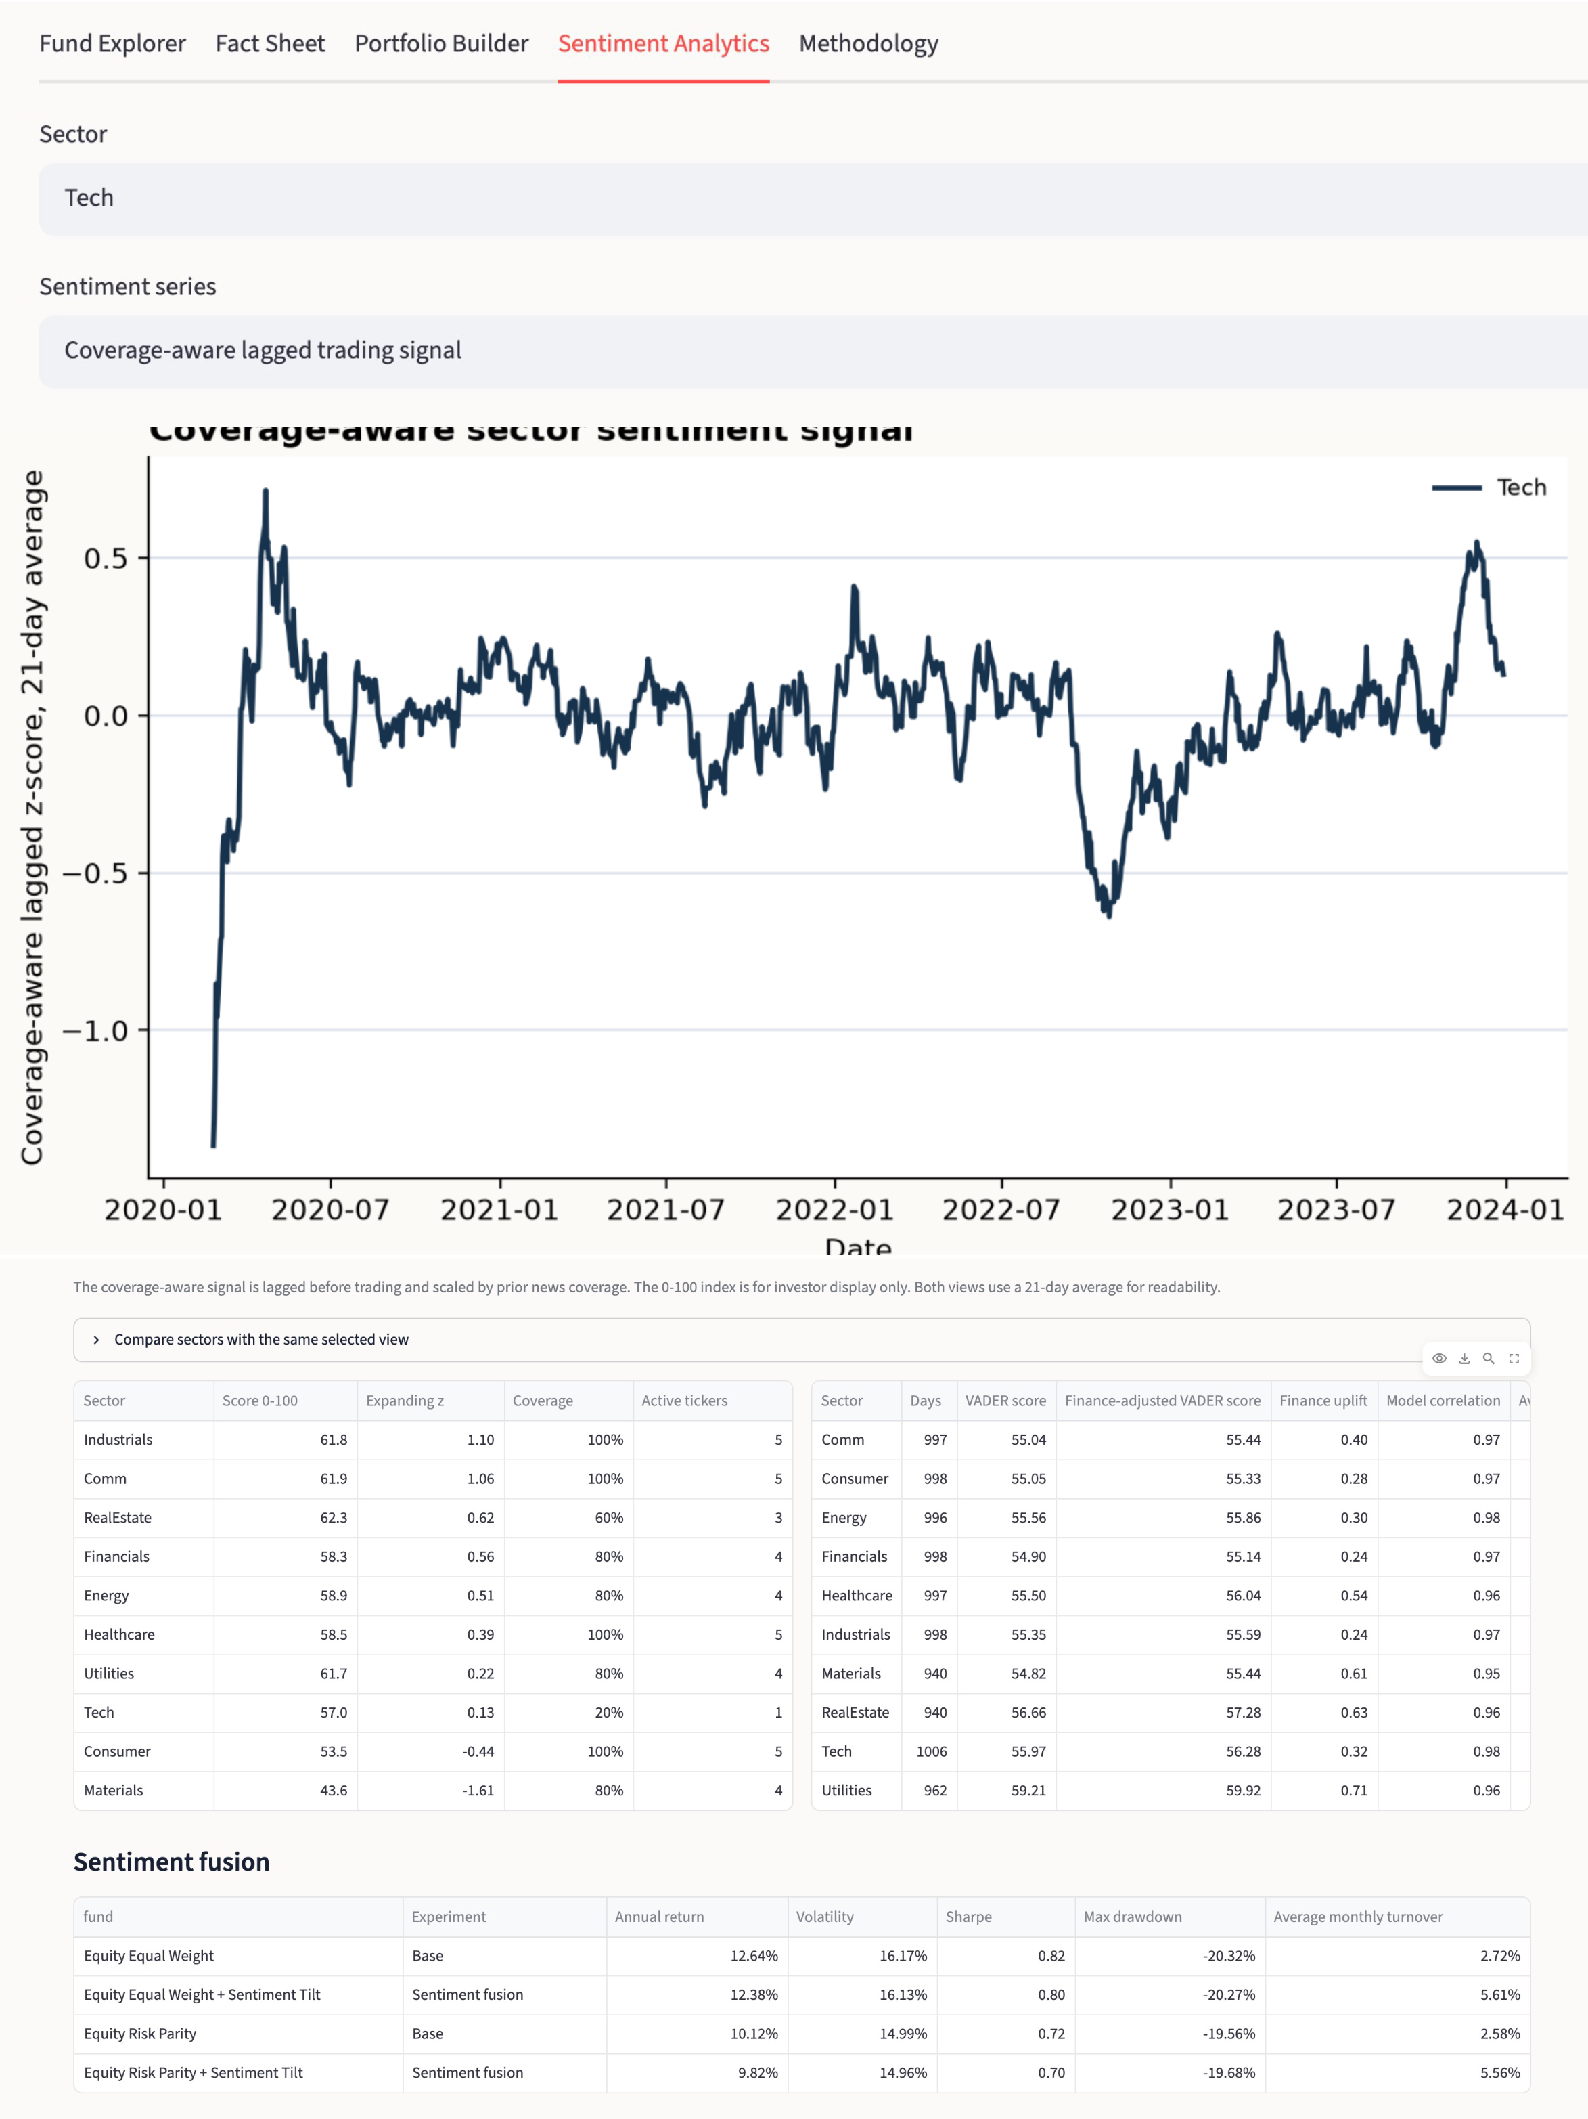

References
Baker, M. and Wurgler, J. (2007). Investor sentiment in the stock market. Journal of Economic Perspectives, 21(2), 129-152.
DeMiguel, V., Garlappi, L. and Uppal, R. (2009). Optimal versus naive diversification: How inefficient is the 1/N portfolio strategy? Review of Financial Studies, 22(5), 1915-1953.
Hutto, C. and Gilbert, E. (2014). VADER: A parsimonious rule-based model for sentiment analysis of social media text.
Maillard, S., Roncalli, T. and Teiletche, J. (2010). The properties of equally weighted risk contribution portfolios. Journal of Portfolio Management, 36(4), 60-70.
Markowitz, H. (1952). Portfolio selection. Journal of Finance, 7(1), 77-91.
Tetlock, P. (2007). Giving content to investor sentiment: The role of media in the stock market. Journal of Finance, 62(3), 1139-1168.
Official FINS3645 starter data: equity prices, crypto prices, and news headline files accessed via src/data_access.py.

