FINS3645: Financial Market Data Design and Analysis

AlphaBlend Investment Platform
Part B Report: Funds, Sentiment and App

FINS3645 Individual Project (Part B, Stations 3 to 4)
Academic Year 2026

Abstract
AlphaBlend is the prototype of an investment platform offering 15 different rules-based funds across US equities, cryptocurrencies, and a combined basket of both tokens and stocks, each built with one of the five optimization methods used, alongside with a news fear and greed index and a deployed web app. The fund with the best risk-adjusted performance is the combined Max Sharpe fund, with an out-of-sample Sharpe ratio of 0.983 and a 26.6% annualised return over the period 2021 to 2023. The Hierarchical Risk Parity method delivered the second-lowest maximum drawdown in each asset family, behind Minimum Variance, offering less volatility but less returns. The news-sentiment is measured through a VADER model adapted to financial articles, which has been extended with 123 web-scraped words and 204 idioms, which raised the percentage of headlines carrying a non-neutral score from 39.3% under the unedited VADER to 47.2% after the changes. Tilting the equity Max Sharpe fund towards sectors with a high sentiment score lifted its Sharpe ratio from 0.534 to 0.552 whilst the max drawdown grew larger, which is evidence that news sentiment should not be relied on as a primary signal.

1. The funds and the backtest design

1.1 Walk-forward design
All weightings for each fund is formed using only past data. The back-test is conducted on both walk-forward and out-of-sample testing, since on each trading day, the optimizer sees a rolling window of the previous 252 trading days, roughly one calendar year before the day, and never the day it is trading. This prevents Look-ahead bias, which is the risk of information that would not have been available in real time, which is the largest threat to a reliable back-test (estimation window is sliced to exclude the current day by construction).
Each fund rebalances on the first trading day of each calendar month, this is a great compromise since: Although daily rebalancing would react faster to market conditions, this would churn the portfolio and also pay far greater transaction costs on every position and, annual rebalancing would be cheaper but slower to adapt. The first out-of-sample return is computed once the first 252-day window is full, with the date being 4 January 2021 for the equity and combined funds, yielding a result of 753 out-of-sample days. However, the crypto funds trade on a 365-day calendar and reaches a full window sooner with the first being 10 September 2020.
The backtest uses the daily one-month Treasury-bill proxy as the risk free rate, sourced from the Fama and French five-factor daily dataset (the RF series in the Kenneth French Data Library), with the period of 2 January 2020 to 29 December 2023. The 2021-2023 backtest window also coincides with the Fed's 2022 hiking cycle, therefore, the zero-rate assumption used in Part A is a much weaker approximation late in the sample compared to the first 1.5 years of the sample. When annualized, this rate is approximately zero in the years 2020 to mid-2022, which then goes up to roughly 5.0% per year from December 2022 onwards. This sourced risk free rate affects two components, the first being the Maximum Sharpe fund which uses the mean daily risk free rate over each 252-day estimation window, drawing only on past data so that there is no look-ahead bias, and every fund's Sharpe ratio is an excess-return Sharpe, the annualised mean of the daily return minus the daily rate divided by annualised volatility. Secondly, the equity and combined funds share the trading calendar of the rate series and are align with no gaps, with the 376 of 1,208 crypto dates that fall on weekends or holidays carrying into the last known trading-day rate forward, the same carry-forward method that is used for days with missing sentiment. Transaction costs are set to zero which assumes a liquid market, and all return series are annualised with the square root of 252 for the equity and combined funds (equity trading calendar) and the square root of 365 for the crypto-only funds, which trade every calendar day.

1.2 The five optimisation methods
The platform offers five different optimization methods with each mapping the rolling 252-day return and covariance estimates to a different set of weights. Because Equal Weight allocates the same capital to every asset, estimation error cannot destabilize its results, making it a tough benchmark to outperform. The Minimum Variance fund minimises portfolio variance using long-only weights, and calculates weightings based on the covariance matrix of asset returns but ignores expected returns often concentrating weightings towards low-volatility assets. The mean-variance tangency portfolio (Max-Sharpe) maximises expected excess return per unit of volatility, being the only method which uses the sample mean return, which can be a notoriously noisy estimate over a single sample, causing its weights to heavily favor toward any asset performing well in the current window. Risk Parity equalises each asset's contribution to the portfolio’s total risk, giving a volatile asset a smaller weight and giving a less volatile asset a higher weighting.
Hierarchical Risk Parity, from Lopez de Prado (2016), allocates risk without inverting the covariance matrix, which is what makes Minimum Variance and Maximum Sharpe susceptible to noisy or near-singular matrices. This fund runs in three stages, the first stage is tree clustering first groups assets by a correlation distance, so that assets moving together will sit in the same branch. The second step is Quasi-diagonalisation, which reorders the covariance matrix to place correlated assets next to one another. Recursive bisection finally walks down the tree, splitting capital between each pair of branches in inverse proportion to their variance, causing the calmer branch to receive more weighting. A synthetic four-asset test conducted by the agent, with two low-variance and two high-variance assets and near-zero cross-correlation, confirms that HRP places 0.901 of its weight on the low-variance cluster and 0.099 on the high-variance one, which matches the paper's prediction.
The formal equation of each method, with every symbol defined, is in Appendix D.

1.3 Fund universe
AlphaBlend offers three different asset families being equity, crypto, and combined, each built with all five optimization methods to get 15 in total. Alphablend offers a high variety of 15 funds, and also draws upon newer methods, since HRP is a 2016 method which post-dates the classical mean-variance toolkit.

2. Out-of-sample results
Table 1 reports the out-of-sample performance for all 15 funds with the returns and volatility annualized. The Sharpe ratio is then measured in excess of the daily risk-free rate, and the maximum drawdown is the largest peak-to-trough fall in the fund's value over its out-of-sample testing period.
Fund | Ann. return | Ann. vol. | Sharpe | Max DD
Equity Equal Weight | 13.2% | 16.2% | 0.687 | -20.3%
Equity Min Variance | 6.2% | 12.8% | 0.325 | -15.4%
Equity Max Sharpe | 12.0% | 18.5% | 0.534 | -26.1%
Equity Risk Parity | 10.5% | 14.6% | 0.580 | -18.5%
Equity HRP | 9.2% | 13.7% | 0.520 | -16.9%
Crypto Equal Weight | 73.5% | 80.5% | 0.878 | -81.6%
Crypto Min Variance | 81.5% | 64.7% | 1.217 | -71.2%
Crypto Max Sharpe | 20.5% | 77.6% | 0.229 | -89.5%
Crypto Risk Parity | 75.5% | 78.3% | 0.929 | -79.5%
Crypto HRP | 76.5% | 75.8% | 0.973 | -78.0%
Combined Equal Weight | 16.2% | 21.2% | 0.664 | -28.7%
Combined Min Variance | 6.3% | 12.8% | 0.329 | -15.6%
Combined Max Sharpe | 26.6% | 24.9% | 0.983 | -26.3%
Combined Risk Parity | 14.4% | 16.0% | 0.765 | -19.8%
Combined HRP | 10.4% | 14.0% | 0.591 | -18.4%
Table 1. Out-of-sample performance of all 15 funds, 2020 to 2023. Ann. return and Ann. vol. are annualised; Sharpe is excess of the daily risk-free rate (Fama/French RF, Kenneth French Data Library); Max DD is the maximum drawdown. Source: results/tables/performance_metrics.csv.
The combined Max Sharpe fund has the best risk-adjusted performance, with a Sharpe ratio of 0.983 and a 26.6% annualised return. This beats all optimized equity only funds, and all standalone crypto funds except for the Minimum Variance fund discussed below, and only narrowly ahead of the crypto HRP fund (0.973). The alpha of the combined MS fund is generated from diversification across two weakly related return sources. The tangency portfolio can hold both equities and crypto together, and since there is low correlation, combining them increases the return per unit of risk beyond what either reaches alone. Therefore, this confirms that a combined product rather than a single asset class product is AlphaBlend’s best offering.
However, the Crypto Max Sharpe is the worst performing of all five crypto funds, with a Sharpe ratio of 0.229 and a maximum drawdown of -89.5%, despite crypto being the highest-returning class in the sample, caused by the method’s reliance on the sample mean return. Because Crypto returns are extremely volatile and fat-tailed, a single 252-day estimate of the mean is dominated by noise. Maximum Sharpe then concentrates portfolio weighting in the coin which spiked in the window, only for the position to reverse once tested out of sample. The method which outperforms on a diversified combined fund can also fatally concentrates risk when limited to a small sample of volatile assets.
Crypto Minimum Variance has a Sharpe ratio of 1.217, which is higher than every equity fund, but should not be interpreted as the best performing fund. The crypto funds run over 1,208 out-of-sample days from September 2020, whilst the equity funds cover 753 days from January 2021, with the crypto series capturing the 2020 to 2021 bull run in full, and having a different window to equity. Minimum Variance achieves its objective by favoring coins with the lowest volatility, but comparing across asset classes is confounded by sample period, so therefore the result deserves caution rather than a strong conclusion.
HRP delivered the second-lowest maximum drawdown in all asset classes, behind Minimum Variance, with -16.9% in equity, -18.4% in combined, and -78.1% in crypto, this resulted in it being the second-best in all five methods. HRP offers greater out-of-sample stability than in-sample optimality, which is the behaviour that Lopez de Prado (2016) predicts for a method that avoids inverting a noisy covariance matrix. For a risk-averse investor, HRP is the most defensible default fund to allocate money towards, although it does not offer the highest returns.
Within equities, Risk Parity has a sharpe ratio of 0.580, then Maximum Sharpe at 0.534, then HRP at 0.520, with Minimum Variance performing the worst at 0.325. Whereas Equal Weight, the estimation-free benchmark, still posts the highest Sharpe of all equity funds at 0.687. Under the previous risk free rate assumption of 0% for the whole testing period, Max Sharpe had a worse sharpe ratio than the HRP fund, but now performs better, and Risk parity still has the best performing sharpe despite changing the assumed risk-free rate, and simple risk-based methods still remain competitive.
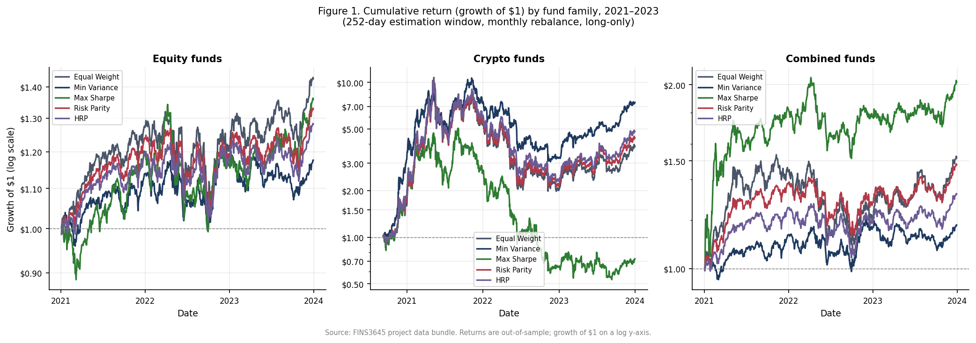
Figure 1. Growth of one dollar invested in each fund, by asset family. Crypto funds dominate the vertical scale and compress the equity and combined lines; the combined Max Sharpe fund is the steadiest strong performer once crypto's swings are set aside.

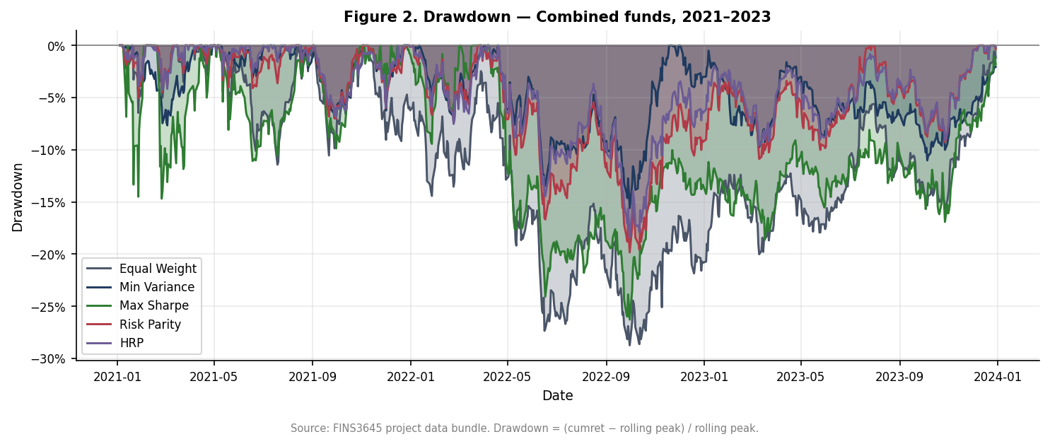
Figure 2. Drawdown of the combined funds, the percentage fall from each fund's running peak. HRP and Risk Parity spend less time deep underwater than Max Sharpe, confirming the stability ranking in Table 1.

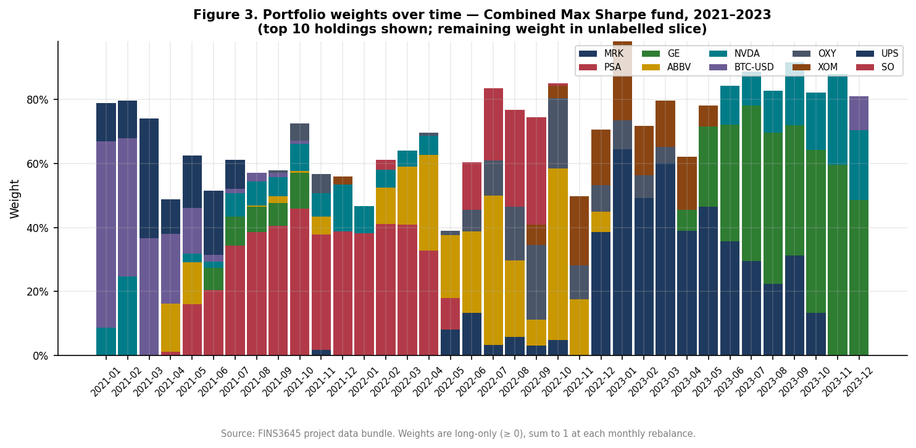
Figure 3. Portfolio weights over time for the combined funds across methods. Equal Weight holds flat lines by construction, while Max Sharpe reallocates aggressively, the visible source of its higher turnover and deeper drawdowns.

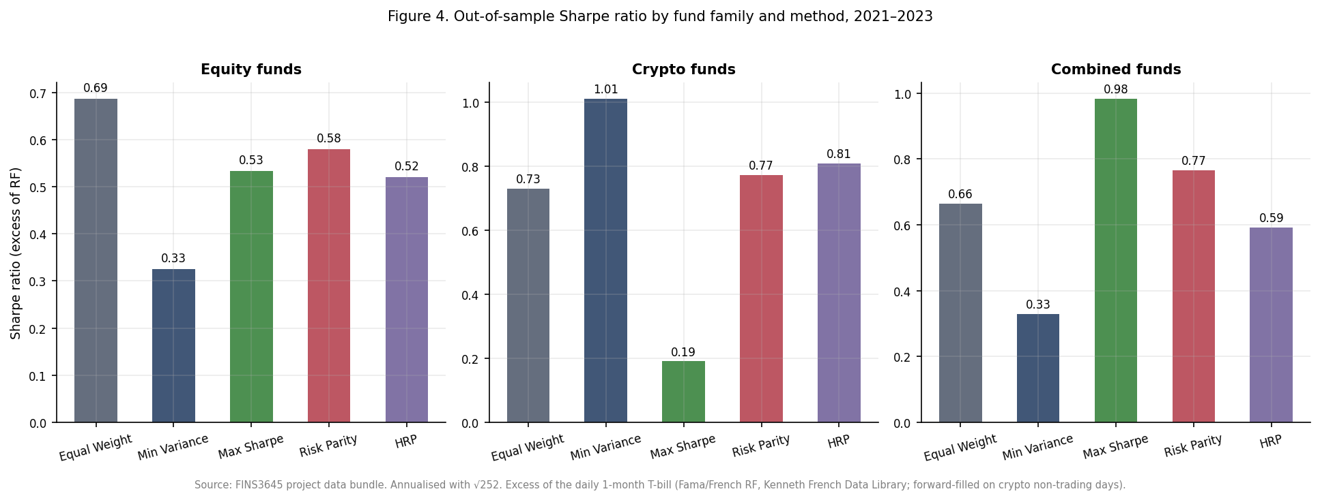
Figure 4. Out-of-sample Sharpe ratio by fund. The combined Max Sharpe bar is the tallest and the crypto Max Sharpe bar among the shortest, the two-sided result that anchors this section.

3. The sentiment index

3.1 The scoring model
AlphaBlend’s sentiment engine is a version of finVADER that has been extended to include more vocabulary and idioms, a rule-based model that scores text on a compound scale from -1 to +1. The base is finVADER (Korab, 2023), which augmented VADER's general lexicon (Hutto and Gilbert, 2014) with two finance dictionaries, SentiBigNomics with about 7,295 terms and Henry's word list with 189 terms. On top of finVADER the platform has adds its own additional layer with 123 finance words and 204 finance idioms, mined from external news and scored by a panel of ten independent raters, kept only where the panel agreed on both direction and strength. Section 4 documents how it was built.
The formal scoring equation, with every symbol defined, is in Appendix E.

3.2 Before and after coverage
Plain VADER assigns a non-neutral score to 51.1% of headlines, finVADER to 39.3%, and the extended model to 47.2%. The fall from plain VADER to finVADER is not a regression as the General VADER treats ordinary finance vocabulary, words such as market, shares, and tax, as mildly emotional since its lexicon was trained on social media, and it therefore flags sentiment that does not exist. finVADER strips out the false positives, resulting in a lower and more accurate number of headlines scored as non-neutral, consistent with Loughran and McDonald (2011) on the mislabelling of finance text by general dictionaries. The extended model then increases this percentage by 7.9 points of increased sentimental words and idioms over finVADER, from both vocabulary and the idiom scoring system which finVADER was missing, without re-importing plain VADER's false positives. This metric measures the coverage of how often the model holds an opinion but not its accuracy, the evidence for its accuracy is in Section 4.

3.3 Sector-level construction
Within each sector the fund-facing model takes an equal-weighted average across the sector's stocks, so one heavily covered mega-cap cannot dominate the sector's mood. This data series is then lagged by at least one trading day, so a decision on day t uses only sentiment from day t minus 1 or earlier, which prevents look-ahead bias using a similar principle in the back-testing. Days without news are handled in two steps, the first being that the last known value is carried forward, on the assumption that sentiment persists until fresh news arrives, and any leading gap with no prior value is set to neutral. Dropping missing days would break the fixed trading calendar the fusion tilt merges onto therefore making the fill function essential for the function of the sentiment model.

3.4 Coverage evidence
A single stock has news on a median 80% of trading days, with a day-to-day standard deviation of 12.81 on the 0 to 100 sentiment scale. Aggregating to sector level lifts the coverage to 99% and cuts the daily standard deviation to 7.30, and pooling all 50 stocks into a market-wide index reaches 100% coverage at a standard deviation of 2.86, roughly a 4.5-fold reduction in daily noise from single stock sentiment scoring. The averaging of the many series together cancels the idiosyncratic noise specific to any one stock whilst the common, market-wide signal survives. The fund tilt runs at sector level rather than on the aggregate precisely because the tilt is a cross-sectional bet and needs sectors to be less correlated, a difference the fully pooled index by construction erases.

3.5 Building the fear and greed index
The public fear and greed index was built using four steps, the first is that each headline's compound score is rescaled from its native -1 to +1 range onto 0 to 100 with 50 being neutral. The 50 stocks are then averaged, equal-weighted, into one market-wide series. The raw level is almost uninformative on its own as the market-wide average sits above 50 on 98% of days and ranges from 45.3 to 62.8, making the market look like it is almost always slightly optimistic. Standardising fixes this by converting each day into a z-score, which is the distance from the index's own historical mean measured in standard deviations, which distinguishes fearful days from greedy ones. The standardisation then uses an expanding window, computing the mean and standard deviation from data up to each date only, so that no future information affects a past reading. Expanding and full-sample z-scores resulted in a correlation of 0.998, telling us that the look-ahead-safe version has no downsides to its accuracy, whilst also remaining valid for a live signal. The latest reading is extreme greed, a z-score of about 2.25, meaning the market sits 2.25 standard deviations above its own 2020 to 2023 average, a window which includes the black-swan events of COVID and the 2022 selloff.

3.6 Attribution
The two methodologies used which is the index construction, from raw score through rescaling, aggregation, and expanding-window standardisation, follows the Week 9 lecture. The decision to fuse sentiment into fund weights by tilting in Section 4 comes from the project brief.
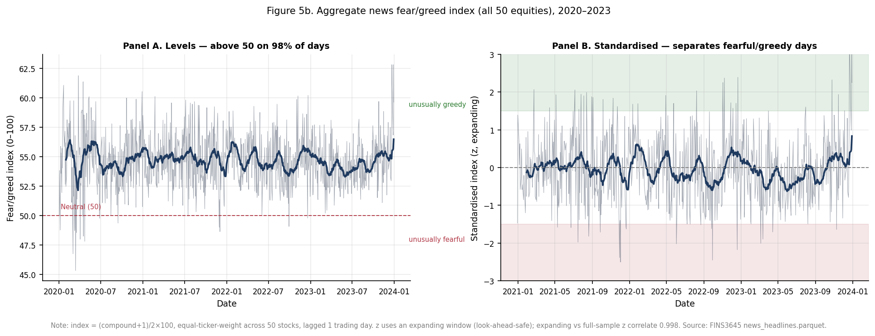
Figure 5. The market-wide sentiment index after expanding-window standardisation. Values are z-scores and the bands mark the fear and greed regions; the series ends in extreme greed.

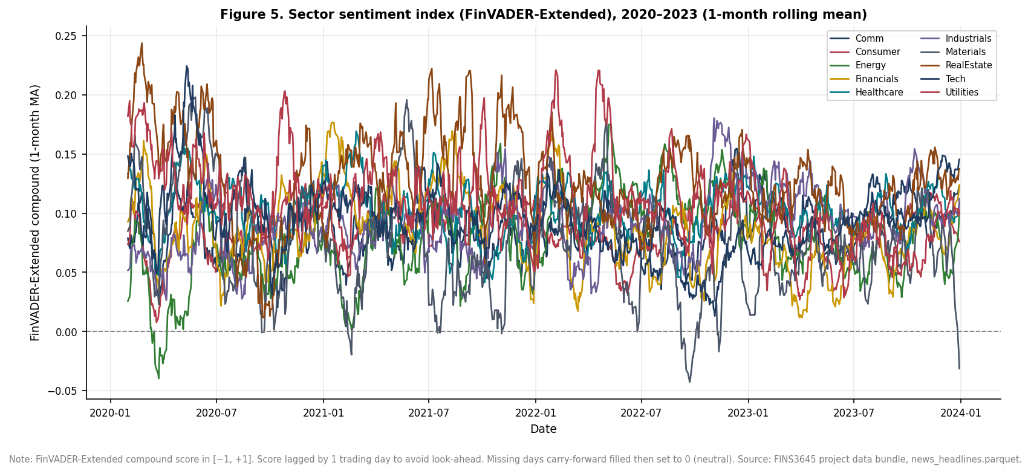
Figure 6. Sector-level sentiment over time. Sectors diverge from one another, and that cross-sectional variation is what the fund tilt exploits.

4. Extensions and innovations

4.1 The lexicon-mining pipeline
A rule-based pipeline using AI agents was used to extend the sentiment lexicon instead of a hand-picked word list. It runs in four stages: Candidate vocabulary is first mined from an external corpus of roughly 2,154 news articles for idioms and 452 for single words, drawn from Reuters, CNBC, MarketWatch, and Bloomberg via RSS and Google News feeds. This external corpus is used to discover candidate words and phrases but never enters the reported results as data. All sentiment scores, coverage figures, and backtests in this report runs exclusively on the provided news_headlines.parquet.
Each candidate is then rated by ten independent agents on a valence scale from -4 to +4 where each rating given by an agent is an isolated pass which cannot see the other agents’ ratings, so the procedure is able to yield ten separate opinions per candidate, from which a mean and a standard deviation score between the agents are computed. A two-stage filter keeps a candidate only if the panel agrees on both the direction and strength, with the filters being that the absolute mean must have valence of at least 0.5, and the cross-agent standard deviation must be below 25%. However In practice, this threshold for SD is too high, with a maximum around 0.52 for words with the only effective constraint being the minimum mean. Replacing subjective human author judgement with a consensus rule across all 10 independent agents is what makes the extension reproducible and defensible rather than arbitrary.
At the end of the scoring and filtering, there were 123 words and 204 idioms left. They are then added onto finVADER, and the idioms required a specific fix. VADER stores multi-word idioms in a special-case table, but a fundamental flaw was that it only applies them when the phrase's last word is a lexicon word, at least three tokens precede it, and the token three positions back is not a lexicon word. Idioms in headlines, such as the phrase "shares soar" at the start of a sentence has too few preceding tokens. The idiom extension now detects all known idioms and collapses it into a single token carrying the idiom's valence, which gets picked up regardless of position. The new idiom handling is effective, where finVADER scores "profit warning" at +0.13, using the wrong sign, since profit reads as positive whereas the idiom handling introduced never triggers, and the collapsed idiom scores it negative.

4.2 What Went Wrong
A first round of web-scraping articles produced 204 idioms and lifted the fusion Sharpe from 0.534 to 0.552, a gain of 0.018. A second round of scraping added 269 more idioms, taking the total to 473, and the fusion sharpe however decreased from a gain of 0.018 in the sharpe ratio to only 0.005. The dilution of the results predates the change in the risk-free rate assumptions of the model and only the live 204-idiom fusion was re-run under the real risk-free rate, giving the 0.018 above. The larger performed worse, therefore the platform reverted to the 204-idiom set and archived the 473-idiom set rather than deleting it in case future adjustments improve the accuracy of the 473-idiom set.
There is a clear reason for the dilution, as reaching 473 idioms meant lowering the frequency threshold to admit rarer phrases, and the marginal candidates also had lower quality. The second round pulled in fragmentary, low-frequency n-grams such as "drop as outlook", "discovery reports jump", and "added just workers". These marginal idioms are rare and fragmentary, not high-frequency boilerplate: each appears only three times in the entire corpus and reads as ambiguous rather than having a clean directional sentiment. Therefore, a selective lexicon can beat a permissive lexicon although the effect is small and specific only to this sample. A smaller, and more carefully vetted lexicon beats a larger one with more noise.

4.3 The fusion result
Adding sentiment tilting into the equity Max Sharpe fund improved its risk-adjusted return but worsened the max drawdown. The fund without sentiment tilting returned 11.97% with a Sharpe ratio of 0.534, and a max drawdown of -26.10%. Tilting its weights toward the sectors with above-median lagged sentiment increased the return to 12.32% and the Sharpe up to 0.552, which is a gain of 0.018, whilst the maximum ever so slightly lowered to -26.70%.
Fund | Ann. return | Ann. vol. | Sharpe | Max drawdown
Eq. Max Sharpe (base) | 11.97% | 18.47% | 0.534 | -26.10%
Eq. Max Sharpe + Sentiment tilt | 12.32% | 18.51% | 0.552 | -26.70%
Table 2. The equity Max Sharpe fund before and after the sentiment tilt. Source: results/tables/fusion_comparison.csv.
Both changes in tandem highlights the trade-off: Because the return and Sharpe ratio rose, the extra return not only resulted in slightly higher volatility, the tilt is shown to have also improved the return per unit of risk. However, the downside is that tilting the portfolio towards whatever is currently in favour concentrates the book into sectors with higher attention, and sectors with higher attention usually reverse much earlier than other sectors as the upside may have already been priced in, which could be the likely source of the deeper drawdown, that being said, both effects are small. Sentiment operates in this platform as a light tilt or adjustment on top of a base allocation, and does not act as a primary signal of the portfolio.
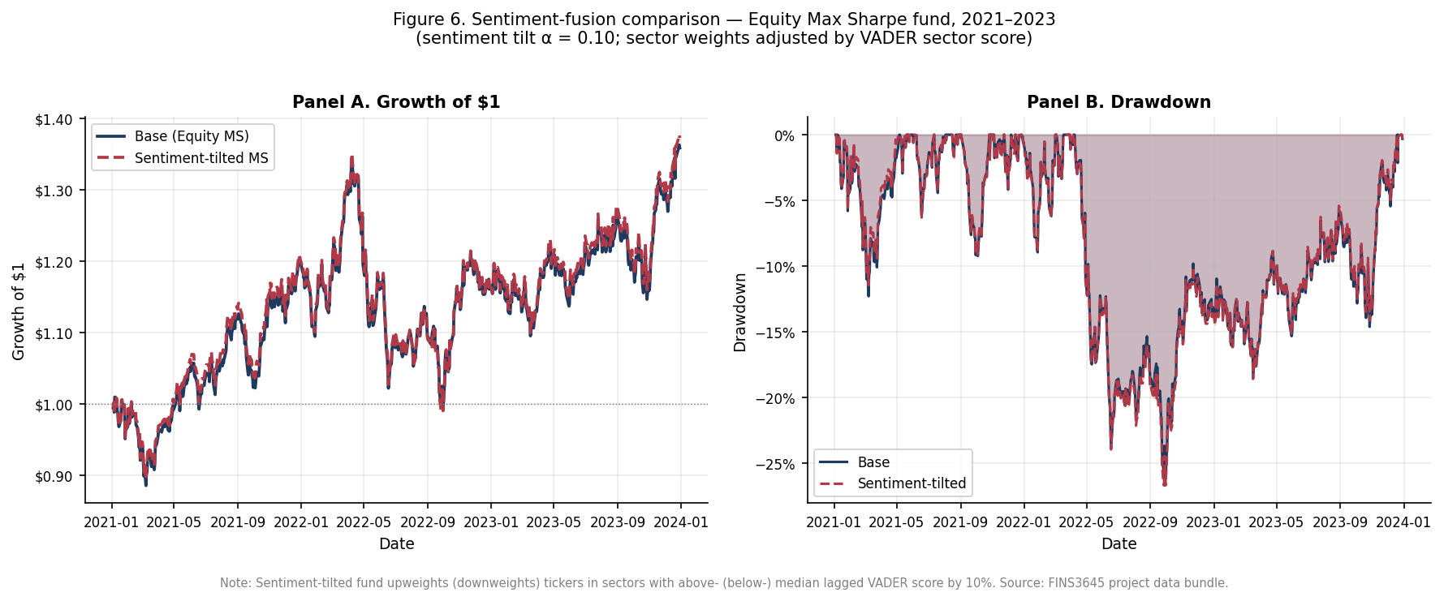
Figure 7. The equity Max Sharpe fund with and without the sentiment tilt. The tilted line ends marginally higher, the visible counterpart to the small Sharpe gain in Table 2.

5. The app and the investor journey

5.1 Structure
The app is organised as an investor journey across the following five pages being: Compare Funds, Fund Fact Sheet, My Allocation, Market Fear and Greed, and Sentiment Analytics. The order is designed to mirror how an investor actually decides, where the Compare Funds surveys all 15 funds side by side to shortlist candidates providing a simple interface to compare each funds’ returns, sharpe, drawdown and volatility side-by-side. The Fund Fact Sheet goes into detail on a specific fund's metrics, holdings, and history. The ‘My Allocation’ page allows the user to set weights across funds and sees the result of their own customized portfolio. The Market Fear and Greed page then shows the current market sentiment using the sentiment gauge, and Sentiment Analytics which shows the level of attention or popularity each of their sector has. Therefore, each page is designed to answer the question the previous page raises.

5.2 Design system
The app is not a default Streamlit script and was iterated so that each chart is rendered through a single shared Plotly theme, allowing the whole product to carry one consistent, interactive, and responsive visual language rather than the slightly different look each default chart would produce. The sentiment centrepiece is a custom fear and greed gauge built with a Plotly indicator, which communicates the market's standardised position using a simple visualization of a guage, in a way that a raw z-score graph can’t do so for non-financial background clients. The growth chart also uses deliberate encoding, with the colour marking the optimisation methods and line style marks the type of asset class, so that all 15 funds are uniquely and meaningfully identifiable and a reader can quickly pick out one method across all three families. There was also a bug which the encoding resolved, which was that the default ten-colour palette repeated itself once 15 funds were plotted and made funds visually indistinguishable from each other. Another design improvement was the hover feature, which initially showed a cluttered legend for all funds instead of the specific fund the mouse was hovering over, and therefore was corrected to only show the single fund that the user’s mouse was above.

5.3 Target user
The platform targets an investor who holds at least 10,000 dollars, has a moderate to high risk, and prefers quantitative, and prefers rules-based management rather than discretionary stock-picking, which was the same value proposition set out in Part A. AlphaBlend sits between passive index funds and opaque, expensive discretionary funds, offering systematically constructed funds with published fact sheets. The fund range fits our target user since it spans a stable HRP equity fund through to a high-return, high-drawdown crypto book, so that the investor can choose a point on the risk spectrum rather than accepting a single default fund. The crypto funds' drawdowns, as deep as -89%, does not guarantee a positive return.

5.4 Deployment constraint
The deployed app only reads precomputed CSV files from the results directory and does not re-run a backtest, re-optimise a portfolio, or invoke the sentiment model at runtime, and does not import either nltk nor finVADER. This is was a deliberate decision when designing the architecture, and not a limitation as a heavy computation runs once offline, and is frozen to disk, so that the app starts instantly, stays within the Streamlit Community Cloud free tier, and can never display numbers that disagree with the report. Recomputing live is a listed common mistake, and a grep check across the codebase confirms that the app avoids these live adjustments.

5.5 Links
https://z5589978projectb-6uf2rcqeabwwwat9k9j5kv.streamlit.app/

6. Critical reflection

6.1 What worked, what did not, and why
Across all funds and the results from their backtests and out-of-sample performance, a common theme emerged in the successful funds: stability and diversification, whilst concentrated bets on a single asset class was proven to lag in performance. HRP's drawdown control and the combined Max Sharpe fund's Sharpe of 0.983 are the clearest wins, both drawing their advantage from spreading risk rather than trying to chase more returns often resulting in higher volatility and risk, and the sentiment layer's 7.9-point coverage gain also adds a modest signal. The disappointments did not come as a surprise, where the crypto Max Sharpe fund's -89% drawdown is the predictable cost of feeding a noisy mean estimate into an unconstrained tangency portfolio on a highly volatile asset. The move from 204 to 473 idioms diluted the signal since the quality of candidates fell as the frequency threshold dropped. The fusion tilt then bought a small Sharpe gain at a small drawdown cost. In each case the mechanism, and not the outcome alone, is what the results indicates needed to be improved

6.2 What the index can and cannot tell you
The sentiment index can pool thousands of individually noisy headlines into a single series and, once standardised, flag days that are unusually fearful or greedy relative to history. It cannot judge whether a headline is true or important, because it scores the tone rather than fact or materiality. It cannot be trusted to get the sign right on every headline, for example, the "profit warning" case, mis-scored at +0.13 before the idiom fix, which shows how a noisy proxy fails on individual items. The sentiment index also cannot stand alone as a buy or sell rule, which is exactly why the fund tilt uses it lightly and why the signal is aggregated to sector level, where idiosyncratic noise is cancelled out. The index is therefore a context indicator, and not a trading trigger.

6.3 Three recommendations
The first recommendation is to match the optimisation method to the client. A drawdown-averse investor should default to HRP or Risk Parity, which posted among the shallowest drawdowns in every family of funds (behind Minimum Variance), accepting lower return for stability. An investor chasing return and able to bear volatility should be able to hold the combined Max Sharpe fund, with its 26.6% return and Sharpe of 0.983, accepting deeper drawdowns for that return. The platform should present method as a risk choice, but not a technical detail.
The second recommendation is to use sentiment as a modest tilt, and not as a primary signal. The fusion result improved Sharpe by only 0.018 while deepening the drawdown, and expanding the idiom set diluted rather than strengthened the signal. Both points to the same conclusion that the sentiment should adjust weights gently around a sound base allocation rather than drive them.
The third recommendation is to address the backtest's remaining unrealistic assumption before any live deployment such as zero transaction costs. A live product should add a turnover-based cost model; the project brief itself treats a transaction-cost model as an innovation. Costs would bite hardest on the methods with the most re-balancing, Maximum Sharpe above all, whose aggressive monthly reallocation is visible in Figure 3. Therefore, the reported edge of the MS fund would shrink once trading costs are accounted for, whilst low-turnover Equal Weight and HRP would be affected the least.

References
Hutto, C. J. and Gilbert, E. (2014). VADER: A Parsimonious Rule-based Model for Sentiment Analysis of Social Media Text. Proceedings of the Eighth International AAAI Conference on Weblogs and Social Media (ICWSM).
Korab, P. (2023). finVADER: financial sentiment analysis with VADER, SentiBigNomics and the Henry lexicon (Python package).
Lopez de Prado, M. (2016). Building Diversified Portfolios that Outperform Out-of-Sample. The Journal of Portfolio Management, 42(4), 59-69.
Loughran, T. and McDonald, B. (2011). When Is a Liability Not a Liability? Textual Analysis, Dictionaries, and 10-Ks. Journal of Finance, 66(1), 35-65.

Appendix

A. HRP synthetic validation
On a four-asset test with two low-variance assets, two high-variance assets, and near-zero cross-correlation, HRP allocated 0.901 to the low-variance cluster and 0.099 to the high-variance cluster. The weights are non-negative and sum to one, and rank identically to Risk Parity while differing in magnitude (HRP near 90/10 against Risk Parity near 75/25). Source: ai/prompt_log_12_add_hrp.md.

B. Borderline idioms to spot-check
The following kept idioms sit closest to the retention floor (|mean valence| = 0.5) and should be reviewed before final submission: "restructuring plan" (-0.50), "share sale" (-0.50), "take private" (+0.70), and "turnaround plan" (+0.80). Source: results/lexicon/kept_idioms.csv.

C. Lexicon artifacts
The final extension comprises 123 words (results/lexicon/kept_lexicon.csv) and 204 idioms (results/lexicon/kept_idioms.csv). The archived 473-idiom experiment is retained in results/lexicon/kept_idioms_473_round2.csv.

D. Formal specification of the portfolio methods
Each fund maps the trailing 252-day window of daily returns to a set of weights by one of five rules. Equations (1) to (7) restate exactly what src/portfolio.py computes. All five methods are long-only and fully invested by construction or constraint, with w_i greater than or equal to 0 and the weights summing to 1.

Equal Weight
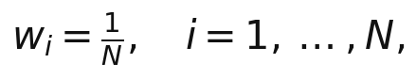 (1)
where N is the number of assets in the fund.

Minimum Variance
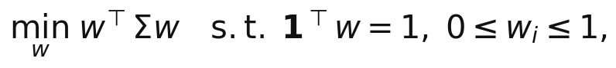 (2)
where Σ is the sample covariance matrix of daily returns over the estimation window.

Maximum Sharpe (tangency portfolio)
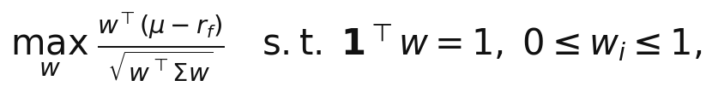 (3)
where μ is the sample mean daily return vector and r_f is the mean daily risk-free rate over the same estimation window (the real Fama and French rate, not zero).

Risk Parity
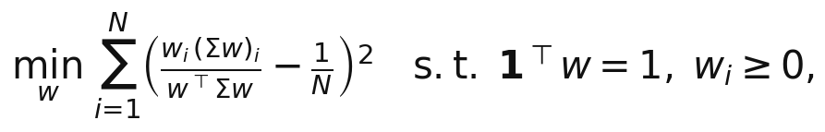 (4)
where w_i(Σw)_i / (w′Σw) is asset i's fractional contribution to total portfolio risk, equalised across all assets at the optimum.

Hierarchical Risk Parity (López de Prado, 2016)
HRP allocates risk in three steps: tree clustering on a correlation distance, quasi-diagonalisation, and recursive bisection.
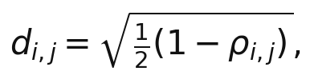 (5)
where ρ_{i,j} is the sample correlation between assets i and j, used to build the distance matrix for tree clustering.
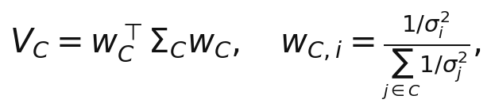 (6)
where V_C is a cluster's variance under inverse-variance weighting and σ_i² is asset i's variance, used to compare two candidate sub-clusters at each split.
(7)
where L and R are the two sub-clusters at a split and α allocates more of the parent's weight to the lower-variance side, recursively down to single assets.

E. Sentiment scoring
Headlines are scored with FinVADER-Extended: VADER's rule-based scorer with the SentiBigNomics and Henry finance lexicons and the mined extension layered on. Equation (8) is the compound score VADER computes for each headline; equation (9) aggregates it into the lagged sector index the fund tilt uses.

Compound score (FinVADER-Extended)
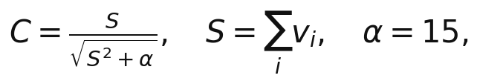 (8)
where C, in the range -1 to +1, is the compound sentiment score of a headline; S is the sum of the rule-adjusted valence scores v_i of its tokens, with the FinVADER-Extended lexicon supplying v_i (including the 123 mined finance words and 204 idioms); and α = 15 is VADER's normalisation constant, which maps S onto the [-1, +1] range.

Sector sentiment index
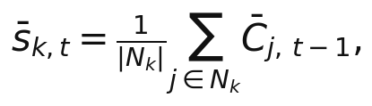 (9)
where N_k is the set of tickers in sector k, the summed term is the mean compound score of ticker j's headlines on day t-1, and the left-hand side is the sector-k sentiment used by the day-t fund tilt. The one-trading-day lag (t-1) ensures no look-ahead enters the weights; missing days are carried forward and any leading gap is set to 0 (neutral).

