FINS5545 FinTech Project 2026 — Part B
Quantvestment
A Multi-Asset Investment Fund with News Sentiment Analytics

1. Fund Design & Backtesting

Asset Universe and Optimization Methods
Quantvestment designed 15 systematic investment portfolios combining three asset universes and five optimization methods. The three universes comprise Equity (50 U.S. stocks across 10 sectors), Crypto (10 major crypto assets), and Combined (both universes aligned to the equity trading calendar). The five optimization methods are Equal-Weight, Minimum-Variance, Maximum-Sharpe (Tangency), Risk Parity, and Mean-CVaR, each representing a distinct risk-return philosophy: Equal-Weight is a non-parametric baseline independent of input estimates; Minimum-Variance and Maximum-Sharpe sit at opposite ends of the classic mean-variance trade-off; Risk Parity balances risk contributions across assets rather than dollar allocations; and Mean-CVaR explicitly targets tail risk. This 5-method × 3-universe grid provides a broad basis for comparing optimization philosophies across equities, crypto, and their combination.
The first four strategies were built under consistent constraints — long-only, fully invested (weights summing to 100%), with no leverage or short-selling across all 15 funds — and solved using scipy's SLSQP solver, with an automatic safeguard that falls back to equal-weight (with a logged warning) if the solver fails to converge in a given period. Mean-CVaR follows a different philosophy: rather than minimizing variance, which penalizes upside and downside movements equally, it minimizes Conditional Value at Risk — the expected loss within the worst 5% of outcomes (β = 0.95) — via a linear-programming formulation (Rockafellar & Uryasev, 2000) that works directly on daily return observations rather than a covariance matrix, the tail-aware objective specified in the project guidelines.

Backtest Design, Assumptions, and Validation
The historical backtesting framework adopts an expanding-window scheme: at the beginning of each month, the model is re-estimated using all accumulated historical data available up to that point in time. Portfolio rebalancing is executed on the first business day of each calendar month, beginning on 1 January 2021 as the starting point of the out-of-sample (OOS) testing period. For the Equity and Combined universes, this results in 36 monthly rebalancing events over 753 OOS days; for the Crypto universe, which operates seven days a week and follows a different calendar, there are 36 rebalancing events over 1,095 days, corresponding exactly to 36 full calendar months from 2021 to 2023.
The expanding-window approach was selected over a rolling-window approach because each re-estimation incorporates all historical information available up to that point, rather than relying only on a fixed window of the most recent N days — generally producing more stable estimates of means and covariances as the amount of available data increases, compared with a rolling window that deliberately discards older observations even when they may still contain useful information.
Several key assumptions were established transparently in accordance with the project guidelines. The risk-free rate was assumed to be zero (rf = 0) for all Sharpe ratio calculations — a substantial simplification, given that the actual U.S. 3-month T-Bill rate during the sample period rose from near 0% in 2021 to above 5% by the end of 2023, averaging approximately 2.4% per annum (FRED, series TB3MS; the T-Bill-as-proxy convention follows Fama & French, 1993). Annualization uses a factor of 252 trading days for Equity and Combined portfolios and 365 days for Crypto, reflecting their respective trading calendars and maintaining consistency across all modules. Transaction costs are assumed to be zero basis points (0 bps) as an initial simplification, with the limitations of this assumption evaluated in the recommendations section.

Finally, backtest integrity was strengthened through explicit, empirical testing for the absence of look-ahead bias, rather than relying solely on a narrative claim: the backtest was executed twice on exactly the same dataset, except that observations after a specified date were deliberately randomized, so that portfolio weights determined before that date should remain identical across both runs if the framework is free from information leakage. This procedure was applied to both the portfolio backtesting engine and the sentiment-fusion engine, and also confirmed that sentiment signals released on the same trading day as a rebalancing date do not influence that day's portfolio decision — verifying that a minimum one-trading-day lag is consistently enforced throughout the system.

2. OOS Results & Fact Sheet

Performance Summary Across 15 Funds
The performance_metrics.csv table 1 (see Appendix) summarizes the out-of-sample (OOS) performance of all 15 portfolios. In the Equity universe, the Sharpe ratio ranking from highest to lowest is Equal-Weight (0.78), followed by Risk Parity (0.68), Maximum-Sharpe (0.57), Minimum-Variance (0.55) — with the latter two performing very similarly — and Mean-CVaR (0.23). In the Crypto universe, the ranking is Risk Parity (0.45), Equal-Weight (0.43), Minimum-Variance (0.39), Mean-CVaR (0.26), and Maximum-Sharpe (0.07), with Maximum-Sharpe consistently being the weakest performer in this universe. In the Combined universe, Risk Parity delivers the strongest performance (0.74), followed by Equal-Weight (0.71), Minimum-Variance (0.55), Mean-CVaR (0.26), and Maximum-Sharpe (0.24).
The dominance of Equal-Weight and Risk Parity across all three universes — consistently outperforming Minimum-Variance, Maximum-Sharpe, and Mean-CVaR (Table 1, Appendix) — is consistent with DeMiguel, Garlappi, and Uppal (2009), who demonstrated that the naive 1/N portfolio is difficult to outperform out-of-sample using more sophisticated strategies, as estimation errors in expected returns and covariance matrices can often eliminate the theoretical advantages of more complex methods. As a robustness check, the performance of the Equal-Weight portfolio in each universe was independently verified by recalculating the results directly from the raw price data, without passing through the main portfolio code pipeline (sanity_check_crypto.py); the independently calculated results matched the system outputs to three decimal places.
A consistent and economically meaningful pattern emerges for Maximum-Sharpe (Tangency): this method systematically delivers the weakest performance in the Crypto (0.07) and Combined (0.24) universes, substantially underperforming the other four methods. This pattern is consistent with the classical literature on the fragility of mean-variance optimization. Maximum-Sharpe relies directly on estimated mean returns as an input, whereas historical mean returns are known to be considerably noisier estimators than covariance estimates, which are used by the other four methods. Consequently, even small estimation errors can produce highly concentrated and fragile allocations when evaluated out-of-sample.
The Mean-CVaR portfolio provides a more nuanced empirical finding than may initially appear. In the Equity universe, Mean-CVaR records the lowest Sharpe ratio (0.23). However, in the Crypto and Combined universes, Mean-CVaR (0.26 in both) slightly outperforms Maximum-Sharpe (0.07 and 0.24, respectively), suggesting that its focus on tail risk provides relatively greater resilience than Maximum-Sharpe in these two universes. In terms of maximum drawdown, Mean-CVaR (-18.6% in both Equity and Combined) remains slightly deeper than Minimum-Variance (-18.3% in both), indicating that CVaR estimation during the early stages of the expanding window, when historical data are still limited, may be less stable than the statistically more established variance-based approach.

Exhibits: Growth, Drawdown, Allocation, and Sharpe Ranking
The Growth of $1 chart in Figure 1 illustrates the distinct characteristics of each asset universe. In Equity, Equal-Weight remains the strategy with the highest cumulative growth, consistent with its superior Sharpe ratio, while Minimum-Variance and Maximum-Sharpe finish at similar terminal wealth despite markedly different volatility paths (23.7% for Maximum-Sharpe versus only 12.8% for Minimum-Variance). In Crypto, Maximum-Sharpe falls substantially behind the other four methods throughout the period, reflecting its considerably lower Sharpe ratio — a pattern echoed in Combined, where Maximum-Sharpe again remains the weakest performer while Risk Parity and Equal-Weight lead.
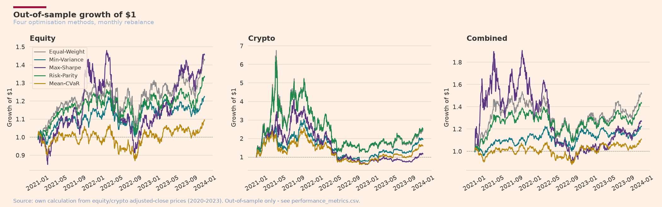
Figure 1. Out-of-sample growth of $1 — Equity, Crypto, and Combined.
The drawdown results in Figure 2 further confirm the relative fragility of Maximum-Sharpe: its maximum drawdown reaches -38.3% in Equity and -52.7% in Combined, substantially deeper than the other methods' -18% to -29% range within the same universes — consistent with its tendency to produce concentrated allocations in a small number of highest-estimated-return assets, leaving the portfolio particularly vulnerable to sharp reversals when those estimates prove inaccurate.
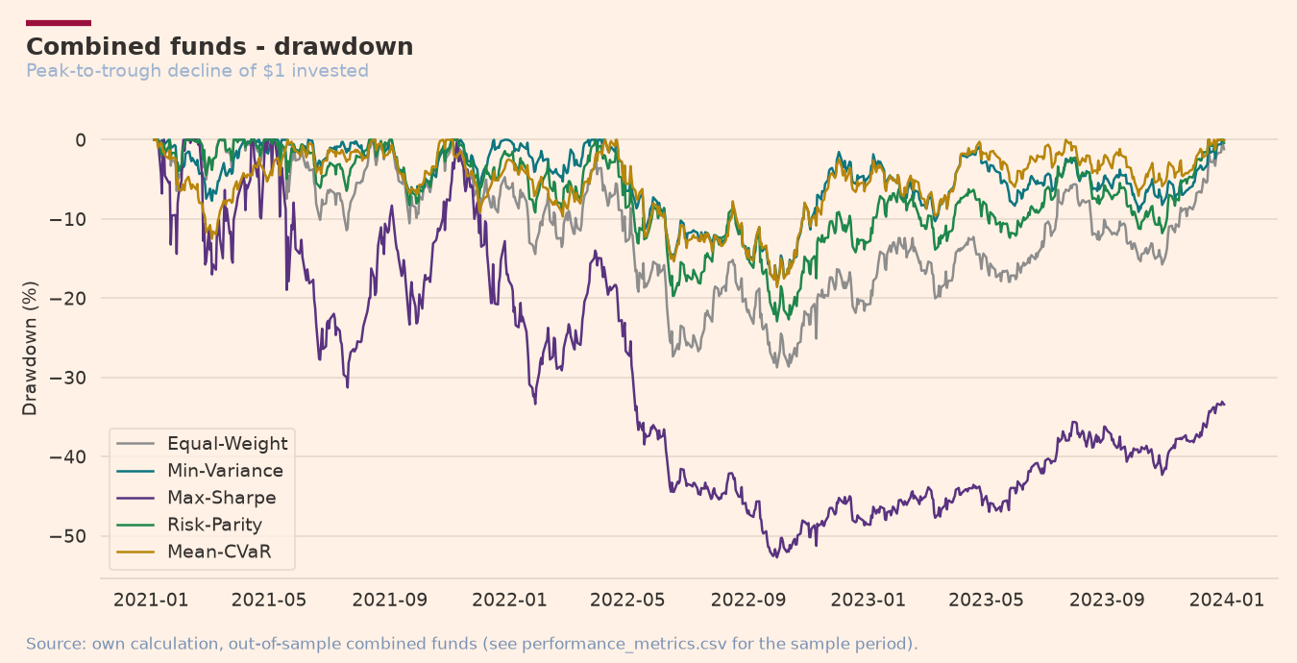
Figure 2. Drawdown, universes Combined, five methods.
The Combined Minimum-Variance weight allocation in Figure 3 provides clear economic insight: because minimum-variance optimisation mathematically seeks the lowest possible aggregate volatility, the allocation naturally tilts toward defensive, low-risk sectors — particularly Healthcare and Consumer, together accounting for over 75% of the allocation throughout the period — while systematically avoiding highly volatile crypto assets, regardless of their potential returns.
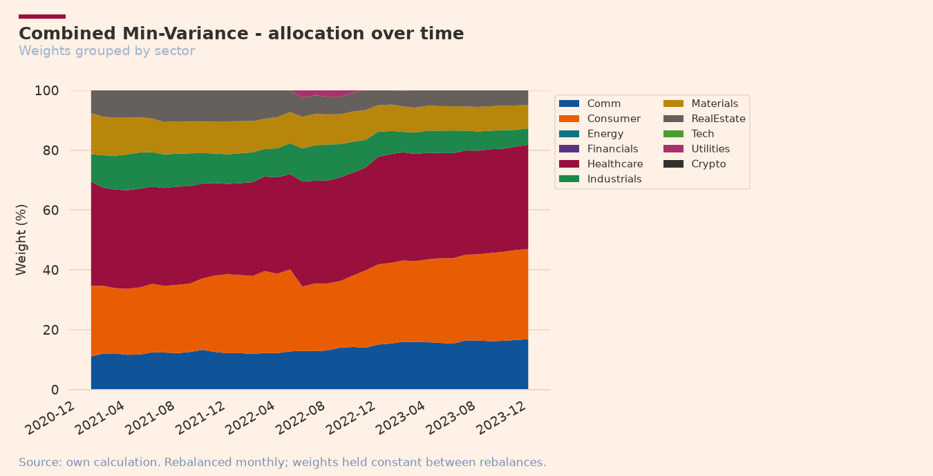
Figure 3. Weight allocation over time, Combined Minimum-Variance fund
The Sharpe ratio bar chart in Figure 4 summarizes the findings above: Equal-Weight and Risk Parity consistently rank among the top performers across all three universes, while Maximum-Sharpe stands out as the weakest performer in the Crypto and Combined universes. This pattern is associated with the fragility of mean-variance estimation discussed above, rather than indicating an implementation failure.
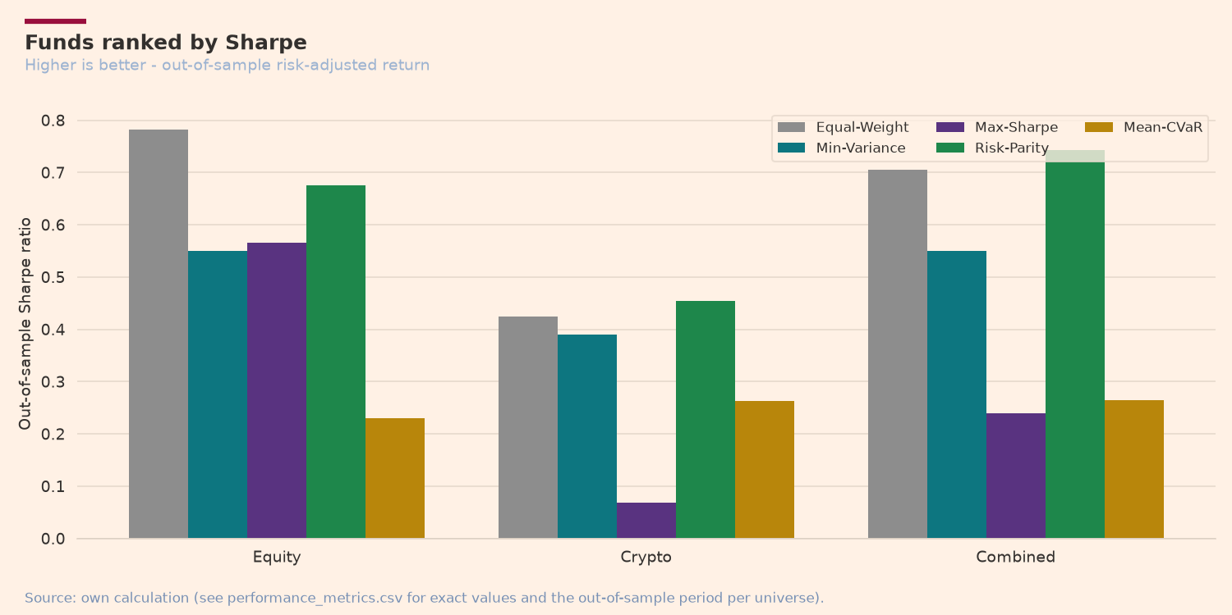
Figure 4. Sharpe ratio for 15 funds, grouped by universe and method

3. Sentiment Index

Sentiment Scoring Methodology
Sentiment scores for news headlines were assessed using the finVADER module, an extension of VADER enhanced with two published financial sentiment lexicons: SentiBignomics and Henry (2008). This choice follows Loughran & McDonald (2011), who argue that standard VADER often classifies financial headlines as neutral despite clear emotional content, since general-purpose lexicons do not recognize financial-specific vocabulary such as earnings terms, corporate forecasts, or corporate actions.
As a benchmark, standard VADER was also run in parallel, with its results reused in Section 4 for comparison. Following VADER's own processing principles, headline text was left unstripped of capitalization and punctuation, since VADER relies on these — along with negation and intensifier words — to measure sentiment intensity. All 146,830 headlines were processed in full; the pipeline was also optimized, since re-initializing the sentiment analyzer for every headline had made processing take roughly 15 minutes, whereas initializing it once outside the loop reduced this to 10–20 seconds (an ~80× speedup) while producing identical scores.

Sector Index Construction and Missing-Data Handling
The sector sentiment index is constructed through three stages:
- Each headline is assigned an individual sentiment score.
- All headline scores for the same ticker on the same day are averaged to produce a single daily score for each ticker.
- The daily ticker scores are then equal-weighted across all companies within the same sector, producing a single daily sentiment index value for each sector.
A key design decision concerns the treatment of days with no available news headlines. The chosen approach is to retain these observations as missing values (NaN) rather than replacing them with zero or carrying forward the previous day's value. The rationale is that the absence of news on a given day does not imply that market sentiment is neutral; therefore, imputing artificial value could introduce information bias. For visualization purposes, these data gaps are smoothed using a 21-day rolling average, but this treatment is applied only during chart generation and does not alter the stored raw data files.
In terms of data coverage, approximately 75% of ticker-day combinations (37,962 out of 50,300) contain at least one news headline. At the sector level, data coverage reaches 98% of sector-day observations, because a sector-level missing value occurs only when all five companies within that sector have no news on the same day.

Sector Patterns and the Fear-and-Greed Gauge
The cross-sector sentiment patterns shown in Figure 5 exhibit economically meaningful variation. Utilities records an extreme sentiment spike at the beginning of the sample period (early 2020), substantially exceeding its normal range throughout the remainder of the period. This coincides with the onset of the COVID-19 pandemic, when utilities were frequently portrayed in financial news as a defensive “safe haven” amid heightened market uncertainty. Energy shows a clear upward trend in sentiment throughout 2020–2022, consistent with the recovery in global energy commodity prices following the pandemic and the surge in energy prices associated with geopolitical conflicts during this period. Most other sectors fluctuate around positive sentiment levels throughout the sample, consistent with the finding that financial news coverage generally exhibits a positive sentiment bias.
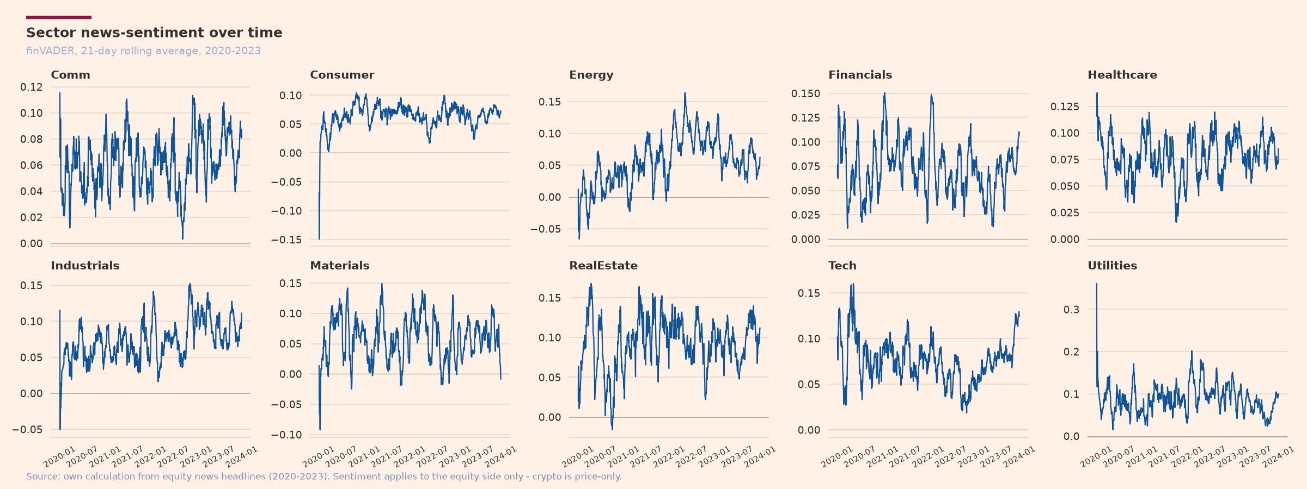
Figure 5. Sector news sentiment over time, 10 equity sectors.
As an enrichment feature, a market fear-and-greed gauge was constructed (Figure 6) by averaging sentiment across all equity issuers, smoothing the resulting series using a 21-day rolling average, and presenting it in two formats: a 0–100 scaled score and a standardized z-score version. The raw score tends to remain around or above the neutral point (50), confirming the presence of positive bias in financial news publications, whereas the standardized version reveals market fear spikes not apparent in the raw score — this indicator is also displayed in the Streamlit application under the Sentiment Analytics tab. Two extreme sentiment episodes emerge that are obscured by the raw score: a sharp decline in early 2020, coinciding with the COVID-19-induced market crash, and a sharp upward movement toward greed at the end of the sample period (late 2023), consistent with the stock market rally leading into year-end. Outside these two episodes, the index fluctuates within a relatively narrow range, indicating that most trading days do not exhibit statistically extreme sentiment signals — the gauge's primary value therefore lies in identifying these exceptional days, rather than capturing normal day-to-day fluctuations.
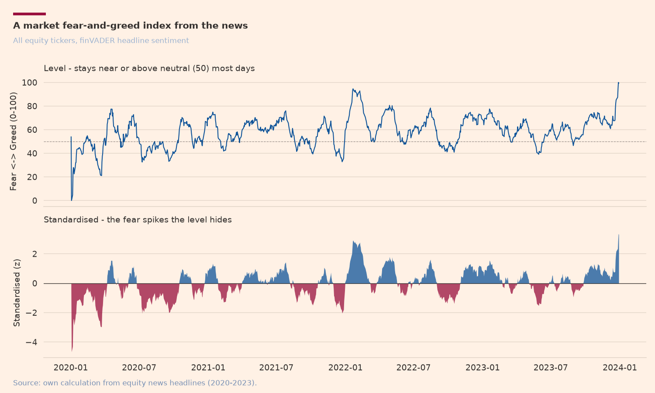
Figure 6. A market fear-and-greed index from the news.
The entire sentiment analysis is limited to equity stocks, as the available crypto dataset does not contain corresponding news data. Furthermore, news headlines represent a potentially noisy proxy for the sentiment expressed in the full articles, which is acknowledged as a limitation of the analysis.

4. Innovation

Innovation 1: Mean-CVaR (Structured Data)
As an innovation in the structured-data component, Mean-CVaR was selected from several robustness and tail-risk approaches considered, including covariance shrinkage, volatility targeting, blending equal-weight with minimum-variance, and transaction-cost modelling. Mean-CVaR was selected because it provides the most conceptually distinct framework from the four baseline methods already implemented. While the other four methods are based on covariance or variance, Mean-CVaR focuses the optimization directly on the tail-risk characteristics of the return distribution. The formulation was not implemented as a rough approximation; instead, it uses an exact linear programming formulation following Rockafellar and Uryasev (2000), solved using the HiGHS solver. The method was applied comprehensively across all three universes (Equity, Crypto, and Combined).
As discussed in Section 2, the out-of-sample results for Mean-CVaR show moderate performance — outperforming Maximum-Sharpe in the Crypto and Combined universes, but underperforming Minimum-Variance in Equity. These results are reported transparently to demonstrate that technically correct implementation of an advanced method does not necessarily produce the best performance in every universe. This finding is consistent with the principle that innovation should be credited for a valid and properly executed process, rather than solely for portfolio performance outcomes.

Innovation 2: Custom Lexicon (Unstructured Data)
In the unstructured-data component, innovation was developed by extending the VADER lexicon with a custom financial vocabulary, distinct from the third-party finVADER module used as an initial benchmark. An AI agent was used to evaluate financial terminology: 23 frequently occurring headline terms not already in the standard VADER lexicon were proposed as candidates (e.g., "beat," "upgrade," "downgrade," "buyback," "write-down"), each assessed through two independent stages — standard dictionary meaning and expected market reaction within its financial context — and selected only when both stages agreed on sentiment direction, with a maximum 1.5-point difference between the two scores.
The process also found that the VADER analyzer matches at the individual-word level and does not process multi-word phrases, so all two-word candidates were excluded to avoid misinterpretation. Of the 23 candidates, 19 were incorporated and four rejected: "restructuring" and "layoffs" (meanings too context-dependent, potentially signalling either operational efficiency or underlying corporate distress), "recall" (more commonly means "to remember" in general usage), and "raised/raises" (direction depends entirely on the following word, e.g. "raised guidance" versus "raised concerns") — full documentation of the curation process, including the complete two-stage rating table, is stored in ai/lexicon_extension_log.md.
To test the impact of the custom lexicon on sentiment scores (Figure 7), the three models — standard VADER, finVADER, and finVADER with the custom lexicon — were compared using the same market sentiment index. The results revealed an unexpected pattern that ran counter to the initial expectation that financial-specific vocabulary would progressively and consistently raise sentiment scores: standard VADER recorded the highest mean score (0.1131), followed by finVADER with the custom lexicon (0.0752), while standard finVADER recorded the lowest mean score (0.0713) — likely because the financial lexicons neutralize general-purpose vocabulary that standard VADER interprets as emotionally positive, simply because those terms are not recognized as financial-specific expressions in the first place.
More importantly, with respect to the custom lexicon's own contribution specifically, adding the 19 custom terms raised the mean score relative to standard finVADER (0.0752 versus 0.0713) — confirming that the newly added terms carry the expected net-positive directional effect, even though the magnitude of that effect was not large enough to change the model's overall ranking relative to standard VADER.
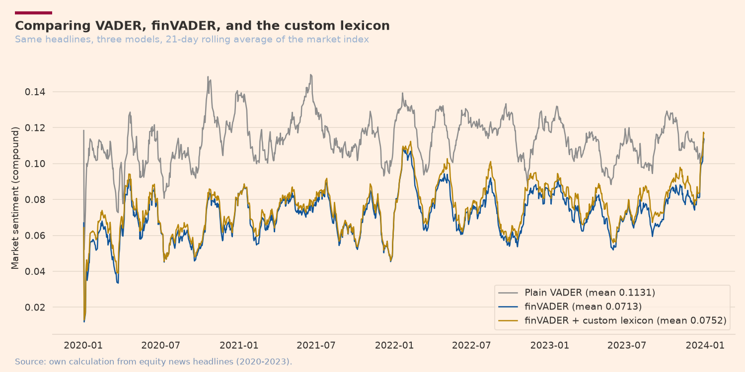
Figure 7. Comparing VADER, finVADER, and the custom lexicon.
This pattern differs from the initial expectation that incorporating financial-specific lexicons would progressively and consistently increase sentiment scores; a possible explanation is that the financial lexicons used by both finVADER and its custom extension neutralize some general-purpose vocabulary that standard VADER interprets as positively emotional, simply because those terms are not recognized as financial-specific expressions. More importantly, regarding the contribution of the custom lexicon itself, adding the 19 custom terms increased the mean score relative to standard finVADER (0.0752 vs. 0.0713), confirming that the newly added terms have the expected net-positive directional effect — although the magnitude is not large enough to change the relative ranking compared with standard VADER.

Innovation 3: Sentiment-Portfolio Fusion
The two innovations were subsequently integrated through a fusion mechanism to test whether sentiment signals could improve the performance of an equity portfolio. The selected base portfolio was Equity Minimum-Variance, as it is one of the portfolios with the lowest volatility in the Equity universe (Table 1), allowing the effect of the sentiment tilt on the portfolio's risk-return profile to be observed more clearly. The weight-adjustment (tilt) formula multiplies each base portfolio weight by a factor of (1 + λ × sentiment z-score), where the z-score is calculated on a rolling basis from sentiment scores subject to a minimum one-trading-day lag; after applying the adjustment, the allocations are clipped to maintain the long-only constraint and then renormalized so that the total portfolio weight equals 100%.
The economic rationale draws on Tetlock (2007) regarding the relationship between media coverage volume and stock price movements, and directly connects the findings from Part A to Part B: statistical analysis using the Mann–Whitney U test (p < 0.001) showed that days with extreme return outliers had approximately 1.7 times more headlines than normal days. This was developed into an intensity-confidence mechanism, whereby the sentiment adjustment is multiplied by a confidence factor — capped between 0.5× and 2× — based on an issuer's relative news volume compared with its historical level, so signals backed by higher news volume receive greater influence while single-headline signals are attenuated. To prevent overfitting, six configurations (Base, Naive Momentum, Naive Contrarian, Intensity Momentum, Intensity Contrarian, and Intensity Momentum with the custom lexicon) were compared using a disciplined discovery-holdout framework: evaluated on the 2021–2022 discovery period to lock in the selection, with the 2023 holdout period processed only once afterward.
Naive Momentum achieved the highest discovery-period Sharpe ratio (0.655, versus 0.579 for the base portfolio) and was selected as the primary model. During the holdout period, the base portfolio achieved a Sharpe ratio of 0.492, while the selected configuration achieved 0.617 — a substantial improvement without evidence of overfitting-related performance deterioration.
Interestingly, the intensity-confidence configuration — the main innovation in this component — was not selected as the winner in this particular run: Intensity Momentum's discovery Sharpe ratio (0.605) was slightly lower than Naive Momentum's (0.655), though both outperformed the base. This is consistent with the principle that innovation credit lies in the quality of a validly developed and tested process; the intensity-confidence mechanism remains an original contribution that demonstrated effectiveness, even though it was not the best-performing configuration here.
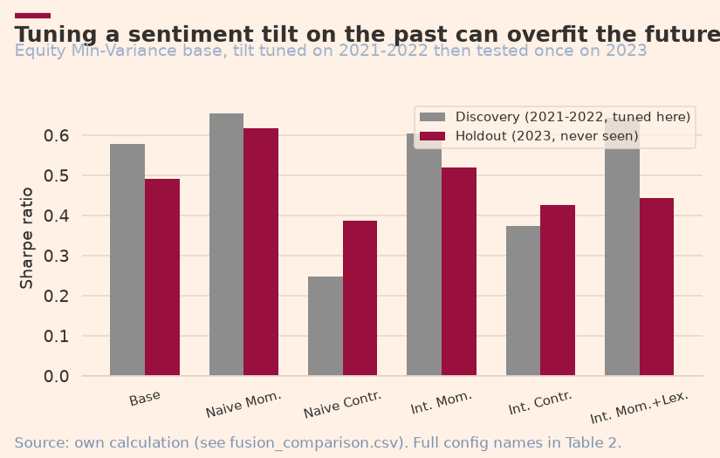
Figure 8. Tuning a sentiment tilt on the past can overfit the future.
A complete summary of all six configurations is provided in Table 2 (see Appendix) and Figure 8 above, while Figure 9 below directly addresses the question this fusion mechanism was built to answer — does news sentiment improve the equity fund? — by comparing the growth of $1 for the base portfolio against the selected tilt strategy during the holdout period.
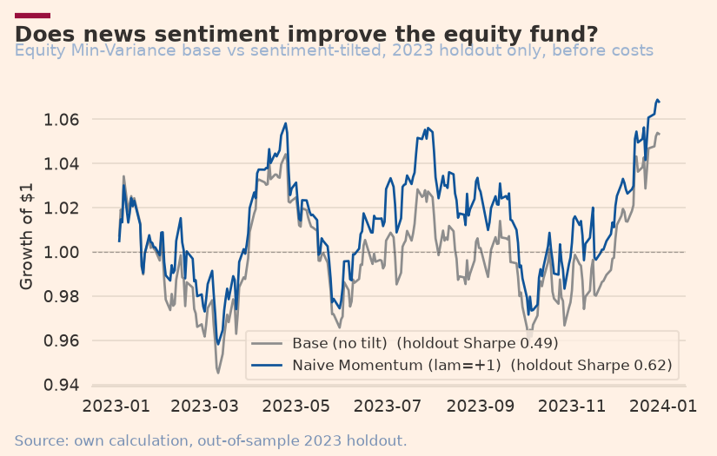
Figure 9. Does news sentiment improve the equity fund?

Presentation Innovation: Design System
Beyond the three main innovations, the project's visual design system also represents a distinct form of presentation innovation, rather than relying on default visual styling. Two color-palette variants were deliberately developed according to their respective media contexts: an editorial salmon-and-cream palette, inspired by the Financial Times, for the written report and optimized for readability in print and PDF documents; and a modern fintech navy-and-green palette for the Streamlit application, aligned with the visual conventions of digital investment products, where dark blue conveys trust and green represents growth. Both variants are built upon the same underlying structural design system — including typography, heading and subheading formats, and data-source placement — ensuring structural consistency while allowing the color scheme to adapt to the purpose of each medium. This approach ensures that every exhibit remains self-contained, with a clear title, labelled axes, and explicit data sources across both contexts.

5. App & Investor Journey

Application Features
The Quantvestment application is designed to facilitate the user's investment journey through four main tabs:
- Compare Funds: presents a performance table covering all 15 funds, formatted using percentages and ratios, together with a Sharpe ratio bar chart by asset universe and optimization method.
- Fund Fact Sheet: provides a portfolio selection menu, four key metric cards (annualized return, volatility, Sharpe ratio, and maximum drawdown), a Growth of $1 chart, a drawdown chart, and the allocation of the ten largest asset holdings.
- Sentiment Analytics: presents sentiment indices across 10 sectors, a fear-and-greed indicator, a comparison of three sentiment-lexicon models, and tables and charts showing the discovery-holdout evaluation results.
- Build Allocation: allows users to select multiple portfolios, adjust allocation proportions using sliders, specify an annual management fee, and view growth charts and net performance metrics after accounting for management fees.

Technical Architecture and Target Users
From a technical architecture perspective, the application reads precomputed CSV files from the results/ directory (generated by scripts/run_part_b.py) without recalculating the backtest or reprocessing sentiment data at runtime, to accommodate Streamlit Community Cloud's limitations. Visually, it implements a navy-and-green fintech design system (plotstyle.py) — a dedicated colour palette distinct from the report's salmon-and-cream variant (see Section 4) — via a customised Streamlit theme with a dark navy background and green accents, consistent with digital investment-product conventions, with caching used throughout to maintain interface responsiveness. Its target users are retail investors seeking systematic exposure to U.S. equities and cryptocurrencies, under a business model based on an annual management fee whose impact is simulated in the Build Allocation tab so users can observe its effect on net returns.
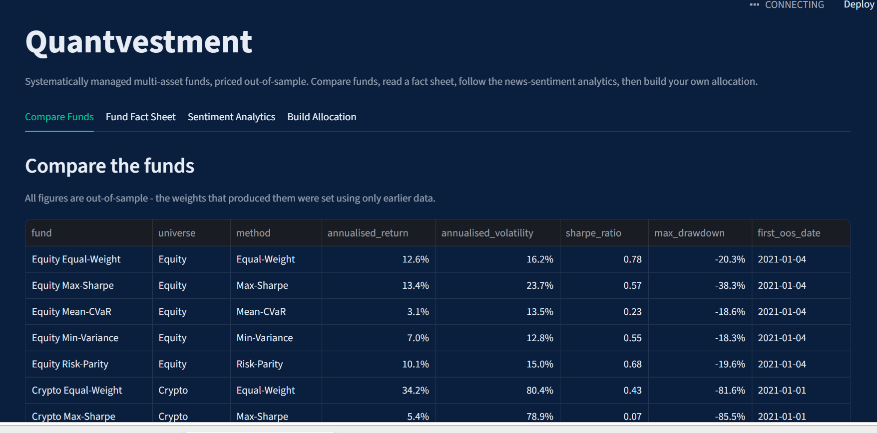
Figure 10. The Quantvestment application on Streamlit Community Cloud.

Deployment and Reproducibility
The application is deployed from a public GitHub repository (z5680410-unsw/z5680410_projectB) and operates directly on Streamlit Community Cloud. Accessibility testing was conducted through a web browser in incognito mode to verify that the application is publicly accessible. The development process also documented two aspects related to reproducibility:
- Correcting the .gitignore configuration, which had previously blocked four key CSV files (fund_returns.csv, fund_weights.csv, sector_sentiment_index.csv, and performance_metrics.csv) before the final commit.
- Automatically testing each application tab using the streamlit.testing.v1.AppTest framework to simulate user interactions before submission.

6. Critical Reflection & Recommendations

What Worked
Several aspects of the project's methodology demonstrate measurable reliability:
- The expanding-window backtesting design, combined with independent validation using the sanity_check_crypto.py script, successfully distinguished potential coding errors from genuine characteristics of cryptocurrency price movements over the tested sample period.
- Proactive testing identified and corrected two technical issues before the final stage: an inconsistency in the initial OOS date for the Combined portfolio and .gitignore rule that was blocking the main output files.
- When backtest results changed between two otherwise-identical pipeline runs, systematic debugging — comparing scipy/pandas versions and rerunning under each — confirmed the code itself was unchanged; the difference stemmed from the numerical solver's sensitivity to ill-conditioned financial covariance matrices, consistent with the brief's own "solver scaling" warning. Library versions are now pinned in requirements.txt for full reproducibility.

Limitations
On the other hand, several limitations should be transparently acknowledged:
- The impact of the sentiment adjustment on the equity portfolio is economically meaningful — the holdout Sharpe ratio increased from 0.492 for the base portfolio to 0.617 for the selected Naive Momentum strategy. This improvement should nevertheless be tested against actual transaction costs before being considered fully implementable, given that the tilt introduces additional turnover relative to the base portfolio.
- The custom lexicon performed slightly below standard finVADER during the discovery stage, largely due to its limited vocabulary size (19 custom terms compared with thousands of terms in finVADER).
- Maximum-Sharpe consistently emerged as the weakest method in the Crypto and Combined universes, consistent with the estimation fragility of mean-variance optimization discussed above. However, it has not yet been tested whether shrinkage techniques applied to expected-return estimates could improve its stability.
- The assumption of a zero risk-free rate and the absence of transaction costs limit the direct applicability of the results to real-world investment practice, although incorporating the actual risk-free rate (averaging approximately 2.4% p.a. over the sample period, based on FRED TB3MS) has been identified as a straightforward next step.

Recommendations
Based on the evaluation results, three recommendations are proposed for further development:
- Integrate transaction-cost modelling: incorporate explicit per-transaction costs to test whether the Sharpe ratio improvement from the sentiment signal (0.492 to 0.617 in the holdout period) continues to provide value after accounting for rebalancing costs, given that the tilt generates additional turnover relative to the base portfolio.
- Expand the custom lexicon curation: increase the coverage of the custom vocabulary and involve a larger panel of independent evaluators, while also introducing sector-specific lexicons to account for variations in terminology across industries.
- Stabilize Maximum-Sharpe estimation: apply shrinkage techniques to expected-return estimates, such as James-Stein or Black-Litterman, to reduce Maximum-Sharpe's sensitivity to estimation noise, which is currently the primary source of its fragility in the Crypto and Combined universes.

References
Board of Governors of the Federal Reserve System (US). 3-Month Treasury Bill Secondary Market Rate (TB3MS). Federal Reserve Bank of St. Louis, FRED.
DeMiguel, V., Garlappi, L., & Uppal, R. (2009). Optimal Versus Naive Diversification: How Inefficient is the 1/N Portfolio Strategy? Review of Financial Studies, 22(5), 1915–1953.
Fama, E. F., & French, K. R. (1993). Common Risk Factors in the Returns on Stocks and Bonds. Journal of Financial Economics, 33(1), 3–56.
Henry, E. (2008). Are Investors Influenced By How Earnings Press Releases Are Written? Journal of Business Communication, 45(4), 363–407.
Loughran, T., & McDonald, B. (2011). When Is a Liability Not a Liability? Textual Analysis, Dictionaries, and 10-Ks. The Journal of Finance, 66(1), 35–65.
Rockafellar, R. T., & Uryasev, S. (2000). Optimization of Conditional Value-at-Risk. Journal of Risk, 2, 21–42.
Tetlock, P. C. (2007). Giving Content to Investor Sentiment: The Role of Media in the Stock Market. The Journal of Finance, 62(3), 1139–1168.

Appendix — Exhibit

Table 1 — Performance Metrics (15 funds)
Funds | Return p.a. | Vol p.a. | Sharpe | Max DD | First OOS
Equity Equal-Weight | 12.6% | 16.2% | 0.78 | -20.3% | 2021-01-04
Equity Min-Variance | 7.0% | 12.8% | 0.55 | -18.3% | 2021-01-04
Equity Max-Sharpe | 13.4% | 23.7% | 0.57 | -38.3% | 2021-01-04
Equity Risk-Parity | 10.1% | 15.0% | 0.68 | -19.6% | 2021-01-04
Equity Mean-CVaR | 3.1% | 13.5% | 0.23 | -18.6% | 2021-01-04
Crypto Equal-Weight | 34.2% | 80.4% | 0.43 | -81.6% | 2021-01-01
Crypto Min-Variance | 25.1% | 64.3% | 0.39 | -75.6% | 2021-01-01
Crypto Max-Sharpe | 5.4% | 78.9% | 0.07 | -85.5% | 2021-01-01
Crypto Risk-Parity | 35.8% | 78.7% | 0.45 | -80.4% | 2021-01-01
Crypto Mean-CVaR | 17.0% | 64.7% | 0.26 | -76.6% | 2021-01-01
Combined Equal-Weight | 15.0% | 21.2% | 0.71 | -28.7% | 2021-01-04
Combined Min-Variance | 7.0% | 12.8% | 0.55 | -18.3% | 2021-01-04
Combined Max-Sharpe | 8.3% | 34.8% | 0.24 | -52.7% | 2021-01-04
Combined Risk-Parity | 12.8% | 17.2% | 0.74 | -22.9% | 2021-01-04
Combined Mean-CVaR | 3.6% | 13.5% | 0.26 | -18.6% | 2021-01-04
Table 1. Out-of-sample performance of all 15 funds, 2021–2023. rf=0. Source: performance_metrics.csv

Table 2 — Discovery vs holdout comparison (6 configurations)
Configuration | Sharpe Discovery | Sharpe Holdout
Base (no tilt) | +0.579 | +0.492
Naive Momentum (λ=+1) — selected | +0.655 | +0.617
Naive Contrarian (λ=-1) | +0.248 | +0.386
Intensity Momentum (λ=+1) | +0.605 | +0.520
Intensity Contrarian (λ=-1) | +0.375 | +0.427
Intensity Momentum + Lexicon Custom | +0.644 | +0.443
Table 2. Discovery = 2021–2022 (used for selection). Holdout = 2023 (opened once). Source: fusion_comparison.csv

