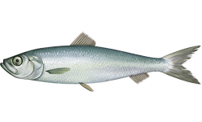
4VWX Atlantic Herring
Background on Fishery
The Atlantic herring (Clupea harengus) is a small pelagic species found on both sides of the North Atlantic Ocean. Herring are a schooling fish that form predictable aggregations for feeding, overwintering, and spawning. The 4VWX herring stock is divided in multiple management components for the purposes of assessment and management (Figure 1):
- Southwest Nova Scotia/Bay of Fundy (SWNS/BoF) spawning component
- Offshore Scotian Shelf banks spawning component
- Coastal Nova Scotia spawning component
- Southwest New Brunswick (SWNB) migrant juveniles (weir fishery)
Each spawning component has several spawning areas and there is mixing of herring among the 4VWX spawning components and the 5YZ (US stock) during annual feeding and overwintering migrations. The assumption that herring exhibit spawning-area fidelity has been the basis of the definition of herring stocks and fisheries management. Spawning areas in close proximity with similar spawning times share a common larval distribution area and are considered part of the same component. Although the SWNB “migrant juvenile” weir fishery occurs within the spatial bounds of the SWNS/BoF management area (Figure 1), it is considered a separate component and includes a mixture of herring from 4VWX and 5YZ spawning areas.

MANAGEMENT COMPONENT | DETAILS
Southwest Nova Scotia/Bay of Fundy (SWNS/BoF) | - Largest component by landings (~75% for the 4VWX stock)  - Primary spawning areas: German Bank, Scots Bay (Figure 1)  - Multiple gear types, including purse seine with accounts for ~90% of total catches for this component; other gear include gillnet and weir  - Purse seiners target spawning aggregations and summer feeding aggregations and historically (pre-2002) overwintering aggregations  - Managed by TAC; excludes catches from weirs in SWNB
Offshore Scotian Shelf banks | - Data limited and stock structure is unknown  - Managed with arbitrary allocation of 12,000 t  - Offshore fishing activity is limited due to distance  - Spawning times and locations are unknown
Coastal Nova Scotia | - Acoustic surveys in 2 of 3 spawning areas (South Shore and Eastern Shore); no surveys/fishery in Cape Breton  - Managed with separate TACs for each area based survey index
Southwest New Brunswick (SWNB) migrant juveniles (weir fishery) | - Effort controlled (allowing a maximum number of weirs)  - Landings are primarily juveniles and are counted toward US herring stock  - Unknown proportion of juveniles are from 4VWX stock, supported by tagging studies
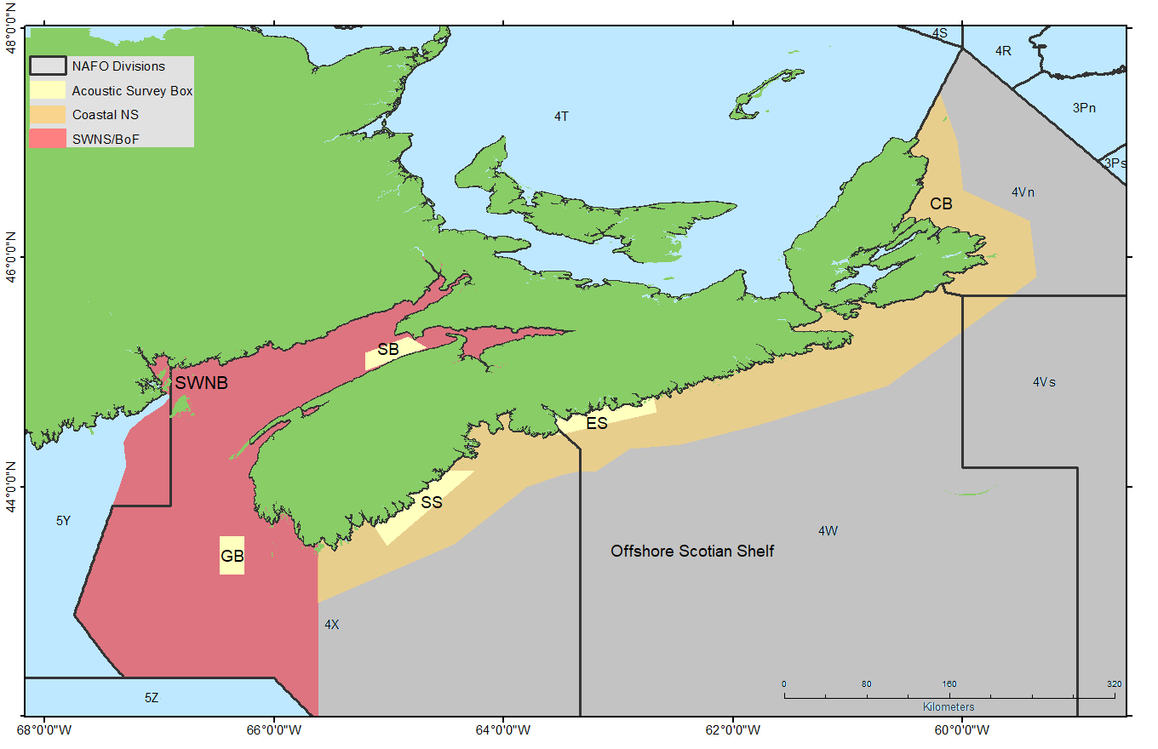
Figure 1. Map of herring fishing areas in NAFO area 4VWX.

Summary of management components for the 4VWX herring stock:
- SWNS/BoF management component: red shading, SB = Scots Bay spawning area; GB = German Bank spawning area
- Offshore Scotian Shelf management component: grey shading, area in 4VWX east of SWNS/BoF and greater than ~25 miles from shore.
- Coastal NS management component: gold shading, area in 4VWX east of SWNS/BoF and within ~25 miles from shore. SS = South Shore; ES = Eastern Shore; CB = Cape Breton.
- SWNB Weir management component = Southwest New Brunswick (herring landed by weir in coastal SWNB). Note: herring landed in SWNB by other gear types are included in the SWNS/BoF management component
Exercise 1. Spatial Definition of Stock/Data-limited Methods

Exercise Goals:
1. Identify ways to approach defining an LRP for the 4VWX herring stock in a data-limited context, where the “stock” area contains multiple management components.
2. What approaches would you use to define an LRP when data are limited for the entire stock area?
3. What are the implications for defining an LRP based only on data for a portion of the stock area?

The 4VWX herring stock consists of 4 different management components (Figure 1). The 4VWX herring stock will be prescribed to the Fish Stocks Provisions as a single stock and a single LRP will be required for the stock, despite being managed by separate components. Data availability differs among the four components. The majority of the 4VWX herring fishery is within the SWNS/BoF management area (~75% by landings) so the focus of data collection and reporting has been focused primarily on this component.

Consider the following three approaches of defining an LRP for the 4VWX herring stock:
- An LRP based on the entire 4VWX stock (all 4 management components).
- An LRP based on the SWNS/BoF management component only (SWNS/BoF is the primary focus for monitoring).
- An alternative to the two points above.

Available data/indicators:
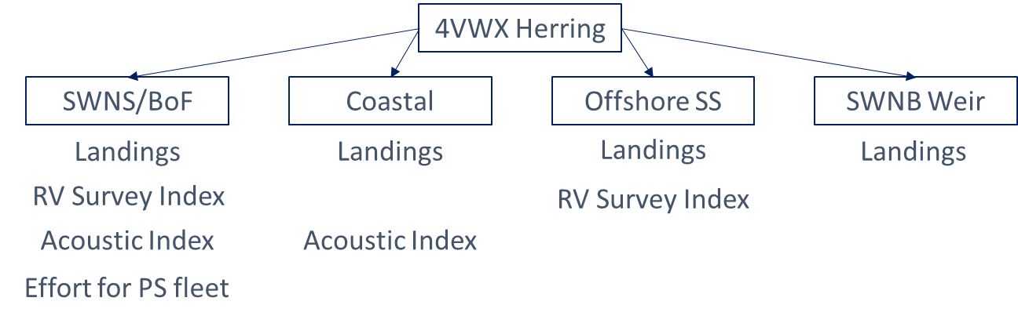
Candidate Criteria for Best-Practice Indicators and LRPs:
- Consistent with an objective to avoid serious harm to the stock
- Based on the best available information
- Operationally useful
- Reliably estimated

Exercise Questions:
- Evaluate the props and cons of various data sources (catch, CPUE, RV survey index, acoustic survey index) that differ in terms of spatial and temporal coverage and which could serve as indicators of stock status.
- Select a spatial area (all 4VWX or the SWNS/BoF management component or an alternative spatial area) and define an LRP for that area using an indicator generated from the dataset provided. If more than one LRP is considered, evaluate the pros and cons of each.
- As a group, prepare a 1-2 slide (< 5 minute) presentation to explain
- The spatial area chosen
- The preferred stock status indicator
- The preferred LRP
- The rationale for each (including how choices reflect candidate best practice criteria)
- Include a time series plot of the indicator and add a line to represent the LRP.

Datasets: landing.csv; ex1.csv
R script : ex1.R

4VWX stock area:
- Total annual catch by management area (1963-2020) in tonnes [landings.csv; col “Landings”, units (t)]
- A total biomass index from the groundfish RV survey (1981-2020). The survey is conducted in the summer using a bottom trawl. The biomass is calculated based on swept area biomass by strata (See Rmarkdown File with Figures). The index is a relative index of biomass and includes survey strata for which there are sufficient data. [ex1.csv; col “RV_4VWX”, units (t)]
SWNS/BoF management component:
- Total annual catch from the purse seine fleet (1968-2020) in t. The purse seine fleet comprises generally > 90% of the SWNB/BoF landings. [ex1.csv; col “PS_Catch”, units (t)]
- Total annual effort (1977-2020) for the purse seine fleet. [ex1.csv; col “Effort”, units (number of trips)]
- An index of spawning stock biomass (SSB) (1999-2020) from acoustic surveys conducted during the spawning season on the German Bank (Aug-Oct) and Scots Bay (June-Sept) spawning grounds (see Figure 1). These surveys involve ~ 6-18 transects through a standardized survey area on each spawning ground and surveys are conducted ~6-8 times per season (14 days apart to avoid double counting). The biomass for a fixed area is estimated for each survey based on the estimated density of herring. The biomass is summed over each survey and the annual index is the total sum of the German Bank and Scots Bay surveys over the spawning period. The index is a relative index of SSB. [ex1.csv; col “AI_SWNSBoF”, units (t)]
- The total biomass index from the groundfish RV survey (1981-2020). The survey is conducted in the summer using a bottom trawl. The biomass is calculated based on swept area biomass by strata (See Rmarkdown File with Figures). The index is a relative index of biomass and includes survey strata for which there are sufficient data in SWNS/BoF. [ex1.csv; col “RV_ SWNSBoF”, units (t)]
Costal NS management component
- An index of spawning stock biomass (SSB) (1998-2020) from acoustic surveys conducted during the spawning season for Eastern Shore and South Shore (no data for Cape Breton). These surveys do not follow a standard study design and only target schools of herring. Multiple surveys are conducted throughout the spawning period (at least 14 days apart to avoid double counting) and the annual index is the total sum of the surveys over the spawning period. The index is a relative index of SSB. [ex1.csv; cols “AI_SS” and “AI_ES”, units (t)]

