15.Table工具
generator.cs
#region Client / Design
#region Server
tableGenerate.cs
void table_generate(){}
FormMain.cs
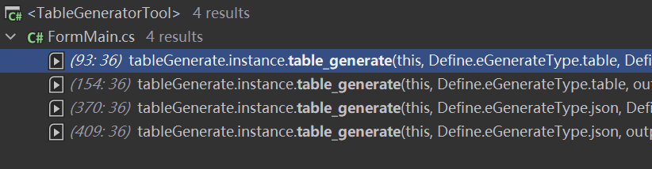
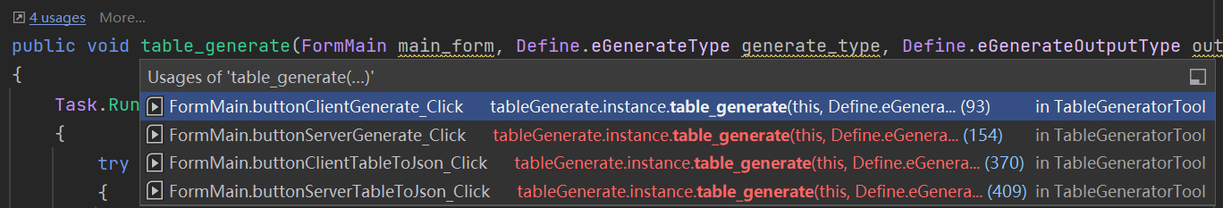
public void Generate(Define.eGenerateType generate_type, Define.eGenerateOutputType out_type, bool resource_data, string table_path, string output_path, List<stringlist_file, bool is_csv_only, bool is_client_loader_header_file, Dictionary<string, List<byte[]>> dic_table_bytes_data)
{
#region file check
List<stringlist_table_file = null;
if (null == list_file || 0 == list_file.Count)
{
Regex regex = new Regex("~"); // Regex regex = new Regex(string.Format("[{0}]", Regex.Escape(new string(Path.GetInvalidFileNameChars()))));
list_table_file = Directory.GetFiles(table_path, "*.xlsx", SearchOption.TopDirectoryOnly).Where(e => !regex.IsMatch(e)).ToList();
}
}

//源头表路径 E:\zhanwang\ServerPro\Tools\CommonTable
//生成的代码文件的路径
E:\zhanwang\ServerPro\Tools\TableGeneratorTool\bin\temp
CCP:E:\zhanwang\ServerPro\Tools\TableGeneratorTool\bin\temp\temp_2024-02-28_11-11-42\output\server\header
CS:E:\zhanwang\ServerPro\Tools\TableGeneratorTool\bin\temp\temp_2024-02-28_11-11-42\output\server_cs\header
//编译后的数据资源路径
.table(S)
.h（C|S）
.cpp(C)
.cs(S)
.csv(C)
.json(S)

服务器：
tableGenerate.instance.table_generate(this, Define.eGenerateType.table, output_type, false, temp_path_base, path_target_output, ConfigManager.instance.config.server_output_local_server_path, ConfigManager.instance.config.server_table_path, _form_select_table.excelTableList);
.table(S)
.h（C|S）
.cs(S)
tableGenerate.instance.table_generate(this, Define.eGenerateType.json, output_type, false, temp_path_base, path_target_output, ConfigManager.instance.config.server_output_local_server_path, ConfigManager.instance.config.server_table_path, _form_select_table.excelTableList);
.json(S)

//读取解析具体表
private void create_server_table_file(

