18.MMOARPG服务器架构之Server_Framework

1.Client
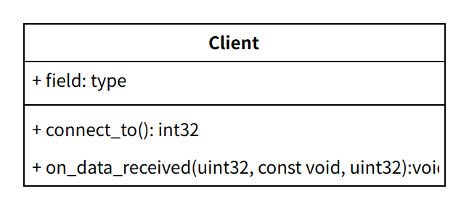
1.1 connect_to() 可以通过net::tcp_client绑定
int32 client::connect_to()
{
boost::bind(&client::on_conn_status, this, _1, _2, _3),
boost::bind(&client::on_conn_closed, this, _1),
boost::bind(&client::on_data_received, this, _1, _2, _3)
}
1.2 客户端收到消息
void client::on_data_received(uint32 connindex, const void *data_ptr, uint32 data_len)
{
g_worker->recv_data(m_peer, data_ptr, data_len);
}
1.3 获取worker
#define g_worker worker_proxy::get_instance().get_worker()
worker_proxy// 对worker 代理，提供获取worker的接口

2.work
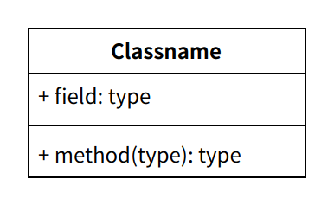
2.1 void worker::recv_data(peer* p_peer, const void* data_ptr, uint32 data_len)
{
if (can_proc_msg())
{
msg_dispatch::get_instance().dispatch_to_processer(p_peer, data_ptr, data_len);
}
}

3.msg_dispatch
void register_unit_handler(int32 msg_id, void (UNIT::* msg_handle)(peer*, google::protobuf::Message*))
{
boost::shared_ptr<msg_dispatch_info<UNIT>> info(new msg_dispatch_info<UNIT>);
msg_dispatch::get_instance().register_handler(msg_id, info);
}
void msg_dispatch::dispatch_to_processer(peer* p_peer, const void* data_ptr, uint32 data_len)
{
proto_unpacker unpacker(data_ptr, data_len);

int32 msg_id = unpacker.get_protocol();
int32 unit_type = unpacker.get_unit_type();

if (unit_type == WORKER_BASE_MSG_TYPE)
{
g_worker->proc_msg(p_peer, unpacker);
}
else
{
e_server_type server_type = (e_server_type)unpacker.get_server_type();
int32 unit_index = unpacker.get_unit_id();

if (p_peer->m_type == e_peer_type::peer_type_single)
{
unit_index = p_peer->m_unit_index;
}

base_session_mgr* unit_mgr = g_worker->get_session_unit_mgr((e_unit_type)unit_type);
if (unit_mgr == nullptr)
{
return;
}
unit_mgr->proc_msg(unit_index, p_peer, unpacker);
}
}

4.session_unit
void session_unit::proc_msg(peer* p_peer, proto_unpacker& unpacker)
{
if (!can_proc_msg())
{
return;
}
e_server_type server_type = (e_server_type)unpacker.get_server_type();
if (g_worker->is_this_server(server_type))
{
msg_dispatch::get_instance().dispatch_to_handler(this, p_peer, unpacker);
}
else
{
trans_msg(unpacker);
}
}

5.msg_dispatch_info

6.unit_pool
class key_unit_pool : virtual public unit_pool<U, NUM>
{
public:
// 注册逻辑单元索引
virtual bool regist_unit_key(int32 unit_idx)
{
U* unit = unit_pool<U, NUM>::get_unit_by_idx(unit_idx);
m_unit_map[key] = unit;
return true;
}
boost::unordered_map<K, U*> m_unit_map;
}

