Instructions:

In order to run the program, first you need to import the database attached to the zip file. First, open Mysql Workbench, then create a new connection with IP address 127.0.0.1, user name root, and password uvhrkh12.

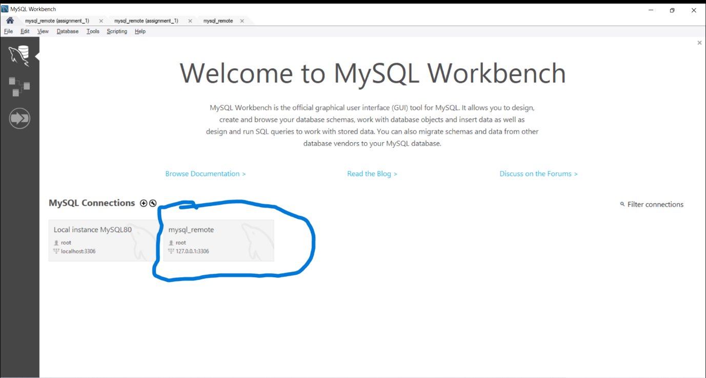

After you have created the connection, open the connection and choose Server at the top of the window.

Then choose the import option and import the Dump folder attached with the zip folder.

After that you need to download mysql-connector-j-8.0.31.jar

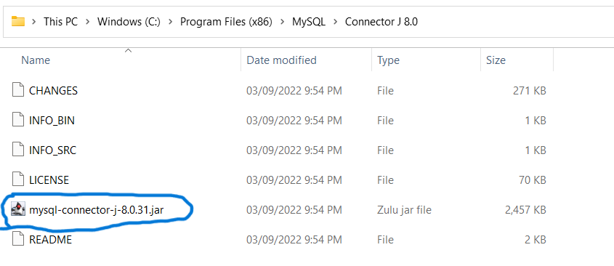

After you have downloaded it, open the assignment in VS Code, click on referenced libraries, and add the mysql-connector file.

