**ERD**

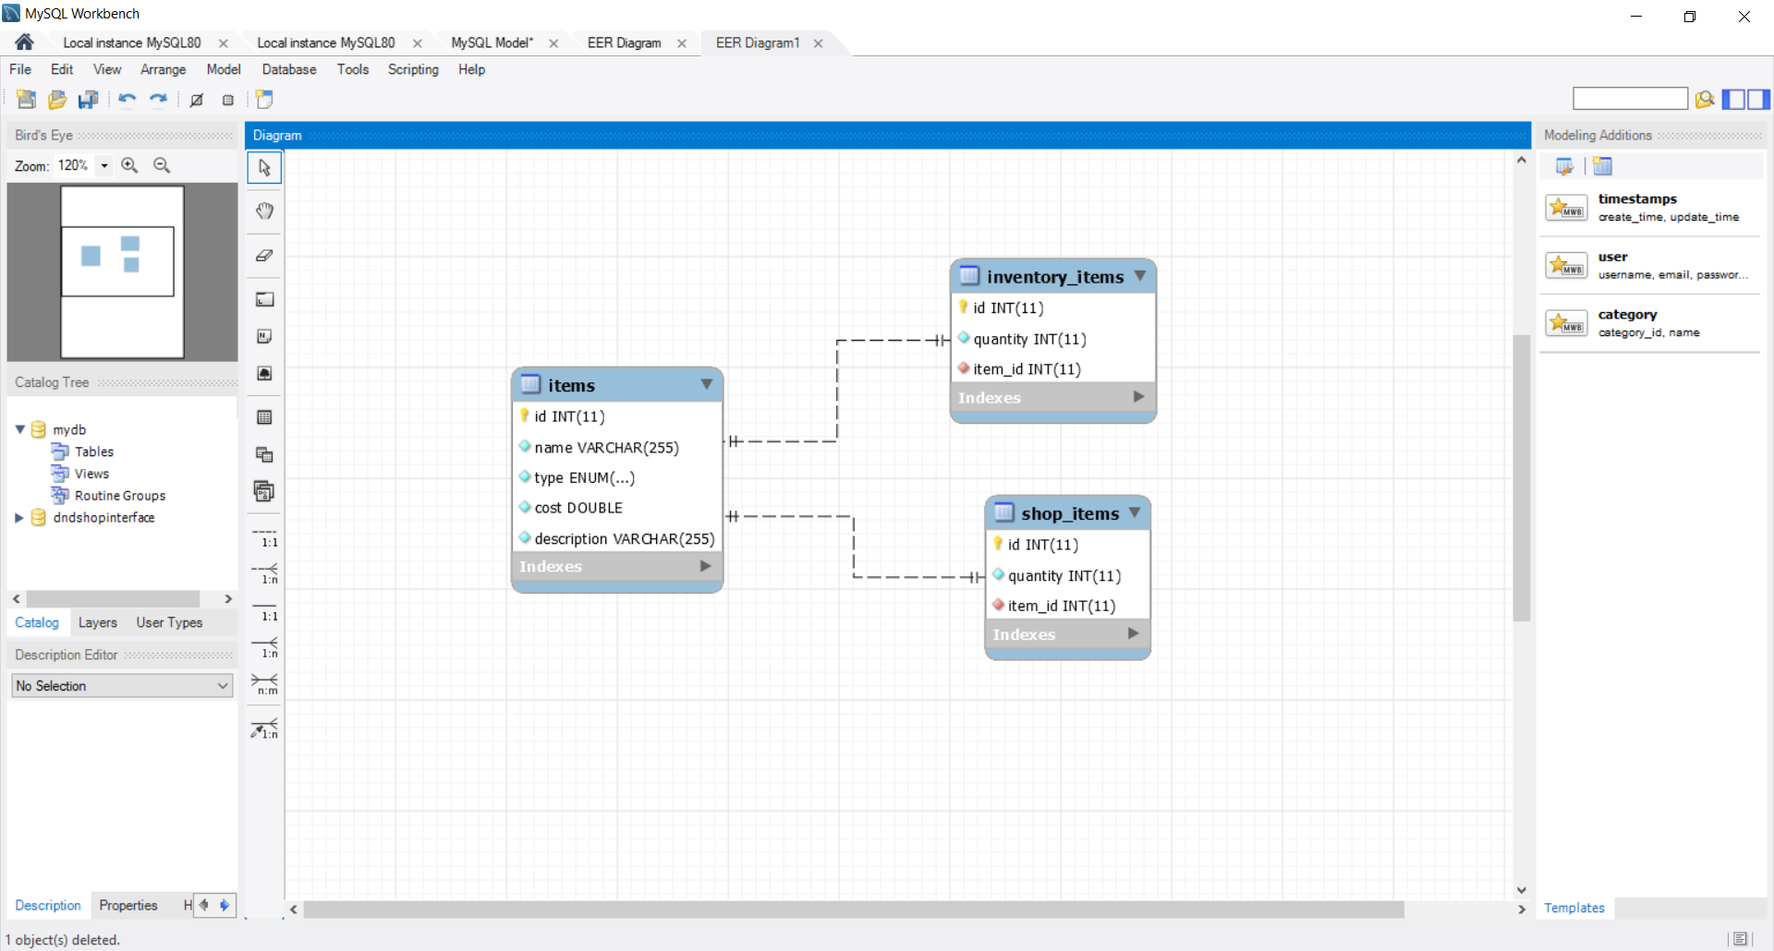

**USER STORIES**

* As an adventurer, I would like to be able to view all weapons, gear and tools known to myself in the world, so that I can see what items I can obtain.
* As an adventurer, I would like to be able to be able to add to the known items if I come across an undiscovered item, so that I can keep track of any new items encountered.
* As an adventurer, I would like to be able to update current known items if my knowledge about those items are altered, so my item knowledge is as up to date as possible.
* As an adventurer, I would like to view my inventory items, so that I can keep track of items that I have picked up along my travels.
* As an adventurer, I would like to be able to delete items from my inventory, so that I can drop items that I no longer require.
* As an adventurer, I would like to be able to add items to my inventory, so that I can update my inventory with new items that I have acquired.
* As an adventurer, I would like access to a shop and would like to view both my inventory and the shop inventory in order to see what I have and what I can purchase from the shop.
* As an adventurer, I would like to be able to purchase items, such that the purchased item would be transferred from the shop inventory to my inventory.