2.)

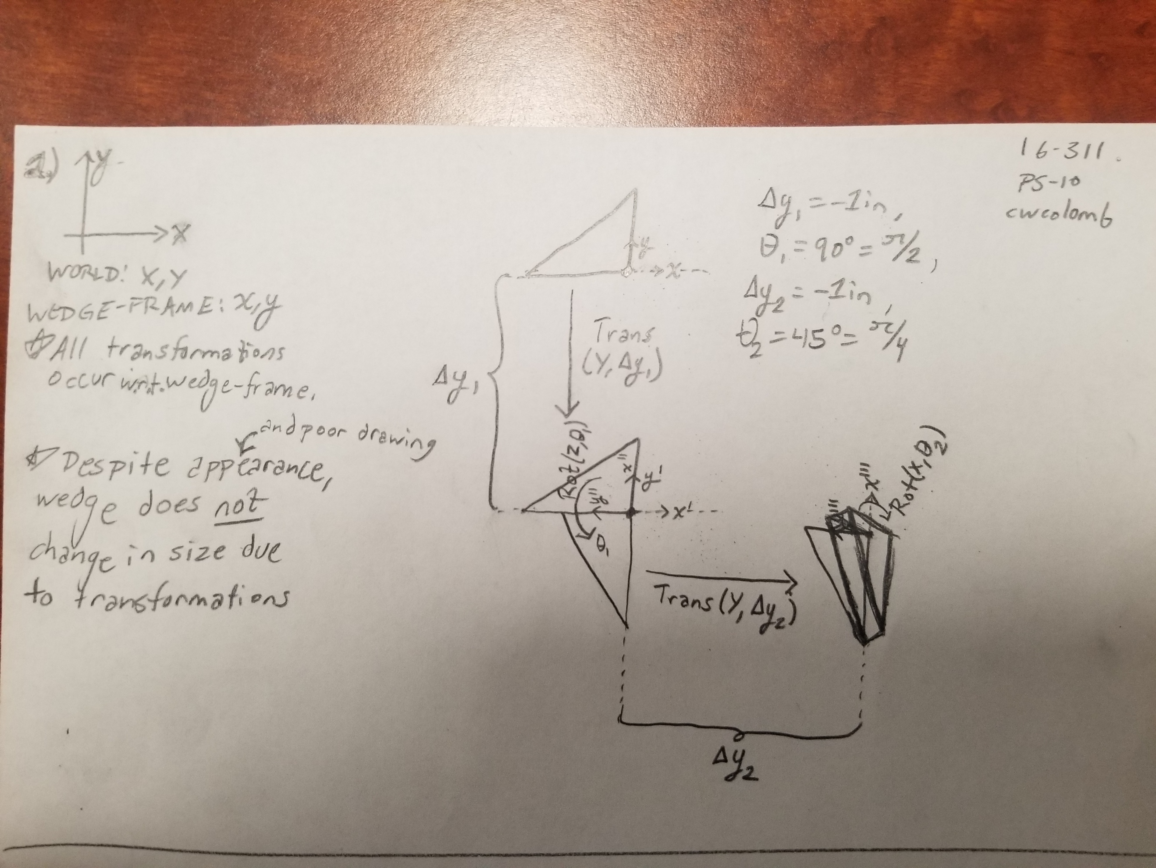

3.)

a.)

b.)

**Translation of ­-2 units in the x direction, 5 units in the y, and 9 in the z**.

**Rotation about X-axis of** , because

4.)