2.)

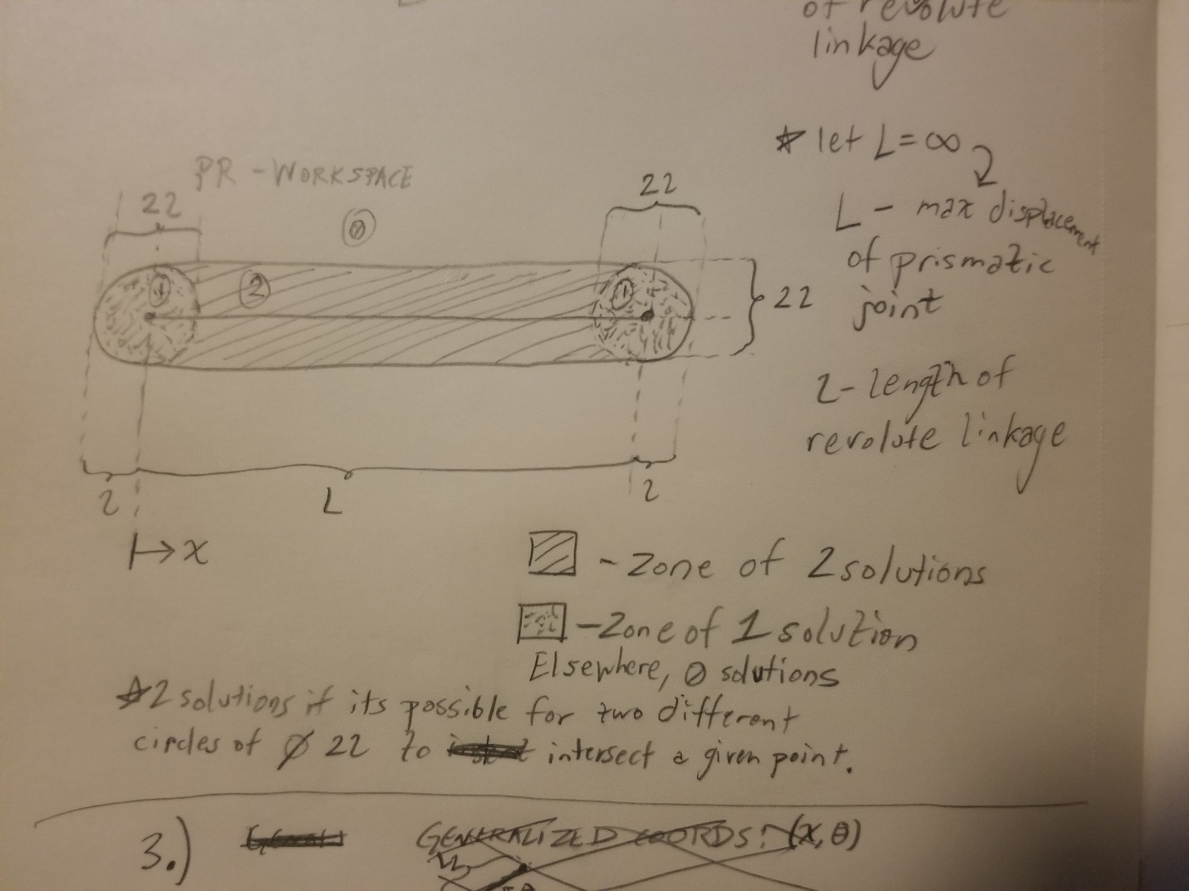

3.)

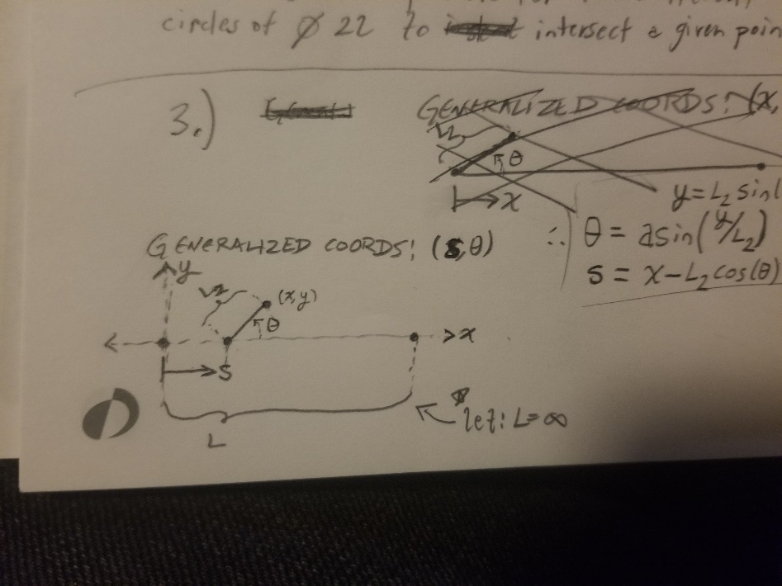

$$y=L_{2}\sin\left(θ\right) \\ ∴θ=\sin^{-1}\left(\frac{y}{L_{2}}\right) \\ ∵\sin^{-1}{:} \left[-1,1\right]↦\left[-\frac{π}{2},\frac{π}{2}\right]$$

$$θ=\left\{\begin{matrix}\sin^{-1}\left(\frac{y}{L_{2}}\right), & x>0 \\ \sin^{-1}\left(-\frac{y}{L_{2}}\right)+π, & x<0\end{matrix}\right.$$

$$x=s+L_{2}\cos\left(θ\right) \\ ∴s=x-L_{2}\cos\left(θ\right)$$

* Gives one $θ$ for all (x,y), thus producing a singular solution set since *s* is determined by $θ$.

4.)

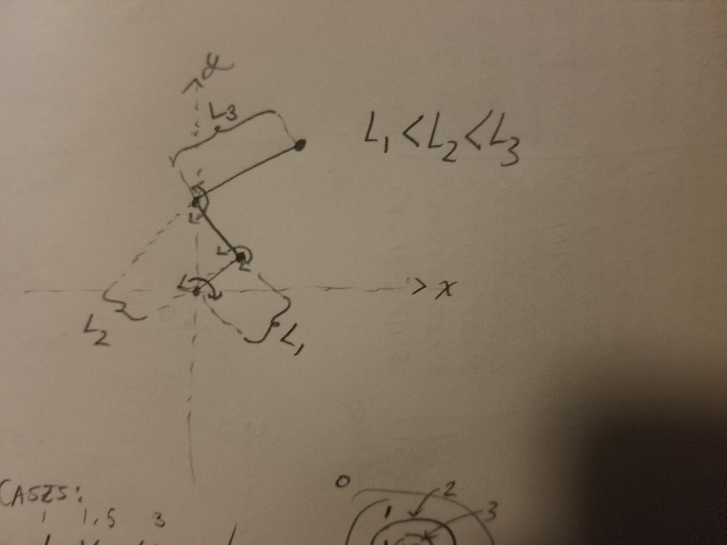

Since the sum of linkage lengths is unknown, two workspace classifications emerge: one where $L_{1}+L_{2}<L_{3}$ and one where $L_{1}+L_{2}>L_{3}$:

**Case 1: $L_{1}+L_{2}<L_{3}$**

Example configuration: $\left[L_{1}, L_{2}, L_{3}\right]=\left[1, 1.5, 2\right]L_{1}$

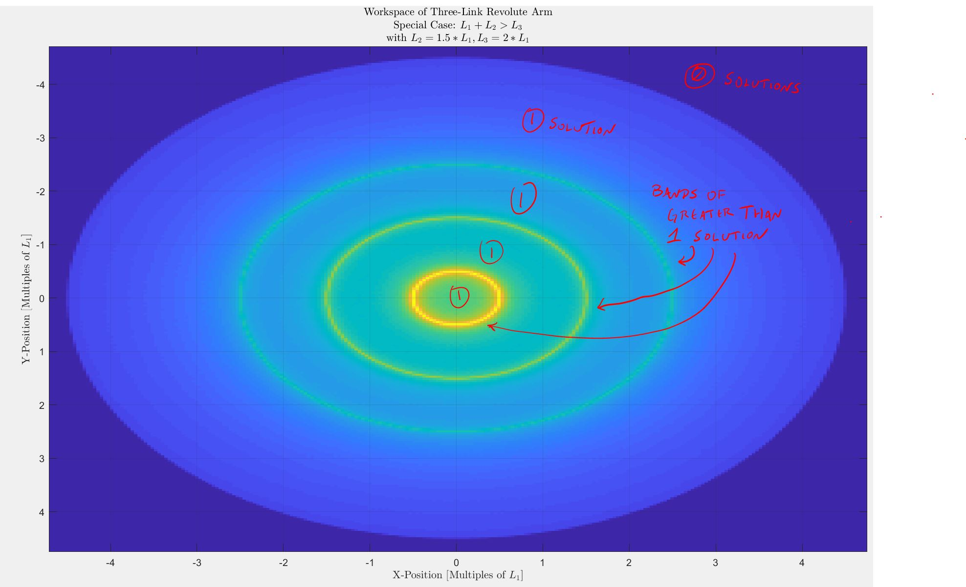

**Case 2: $L_{1}+L_{2}>L_{3}$**

Example configuration: $\left[L_{1}, L_{2}, L_{3}\right]=\left[1, 1.5, 3\right]L_{1}$

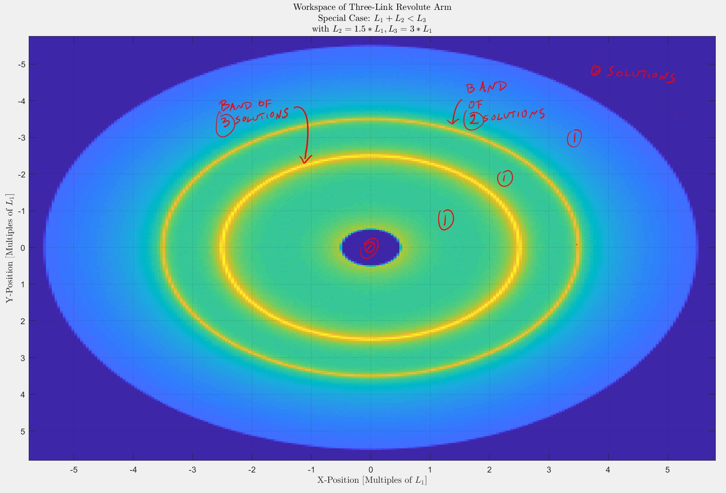

Region of no solutions is created in center because linkage 3 is not long enough to reach in any configuration.

NOTE:

*\* Ignore gradients around bands. This is an artifact of the quick and dirty way theta space was converted to XY-space. The gradients are not indicative of regions of greater than 1 solution, only the bands themselves are.*