2.)

For any $X,Y,Z,Ω$ position of the RR-Arm’s end effector in the world-frame, there are infinitely many robot configurations (so long as all actuators values are considered to be able to take up any value within a bounded subset of the real numbers) since the system is overactuated and, for any position, the arm could scrunch back slightly while maintaining the same Z-height and the mobile robot platform could then translate in the x-y plane while maintaining the same orientation, $Ω$, to make up the difference.

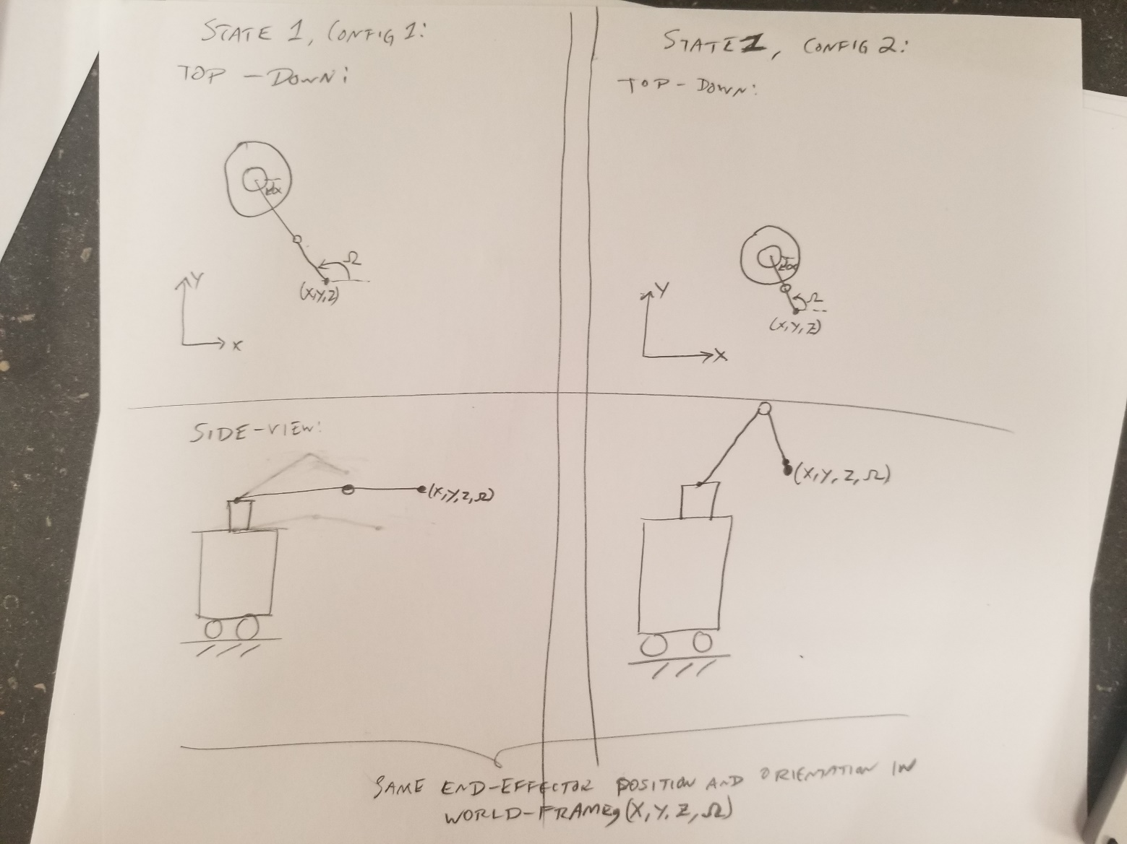

3.)

3.1)

$$\vec{q}=\left[\begin{aligned}x_{i} \\ y_{i} \\ θ_{i} \\ ϕ_{i}\end{aligned}\right]$$

3.2)

* Lectures used *w* to represent constraints and *q* to represent states, where: ${\vec{w}}_{j}\left(\vec{q}\right)*\vec{q}=\vec{0}$

From knife-edge constraint on rear wheels:

$$\frac{δy_{i}}{δx_{i}}=\tan\left(θ_{i}\right) \\ →{\dot{y}}_{i}\cos\left(θ_{i}\right)={\dot{x}}_{i}\sin\left(θ_{i}\right)$$

$$→-{\dot{x}}_{i}\sin\left(θ_{i}\right)+{\dot{y}}_{i}\cos\left(θ_{i}\right)=0$$

$$∴{\vec{w}}_{1}=\left[\begin{matrix}-\sin\left(θ_{i}\right) & \cos\left(θ_{i}\right) & 0 & 0\end{matrix}\right]$$

From turning constraint imposed by front wheel:

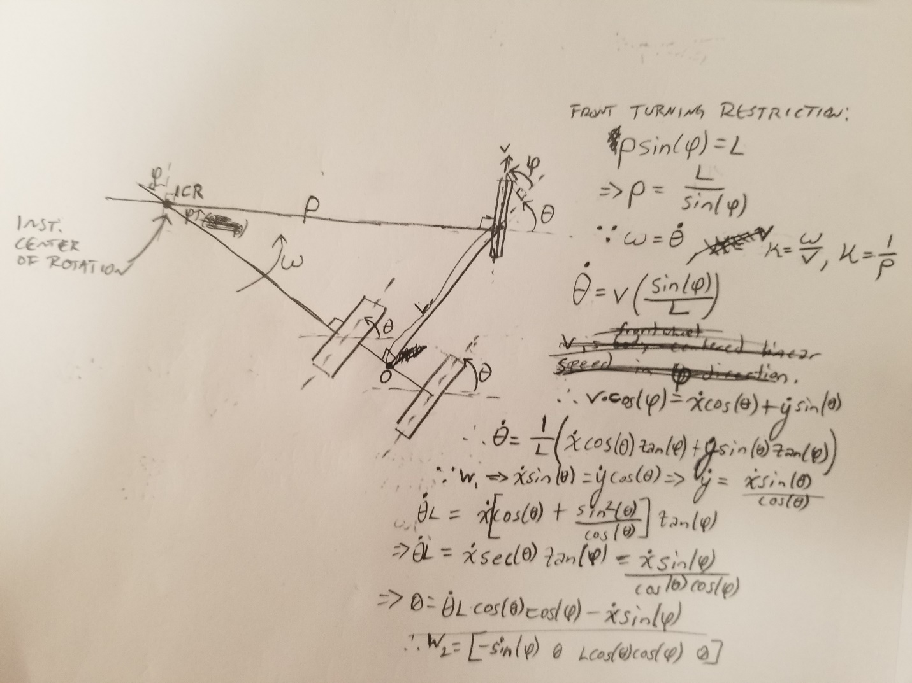

Turning radius: $R_{i}\sin\left(ϕ_{i}\right)=l_{i}→R_{i}=\frac{l_{i}}{\sin\left(ϕ_{i}\right)}$

Curvature of Path of Front Wheel: $∵κ=\frac{ω_{f}}{V_{f}} where κ=R_{i}^{-1}$

$$∴ω_{f}=\frac{V_{f}}{R_{i}}=\frac{V_{f}\sin\left(ϕ_{i}\right)}{l_{i}}$$

$V_{f}$ is linear speed of front wheel, $ω_{f}$ is rotational speed of front wheel about ICR.

$$∴ω_{f}={\dot{θ}}_{i}$$

Relation between $V_{f}$ and translational speed of origin:

$$\left(V_{f} ∘{\hat{X}}_{i}\right)=V_{f}cos\left(ϕ_{i}\right)={\dot{x}}_{i}\cos\left(θ_{i}\right)+\dot{y}\sin\left(θ_{i}\right) \\ →V_{f}=\frac{{\dot{x}}_{i}\cos\left(θ_{i}\right)}{\cos\left(ϕ_{i}\right)}+\frac{{\dot{y}}_{i}\sin\left(θ_{i}\right)}{\cos\left(ϕ_{i}\right)}$$

$$∴{\dot{θ}}_{i}=\frac{1}{l_{i}}\left({\dot{x}}_{i}\cos\left(θ_{i}\right)\tan\left(ϕ_{i}\right)+{\dot{y}}_{i}\sin\left(θ_{i}\right)\tan\left(ϕ_{i}\right)\right)$$

Constraint 1: $∵{\dot{x}}_{i}\sin\left(θ_{i}\right)={\dot{y}}_{i}\cos\left(θ_{i}\right) → {\dot{y}}_{i}={\dot{x}}_{i}\frac{\sin\left(θ_{i}\right)}{\cos\left(θ_{i}\right)}$

$$→{\dot{θ}}_{i}l_{i}={\dot{x}}_{i}\left(\cos\left(θ_{i}\right)+\frac{\sin^{2}\left(θ_{i}\right)}{\cos\left(θ_{i}\right)}\right)\tan\left(ϕ_{i}\right)$$

$$→{\dot{θ}}_{i}l_{i}={\dot{x}}_{i}sec⁡(θ_{i})\tan\left(ϕ_{i}\right)$$

$$→{\dot{θ}}_{i}l_{i}=\frac{{\dot{x}}_{i}\sin\left(ϕ_{i}\right)}{\cos\left(θ_{i}\right)\cos\left(ϕ_{i}\right)}$$

$$→\dot{θ}l_{i}\cos\left(θ_{i}\right)\cos\left(ϕ_{i}\right)-{\dot{x}}_{i}\sin\left(ϕ_{i}\right)=0$$

$$∴{\vec{w}}_{2}=\left[\begin{matrix}-\sin\left(ϕ_{i}\right) & 0 & l_{i}\cos\left(θ_{i}\right)\cos\left(ϕ_{i}\right) & 0\end{matrix}\right]$$

Complete Set of Constraints:

$$∴{\vec{w}}_{1}=\left[\begin{matrix}-\sin\left(θ_{i}\right) & \cos\left(θ_{i}\right) & 0 & 0\end{matrix}\right]$$

$$∴{\vec{w}}_{2}=\left[\begin{matrix}-\sin\left(ϕ_{i}\right) & 0 & l_{i}\cos\left(θ_{i}\right)\cos\left(ϕ_{i}\right) & 0\end{matrix}\right]$$

3.3)

where: $\dot{\vec{q}}={\vec{g}}_{1}u_{1}+{\vec{g}}_{2}u_{2}+…$

Two controllable parameters of tricycle are pedaling velocity and turning of front wheel.

Control Vector for Rear Wheels:

Direction of travel when pedaling at $u_{1}$ with a fixed front wheel orientation.

$${\dot{x}}_{i}=u_{1}\cos\left(θ_{i}\right)$$

$${\dot{y}}_{i}=u_{1}\sin\left(θ_{i}\right)$$

$${\dot{θ}}_{i}=\frac{u_{1}}{R_{i}}$$

$$∵\tan\left(ϕ_{i}\right)=\frac{l_{i}}{R_{i}}$$

$${\dot{θ}}_{i}=u_{1}\frac{l_{i}}{l_{i}R_{i}}=u_{1}\frac{\tan\left(ϕ_{i}\right)}{l_{i}}$$

$$∴{\vec{g}}_{1}=\left[\begin{aligned}\cos\left(θ_{i}\right) \\ \sin\left(θ_{i}\right) \\ tan\left(ϕ_{i}\right)/l_{i} \\ 0\end{aligned}\right]$$

Control Vector for Turning of Front Wheel:

Turning front wheel affects only $ϕ_{i}$ and angle of turn $u_{2}$ directly controls $ϕ_{i}$.

$$∴{\vec{g}}_{2}=\left[\begin{aligned}0 \\ 0 \\ 0 \\ 1\end{aligned}\right]$$

3.4)

Yes.

First Control Vector:

${\vec{g}}_{1}∘{\vec{w}}_{1}= -\sin\left(θ_{i}\right)\cos\left(θ_{i}\right)+\cos\left(θ_{i}\right)\sin\left(θ_{i}\right)+0+0=0 ∴{\vec{g}}_{1}⊥{\vec{w}}_{1}$

${\vec{g}}_{1}∘{\vec{w}}_{2}=-\cos\left(θ_{i}\right)\sin\left(ϕ_{i}\right)+0+\frac{l_{i}}{l_{i}}\frac{\cos\left(θ_{i}\right)\cos\left(ϕ_{i}\right)\sin\left(ϕ_{i}\right)}{\cos\left(ϕ_{i}\right)}+0=0 ∴{\vec{g}}_{1}⊥{\vec{w}}_{2}$

Second Control Vector:

${\vec{g}}_{2}∘{\vec{w}}_{1}=0+0+0+0=0 ∴{\vec{g}}_{2}⊥{\vec{w}}_{1}$

${\vec{g}}_{2}∘{\vec{w}}_{2}=0+0+0+0=0 ∴{\vec{g}}_{2}⊥{\vec{w}}_{2}$

3.5)

First Degree of Control:

${\vec{g}}_{1}$ is the change in state (effectively the direction of travel) when pedaling with a fixed front wheel orientation.

Second Degree of Control:

${\vec{g}}_{2}$ is the change in the front wheel orientation when turning it.

3.6)

Need four linearly independent control vectors. Must find ${\vec{g}}_{3}$ and ${\vec{g}}_{4}$ using Lie Brackets.

$${\vec{g}}_{3}=\left[{\vec{g}}_{1},{\vec{g}}_{2}\right]=\left[\frac{δ{\vec{g}}_{2}}{δ\vec{q}}\right]{\vec{g}}_{1}-\left[\frac{δ{\vec{g}}_{1}}{δ\vec{q}}\right]{\vec{g}}_{2}$$ $→{\vec{g}}_{3}=\left[\begin{matrix}0 & 0 & 0 & 0 \\ 0 & 0 & 0 & 0 \\ 0 & 0 & 0 & 0 \\ 0 & 0 & 0 & 0\end{matrix}\right]\left[\begin{aligned}\cos\left(θ_{i}\right) \\ \sin\left(θ_{i}\right) \\ tan\left(ϕ_{i}\right)/l_{i} \\ 0\end{aligned}\right]-\left[\begin{matrix}0 & 0 & -sin⁡(θ_{i}) & 0 \\ 0 & 0 & \cos\left(θ_{i}\right) & 0 \\ 0 & 0 & 0 & \sec^{2}\left(ϕ_{i}\right)/l_{i} \\ 0 & 0 & 0 & 0\end{matrix}\right]\left[\begin{aligned}0 \\ 0 \\ 0 \\ 1\end{aligned}\right]$

$$→{\vec{g}}_{3}=\left[\begin{aligned}0 \\ 0 \\ \left(\frac{-1}{l_{i}\cos^{2}\left(ϕ_{i}\right)}\right) \\ 0\end{aligned}\right]$$

$${\vec{g}}_{4}=\left[{\vec{g}}_{2},{\vec{g}}_{3}\right]=\left[\frac{δ{\vec{g}}_{3}}{δ\vec{q}}\right]{\vec{g}}_{2}-\left[\frac{δ{\vec{g}}_{2}}{δ\vec{q}}\right]{\vec{g}}_{3}$$

$$→{\vec{g}}_{4}=\left[\begin{matrix}0 & 0 & 0 & 0 \\ 0 & 0 & 0 & 0 \\ 0 & 0 & 0 & \left(\frac{-2\sin\left(ϕ_{i}\right)}{l_{i}\cos^{3}\left(ϕ_{i}\right)}\right) \\ 0 & 0 & 0 & 0\end{matrix}\right]\left[\begin{aligned}0 \\ 0 \\ 0 \\ 1\end{aligned}\right]-\left[\begin{matrix}0 & 0 & 0 & 0 \\ 0 & 0 & 0 & 0 \\ 0 & 0 & 0 & 0 \\ 0 & 0 & 0 & 0\end{matrix}\right]\left[\begin{aligned}0 \\ 0 \\ \left(\frac{-1}{l_{i}\cos^{2}\left(ϕ_{i}\right)}\right) \\ 0\end{aligned}\right]$$

$$→{\vec{g}}_{4}=\left[\begin{aligned}0 \\ 0 \\ \left(\frac{-2\sin\left(ϕ_{i}\right)}{l_{i}\cos^{3}\left(ϕ_{i}\right)}\right) \\ 0\end{aligned}\right]$$

3.7)

Test of Linear Independence of New Motion ${\vec{g}}_{3}$ from Previous Allowable Motions ${\vec{g}}_{1}, {\vec{g}}_{2}$:

Let: $a{\vec{g}}_{1}+b{\vec{g}}_{2}+c{\vec{g}}_{3}=\vec{0}$

$$→a\left[\begin{aligned}\cos\left(θ_{i}\right) \\ \sin\left(θ_{i}\right) \\ tan\left(ϕ_{i}\right)/l_{i} \\ 0\end{aligned}\right]+b\left[\begin{aligned}0 \\ 0 \\ 0 \\ 1\end{aligned}\right]+c\left[\begin{aligned}0 \\ 0 \\ \left(\frac{-1}{l_{i}\cos^{2}\left(ϕ_{i}\right)}\right) \\ 0\end{aligned}\right]=\left[\begin{aligned}0 \\ 0 \\ 0 \\ 0\end{aligned}\right]$$

$$→\left[\begin{aligned}\operatorname{acos}\left(θ_{i}\right) \\ asin⁡(θ_{i}) \\ \frac{atan\left(ϕ_{i}\right)}{l_{i}}-\frac{c}{l_{i}\cos^{2}\left(ϕ_{i}\right)} \\ b\end{aligned}\right]=\left[\begin{aligned}0 \\ 0 \\ 0 \\ 0\end{aligned}\right]$$

$$\underset{→}{Solve System}\left\{a,b,c\right\}=\left\{0,0,0\right\}$$

**Therefore, ${\vec{g}}_{1}, {\vec{g}}_{2},{\vec{g}}_{3}$ are linearly independent**

Test of Linear Independence of New Motion ${\vec{g}}_{4}$ from Previous Allowable Motions ${\vec{g}}_{1}, {\vec{g}}_{2}$:

Let: $a{\vec{g}}_{1}+b{\vec{g}}_{2}+c{\vec{g}}_{4}=\vec{0}$

$$→a\left[\begin{aligned}\cos\left(θ_{i}\right) \\ \sin\left(θ_{i}\right) \\ tan\left(ϕ_{i}\right)/l_{i} \\ 0\end{aligned}\right]+b\left[\begin{aligned}0 \\ 0 \\ 0 \\ 1\end{aligned}\right]+c\left[\begin{aligned}0 \\ 0 \\ \left(\frac{-2\sin\left(ϕ_{i}\right)}{l_{i}\cos^{3}\left(ϕ_{i}\right)}\right) \\ 0\end{aligned}\right]=\left[\begin{aligned}0 \\ 0 \\ 0 \\ 0\end{aligned}\right]$$

$$→\left[\begin{aligned}\operatorname{acos}\left(θ_{i}\right) \\ asin⁡(θ_{i}) \\ \frac{atan\left(ϕ_{i}\right)}{l_{i}}-c\left(\frac{2\sin\left(ϕ_{i}\right)}{l_{i}\cos^{3}\left(ϕ_{i}\right)}\right) \\ b\end{aligned}\right]=\left[\begin{aligned}0 \\ 0 \\ 0 \\ 0\end{aligned}\right]$$

$$\underset{→}{Solve System}\left\{a,b,c\right\}=\left\{0,0,0\right\}$$

**Therefore, ${\vec{g}}_{1}, {\vec{g}}_{2},{\vec{g}}_{4}$ are linearly independent**

3.8)

New motion ${\vec{g}}_{3}=\left[\begin{aligned}0 \\ 0 \\ \left(\frac{-1}{l_{i}\cos^{2}\left(ϕ_{i}\right)}\right) \\ 0\end{aligned}\right]$ is a rotation of $O_{i}$ about the instantaneous center of rotation, $C_{i}$, due to the orientation of the front steering wheel.

New motion ${\vec{g}}_{4}=\left[\begin{aligned}0 \\ 0 \\ \left(\frac{-2\sin\left(ϕ_{i}\right)}{l_{i}\cos^{3}\left(ϕ_{i}\right)}\right) \\ 0\end{aligned}\right]$ is a rotation of $O_{i}$ about the instantaneous center of rotation, $C_{i}$, due to the orientation of the front steering wheel.

3.9)

A tricycle and Ackerman-like cart have mathematically similar control kinematics in terms of their respective control vectors, *g*, and constraints *w*. The primary difference between them is that the tricycle has an unbounded turning radius whereas the linkage between the two front steering wheels of the cart imposes a lower bound on the cart’s turning radius.