1.)

a.)

b.)

c.)  
When passing an image through either of these filters, each input image corresponds to a unique output; so, as long as the applied filter is known, it should be possible to implement deconvolution to recover the original image.

d.)

2.)

Mask 1:

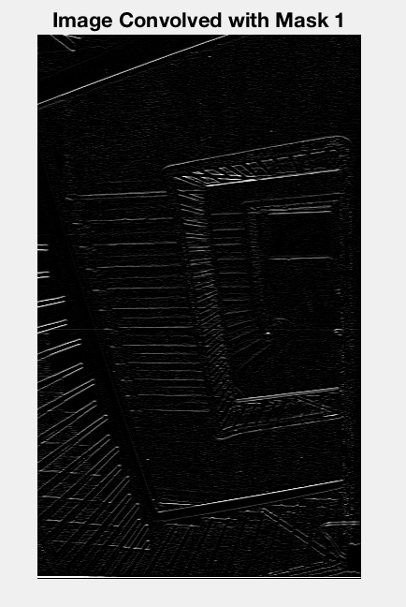

Highlighted horizontal edges.

Mask 2:

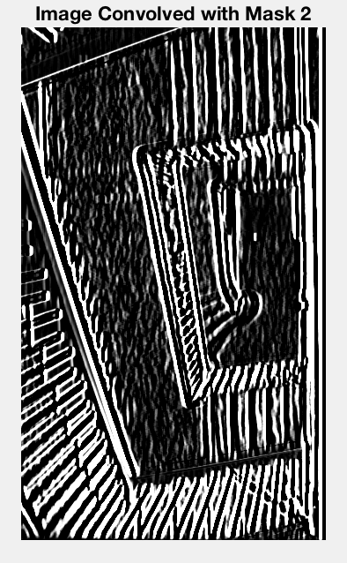

Highlighted vertical edges and widened their presence on the output image (made the vertical edges bold).

Mask 3:

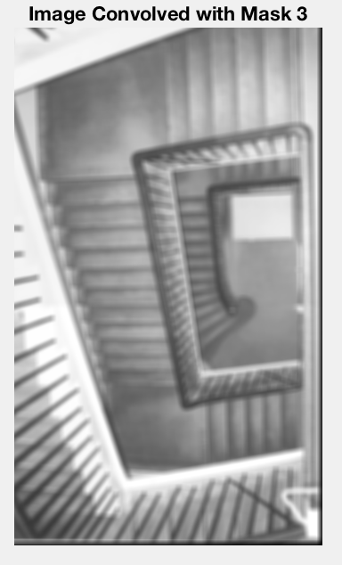

Performed a blurring operation; namely, a mean filter.

3.)

4.)

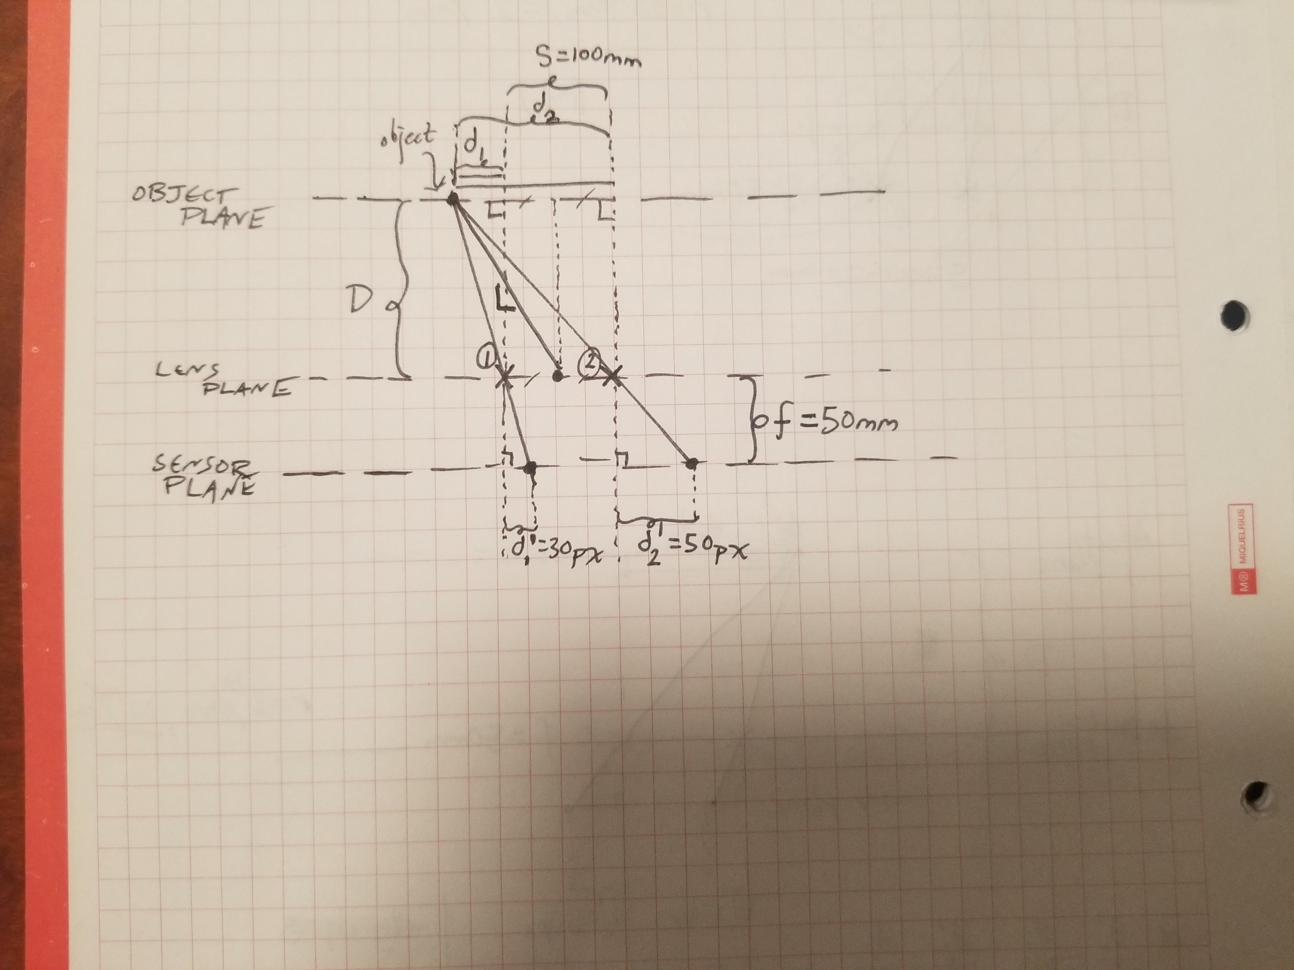

Find L.