2.)

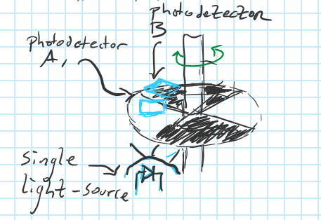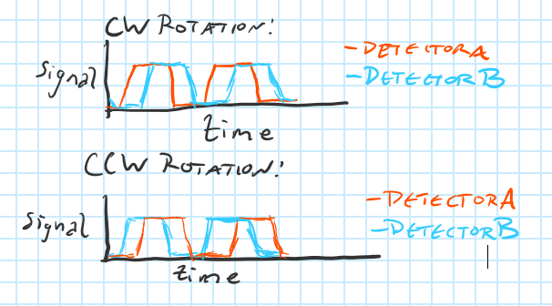

Another photodetector was added, offset from the first detector by half of the width of a slit; if Detector A is illuminated before Detector B, the rotation is clockwise, if Detector B is illuminated before Detector A, the rotation is counterclockwise.

3.)

Kp = 16, Kd=18, Ki = 4

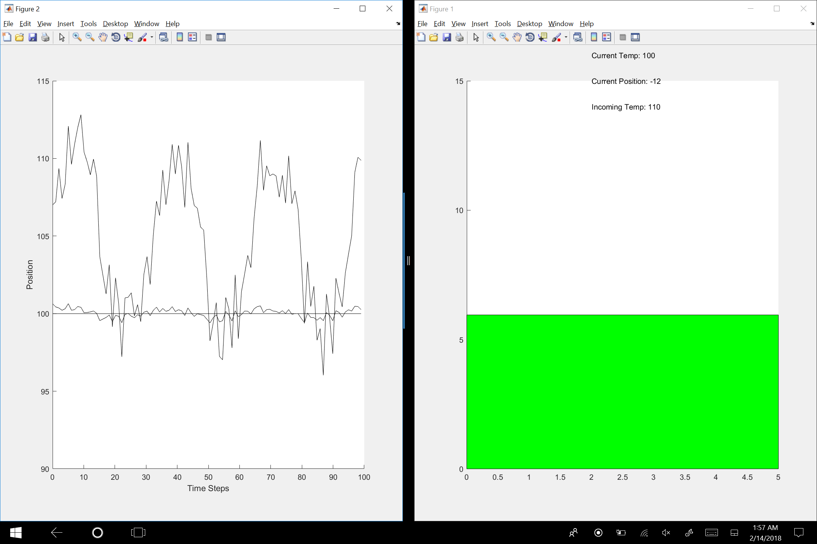

First, only a Kp was used. The value was gradually increased until the control had the ability to produce oscillations of the pool temperature about the set-point. Then, a value of Kd was introduced equal to half of that of Kp to counter-act the effect of sudden changes in the incoming temperature and smooth out (flatten) the pool’s response. This value was progressively increased until a sufficiently flat response curve (fluctuations of less than 1 degree) was produced. Lastly, a Ki value was added incrementally from 0 to center the oscillations around the setpoint until the temperature of the pool water remained at 100 degrees for the entirety of the filling cycle.

4.)

Some sort of singularity like occurrence, wherein a run-away increase in the capability of artificial systems is triggered once man-made artificial intelligences surpass a certain ability is certainly possible. Most artificially intelligent systems have some sort of goal or reward-function which they are designed to optimize. Currently, while AI systems are very good at optimizing their given functions -often to a super-human level, they are application-specific and, as such, are largely incapable of understanding their own design or ways in which they could improve themselves unless such functionality was explicitly programmed by their designers. However, consider if an artificial general intelligence (AGI) were to be created with the capability of understanding the state of the entire world in which it exists, including its own software architecture, and finding a means of optimizing its reward function within this infinitely complex world-space, in a similar vain to the way humans decide how to best go about a task. If such an AGI were to exist and to be given a task like maximizing the value of a stock portfolio, it might see that instead of just performing a series of investments like a normal AI would, it could gain a considerable advantage by first spending time improving its own design, or even creating other agents to improve its own design, before setting off on its task. A sufficiently powerful version of such a system given any unconstrained reward function would likely invest significantly in improving its own human-made design since more intelligence typically yields bigger gains in any domain. Since such growth would happen digitally, the only constraint to the rapidity of its development would be computing power. As such, a form of a singularity is possible under the power of Moore’s Law – once computing power becomes sufficient enough to run just one AGI, that AGI will likely begin making or designing improvements to whatever its greatest bottleneck is at the moment, creating a more fertile ecosystem upon which other AGI could be built. The net result would be rapid development in both computing power and AGI design, quickly out-passing the best human design which existed prior.

5.)

In terms of being the most likely path to successfully reach its target, Path C is the best. By going through fire Path A poses a risk to the robot’s safety. By including a series of loops and turns, Path B risks the robot getting lost while executing its trajectory. Therefore, despite Path C potentially being the longest option, it presents the highest likelihood of the robot successfully making it to its destination.