# 16-384 Capstone

## 2.2 Report

### 2.2.1. Written Questions

2.2.1.1.) **Denavit-Hartenberg Transformations**

|  |  |  |  |  |  |  |  |  |  |  |  |  |  |  |  |  |  |  |  |  |  |  |  |  |  |  |
| --- | --- | --- | --- | --- | --- | --- | --- | --- | --- | --- | --- | --- | --- | --- | --- | --- | --- | --- | --- | --- | --- | --- | --- | --- | --- | --- |
| |  |  |  |  |  | | --- | --- | --- | --- | --- | | Robot A | | | | | | LINK i |  |  |  |  | | 1 | 0 | 0 | 1 |  | | 2 | 0 |  |  |  | | 3 | 0 | 0 |  | 0 | | *Computed using Robot.fk(q) in Report_2211.m* |
| |  |  |  |  |  | | --- | --- | --- | --- | --- | | Robot B | | | | | | LINK i |  |  |  |  | | 1 | 0 |  | 1 |  | | 2 | 0 |  |  |  | | 3 | 0 |  |  |  | | 4 | 0 |  |  | 0 | | 5 | 0 |  | 0 |  | | 6 | 0 |  | 0 |  | | 7 = ee | 0 |  | 0 |  | | *Computed using Robot.fkf(3,q) in Report_2211.m* |
| |  |  |  |  |  | | --- | --- | --- | --- | --- | | Robot C (Capstone Robot) | | | | | | LINK i |  |  |  |  | | 1 | 0 |  | 116.23 |  | | 2 | 327.76 |  | 0 |  | | 3 | 0 |  | 2.5 |  | | 4 | 254.10 |  | 94.05 |  | | 5 | 266.70 |  | 54.23 |  |   *All units in [mm] and [rad].*   * NOTE: Piazza Post @292 said to analyze the new diagram of the capstone robot and not the RobotC in the assignment. * NOTE: Upon further measurement of the CAD, it was determined that =2.5mm. This is only true for physical RobotB (not RobotA), which used dissimilar right angle brackets on joints 2 and 3, as is also the case in the provided CAD. | *Computed using Robot.fkf(3,q) in Report_2211.* |

2.2.1.2.) **Workspace**

*Computed using Report_2212.m*

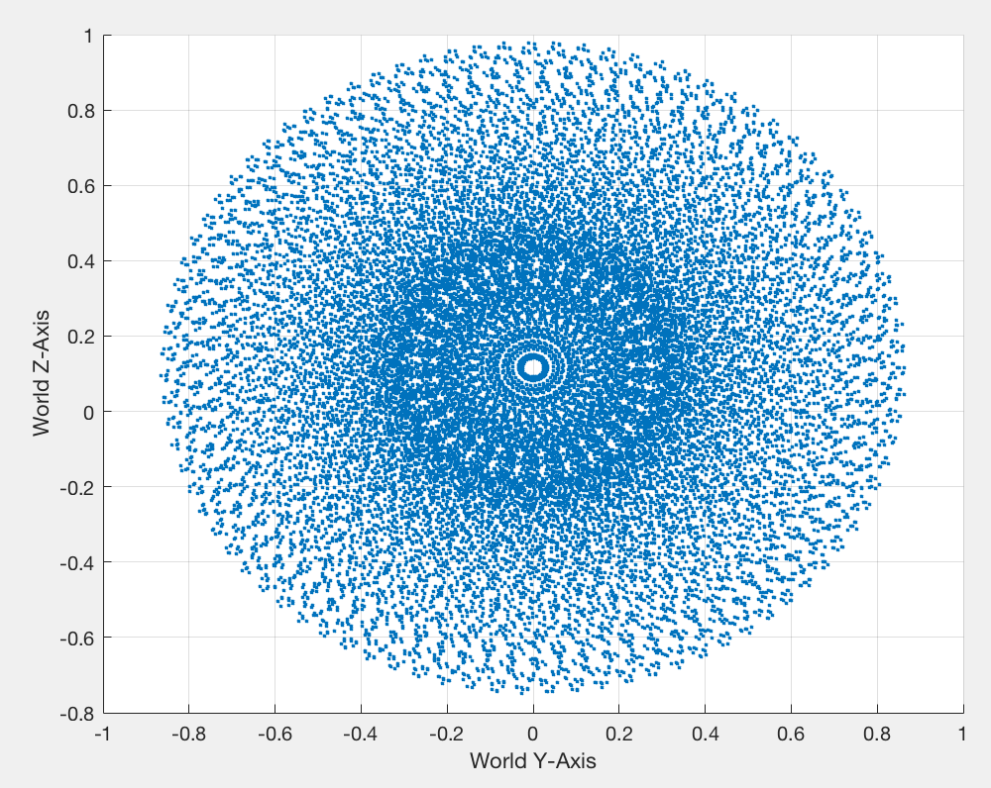

*\* units in [m].*

2.2.1.3.) **Manipulability**

*Computed using Report_2213.m* using Yoshikawa Manipulability:

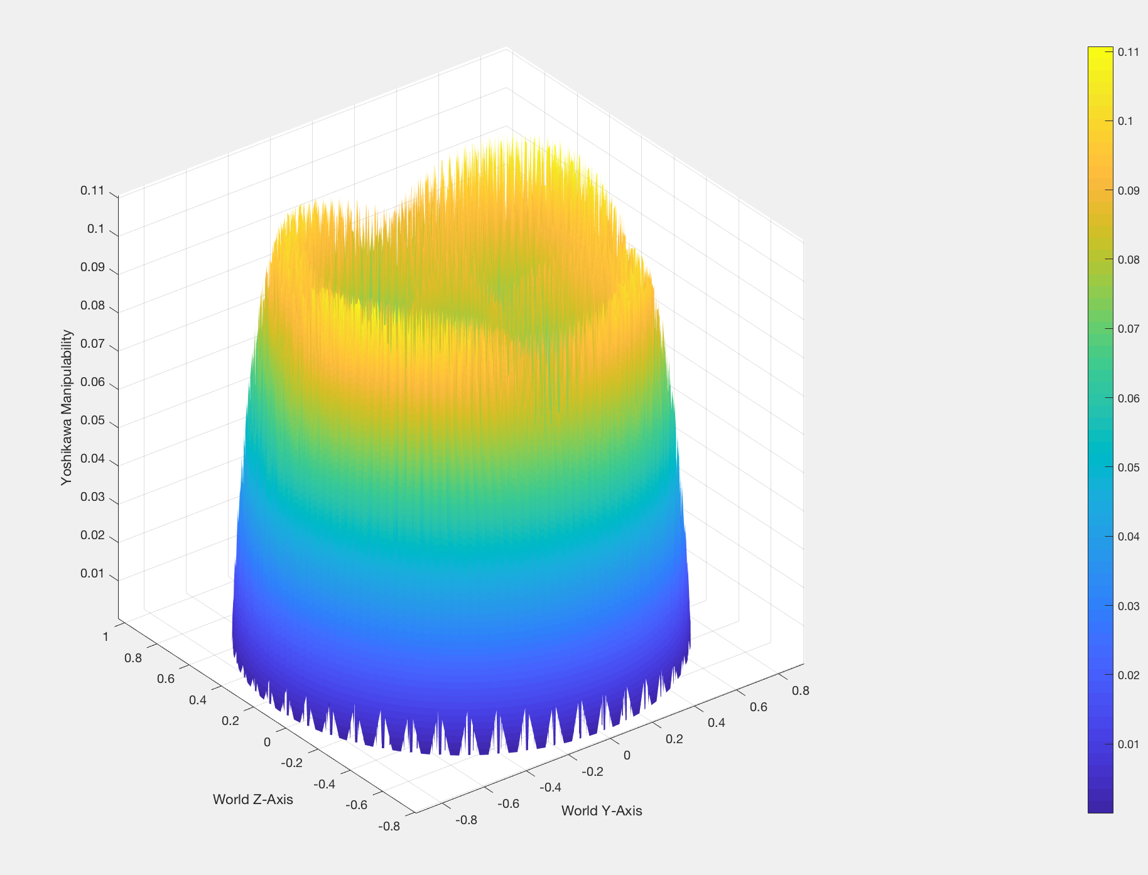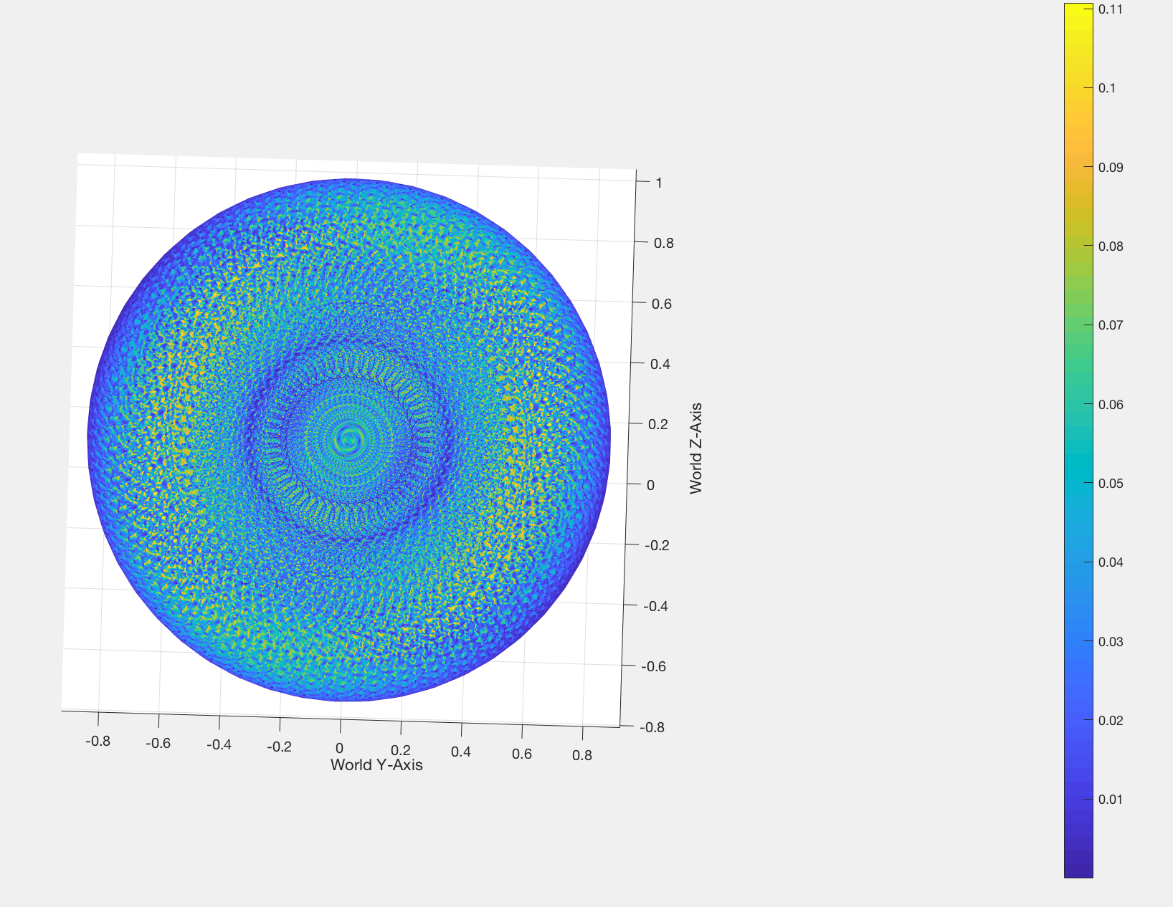

*\* units in [m].*

*NOTE: All positions below z=0 are* ***inaccessible*** *due to the table.*

2.2.1.4.) **Determine Initial Home Position**

An ideal home position would be one with high manipulability and access to a large area of nearby points with similarly high manipulability. As such, some point near the center of the large yellow band of high manipulability which is also near to the starting position of the paths (eg. for the straight path). would be ideal.

Since, the plane of is at , one such point which shares the same starting z value as the straight path and is closer to the origin is **.** Using IK from the Robot3D class (in *Report_2214.m*), this gives an ideal home joint configuration of:

**.**

2.2.1.5.) **3D Jacobians**

Since each ith column of the analytical jacobian for a 5-DOF serial revolute kinematic chain is:

The forward kinematics of the end effector must be determined.