*Read the README File for

1. Functions that have been implemented
2. Instructions on how to compile and run your program.
3. Known Bugs

Sample Outputs of **doctrove_z_p2**

After running the Server class file, this is the first thing a new client will see when its socket is accepted.

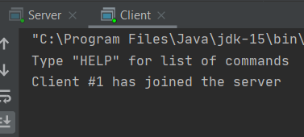

The Server side of this interaction

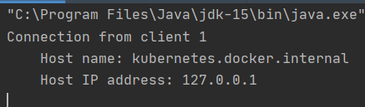

**UNREVISED COMMANDS (1)**

1. LIST: Unchanged from program one, lists off all the records contained in the “records.txt” file

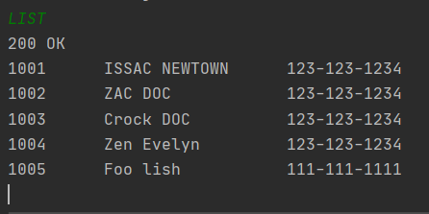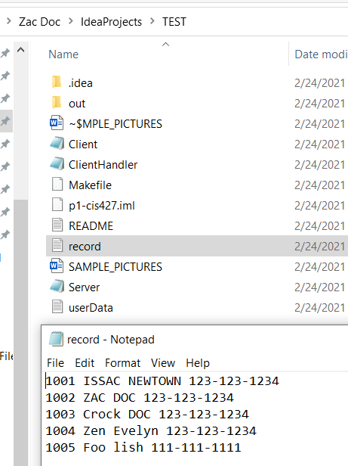

**REVISED COMMANDS (4)**

1. (HELP): Added the four new commands and their formatting. This static function only tells new clients what commands are present and how to invoke them, nothing more.

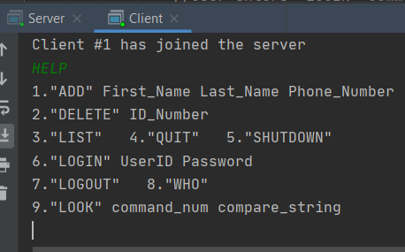

1. ADD: Now that the server is multi-client friendly, all commands that make changes to files (“record.txt” and “userData.txt”) must retrieve data from the file and then write back to the file within the scope of each command. Without this constant accessing of files, clients would not see the changes they made be on other client’s screens. The first command to receive this revision was the ADD command.

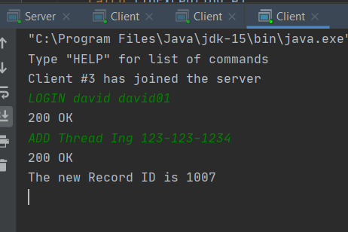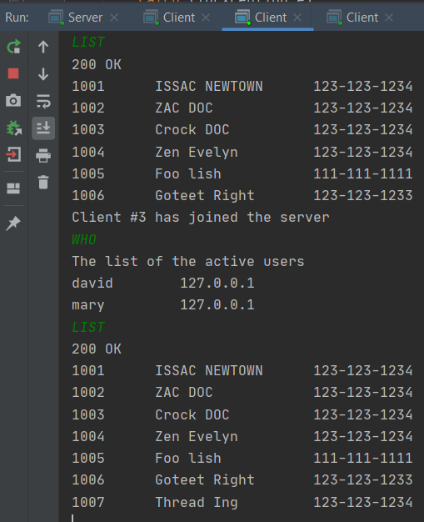Project 2 also entailed an increase in security, so the ADD command does not work unless the client logs in as one of four UserIDs.



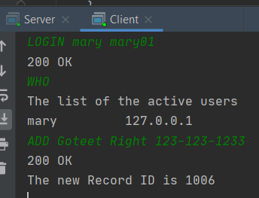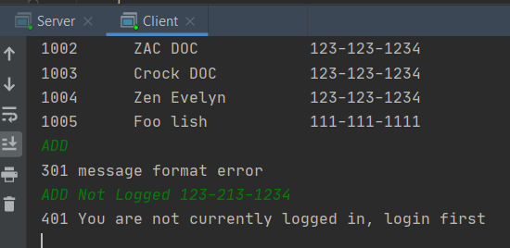



1. 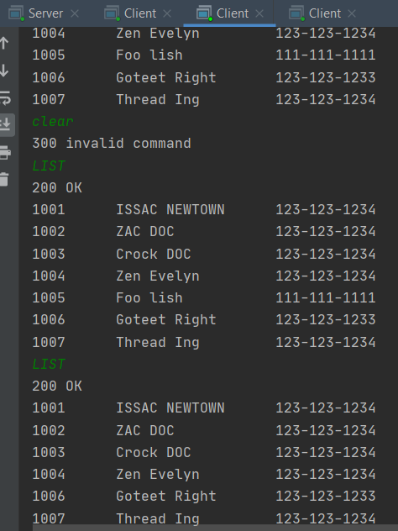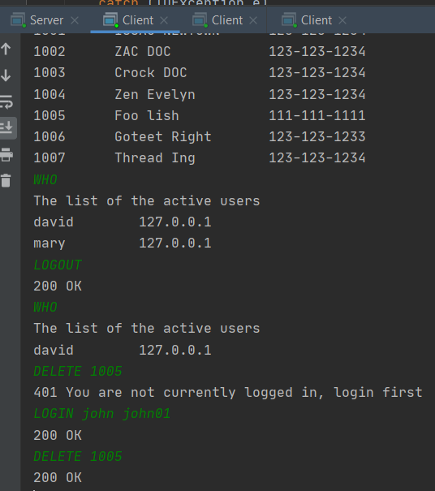DELETE: The DELETE command got the exact same treatment as the ADD command: Instant file changing feedback for interactivity between the client and the server, as well as Login security to prevent anonymous record changing



1. 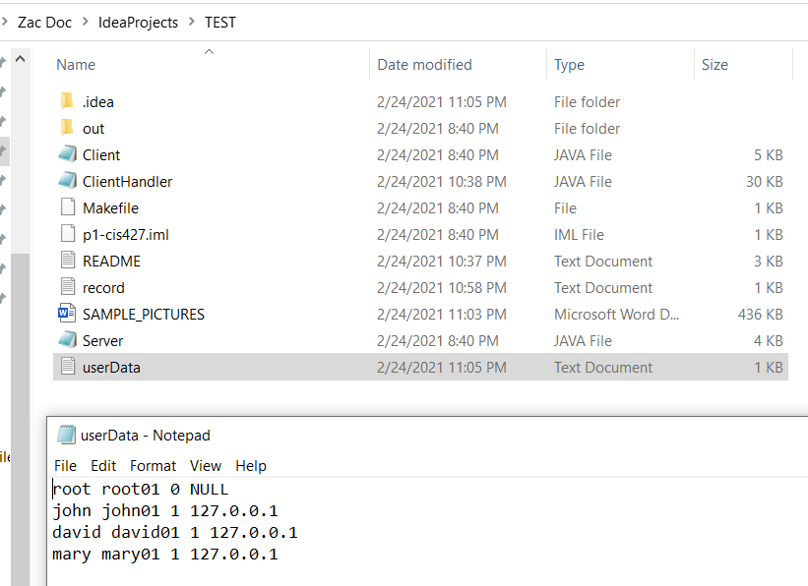QUIT: Does pretty much the same thing like in P1, but this time with the addition UserIDs the QUIT command now automatically logs the client out before terminating itself. 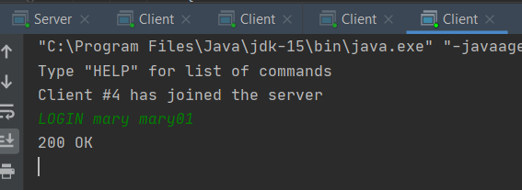

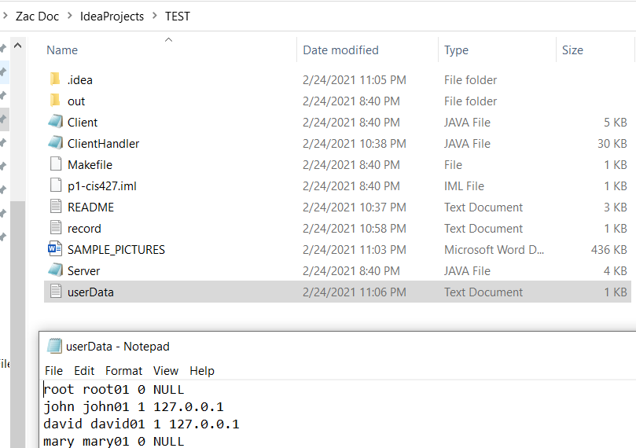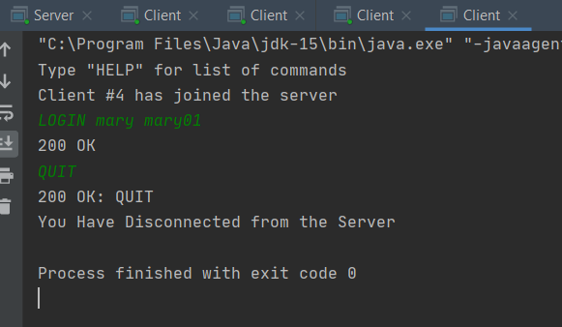



1. 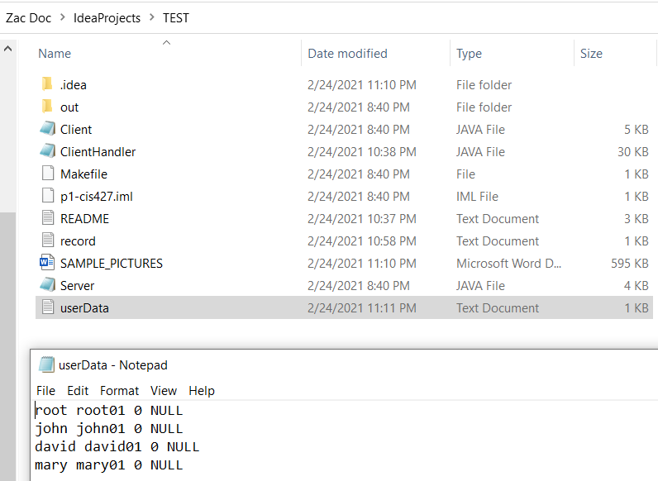SHUTDOWN: Just like the revision to the QUIT command, the SHUTDOWN command now logs out all active users before shutting down all clients and then the server. But unlike the QUIT command, the SHUTDOWN command can only be activated using the root userID.

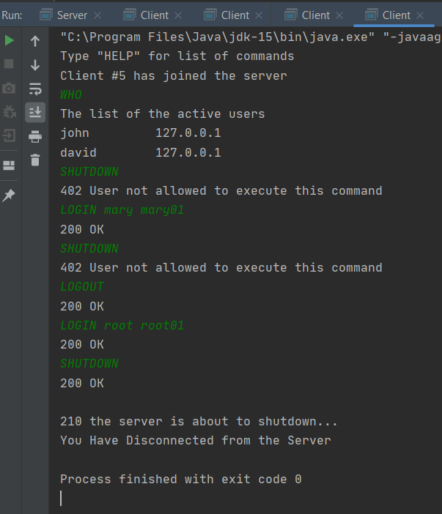

**NEW COMMANDS (4)**

1. LOGIN: A requirement to ADD a record, DELETE a record, or SHUTDOWN the server (Applies to root UserID only).



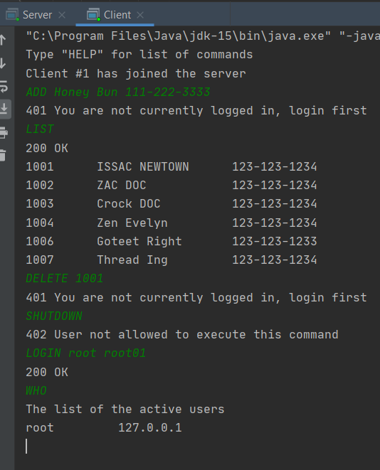

1. LOGOUT: Takes away an active user’s ability to use ADD, DELETE, and SHUTDOWN (If Applicable) commands.



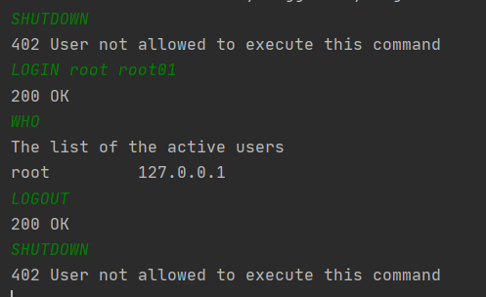

1. WHO: Let’s other clients see what User ID’s are actively being used.

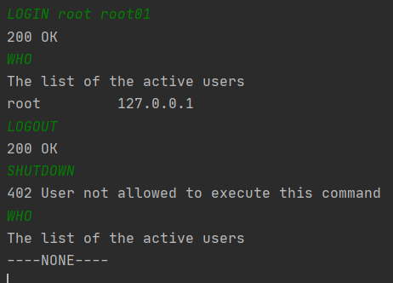

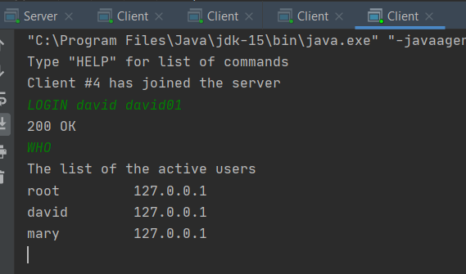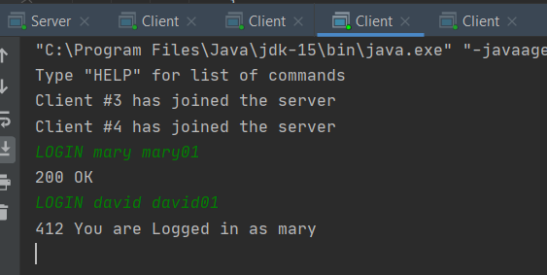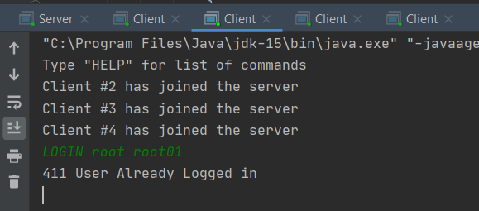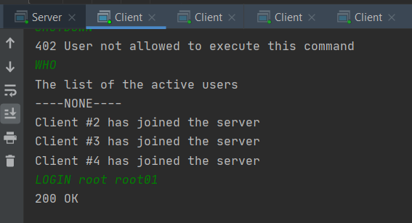



LOOK: Lets clients filter out a specific string in the first name, last name, and phone number entries in the record 