Hotel Booking Demand Project
UNSUPERVISED LEARNING | 2025/2026 | FCT NOVA
Team: Francisco Rodrigues dos Santos (72908), Duarte Ferreira (75419), João Rivera (73418)
Repository: https://github.com/zDud4s/ANSup-hotel-project

Abstract
We segment hotel reservations into recurring booking-behaviour profiles using only information available at the moment of booking confirmation. A leakage-controlled, mixed-type preprocessing pipeline (engineered booking-shape features, cyclic seasonality, one-hot categoricals with rare-category grouping, and block balancing) yields a dense Euclidean representation. On it we compare three clustering families, MiniBatch k-means, intelligent k-means (iK-means) and Gaussian Mixture Models (GMM), under a single protocol: Silhouette, Calinski Harabasz and Davies Bouldin computed in the clustering space, repeated over ten seeds, with a mean pairwise Adjusted Rand Index (ARI) stability gate of 0.80. The only family that is simultaneously stable and interpretable is iK-means under StandardScaler, which determines k = 7 segments. A bootstrap (data-perturbation) stability test, the principled complement to seed stability, confirms iK-means is the only family reproducible under resampling (ARI 0.86, the only family clearing the 0.80 gate, against 0.50 for k-means and 0.66 for GMM). A representation study comparing one-hot, PCA and a principled Factor Analysis of Mixed Data (FAMD) coding shows the headline is sharpened by PCA-13 in both separation and stability, while the FAMD coding does not help it. A t-SNE embedding confirms the seven segments occupy coherent regions (trustworthiness about 0.996), and a cluster-aware anomaly analysis isolates data-quality records from rare but plausible behaviour. The most decision-relevant finding is a coherent segment of long-lead, non-refundable group bookings with near-zero realised price and almost universal cancellation, recovered purely from index-time features.

1. Introduction
Hotels decide how to handle a reservation (pricing, allocation, overbooking buffers and marketing) at the moment the booking is confirmed, long before the guest arrives or cancels. We therefore ask a segmentation question framed at that moment: what recurring booking-behaviour profiles emerge from reservation records, using only information available at booking confirmation? The unit of analysis is one booking, not one customer, and conclusions are expressed as recurring behaviours rather than fixed customer types.
Clustering is the appropriate tool because no supervised label captures behaviour at booking time. The operational question is to discover structure, not to predict a known target. The study is organised around five research questions. RQ1 (framing): what is the concrete segmentation question and why is clustering appropriate? RQ2 (representation): which preprocessing and encoding choices for mixed data are justified, and how do they shape similarity? RQ3 (modelling): which family and configuration yields the most coherent and stable clusters? RQ4 (interpretation): what do the clusters represent, and do they help answer the question? RQ5 (robustness): how sensitive are the conclusions to preprocessing, representation and randomness?

2. Dataset documentation
We use the Hotel Booking Demand dataset (course release v1), 119,390 rows by 32 columns, each row a booking for a city or resort hotel in Portugal over July 2015 to August 2017. The source is Kaggle (jessemostipak/hotel-booking-demand). The data is distributed under CC BY 4.0, so we credit the authors, link the licence, and document every transformation (data/ATTRIBUTION.md). The raw CSV is not committed. The full SHA-256 fingerprint (7c2ae42a7353905ea136e5c2287f17c92c5435826598bfbb8491c6f0c7b1fc06) is validated on load by src/data/validate.py.
Known data-quality issues. company is missing in 94.3% of rows and agent in 13.7%, both ID-like and dropped. country is missing in 0.41% and high-cardinality, with about 93 codes. meal == "Undefined" and a few negative or zero adr values are recoded before imputation. Numerical features are heavily right-skewed (lead time, previous cancellations), which motivates a RobustScaler variant alongside the StandardScaler baseline. Where supervised treatments of this dataset delete edge-case rows, for example the single ADR above €4,000 and bookings with no registered adults, we instead retain them. The 403 zero-adult, 180 zero-party and 715 zero-night bookings are kept and handled by explicit zero-guards in the engineered party_size and weekend_share features, and the most degenerate such records are surfaced, not silently discarded, by the cluster-aware anomaly analysis (E1, Section 5.4), so no booking is dropped on an outcome we are trying to characterise.
Leakage control. Outcome and post-event variables are excluded from clustering inputs and reserved for post-hoc profiling only: is_canceled, reservation_status and reservation_status_date (post-event), and assigned_room_type, booking_changes and days_in_waiting_list (resolved after confirmation). Every clustering input is available at or before index time (booking confirmation).

3. Methods

3.1 Representation (RQ2)
Feature governance is centralised in src/preprocessing/feature_config.py. The numerical inputs (7) are lead_time, four engineered booking-shape features (total_nights, party_size, has_kids, weekend_share) that collapse five correlated raw count columns into behavioural shape, and two cyclic week-of-year features (sin, cos) so that week 52 and week 1 are close in feature space. The categorical inputs (6) are hotel, market_segment, distribution_channel, reserved_room_type, deposit_type and customer_type.
Numericals are median-imputed and scaled. Categoricals are imputed with a constant, rare categories below a minimum frequency are grouped into "Other", one-hot encoded, and a variance floor drops dummies too rare to define a stable distance dimension. The surviving one-hot columns are kept as 0/1 indicators. They are not individually variance-standardised, which would let a rare dummy contribute as much distance as a common one and so let rare categories dominate the metric. Because the one-hot block is far wider than the numerical block, a single block-balancing weight is instead applied to the categorical block as a whole, equalising the summed variance of the two blocks, so both blocks contribute comparable variance to the distance without distorting the within-block 0/1 geometry. The resulting representation is dense and Euclidean, and all evaluation indices are computed in this same space, with no metric switch between clustering and evaluation. We hold adr, special requests, parking, guest history and country out as profiling-only variables. adr and guest history are consequences of, or are resolved after, the booking choices we cluster on, while special requests and parking are excluded as a deliberate scope-control decision: although available at booking time, they describe on-site service preferences rather than the stay, channel and commitment shape this segmentation question targets, so we recover them post-hoc instead of letting them co-define the segments. country is treated as a control to avoid nationality acting as a proxy for cluster identity.

3.2 Clustering families and protocol
We compare three conceptually distinct families on the same representation under both StandardScaler and RobustScaler. First, MiniBatch k-means is the mandatory baseline, over a predefined and justified range k in {2,…,8}, where below 2 is trivial and above 8 is not operationally interpretable. Second, iK-means uses Mirkin's anomalous-pattern initialisation, which auto-determines k deterministically and so avoids an arbitrary k search. Third, GMM with EM uses AIC and BIC for model selection. The evaluation protocol is fixed across families: Silhouette plus Calinski Harabasz and Davies Bouldin, each computed in the clustering space, ten locked seeds {0,…,9} reported as mean and standard deviation, and a stability rule that accepts a partition only if its mean pairwise ARI over the 45 seed pairs reaches 0.80. Because seed stability is structural, and trivially perfect, for the deterministic iK-means, we add a second and more demanding stability notion, bootstrap (data-perturbation) stability. Each method is refit on ten 80% row subsamples and its partition compared by ARI to the full-data reference. A method is robust only if it is reproducible when which bookings are observed changes, not merely when the random seed does. For GMM we report AIC and BIC curves as the family-specific diagnostic, extended to k = 15 to check that the k = 8 search bound is not hiding an interior optimum.

3.3 Robustness and extension methods
Robustness (RQ5) is probed on six axes: seed variation, bootstrap data perturbation, StandardScaler versus RobustScaler, a representation comparison (one-hot versus PCA versus FAMD, Section 5.3), the inclusion of price (ADR sensitivity), and the representation sensitivity of the anomaly ranking (E1). E4 fits PCA on the StandardScaler matrix, retains the smallest number of components reaching 90% cumulative variance, and re-runs the full protocol in both the original and reduced spaces. The FAMD comparator hand-codes the categoricals with the Factor Analysis of Mixed Data χ² metric (each one-hot dummy of prevalence p re-coded (x−p)/√p, the principled mixed-data coding that PCA-on-one-hot lacks), then reduces to 90% inertia, testing whether the encoding, not just the dimensionality, changes the structure. The ADR sensitivity re-clusters with price added as an eighth winsorised numeric, to test whether excluding it changes the segmentation. E1 defines a cluster-conditioned anomaly score, the distance to the cluster centroid normalised by within-cluster dispersion, on the headline partition, reports a top-20 auditable set, and tests sensitivity to representation. E5 uses t-SNE for visualisation only on a fixed 5,000-row subsample (seed 42), across perplexities {5, 30, 50} and three seeds, reporting trustworthiness as an embedding reliability diagnostic.

4. Experiments
A single entry point, bash run_all --full, regenerates every figure, table and the experiment log end to end. A --fast 5,000-row mode verifies pipeline integrity. All runs are logged to experiments.csv with method, parameters, seeds, metrics and diagnostics. The full pass covers MiniBatch k-means (7 k-values, 10 seeds, 2 scalers), iK-means (2 scalers, 10 seeds), GMM (7 k-values, 10 seeds, 2 scalers, full-covariance EM with n_init = 10, fit on the full data), the cross-family comparison, the headline profiling, and the extensions. GMM model selection is summarised by its AIC and BIC curves, and we additionally extend the component search to k = 15 to verify that the bound k = 8 is not masking an interior optimum.
Stability is summarised by the mean pairwise ARI across the ten seeds at each k (Figure A3). MiniBatch k-means never reaches the 0.80 acceptance threshold under either scaler, whereas iK-means is perfectly stable by construction, since its anomalous-pattern peeling is deterministic.

5. Results

5.1 Family comparison and model selection (RQ3)
Table 1 reports the best configuration per family on the full data. iK-means under StandardScaler is the only stable, non-degenerate solution. It determines k = 7 with mean pairwise ARI = 1.0, because its anomalous-pattern peeling is deterministic given the data, so every seed reaches the same partition. MiniBatch k-means never reaches the 0.80 gate, with a best ARI of 0.57 at robust k = 4. GMM is worse still, with BIC decreasing to the k = 8 bound (Figure A2) and, when the component search is extended to k = 15, still decreasing to that new boundary, so no parsimonious interior optimum exists, alongside near-zero or negative silhouette and ARI of at most 0.45. The highest silhouette overall, iK-means under RobustScaler at k = 2 with 0.871, is a degenerate split that isolates a microscopic outlier group from everyone else. We exclude it from the headline and instead exploit it in the anomaly analysis (Section 5.4).
Solution | k | Silhouette | Davies Bouldin | mean ARI | Verdict
iK-means + StandardScaler | 7 | 0.140 | 1.82 | 1.000 | Primary, stable and interpretable
iK-means + RobustScaler | 2 | 0.871 | 0.40 | 1.000 | Degenerate anomaly split, used in E1
MiniBatch k-means (robust) | 2 | 0.177 | 2.15 | 0.469 | Fails stability gate
MiniBatch k-means (robust) | 4 | 0.144 | 2.10 | 0.569 | Fails stability gate
GMM (robust, BIC) | 8 | −0.011 | 5.87 | 0.445 | Fails gate, weak separation
GMM (standard, BIC) | 8 | −0.015 | 6.75 | 0.304 | Fails gate, weak separation

Table 1. Best configuration per family (full population, 10 seeds). The headline is the only stable, non-degenerate solution.
Seed stability alone is a weak test for iK-means, whose partition is deterministic by construction. We therefore add a bootstrap (data-perturbation) stability test, refitting on ten 80% subsamples and computing ARI against the full-data reference (Figure 1). It tells the more demanding story. iK-means is the most reproducible family under resampling (ARI 0.86 ± 0.16) and the only family clearing the 0.80 gate on this notion, while MiniBatch k-means at 0.50 and GMM at 0.66 fail it just as they fail the seed gate. The headline stability is thus corroborated by a test it could have failed, not merely by its determinism. The residual spread of about 0.16, where the recovered k can drift on a resample, is the honest limit of that claim.
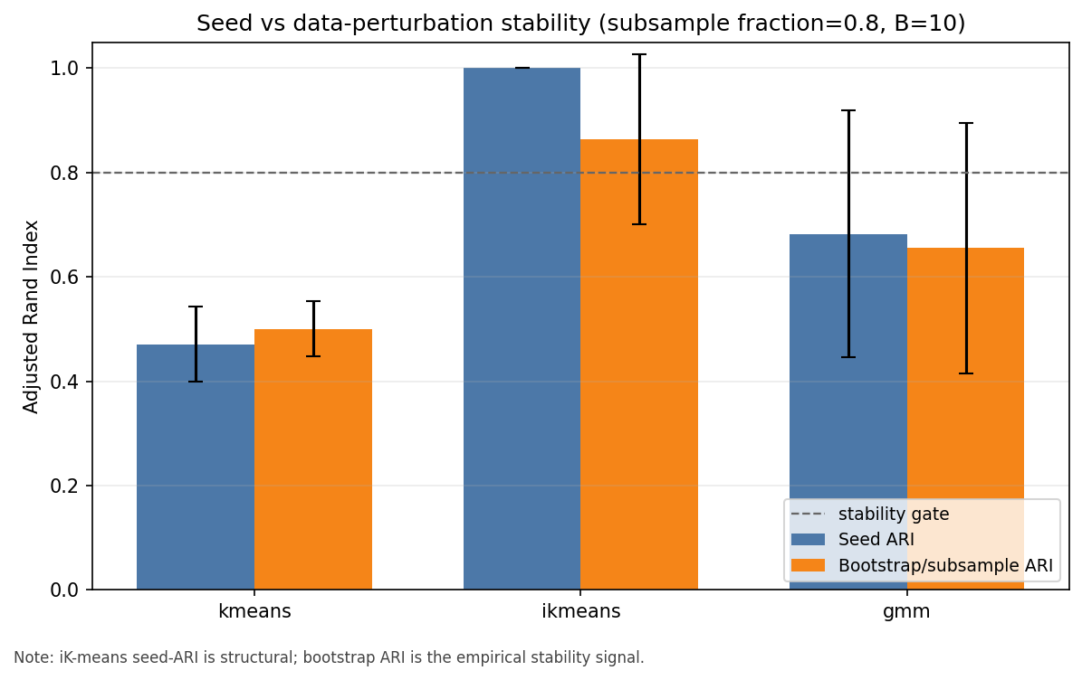
Figure 1. Bootstrap versus seed stability by family (mean ARI and standard deviation over ten 80% subsamples, dashed line = 0.80 gate). iK-means is the only family stable under data perturbation, not just under reseeding.

5.2 What the seven segments represent (RQ4)
Figure 2 shows the z-scored per-segment means of the clustering numericals, and Table 2 adds size and post-hoc descriptors, where price and cancellation are profiling-only. The segments are behaviourally distinct and interpretable.
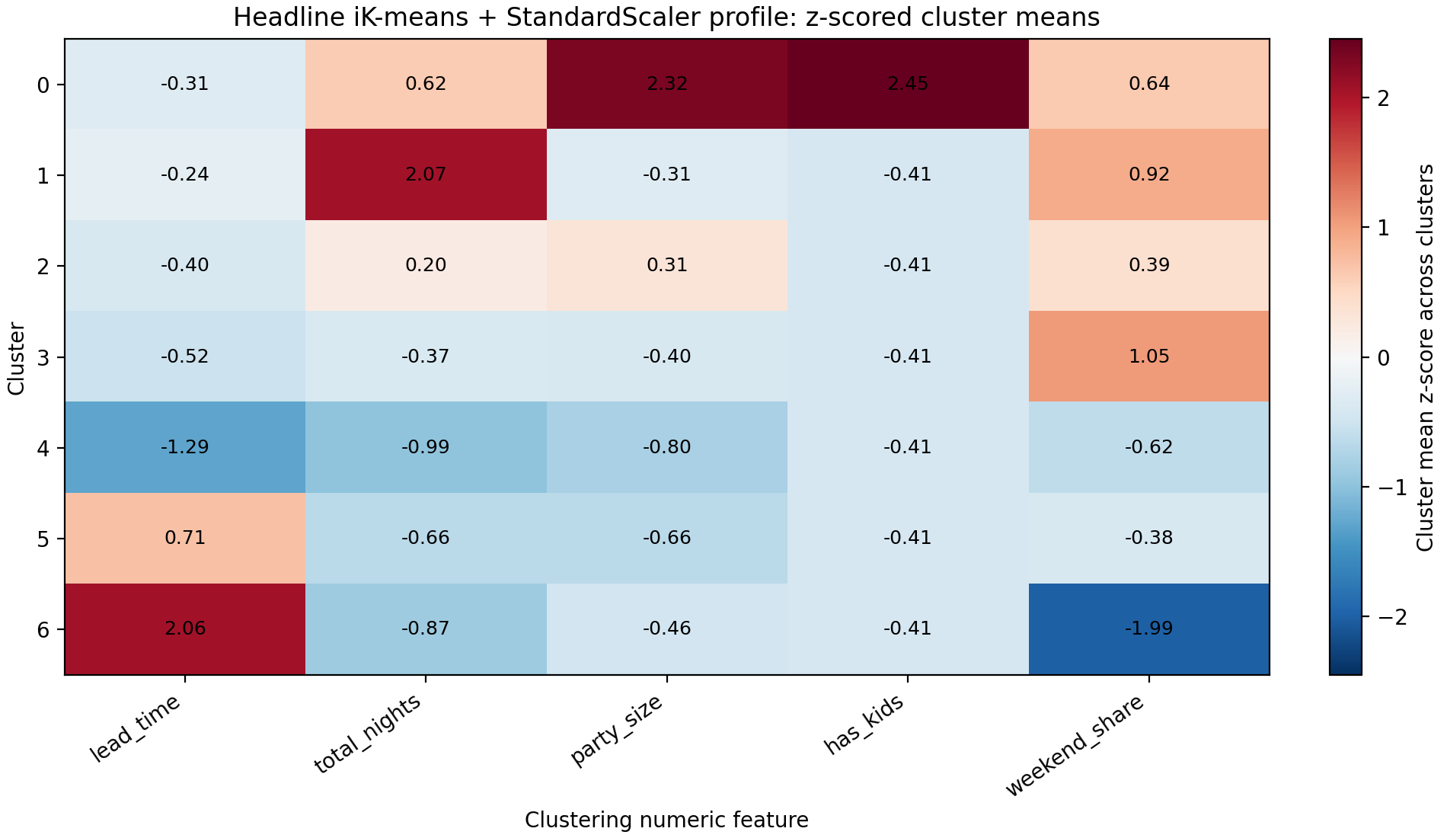
Figure 2. Headline iK-means with StandardScaler profile: per-segment z-scored means. Colour shows which segment is high (red) or low (blue) on each axis.
# | Share | Lead (d) | Nights | Party | ADR | Cancel% | One-line profile
0 | 7.8% | 89 | 3.9 | 3.4 | 154 | 35% | Families: children present, large party, family rooms (F/G), highest price
1 | 18.3% | 93 | 5.2 | 1.9 | 95 | 28% | Extended resort stays: longest stays, 99% Resort Hotel
2 | 9.2% | 84 | 3.6 | 2.3 | 136 | 39% | City premium room: 100% City Hotel, room D, higher rate
3 | 22.8% | 77 | 3.1 | 1.9 | 101 | 33% | Mainstream city economy: largest segment, 100% City, room A, Online TA
4 | 13.4% | 35 | 2.6 | 1.6 | 91 | 16% | Committed last-minute: shortest lead, Direct or Corporate, lowest cancellation
5 | 16.7% | 145 | 2.9 | 1.7 | 84 | 25% | Long-lead groups and parties: Transient-Party, Groups, early planners
6 | 11.7% | 219 | 2.7 | 1.8 | ≈0 | ≈100% | Non-refundable cancellation segment: very long lead, Non-Refund deposit, virtually all cancelled

Table 2. Headline seven-segment profile. Lead time, nights, party and shape drive the clustering, while ADR and cancellation rate are post-hoc descriptors.
Two results stand out. Segment 4, the committed last-minute Direct or Corporate bookings, cancels least and is the kind of demand a hotel most wants to protect. Segment 6 is the most striking: a coherent group of about 12% of bookings that are very long lead, non-refundable and group channel, whose realised price is essentially zero and which cancel almost universally. Crucially, the segmentation was built only from index-time features (lead time, party shape, channel, deposit type, seasonality), and the near-100% cancellation and zero price are post-hoc discoveries. This is the well-documented non-refundable cancellation pattern of this dataset, recovered cleanly and without leakage.
This recovery is corroborated by convergent evidence from an independent paradigm. Published supervised cancellation models on this same dataset, for example Random Forest classifiers reaching about 89% accuracy, consistently rank deposit type, lead time and ADR as their top predictors of cancellation. Those are precisely the axes along which our segmentation, built without ever seeing the cancellation label, separates Segment 6 (long lead, Non-Refund, near-zero ADR) from the committed, low-cancellation Segment 4 (short lead, Direct or Corporate). That an unsupervised, leakage-free model reconstructs the structure a supervised cancellation predictor depends on is strong external validation that the index-time segments capture operationally meaningful, cancellation-relevant behaviour rather than arbitrary partitions.
We make this quantitative with a post-hoc predictive-utility test that uses is_canceled strictly as an evaluation target, never as a clustering input (Figure 3b). On a fixed 30% stratified hold-out, a discriminator that knows only a booking's segment label, scoring it by that segment's training cancellation rate, reaches ROC-AUC 0.72, against 0.50 for chance and 0.87 for a Random Forest given the entire index-time feature matrix. The seven segments thus recover about 60% of the attainable cancellation signal from a single categorical label (Cramér's V = 0.49 between label and outcome), despite the clustering never seeing that outcome. The Random Forest's own importances, fit on our representation, independently rank lead_time, deposit_type (Non-Refund and No-Deposit) and week seasonality at the top (Figure 3c), the very axes that define Segments 6 and 4. This corroborates the convergence above with in-study numbers rather than an external citation. The per-segment cancellation rates recovered here also reproduce Table 2 exactly, with Segment 6 at 99.7% and Segment 4 at 15.7%.
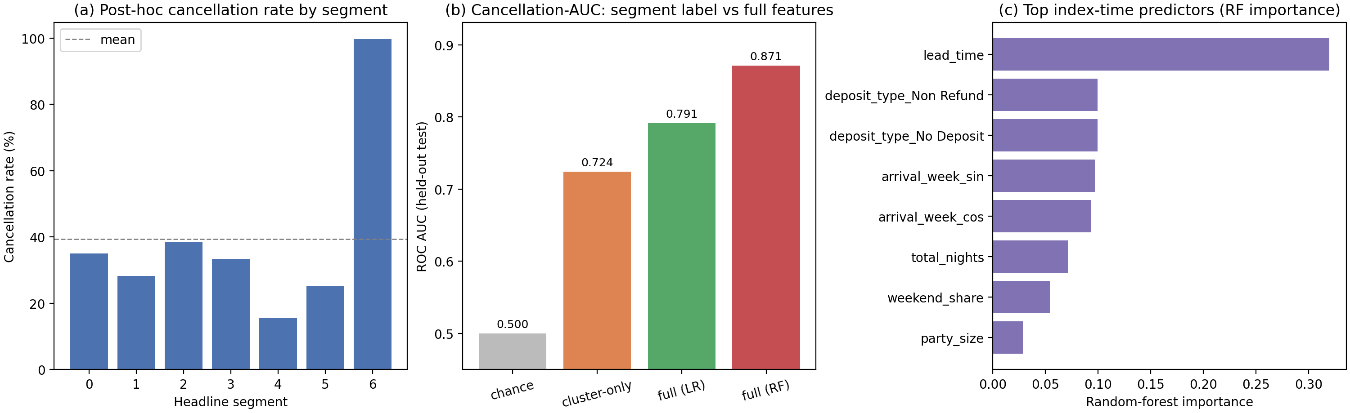
Figure 3. Post-hoc predictive utility of the segments (cancellation used only as an evaluation target). (a) Cancellation rate per segment. (b) ROC-AUC of the segment label alone versus the full index-time feature matrix (chance = 0.50). (c) Random Forest index-time predictors, recovering deposit type, lead time and seasonality.
Finally, to expose the decision boundaries behind the segments, not just their average profiles, we fit a shallow surrogate decision tree (depth 4, a predefined readability bound) that predicts the headline cluster label from the same governed features. Despite being only four levels deep, it reproduces the iK-means partition with substantial five-fold cross-validated fidelity (about 0.79 accuracy, fit-accuracy 0.83, far above the 0.23 majority-class baseline and logged in experiments.csv), so its rules are a largely faithful, transparent description of the segmentation rather than a separate model. Each segment reduces to a short axis-aligned conjunction. For example, a City Hotel booking with a Non-Refund deposit and long lead isolates the cancellation segment (Segment 6, leaf purity 1.0), while a Resort booking through a TA/TO channel with children present isolates the families segment (Segment 0, purity 1.0). The full per-segment rule set is in Appendix A, Figure A6, and tables/surrogate_tree_signatures.csv. That seven behavioural segments are substantially recoverable from four-deep splits on hotel, deposit type, channel, lead time, customer type and party shape, where a depth-4 tree alone reproduces about 80% of the assignment, confirms they are largely rule-like operational groups a revenue team could apply at booking time, not diffuse statistical artefacts.

5.3 Cluster coherence and representation robustness (RQ4, RQ5)
A t-SNE embedding of the primary space, coloured by the k = 7 labels (Figure 4), shows the segments occupy largely coherent, separable regions. Trustworthiness is about 0.996 across perplexities, so the visual gaps are reliable. The within-segment fragmentation reflects discrete one-hot combinations rather than noise.
We then compare three representations of the same governed inputs under the full protocol (RQ2, Figure 5). Retaining 90% of the variance by PCA (13 components) leaves the headline unchanged, since iK-means still selects k = 7, and improves it on every axis: silhouette rises from 0.140 to 0.158, Davies Bouldin from 1.82 to 1.72, and bootstrap stability from 0.86 to 0.91. A principled FAMD coding, the χ² mixed-data metric with (x−p)/√p per dummy, was expected to do better, but empirically does not help the stable headline: iK-means silhouette falls to 0.13 and its bootstrap stability collapses to 0.23, because the χ² up-weighting of rare categories spreads inertia across many thin directions that the anomalous-pattern peeling latches onto unstably. FAMD does give the best k-means separation (silhouette 0.18), yet k-means stays the less stable family. A fourth probe abandons Euclidean geometry entirely for Gower distance, the canonical mixed-data dissimilarity, under hierarchical clustering (Figure A4, fixed 5,000-row subsample): the headline structure is metric-dependent, recovered only moderately under complete linkage (ARI 0.51 against the iK-means headline) and weakly under chaining-prone average linkage (0.12). The RQ2 lesson is concrete. The conclusions are robust to, and improved by, linear PCA, but sensitive to the categorical metric, because both the FAMD χ² coding and the non-Euclidean Gower distance recover different structures. The headline is therefore the most stable, interpretable partition within its governed Euclidean representation, not a metric-invariant truth, and we report this rather than assume one representation is canonical. Finally, an ADR-inclusion test confirms the governance choice to exclude price. Adding price as a clustering input shifts the partition (ARI 0.71 versus the headline) and worsens its quality (silhouette 0.14 to 0.12), while the price-free segments already separate on price post-hoc (η² about 0.18), so price is best treated as a recoverable descriptor, not a co-defining input.
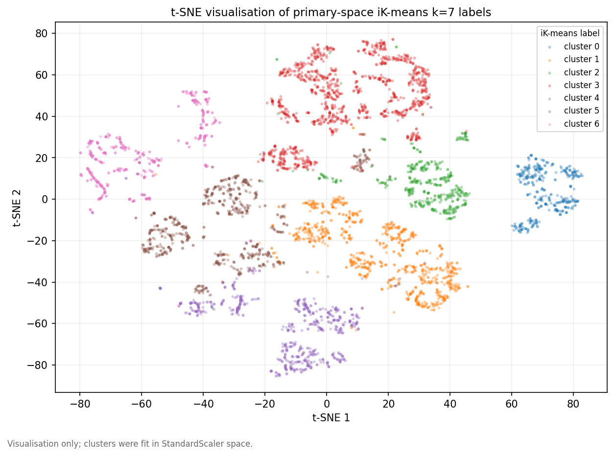
Figure 4. t-SNE of the primary space coloured by the seven iK-means labels (visualisation only, trustworthiness about 0.996).
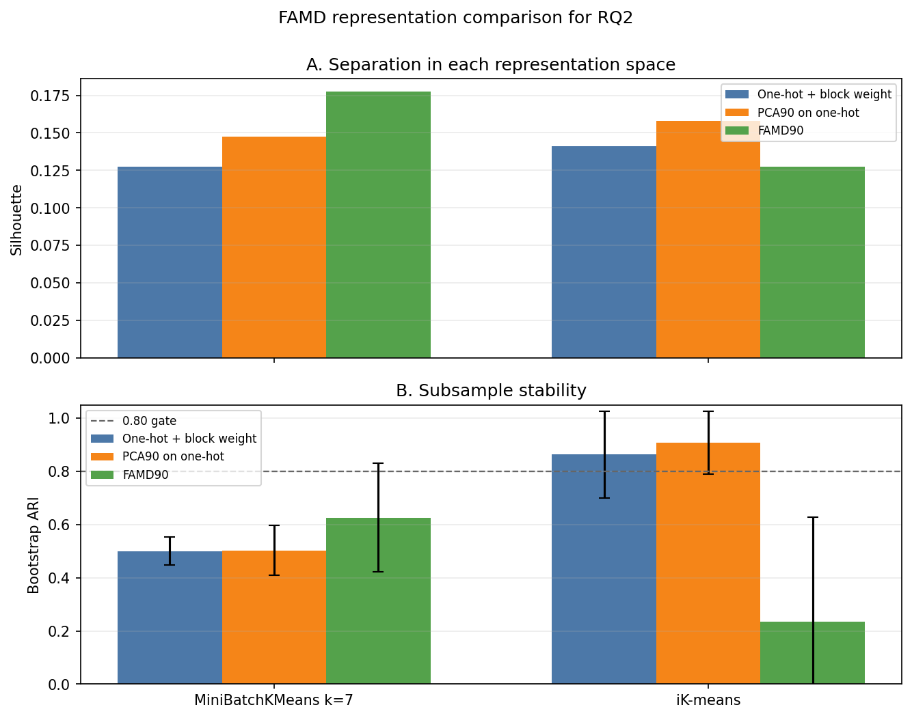
Figure 5. Representation comparison (one-hot versus PCA versus FAMD) by method: separation (silhouette) and bootstrap stability. PCA improves the iK-means headline on every axis, and the E4 study confirms k = 7 is invariant under it, while the principled FAMD coding does not, only sharpening the less stable k-means.

5.4 Cluster-aware anomaly analysis (E1)
Scoring each booking by its dispersion-normalised distance to its own cluster centroid surfaces two archetypes (Figure A5). The first is long-lead, zero-ADR group bookings that cancelled, flagged as data-quality records, likely placeholder or non-revenue entries, the extreme tail of Segment 6. The second is extreme long stays of 45 to 69 nights, some rare but plausible. Of the top-20, roughly thirteen are data-quality flagged and seven are plausible behaviour. The ranking is robust to the PCA representation change (Jaccard 0.90 between original and PCA top-200) but only weakly overlaps the RobustScaler degenerate cluster (Jaccard 0.06). The two notions of anomaly, atypical for one's own segment versus extreme raw magnitude, are genuinely different, and we report both rather than conflating them.

6. Discussion
What we measured and why. We measured recurring booking behaviour at confirmation time, because that is when operational and marketing decisions are made, and the segmentation question is deliberately index-time and leakage-free.
How modelling choices operationalise it. Mixed-type data is mapped to a dense Euclidean space with engineered behavioural features, cyclic seasonality, governed one-hot encoding and block balancing, so that the implied similarity reflects booking shape rather than raw column counts or one-hot width, and indices are computed in that same space.
Evaluation protocol. We required both internal quality (Silhouette, Calinski Harabasz and Davies Bouldin) and reproducibility (ARI at least 0.80 over ten seeds), with family-appropriate diagnostics such as the GMM AIC and BIC curves.
Interpretation in context. The answer to RQ3 is iK-means with StandardScaler at k = 7, the only family that is both stable and able to yield non-trivial segments. The answer to RQ4 is that the seven segments are operationally meaningful, namely families, extended resort stays, city premium and economy rooms, committed last-minute demand, long-lead groups, and a non-refundable cancellation segment, and they form coherent regions in an independent nonlinear embedding. The answer to RQ5 is that the headline is corroborated by a bootstrap stability test, not merely by the structural seed ARI, and is improved by PCA-13, whereas the instability of k-means and GMM is itself a finding, since both fail the 0.80 gate on the seed notion and the bootstrap notion, and an extended BIC search to k = 15 finds no parsimonious GMM optimum. Both a principled FAMD coding and a non-Euclidean Gower-distance hierarchical clustering recover different partitions, so the conclusions are robust to linear dimensionality reduction but sensitive to the categorical metric. The headline is the most stable, interpretable partition within its governed Euclidean representation, not a metric-invariant truth, and including price degrades quality, so the feature and metric scope is a conscious, evidence-based choice. The most decision-relevant output is Segment 6, a cancellation-risk group identifiable at booking time from long lead and non-refundable deposit, together with Segment 4, the committed last-minute demand worth protecting.

7. Limitations and ethics
Separation is modest in absolute terms, with a headline silhouette of about 0.15. The data supports a stable and interpretable segmentation, not strongly isolated clusters, and we state this rather than overclaim. The high-silhouette RobustScaler solution is degenerate and is reported as such. The iK-means seed stability is structural, from deterministic peeling, so we do not rest on it but corroborate it with a bootstrap test (ARI 0.86, the only family above the 0.80 gate) and report the residual spread honestly. The segmentation is also metric-dependent, since a principled FAMD coding and a non-Euclidean Gower distance recover different partitions, so we frame the headline as the most stable, interpretable structure within its governed Euclidean representation rather than the data's unique clustering. The t-SNE embedding uses a fixed 5,000-row subsample and is for visualisation only, so its distances are not globally meaningful. The anomaly analysis has no ground truth, since rare is not the same as bad, and is framed as atypicality for one's own segment. Ethically, country is held out as a control so that nationality cannot act as a proxy for cluster identity, and post-event outcomes never enter the segmentation. This exclusion is a conscious trade-off, not an oversight. Supervised studies of this dataset report that nationality is strongly predictive of cancellation, for example cancellation rates differing by a factor of two across source countries, so it carries real signal we forgo. We forgo it deliberately, because segmenting on nationality would risk operationalising a discriminatory proxy such as pricing or overbooking guests differently by country, and we judge a fair, behaviour-based segmentation more defensible than a marginally sharper one built on a protected attribute.
Use of generative-AI tools. In line with the course policy, we disclose that generative-AI assistants were used during this project for implementation support, such as code scaffolding and refactoring of the pipeline and extension scripts, for help structuring analyses and this report, and for consultation on methodological options. All modelling decisions, parameter choices and interpretations were reviewed and are reproducible end to end from the repository (run_all), and the team is able to explain and re-derive every result.

References
1. António, N., de Almeida, A., & Nunes, L. (2019). Hotel booking demand datasets. Data in Brief, 22, 41 to 49. https://doi.org/10.1016/j.dib.2018.11.126
2. Pedregosa, F., et al. (2011). Scikit-learn: Machine Learning in Python. Journal of Machine Learning Research, 12, 2825 to 2830.
3. Mirkin, B. (2005). Clustering for Data Mining: A Data Recovery Approach. Chapman & Hall/CRC.
4. van der Maaten, L., & Hinton, G. (2008). Visualizing data using t-SNE. Journal of Machine Learning Research, 9, 2579 to 2605.
5. Creative Commons. Attribution 4.0 International (CC BY 4.0). https://creativecommons.org/licenses/by/4.0/

Appendix A: Supplementary figures
Diagnostic and extension figures referenced from the main text are collected here. Each is reproduced end to end by run_all and is not counted against the main-body page budget.
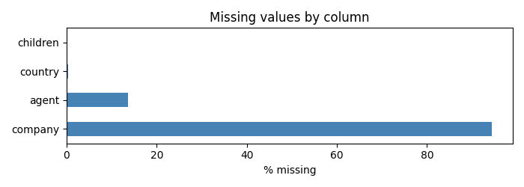
Figure A1. Missingness by column: company and agent dominate and are dropped as ID-like, while country is rare-grouped.
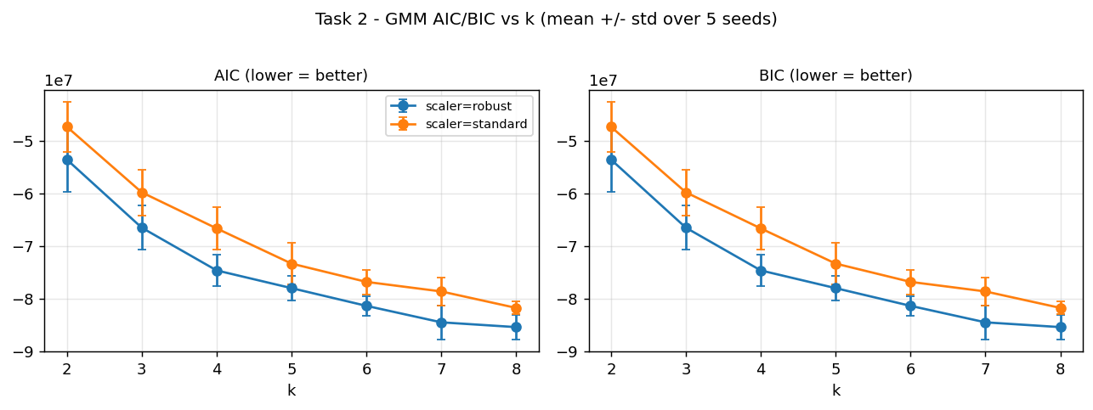
Figure A2. GMM AIC and BIC versus the number of components: both decrease monotonically to the k = 8 bound, that is, no interior optimum.
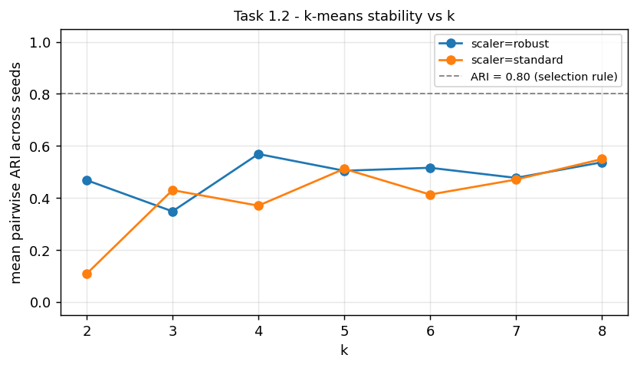
Figure A3. Mean pairwise ARI across k for MiniBatch k-means (both scalers). No configuration reaches the 0.80 stability gate, which is why the baseline is judged seed-fragile.
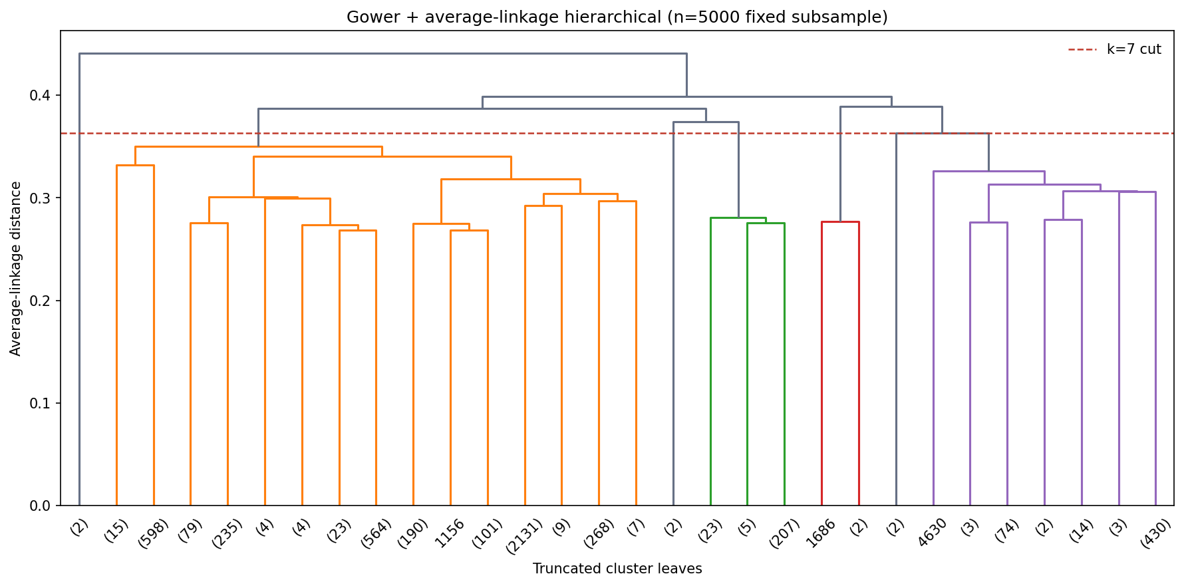
Figure A4. Gower with average-linkage hierarchical dendrogram (fixed 5,000-row subsample). Under this non-Euclidean mixed-data metric the headline seven-segment structure is only partially recovered (complete-linkage ARI 0.51, average-linkage 0.12), evidencing metric dependence.
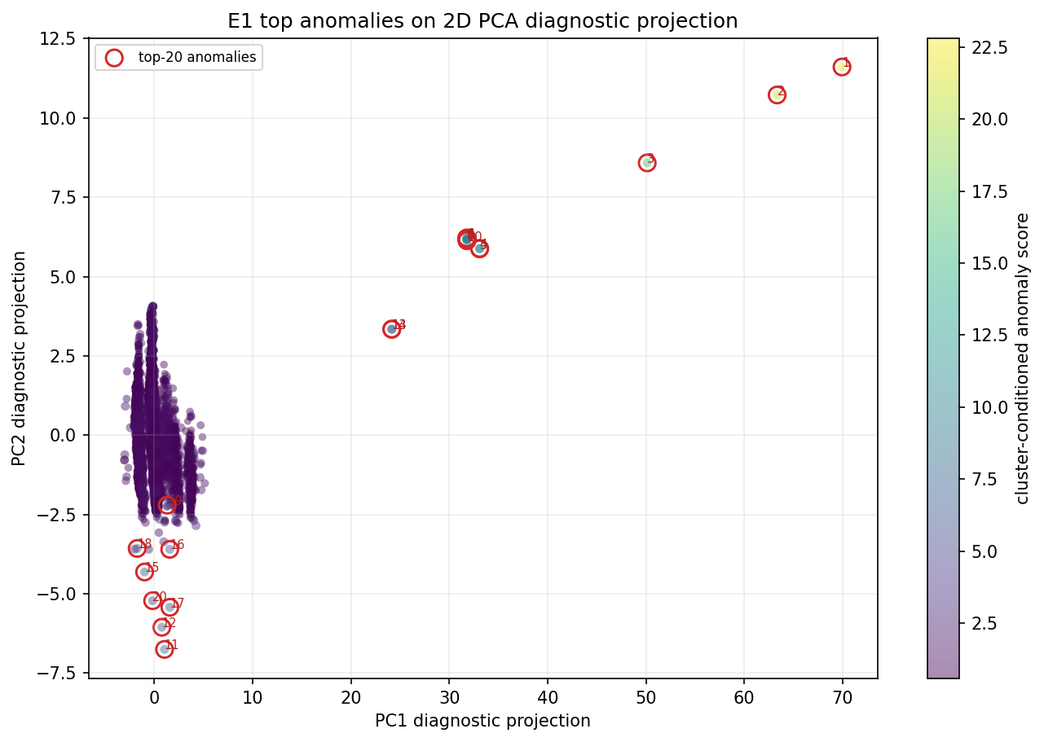
Figure A5. E1: primary-space projection coloured by anomaly score. The top-ranked anomalies sit at the peripheries of their segments.
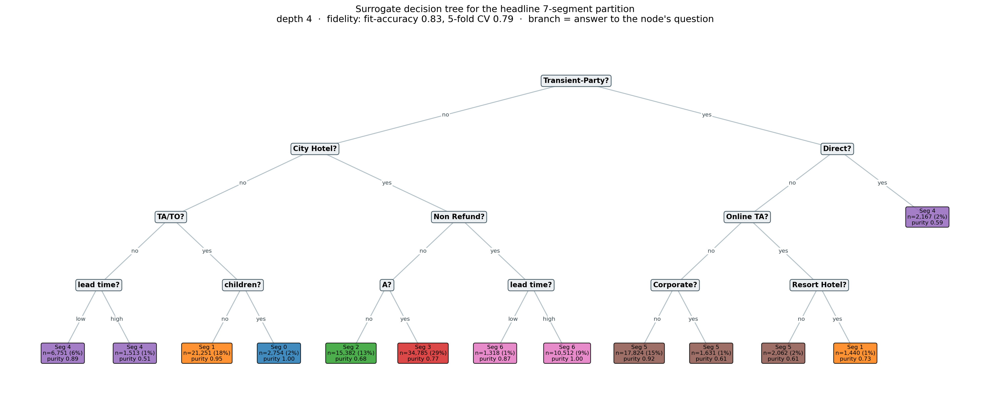
Figure A6. Surrogate decision tree (depth 4) approximating the headline seven-segment partition. Each leaf is a short conjunction of index-time splits (hotel, deposit type, channel, lead time, party shape) mapping to a segment. Substantial cross-validated fidelity, about 0.79, means these rules largely describe the iK-means clusters.

