Automated Spam & Fraud Message Detection for Business Messaging Channels
Deep Learning Course - Project Proposal
Team member | Haidar AlDahan – Group 11
Date | 18th September 2026

1. Problem Definition
Input: the raw text of a single inbound message (an SMS, or the same kind of short free text message received over WhatsApp on a business channel).
Output: a binary label: spam (fraud/unwanted) or ham (legitimate).
Task type: binary text classification (NLP).
Why it matters: Many wholesale and logistics businesses now take orders and customer inquiries over messaging channels (SMS/WhatsApp) instead of only through a web form. These channels attract the same premium-rate-number scams, phishing links, and prize/lottery spam that plague personal SMS. An automatic filter that flags likely spam/fraud before it reaches a human agent (or before an automated reply engine processes it) reduces wasted staff time and the risk of a scam link being acted on.

2. Dataset
SMS Spam Collection (Almeida & Hidalgo, 2011), a corpus of real SMS messages compiled from UK/Singapore consumer complaint forums and a Grumbletext archive (spam) plus messages volunteered for academic research (ham). Hosted on the UCI Machine Learning Repository.
Total messages | 5,572 real, individually labeled SMS messages
Labels | Binary- ham (4,825, 86.6%) / spam (747, 13.4%): imbalanced
Message length | Ham: mean 14.1 words (median 11) - Spam: mean 23.7 words (median 25)
Duplicates | 403 exact duplicate messages in the raw corpus removed during preprocessing before splitting
License / access | Creative Commons Attribution 4.0 (CC BY 4.0) - freely usable with credit: public on the UCI ML Repository

3. Train / Validation / Test Split
Split | Size | Purpose
Train | 3,620 msgs (70%) | 70% used for model fitting.
Validation | 776 msgs (15%) | 15% used for tuning, model selection, and threshold calibration.
Test | 775 msgs (15%) | 15% held out untouched to be used once for final evaluation.
Exact duplicate messages (403 of the 5,572) are removed first, leaving 5,169 unique messages (12.6% spam) so the same message never appears in two different subsets. The split is then stratified per class with a fixed random seed, preserving that 12.6% spam ratio in every subset.

4. Validation Metric
Primary metric: F1-score on the spam (positive) class, computed on the validation set. With only 13.4% of messages labeled spam, plain accuracy is misleading - a model that predicts “ham” for every message already scores 86.6% accuracy while catching zero spam. F1 balances precision (not misflagging legitimate customer messages, which would frustrate real buyers) against recall (actually catching spam/fraud attempts), which is the right trade-off for a business messaging filter. Precision and recall will also be reported individually to make that trade-off visible when tuning the decision threshold.

Figure 1 - Representative Data Samples
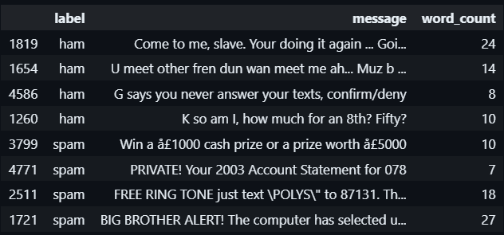
4 real ham and 4 real spam messages, sampled directly from the corpus.

Figure 2 - Message Length Distribution by Class
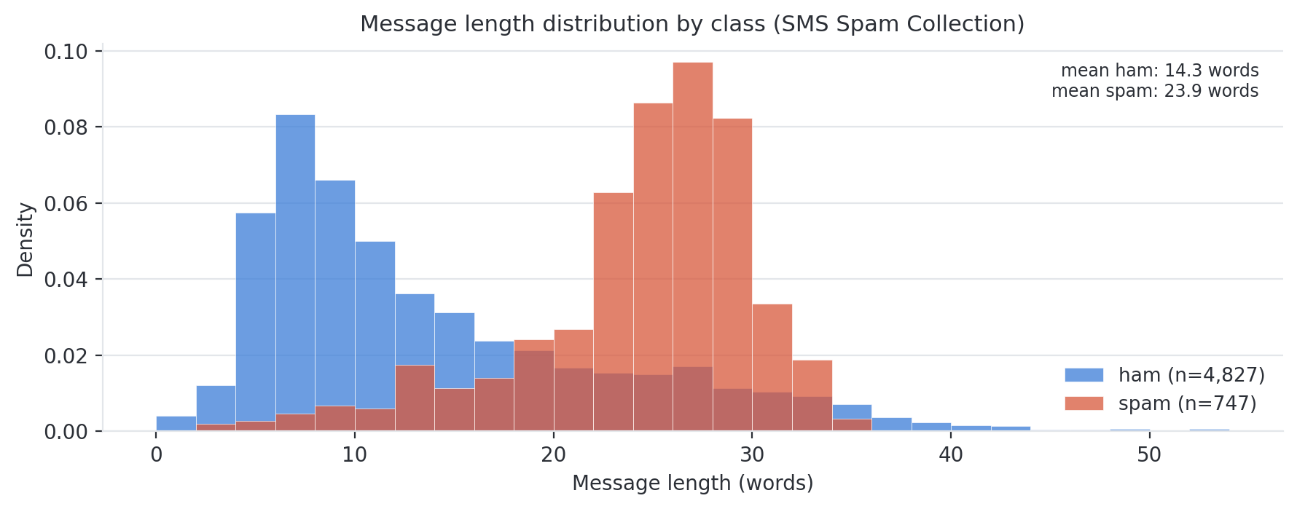
Word-count distribution of all 5,574 messages, split by class. Spam messages run noticeably longer on average (23.9 vs. 14.3 words) — a signal the model can learn from alongside the message content itself.

Reference: Almeida, T. A., Gómez Hidalgo, J. M., & Yamakami, A. (2011). “Contributions to the study of SMS spam filtering: new collection and results.” Proceedings of the 11th ACM Symposium on Document Engineering.
Dataset link: https://archive.ics.uci.edu/dataset/228/sms+spam+collection
Found the data on Kaggle: https://www.kaggle.com/datasets/uciml/sms-spam-collection-dataset?resource=download

