King Fahd University of Petroleum & Minerals
Information and Computer Science Department
SWE 439: Software Quality Engineering (Term 261)
Active Learning Homework #1
AI-Assisted Code Smell Detection: Two LLMs vs. a Static Analysis Tool on Apache Commons CLI
Team Member | Student ID
Haidar AlDahan | 202256620
Muhannad AlMelaifi | 202253960
Amjad AlSadiq | 202269000
Mahdi Al Hassan | 202271080
Section: 01 Date: 24 October 2026

Summary
This report compares code-smell detections from PMD (static analysis baseline), ChatGPT (proprietary) and DeepSeek (open-weight) on Apache Commons CLI (34 files, 2,840 LOC) for three smells: Long Method, God Class and Long Parameter List. Each LLM was run three times with the same prompt and input.
- Agreement with PMD (Run 1 overlap) ranged from 20.0% (ChatGPT, God Class) to 66.7% (DeepSeek, God Class).
- Repeatability was low: three-run consistency was 12.5%–28.6% for Long Method and Long Parameter List, and only four detections appeared in all six LLM runs.
- Explanation quality was 3/3 for 10 of the 11 scored explanations, so the rubric barely separated the LLMs and says nothing about correctness.
- Recommendation: use PMD as the repeatable gate and the LLMs as a second opinion and explanation aid, with repeated runs and human review.

1. Selection of Tools and Models

1.1 Tool, models and settings
Item | Name / version | Interface | Settings and notes
Static tool (baseline) | PMD 7.28.0 (results identical on OpenJDK 21.0.12 and Eclipse Adoptium JDK 17.0.15) | Command line: pmd check, XML report | Custom ruleset: GodClass (default); NcssCount with methodReportLevel = 30; ExcessiveParameterList with minimum = 5; --no-cache. Run on the comment-stripped sources.
Proprietary LLM | ChatGPT, model: GPT-6.1 Sol | Web interface (chatgpt.com) with file upload | New chat for each run; web search off; memory / custom instructions off.
Open-weight LLM | DeepSeek web chat, model: DeepSeek-V3 | Web interface (chat.deepseek.com) with file upload | New chat for each run; "Deep thinking" off; "Smart Search" off.

1.2 Exact prompt
The same prompt was used unchanged in all six runs, with commons-cli-scope.txt attached.
You are a code reviewer. The attached file "commons-cli-scope.txt" contains the Java source code of the Apache Commons CLI library (34 files, comments removed). Each file starts with a line "// ===== FILE: <path> =====".

Analyze the code for exactly these three code smells and ignore all others:

1. Long Method - a method that is too long or does too many things, making it hard to read and maintain.
2. God Class - a class that knows or does too much: it has many methods and responsibilities and depends heavily on data of other classes.
3. Long Parameter List - a method or constructor that takes too many parameters.

For EVERY detection, report these five fields:
- Smell: one of the three names above
- Code unit: the class name for God Class, or ClassName.methodName(parameter types) for the other two
- File: the file path from the "// ===== FILE" header
- Evidence: specific elements quoted or cited from the code (method/variable names, parameter lists, branches, loops, calls) that you are relying on
- Explanation: 1-3 sentences connecting that evidence to the defining characteristic of the smell

Rules:
- List detections grouped by smell, and inside each group in the order they appear in the source file.
- Report only detections you are reasonably confident about; do not pad the list.
- If you find no instance of a smell, write "None found" for that smell.
- Do not suggest refactorings and do not report any other smell.

1.3 Why this prompt
- It names the three smells with short definitions but no numeric thresholds, so each LLM uses its own judgement rather than PMD's limits.
- It requires code evidence and an explanation for every detection, in a fixed five-field format so detections can be matched reliably.
- It asks for source order, so the first two detections per smell can be picked for explanation scoring.
- "Report only detections you are reasonably confident about" and "None found" discourage padding and allow zero detections.

1.4 Reproducibility
- Repository: https://github.com/apache/commons-cli, commit bc23215cff121397c6c473a0633e5a7b77055511 (2026-10-17), directory src/main/java.
- Input preparation: comments and blank lines were removed with the script strip_comments.py (included in the submission), and the two comment-only package-info.java files were excluded, leaving 34 files concatenated into commons-cli-scope.txt. The stripped sources compiled without errors, and PMD ran on the same stripped code, so the tool and the LLMs saw identical input.
- The ruleset (pmd-ruleset.xml), strip_comments.py and reproduce.sh are included in the submission. The ruleset and commands are also in Appendix C, and PMD’s detections are listed in Appendix A.

2. Codebase Selection

2.1 Project and size
Apache Commons CLI is a Java library for parsing command-line arguments. Size was measured with pygount 3.2.0 (pygount --format=summary --suffix=java src/main/java), counting non-blank, non-comment lines (SLOC):
Scope | Files | Code LOC (SLOC) | Comment lines
src/main/java (whole library, tests excluded) | 36 | 2,842 | 5,168
Analysed scope (without 2 package-info.java, comments stripped) | 34 | 2,840 | 0

Comments were stripped (9,788 physical lines in total) so that the code fits into a single LLM upload.

2.2 Selected smells
Smell | PMD rule and setting | Why it is suitable
Long Method | NcssCount (method level), threshold 30 non-commenting statements (PMD default is 60) | Classic smell; PMD measures size directly while an LLM can also judge "does too many things". 7 detections.
God Class | GodClass (default: based on WMC, ATFD and TCC metrics) | Class-level smell; tool uses coupling and cohesion metrics, LLMs use responsibilities, so differences are informative. 5 detections.
Long Parameter List | ExcessiveParameterList, minimum 5 parameters (PMD default is 10) | Simple count-based smell that an LLM can verify from the signature. 10 detections.

We set the thresholds at 30 statements and 5 parameters so that every smell has enough detections for a meaningful overlap percentage.

2.3 Why this project and these smells
- Medium-sized, real-world code from a widely used Apache project, mixing older deprecated and newer classes, so detections are not concentrated in one style.
- All three smells can be judged by an LLM from source text alone and are covered by one PMD ruleset, so the comparison runs on identical input.
- The code is public open source, so uploading it to external AI services raises no confidentiality issue.

3. Code Smell Detection and Analysis

3.1 Procedure and matching rules
- PMD was run once and each LLM three times, always with the same prompt and file; Run 1 of each LLM is compared with PMD.
- A detection is one smell reported for one code unit: the class for God Class, and Class.method(parameter types) for Long Method and Long Parameter List.
- Two detections are the same (common) only if smell, file and code unit, including parameter types, match. Overloads (e.g. the printHelp(...) signatures) are separate units, and cli/HelpFormatter and cli/help/HelpFormatter are different classes.
- Every item an LLM listed counts as a detection, including ones it called borderline; one combined DeepSeek entry (two OptionFormatter.Builder setters) counts as two.
- Source order means the file order in commons-cli-scope.txt (alphabetical by path), then position within the file.
Overlap (%) = Common / (Static + LLM − Common) × 100, using Run 1.
Three-run consistency (%) = All-3-runs / (1-run-only + exactly-2-runs + all-3-runs) × 100, per LLM and smell.

3.2 Static tool results (PMD)
PMD reported 22 detections: 7 Long Method, 5 God Class and 10 Long Parameter List (Appendix A). God Class metrics (WMC, ATFD, TCC): CommandLine (97, 24, 2.0%), DefaultParser (131, 22, 19.1%), HelpFormatter (125, 34, 1.5%), Option (83, 19, 11.1%) and Parser (53, 11, 9.0%).

3.3 LLM detections per run
LLM / run | Long Method | God Class | Long Parameter List | Total
ChatGPT run 1 | 7 | 1 | 3 | 11
ChatGPT run 2 | 3 | 1 | 1 | 5
ChatGPT run 3 | 11 | 1 | 6 | 18
DeepSeek run 1 | 11 | 5 | 10 | 26
DeepSeek run 2 | 9 | 5 | 9 | 23
DeepSeek run 3 | 7 | 8 | 4 | 19

3.4 Worked examples of the formulas
- Overlap, ChatGPT God Class: Common = 1, Static = 5, LLM = 1, so 1 / (5 + 1 − 1) × 100 = 20.0%.
- Overlap, DeepSeek Long Method: Common = 6, Static = 7, LLM = 11, so 6 / (7 + 11 − 6) × 100 = 50.0%.
- Consistency, ChatGPT Long Method: 5 detections in one run only, 5 in exactly two, 2 in all three, so 2 / (5 + 5 + 2) × 100 = 16.7%.
Full results are in Tables 1 and 2 (Section 5).

3.5 Three representative disagreement cases

Case 1 – God Class: DefaultParser (PMD yes; ChatGPT never; DeepSeek always)
- PMD flagged it (WMC 131, ATFD 22, TCC 19.1%). ChatGPT never reported it: its only God Class in all three runs was HelpFormatter, and in run 3 it wrote that DefaultParser, CommandLine and Option "contain substantial functionality" but are "more consistently centered" on one job. DeepSeek reported it in all three runs, citing its fields and about twenty helper methods.
- Reading: the approaches use different criteria. PMD combines size, coupling and cohesion metrics, ChatGPT judged focus of responsibility, and DeepSeek size and breadth. DefaultParser has the highest cohesion of PMD's five classes (fitting ChatGPT's view) and the highest WMC (fitting DeepSeek's), so this shows a difference in criteria, not which approach is right.

Case 2 – Long Parameter List: HelpFormatter.printOptions(PrintWriter, int, Options, int, int) (PMD yes; LLMs mostly no)
- PMD flagged it for its 5 parameters (threshold 5), as it did renderOptions and appendOptions with the same parameter shape. ChatGPT reported it only in run 3 and DeepSeek never; DeepSeek run 1 reported appendOptions but not the other two.
- Code fact: printOptions and renderOptions only call appendOptions(...), whose 51-statement body is also a Long Method hit.
- Reading: the count-based rule fires on the signature alone, while the LLMs concentrated on the 6, 8 and 9 parameter printHelp overloads (the 9-parameter one in all six runs). The disagreement is mainly about the threshold, and DeepSeek flagging only one of three identical shapes shows the LLMs do not apply a consistent rule.

Case 3 – Long Method: HelpFormatter.printUsage(PrintWriter, int, String, Options) (LLMs yes; PMD no)
- ChatGPT reported it in runs 1 and 2 and DeepSeek in run 1; PMD did not, as the method has 18 statements (threshold 30).
- What the LLMs said: ChatGPT: it "combines ordering, option-group deduplication, rendering of individual options and groups, and final output formatting"; DeepSeek: "usage-string construction, group de-duplication, sorting, and output are all combined into one method".
- Reading: the LLMs counted responsibilities (sort, de-duplicate, render, print) while PMD counts statements. Agreement between the two LLMs makes random noise less likely, but whether 18 statements doing four steps is worth refactoring is a judgement for a human reviewer.

3.6 Evidence screenshots
Figures 1 and 2 show Run 1 of each LLM (attached file, prompt and start of the answer). All six answers are kept as PDF exports and text files.
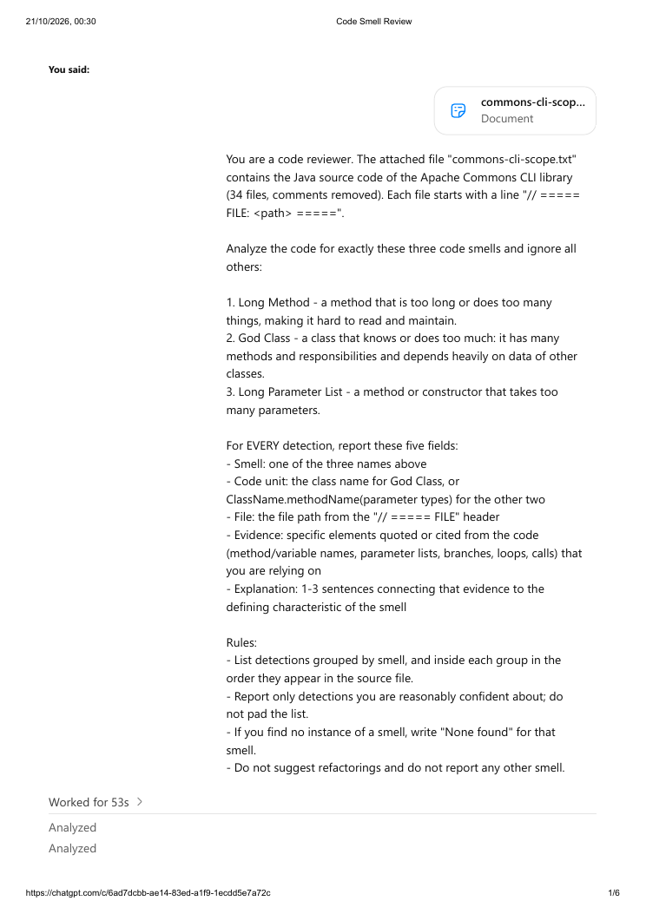 | 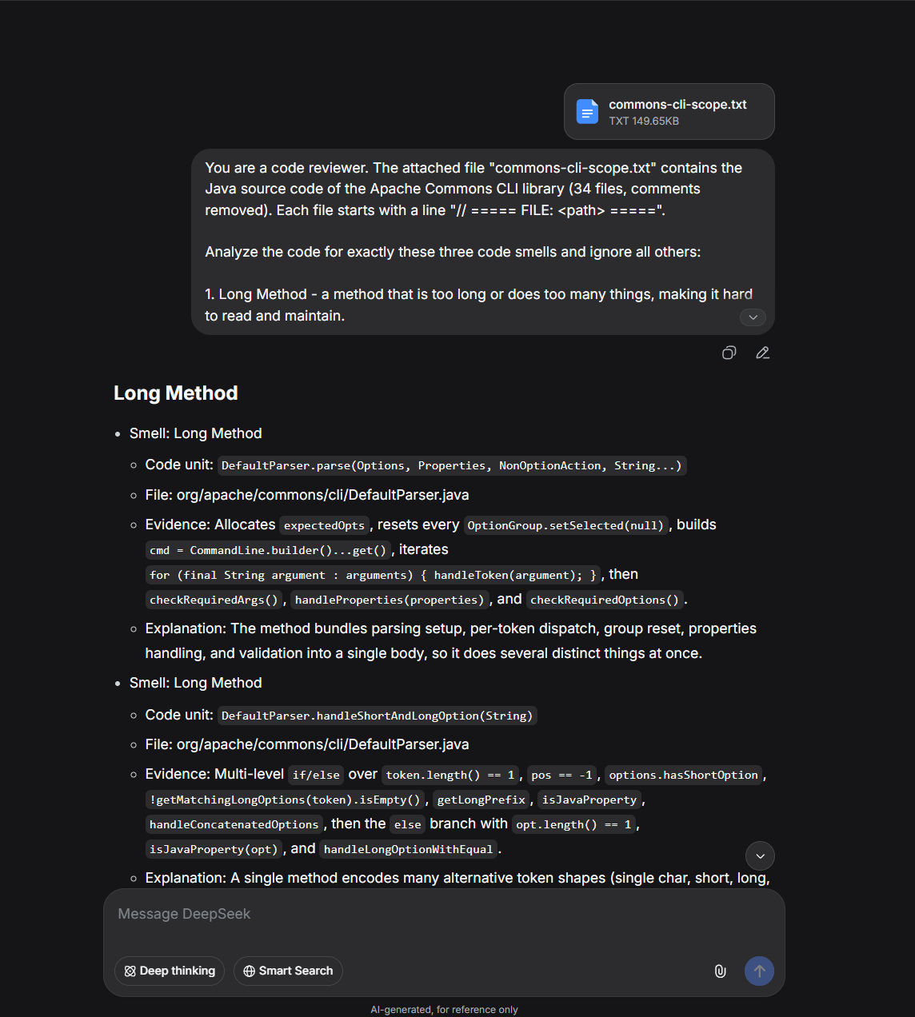
Figure 1 (left): ChatGPT run 1, first page of the exported chat. Figure 2 (right): DeepSeek run 1, first screenshot.
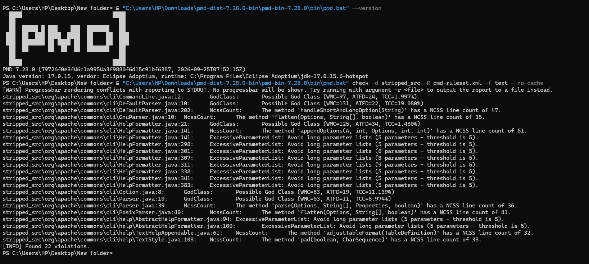Figure 3: PMD 7.28.0 run with the Appendix C ruleset on the comment-stripped sources (Windows, Java 17.0.15): 22 violations, matching Appendix A.

4. Critical Discussion and Reflection

4.1 Reliability
Table 2 (Section 5) gives the three-run consistency. It is low for the two long lists and uneven for God Class:
- Long Method: ChatGPT 16.7% (5 / 5 / 2 detections in one / two / all three runs), DeepSeek 21.4% (4 / 7 / 3). ChatGPT's count per run also swung from 7 to 3 to 11; DeepSeek's was steadier (11, 9, 7).
- Long Parameter List: ChatGPT 12.5% (7 / 0 / 1), DeepSeek 28.6% (9 / 1 / 4); most detections appeared in one run only.
- God Class: ChatGPT 100%, but from a single detection (HelpFormatter), so it says little; DeepSeek 62.5% (3 / 0 / 5), as its list grew from 5 to 8 classes in run 3.
Long lists of borderline items lower consistency even when the core is stable, and the core was stable: four detections appeared in all six runs, namely DefaultParser.handleShortAndLongOption and HelpFormatter.appendOptions (Long Method), HelpFormatter (God Class) and the nine-parameter HelpFormatter.printHelp (Long Parameter List). These are the two longest methods (47 and 51 statements) and the longest parameter list; the variation lies in the less obvious candidates. With three runs and one codebase, these figures are indicative only.

4.2 Detection tendencies
Only patterns seen in several observations are reported; none shows which approach is correct.
- ChatGPT reports God Class conservatively: one class (HelpFormatter) in every run, versus 5, 5 and 8 for DeepSeek, which always included CommandLine, DefaultParser, HelpFormatter, Option and TextHelpAppendable.
- Both LLMs report Long Methods below PMD's threshold: 7 of ChatGPT's 21 Long Method reports (33%) and 14 of DeepSeek's 27 (52%) have fewer than 30 statements (12–28), often multi-step methods such as printUsage (18) and findWrapPos (17).
- DeepSeek uses a looser parameter threshold: in every run it listed methods with 4 or fewer parameters (down to 2), e.g. Options.addOption(String, boolean, String); ChatGPT did so only in run 3.
- Both LLMs agree on the extremes: the longest methods, the longest parameter list and HelpFormatter were reported in every run.
- No LLM run reported Parser as a God Class or the two 5-parameter AbstractHelpFormatter.printHelp signatures, all flagged by PMD.

4.3 Explanation quality
For each LLM and smell, the first two Run 1 detections in source order (or all, if fewer) were scored 0–3, one point each for code reference, smell characteristic and evidence-to-smell link. Every code element cited in the 11 explanations exists in the code. The score rates the explanation, not the detection.

LLM | Smell | Detection scored (Run 1) | Score /3 | Mean
ChatGPT | Long Method | DefaultParser.handleShortAndLongOption | 3 | 3.00
 |  | GnuParser.flatten | 3
ChatGPT | God Class | HelpFormatter (only 1 detection) | 3 | 3.00
ChatGPT | Long Param. List | HelpFormatter.printHelp (6 params) | 3 | 3.00
 |  | HelpFormatter.printHelp (8 params) | 3
DeepSeek | Long Method | DefaultParser.handleShortAndLongOption | 3 | 3.00
 |  | DefaultParser.parse (4 params) | 3
DeepSeek | God Class | CommandLine | 3 | 3.00
 |  | DefaultParser | 3
DeepSeek | Long Param. List | DefaultParser.parse (4 params) | 1 | 2.00
 |  | HelpFormatter.appendOptions (5 params) | 3

- Ten of the 11 explanations scored 3, a ceiling effect: the rubric barely separates the LLMs, both of which quote code and state what the smell means.
- The one deduction: DeepSeek's Long Parameter List explanation for DefaultParser.parse only says its four parameters carry "several unrelated concerns", never that the list is long, so it scores for code reference only.
- A high score does not mean a correct detection: DeepSeek's explanation of DefaultParser.parse as a Long Method scored 3, though PMD counts only 16 statements.

4.4 Ethical implications
- Automation bias: fluent, confident explanations (3/3 even for a 16-statement "Long Method") invite acceptance without checking. Detections should be verified against the code; PMD at least gives a measurable reason.
- Over-reliance on unstable output: the same prompt gave different answers each run (12.5%–28.6% consistency on the long lists), so trusting one run could miss smells or trigger needless refactoring.
- Confidentiality: web chats send source code to external providers with their own retention, training and jurisdiction terms. This was harmless for public code but would be unacceptable for client or employer code without an agreement; self-hosted open-weight models or no-training enterprise terms reduce the risk.
- Accountability: the person who accepts a recommendation remains responsible for it, and LLM assistance should be disclosed.

5. Summary and Recommendations

Table 1: Detection Comparison Summary (PMD vs Run 1 of each LLM)
Comparison Pair | Smell Type | Static Detections | LLM Detections (Run 1) | Common | Static Only | LLM Only | Overlap (%) | Comments
PMD vs ChatGPT (Run 1) | Long Method | 7 | 7 | 5 | 2 | 2 | 55.6% | Missed Parser.parse and adjustTable​Format; added printUsage (18 statements) and parsePattern (28), both under PMD's 30.
PMD vs ChatGPT (Run 1) | God Class | 5 | 1 | 1 | 4 | 0 | 20.0% | Only HelpFormatter; PMD-only: CommandLine, DefaultParser, Option, Parser.
PMD vs ChatGPT (Run 1) | Long Param. List | 10 | 3 | 3 | 7 | 0 | 30.0% | Only the 6-, 8- and 9-parameter printHelp; PMD also flags seven 5-parameter methods.
PMD vs DeepSeek (Run 1) | Long Method | 7 | 11 | 6 | 1 | 5 | 50.0% | Missed only TextStyle.pad; added 5 methods below PMD's threshold (12–28 statements).
PMD vs DeepSeek (Run 1) | God Class | 5 | 5 | 4 | 1 | 1 | 66.7% | Missed Parser; added TextHelp​Appendable.
PMD vs DeepSeek (Run 1) | Long Param. List | 10 | 10 | 5 | 5 | 5 | 33.3% | Matched all printHelp overloads and appendOptions; added 3–4-parameter methods; missed printOptions, renderOptions and both AbstractHelp​Formatter methods.
Table 1: Detection Comparison Summary

Table 2: LLM Reliability and Explanation Quality Summary
LLM | Smell Type | 1 Run Only | Exactly 2 Runs | All 3 Runs | Total Distinct | Consistency (%) | Mean Explanation Quality (/3)
ChatGPT | Long Method | 5 | 5 | 2 | 12 | 16.7% | 3.00
ChatGPT | God Class | 0 | 0 | 1 | 1 | 100.0% | 3.00
ChatGPT | Long Param. List | 7 | 0 | 1 | 8 | 12.5% | 3.00
DeepSeek | Long Method | 4 | 7 | 3 | 14 | 21.4% | 3.00
DeepSeek | God Class | 3 | 0 | 5 | 8 | 62.5% | 3.00
DeepSeek | Long Param. List | 9 | 1 | 4 | 14 | 28.6% | 2.00
Table 2: LLM Reliability and Explanation Quality Summary
Recurring tendencies: ChatGPT reports one God Class per run while DeepSeek reports many; both include Long Methods below PMD's 30-statement threshold (33% and 52% of reports); DeepSeek accepts shorter parameter lists; and both reproduce the extreme cases in every run.

Recommendations
- Keep the static tool as the gate. PMD is repeatable and its thresholds are explicit; the LLMs matched only 20–67% of its Run 1 detections and reached 12.5–28.6% consistency on the long lists, so they cannot replace it.
- Use an LLM as a second opinion. Its extra detections (e.g. printUsage, parsePattern) were mostly just under PMD's threshold: candidates for human review, not findings.
- Run it several times and rank by repetition. One-run-only items made up 12 of ChatGPT's 21 and 16 of DeepSeek's 36 distinct detections, while the stable detections were the clear cases. Requiring at least 2 of 3 runs is a practical filter.
- Use the LLM to explain tool findings. Its explanations were consistently well-formed (10 of 11 scored 3), so it could explain PMD results to developers; this was not tested here and needs human checking.
- Make thresholds explicit when agreement matters. Most Long Method and Long Parameter List differences were threshold differences; stating PMD's limits in the prompt may raise agreement, which remains to be tested.
- Protect the code. Use self-hosted models or no-training terms for non-public code, and keep a human accountable for each accepted recommendation.
Limitations: one project, three smells, one prompt, three runs per LLM, changing web-chat versions, and our own choice of PMD thresholds and matching rules; different choices would change the percentages.

LLM Usage Declaration
Required experimental use: ChatGPT and DeepSeek were used as the two LLMs under test; their outputs are the data in Sections 3–5.
Additional AI assistance: We used Claude (Anthropic) as an assistant for: choosing the codebase and configuring and running PMD (Sections 1–2); preparing the comment-stripped code bundle and the prompt; extracting the detections from the six answers, matching them and computing Tables 1 and 2; drafting the explanation-quality scores (Section 4.3); and drafting the text and formatting of this report (Sections 1–5, appendices).
All team members reviewed and edited the text and scores and understood the AI assistance instructions.

Appendix A – PMD detections (22)
Lines refer to the comment-stripped files. LM = Long Method, GC = God Class, LPL = Long Parameter List.
Smell | File | Code unit | Signature (from source) | Line
GC | cli/CommandLine.java | CommandLine | (class) | 12
GC | cli/DefaultParser.java | DefaultParser | (class) | 10
GC | cli/HelpFormatter.java | HelpFormatter | (class) | 21
GC | cli/Option.java | Option | (class) | 8
GC | cli/Parser.java | Parser | (class) | 10
LM | cli/DefaultParser.java | DefaultParser.handleShortAndLongOption | private void handleShortAndLongOption(String hyphenToken) | 202
LM | cli/GnuParser.java | GnuParser.flatten | protected String[] flatten(Options options, String[] arguments, boolean stopAtNonOption) | 10
LM | cli/HelpFormatter.java | HelpFormatter.appendOptions | <A extends Appendable> A appendOptions(A sb, int width, Options options, int leftPad, int descPad) | 141
LM | cli/Parser.java | Parser.parse | public CommandLine parse(Options options, String[] arguments, Properties properties, boolean stopAtNonOption) | 39
LM | cli/PosixParser.java | PosixParser.flatten | protected String[] flatten(Options options, String[] arguments, boolean stopAtNonOption) | 40
LM | cli/help/TextHelpAppendable.java | TextHelpAppendable.adjustTableFormat | protected TableDefinition adjustTableFormat(TableDefinition table) | 61
LM | cli/help/TextStyle.java | TextStyle.pad | public CharSequence pad(boolean addIndent, CharSequence text) | 108
LPL | cli/HelpFormatter.java | HelpFormatter.appendOptions | <A extends Appendable> A appendOptions(A sb, int width, Options options, int leftPad, int descPad) | 141
LPL | cli/HelpFormatter.java | HelpFormatter.printHelp | public void printHelp(int width, String cmdLineSyntax, String header, Options options, String footer) | 298
LPL | cli/HelpFormatter.java | HelpFormatter.printHelp | public void printHelp(int width, String cmdLineSyntax, String header, Options options, String footer, boolean autoUsage) | 301
LPL | cli/HelpFormatter.java | HelpFormatter.printHelp | public void printHelp(PrintWriter pw, int width, String cmdLineSyntax, String header, Options options, int leftPad, int descPad, String footer) | 307
LPL | cli/HelpFormatter.java | HelpFormatter.printHelp | public void printHelp(PrintWriter pw, int width, String cmdLineSyntax, String header, Options options, int leftPad, int descPad, String footer, boolean autoUsage) | 311
LPL | cli/HelpFormatter.java | HelpFormatter.printHelp | public void printHelp(String cmdLineSyntax, String header, Options options, String footer, boolean autoUsage) | 338
LPL | cli/HelpFormatter.java | HelpFormatter.printOptions | public void printOptions(PrintWriter pw, int width, Options options, int leftPad, int descPad) | 341
LPL | cli/HelpFormatter.java | HelpFormatter.renderOptions | protected StringBuffer renderOptions(StringBuffer sb, int width, Options options, int leftPad, int descPad) | 383
LPL | cli/help/AbstractHelpFormatter.java | AbstractHelpFormatter.printHelp | public void printHelp(String cmdLineSyntax, String header, Iterable<Option> options, String footer, boolean autoUsage) | 94
LPL | cli/help/AbstractHelpFormatter.java | AbstractHelpFormatter.printHelp | public void printHelp(String cmdLineSyntax, String header, Options options, String footer, boolean autoUsage) | 100

Appendix B – Detection matrix (all 45 distinct detections)
A tick means the approach reported that smell for that code unit. G1–G3 = ChatGPT runs, D1–D3 = DeepSeek runs.
Smell | Code unit | PMD | G1 | G2 | G3 | D1 | D2 | D3
LM | CommandLine.getParsedOptionValues(Option,Supplier<T[]>) |  |  |  |  |  | ✓ | ✓
LM | DefaultParser.handleShortAndLongOption(String) | ✓ | ✓ | ✓ | ✓ | ✓ | ✓ | ✓
LM | DefaultParser.handleToken(String) |  |  |  |  |  | ✓ | ✓
LM | DefaultParser.parse(Options,Properties,NonOptionAction,String[]) |  |  |  |  | ✓ | ✓ | ✓
LM | GnuParser.flatten(Options,String[],boolean) | ✓ | ✓ |  | ✓ | ✓ |  | ✓
LM | HelpFormatter.appendOptions(Appendable,int,Options,int,int) | ✓ | ✓ | ✓ | ✓ | ✓ | ✓ | ✓
LM | HelpFormatter.appendWrappedText(Appendable,int,int,String) |  |  |  | ✓
LM | HelpFormatter.findWrapPos(String,int,int) |  |  |  |  | ✓
LM | HelpFormatter.printHelp(PrintWriter,int,String,String,Options,int,int,String,boolean) |  |  |  |  | ✓ | ✓
LM | HelpFormatter.printUsage(PrintWriter,int,String,Options) |  | ✓ | ✓ |  | ✓
LM | Parser.parse(Options,String[],Properties,boolean) | ✓ |  |  | ✓ | ✓
LM | Parser.processProperties(Properties) |  |  |  | ✓
LM | PatternOptionBuilder.parsePattern(String) |  | ✓ |  | ✓ | ✓ | ✓
LM | PosixParser.flatten(Options,String[],boolean) | ✓ | ✓ |  | ✓ | ✓ |  | ✓
LM | TypeHandler.putDefaultMap(Map) |  |  |  |  |  | ✓
LM | HelpFormatter.getTableDefinition(Iterable<Option>) [help pkg] |  |  |  | ✓
LM | TextHelpAppendable.adjustTableFormat(TableDefinition) [help pkg] | ✓ |  |  | ✓ | ✓ | ✓
LM | TextStyle.pad(boolean,CharSequence) [help pkg] | ✓ | ✓ |  | ✓
GC | CommandLine | ✓ |  |  |  | ✓ | ✓ | ✓
GC | DefaultParser | ✓ |  |  |  | ✓ | ✓ | ✓
GC | HelpFormatter | ✓ | ✓ | ✓ | ✓ | ✓ | ✓ | ✓
GC | Option | ✓ |  |  |  | ✓ | ✓ | ✓
GC | Options |  |  |  |  |  |  | ✓
GC | Parser | ✓
GC | PatternOptionBuilder |  |  |  |  |  |  | ✓
GC | TypeHandler |  |  |  |  |  |  | ✓
GC | TextHelpAppendable [help pkg] |  |  |  |  | ✓ | ✓ | ✓
LPL | DefaultParser.parse(Options,Properties,NonOptionAction,String[]) |  |  |  | ✓ | ✓ | ✓ | ✓
LPL | HelpFormatter.appendOptions(Appendable,int,Options,int,int) | ✓ |  |  | ✓ | ✓
LPL | HelpFormatter.printHelp(PrintWriter,int,String,String,Options,int,int,String) | ✓ | ✓ |  |  | ✓ | ✓ | ✓
LPL | HelpFormatter.printHelp(PrintWriter,int,String,String,Options,int,int,String,boolean) | ✓ | ✓ | ✓ | ✓ | ✓ | ✓ | ✓
LPL | HelpFormatter.printHelp(String,String,Options,String,boolean) | ✓ |  |  |  |  | ✓
LPL | HelpFormatter.printHelp(int,String,String,Options,String) | ✓ |  |  |  | ✓
LPL | HelpFormatter.printHelp(int,String,String,Options,String,boolean) | ✓ | ✓ |  |  | ✓ | ✓ | ✓
LPL | HelpFormatter.printOptions(PrintWriter,int,Options,int,int) | ✓ |  |  | ✓
LPL | HelpFormatter.renderOptions(StringBuffer,int,Options,int,int) | ✓ |  |  | ✓
LPL | Option(String,String,boolean,String) |  |  |  | ✓ | ✓ | ✓
LPL | Options.addOption(String,String,boolean,String) |  |  |  |  | ✓
LPL | Options.addOption(String,boolean,String) |  |  |  |  | ✓
LPL | Options.addRequiredOption(String,String,boolean,String) |  |  |  |  | ✓
LPL | AbstractHelpFormatter.printHelp(String,String,Iterable<Option>,String,boolean) [help pkg] | ✓
LPL | AbstractHelpFormatter.printHelp(String,String,Options,String,boolean) [help pkg] | ✓
LPL | OptionFormatter.Builder.setArgumentNameDelimiters(String,String) [help pkg] |  |  |  |  |  | ✓
LPL | OptionFormatter.Builder.setOptionalDelimiters(String,String) [help pkg] |  |  |  |  |  | ✓
LPL | TableDefinition.from(String,List<TextStyle>,List<String>,Iterable<List<String>>) [help pkg] |  |  |  |  |  | ✓

Appendix C – PMD ruleset and commands
Ruleset pmd-ruleset.xml:
<?xml version="1.0"?>
<ruleset name="smells" xmlns="http://pmd.sourceforge.net/ruleset/2.0.0">
<description>3 smells</description>
<rule ref="category/java/design.xml/GodClass"/>
<rule ref="category/java/design.xml/NcssCount">
<properties>
<property name="methodReportLevel" value="30"/>
<property name="classReportLevel" value="100000"/>
</properties>
</rule>
<rule ref="category/java/design.xml/ExcessiveParameterList">
<properties><property name="minimum" value="5"/></properties>
</rule>
</ruleset>

Commands used:
git clone https://github.com/apache/commons-cli.git
git -C commons-cli checkout bc23215cff121397c6c473a0633e5a7b77055511
pygount --format=summary --suffix=java commons-cli/src/main/java
python3 strip_comments.py commons-cli/src/main/java stripped_src commons-cli-scope.txt
pmd check -d stripped_src -R pmd-ruleset.xml -f text --no-cache
Running the command above reproduces the 22 detections listed in Appendix A (see Figure 3).

