

Digital Egypt Pioneers Initiative (DEPI) Graduation Project

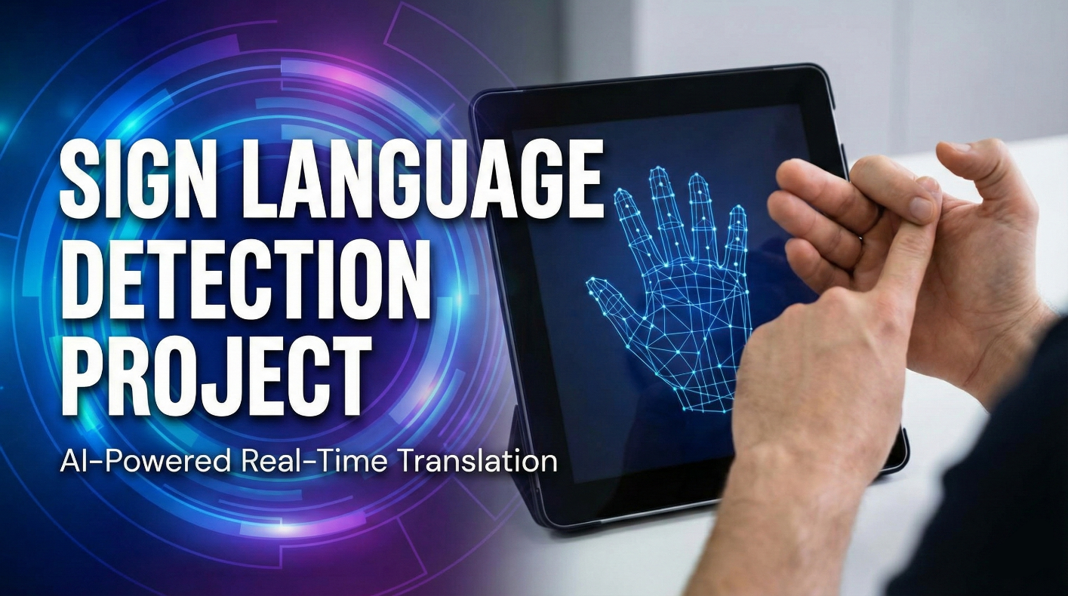

Abdelrahman Elsebaiey
Ahmed Hassan
Mohamed Elnemr
Nora Mohamed
Ziyad Fouda

Summary:
This project aims to build a lightweight and accurate system for detecting specific sign-language words using real-time hand-gesture recognition. The solution combines Mediapipe’s hand-landmark extraction with a custom-trained machine-learning model to deliver fast and reliable predictions.
The system includes a friendly and simple user interface that allows users to start/stop the camera, view live detection results, and interact with the application easily. The UI is designed to be intuitive, beginner-friendly, and suitable for real-time demonstrations.
Overall, the project provides an efficient and user-friendly tool for recognizing selected sign-language words, combining accurate data collection, real-time computer vision, and a clean interface.
Data:
- Problems with Existing Data
Most publicly available sign-language or hand-gesture datasets are image-based and not optimized for Mediapipe.
Because of this, several issues appear:
- Inaccurate or unstable landmark detection: Mediapipe expects clear, centered hands with specific angles and lighting. Many datasets contain low-quality or inconsistent images, causing Mediapipe to produce noisy or incorrect landmarks.
- Variation in background, lighting, and hand orientation: This makes the model learn irrelevant features, reducing accuracy.
- Poor results with YOLO for gesture detection: Even when YOLO is used, many datasets are not annotated for gestures or hand shapes. YOLO may detect the hand bounding box, but not the gesture itself, leading to weak classification performance.
- Inconsistent labeling: Different datasets follow different formats and labeling rules, making training unstable.
Because of these problems, using existing datasets directly leads to bad model accuracy whether using Mediapipe landmarks or YOLO bounding boxes.

- Collecting Our Own Data
To solve the accuracy issues, we build our own custom dataset.
- We record each gesture manually using the webcam.
- For every recording, Mediapipe extracts 21 landmark points for a single hand.
- Each landmark contains an x, y position → a total of 42 features per sample.
- For every gesture/label, we collect around 300 samples.
- All samples are saved into a dataset file (CSV or NumPy) where each row represents:
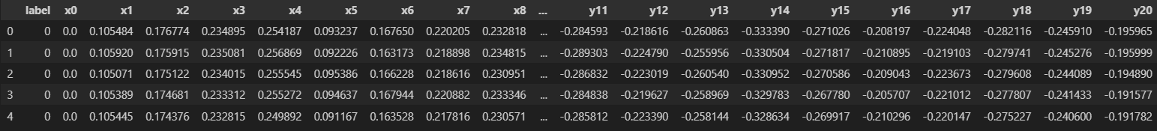
The label, x and y values for each landmark
This approach ensures:
- Consistent lighting
- Same camera quality
- Same hand orientation rules
- Higher accuracy for training
- Dataset tailored exactly for the model
Classes:
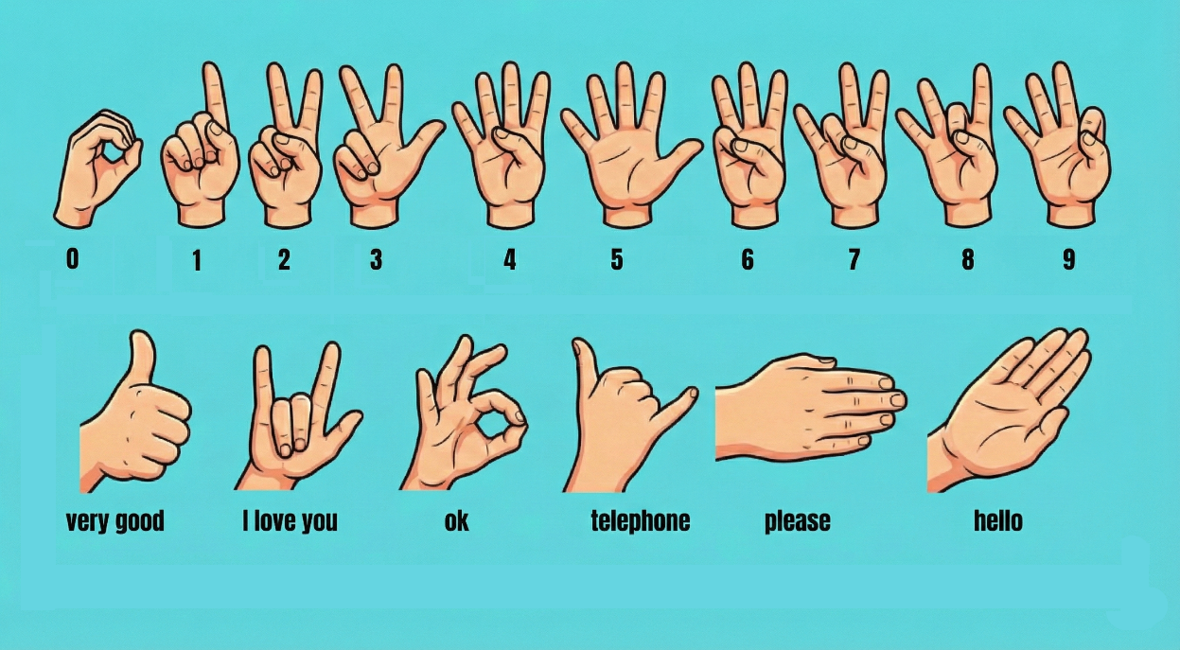

- Mediapipe
Mediapipe is a framework by Google for realtime hand-tracking. It works through:
- Palm Detection Model
  - First, Mediapipe detects the hand region using a lightweight neural network.
  - This creates a bounding box around the hand.
- Hand Landmark Model
  - Inside the box, a second model predicts 21 3D hand landmarks.
  - These landmarks describe fingers, joints, and hand orientation.

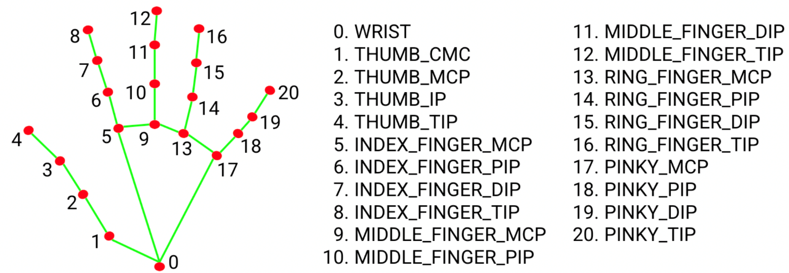
- Coordinate Normalization
  - Landmarks are output as normalized values (0–1) based on the image width and height.
- Tracking
  - After detecting the first frame, Mediapipe switches to tracking mode
→ faster and more stable.

- Output
  - Clean, smooth, accurate 3D positions of the hand that can be used for:
    - Gesture classification
    - Sign-language recognition
    - Robotics
    - AR/VR
Mediapipe is efficient, lightweight, and ideal for building real-time gesture recognition systems like ours.

Model:
To classify the hand gestures, the system uses a Random Forest machine-learning model. This model is well-suited for landmark-based gesture recognition because it can handle noisy data, nonlinear patterns, and high-dimensional inputs such as the 42 landmark features generated by Mediapipe. Random Forest works by training multiple decision trees and combining their outputs, which improves stability and reduces overfitting. After training on our custom dataset, the model achieved strong and consistent performance in predicting the selected sign-language words, making it a reliable choice for real-time gesture detection.

