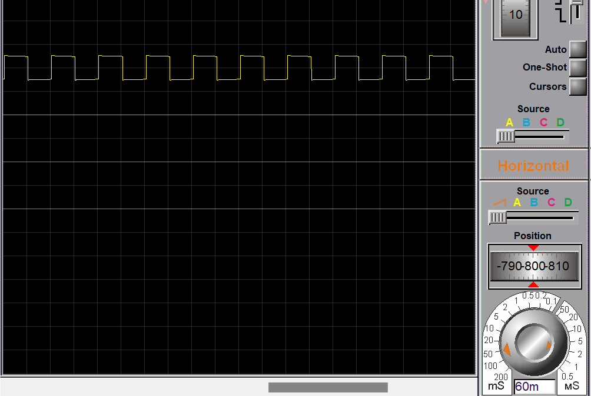

125 count -> 1 second

60ms -> 0.06 seconds

125\*6/100 = 7.5 in (0X05)

15 in (0X04)

RC0 = 0 in 0 count

RC0 = 1 in 15

RC0 = 0 in 30

RC0 = 1 in 45