

293

TGPSI

Technological Project Project leChat

Manual (25-06-2012)

Nº 103629 – David Samuel Pereira Silva

Nº 104289 – Diogo Alexandre Flores Simões de Jesus



Index

Content

1. Client side functionality 3

1.1. How to start? 3

1.2. Preferences 4

1.2.1. Preferences - General 4

1.2.2. Preferences- Connection 5

1.2.3. Preferences – Notifications 6

1.3. Connect 7

1.4. Sending messages 9

1.5. Files 10

1.5.1. Receiving Files 10

1.5.2. Sending files 11

1.6. Commands 12

1.7. Extras 14

1.7.1. Extras – RSS Feed 14

1.7.2. Extras – Browser 16

1.7.3. Extras – Others 17

2. Server-side functionality 18

2.1. How to start 18

2.2. Commands 19

1. Client side functionality

The functionality of the client side features will be described here

* 1. How to start?

To start using leChat properly, you must first set your preferences (fourth button on the top and marked in red in image below).

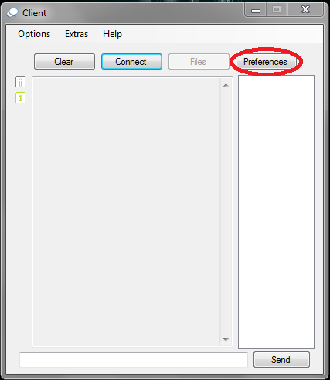

Illustration 1

* 1. Preferences

In the preferences you will find three areas: General, Connection and Notifications. These three areas will help you configure leChat.

* + 1. Preferences - General

In the "General" preferences will find several text boxes empty, the one that will have to fill in the "Nickname" that will identify you in chat; all other text boxes are optional. The selection box will display your present state to the rest of the users of the chat. Be aware that as the configuration is still not over, it will have to fill in the connection area.

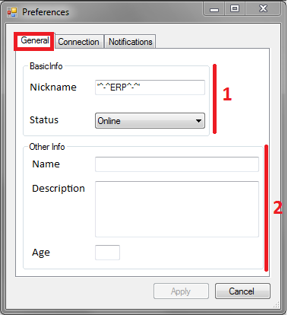

Illustration 2

**Legend:**

**1** – Required.

**2** – Optional.

* + 1. Preferences- Connection

In the "Connection" you can choose a server that has previously saved or write the same on the text boxes "Server" where the first one is the server IP and the second one is the port. This information can be gained through the server administrator. To add a server to the list, all text boxes have to be filled.

Note: With the "Nickname" and "Server" filled out the "Apply" button will be enabled.

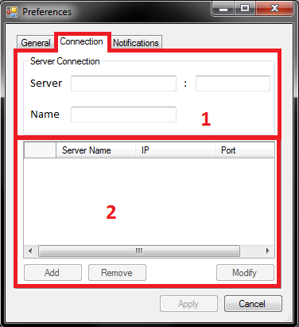

Illustration 3

**Legend:**

**1** – Server info.

**2** – Server list.

* + 1. Preferences – Notifications

In the "Notifications" the user can customize the sound effects of the notifications; In any case, the main window if you receive a message while minimized, it will flash as a warning. The first box if selected will activate the sound effects and will enable the second one where you can choose from a file to be selected as a sound effect.

Note: The program comes with a predefined sound effect.

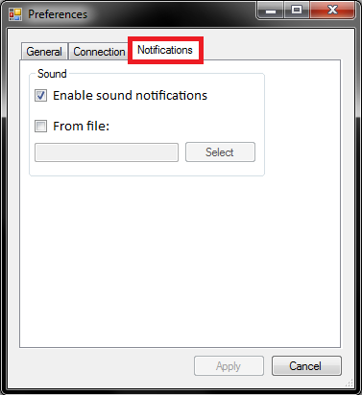

Illustration 4

* 1. Connect

After setting your preferences click on "Connect" button (marked in red in Figure 5), if a message box (Figure 6) appears, review your preferences, if you receive a message box text chat (Figure 7), check the data entered in the preferences and the existence of the server entered.

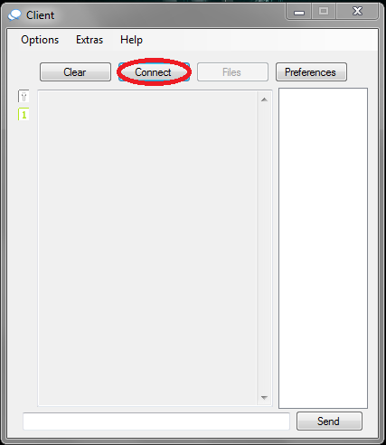

Illustration 5

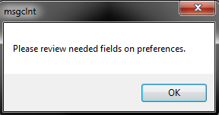

Illustration 6

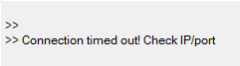

Illustration 7

If the connection was successful the following message will appear in the text box of the chat: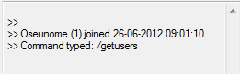

* 1. Sending messages

After being connected the user can send messages by clicking the "Send" button or by pressing "Enter" key on your keyboard and make sure that the text box is not empty. (Figure 8)

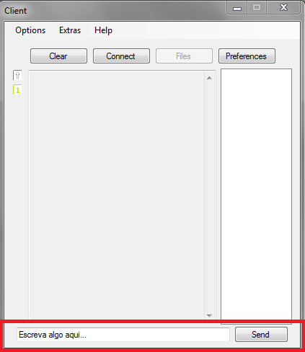

Illustration 8

* 1. Files
     1. Receiving Files

To allow you to receive files, you must press the button that says "Files" and then press the "Receive" and wait for notification to accept or reject the file, note that the sender has to wait for the window to be open.



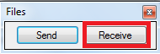

* + 1. Sending files

To allow you to send files, you have to click on "Files" and then "Send" and it will open a new window, then press the "Browse" to select the file and "Send" to send it. By pressing the "Send" in the new window will pop up a text box where the user enters the IP of the client that wants to send (the IP will appear in the chat box.).  
  
Note: The user who will receive has to have the Receive window open first!



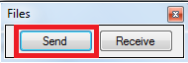

* 1. Commands

Both the client and the server feature commands, client commands can be found in "Help" menu and the option "Commands" (Illustrations).

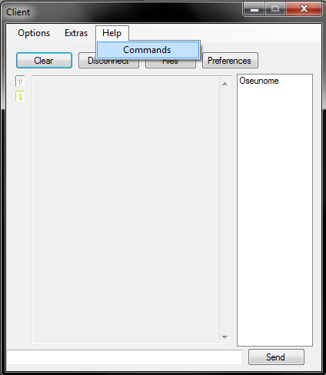

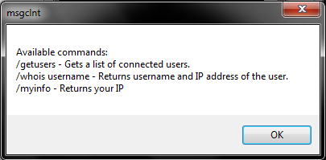

**Command list:**

* **/getusers** – Updates client list
* **/whois “nickname”** – Shows specified user’s IP.
* **/myinfo** – Shows own IP.
  1. Extras

These extras will serve to facilitate access to the user or even entertain you through the latest news from the RSS feed while waiting for a message.

* + 1. Extras – RSS Feed

This extra is for reading news feeds such as the site of “Jornal de Noticias”, these URLs are usually identified by being listed as a RSS feed.



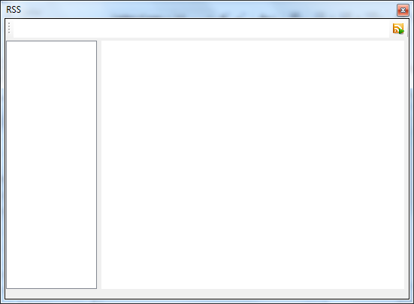

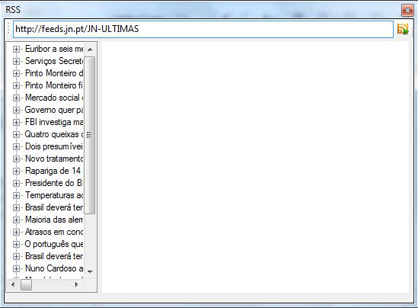

* + 1. Extras – Browser

This simple extra allows you to browse websites.

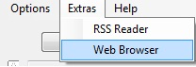

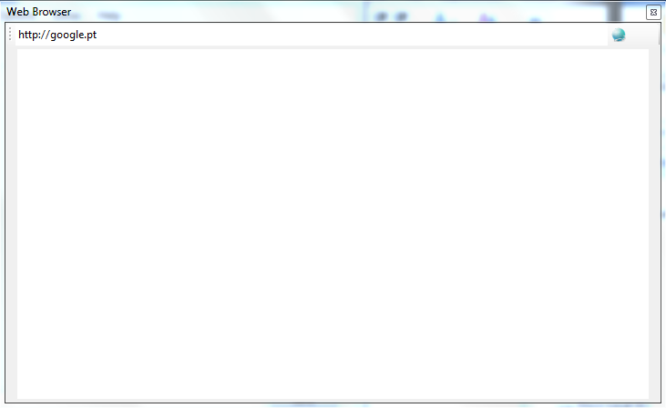

* + 1. Extras – Others

Other extras included will be the detection of CapsLock and NumLock which may give way to those who do not have that advantage on your keyboard. This system will detect the condition of NumLock and CapsLock each time the user is writing.

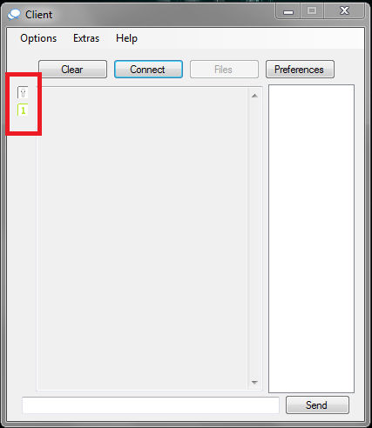

1. Server-side functionality

The functions of the Server will be described in this chapter

* 1. How to start

After starting the application simply enter the connection ports and the IP is assigned automatically if there’s only one network card installed, otherwise it will ask you to select the IP. (Server 1) 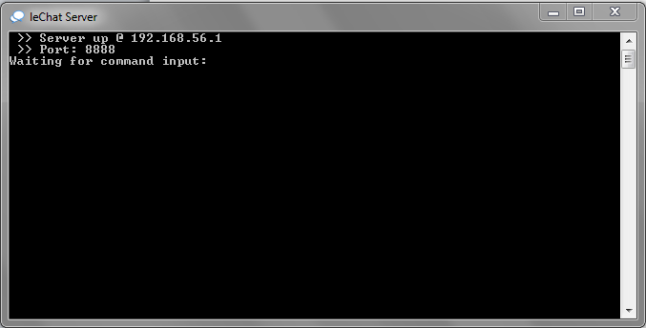

**Explanation**

The first two lines show the address where the server is on the network, the first being the IP and the second one being the port, this information is necessary for users to use the client-side application.

* 1. Commands

As indicated before, the server also provides commands , just type in "help" and a list will appear. (Illustration)



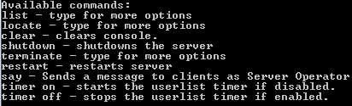

**Command list:**

* **list** – will show two more commands.
  + **list connections** – shows the numbers of connections on the server.
  + **list users** – shows the users connected to the server.
* **locate** – will show two more commands.
  + **locate user** – searches if the inserted user is connected.
  + **locate ip** – searches if the inserted IP is connected.
* **clear** – clears console.
* **shutdown** – shutdowns the server.
* **terminate** – will show one more command.
  + **terminate connection** – terminates a inserted user connection.
* **restart** – restarts the server.
* **say** – sends a message to the clients identified as “Server Operator”
* **timer on/off** – Activates or desactivates the automatic client list update timer.