数字逻辑第一次小测答案：

1.选择题：

D B C D D B

2.填空题：

11101 1D 00101001 $∑m(1,3,5,6,7)$ $∏M(0,2,4)$

3.

F = w‘ + z

|  |  |  |  |  |
| --- | --- | --- | --- | --- |
| xy  zw | 00 | 01 | 11 | 10 |
| 00 | 1 | 1 | d | d |
| 01 |  | d |  |  |
| 11 | d | d | 1 | d |
| 10 | 1 | d | 1 | 1 |

4.

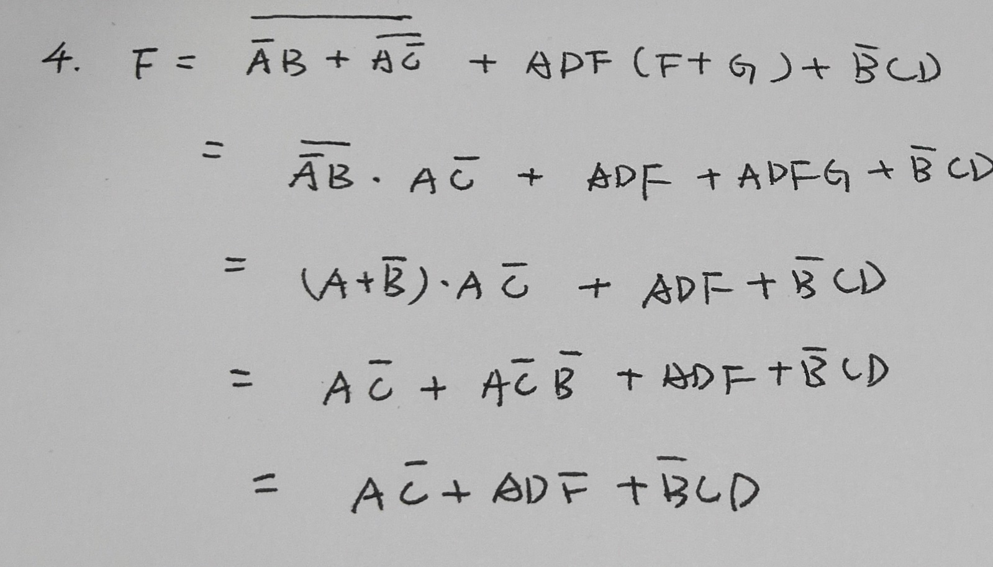

5.

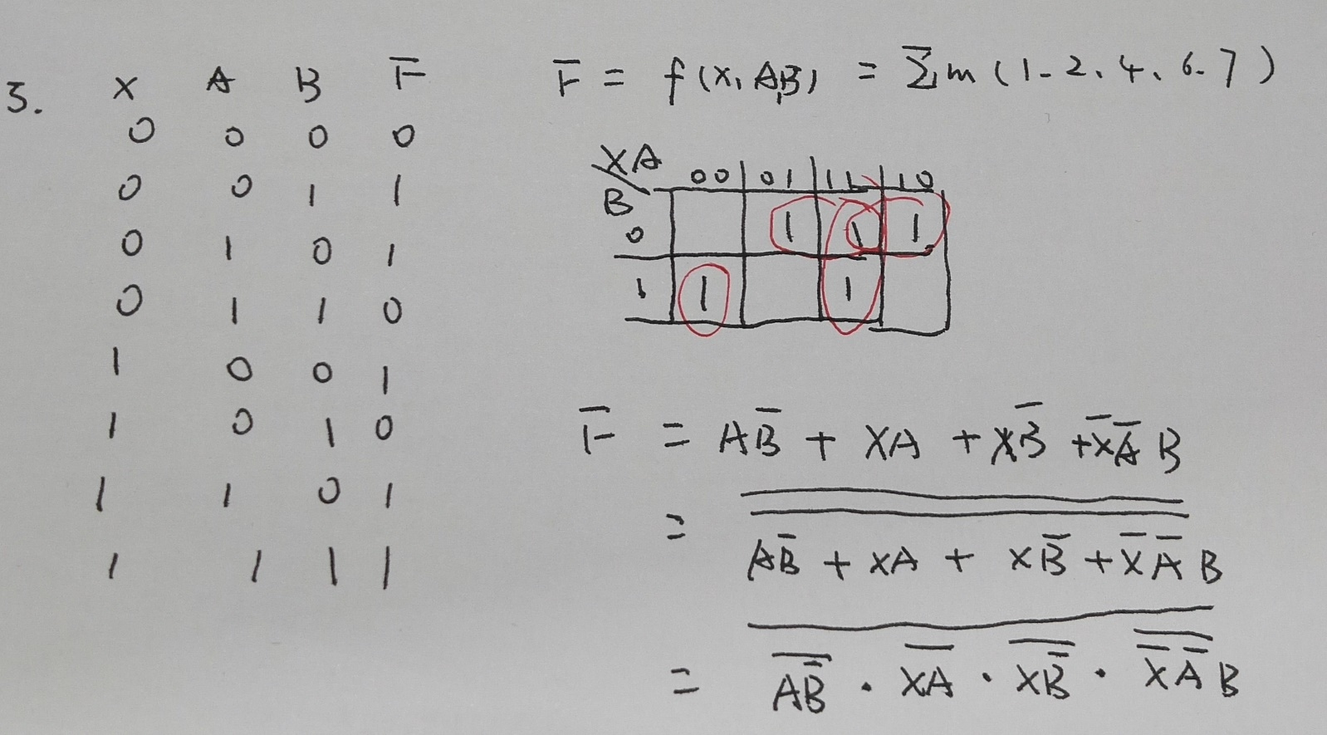

6.

