**Assignment 10: Shared Code Repository – Git Exercise**

Louis Capps

Bellevue University

CSD380 DevOps

Professor Darren Osier

21 July 2024

**Shared Code Repository – Git Exercise**

The Github repository is: <https://github.com/zRedwind2/GitLab>

My Github username is: zRedwind2

The following image is of the repository branches page. I was both release manager and developer 3 for this project. The revert-6-hotfix2 branch was due to a mistake of merging the hotfix2 pull request. As the release manager, I have learned that it is somewhat easy to make a merge mistake and that it should be handled carefully, but I also learned how to go about reverting that mistake quickly should it occur. As Developer 3 I pushed out the hotfix2 again and, as the maintainer, denied that pull request.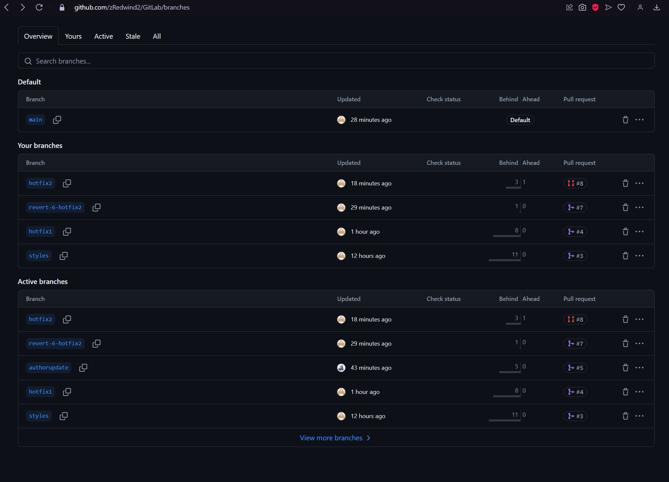

This second image is viewing more branches