**Assignment 5.2: Value Stream Mapping (VSM)**

Louis Capps

Bellevue University

CSD380 DevOps

Professor Darren Osier

30 June 2024

**Value Stream Mapping (VSM)**

For this Value Mapping Stream Process, I chose my weekly Monday assignment planning. It involves identifying the modules for each class, the tasks for each module, writing them into a word document, and then moving those tasks to a to-do list and calendar. The graphic created identifying the value stream for each individual module is the following:

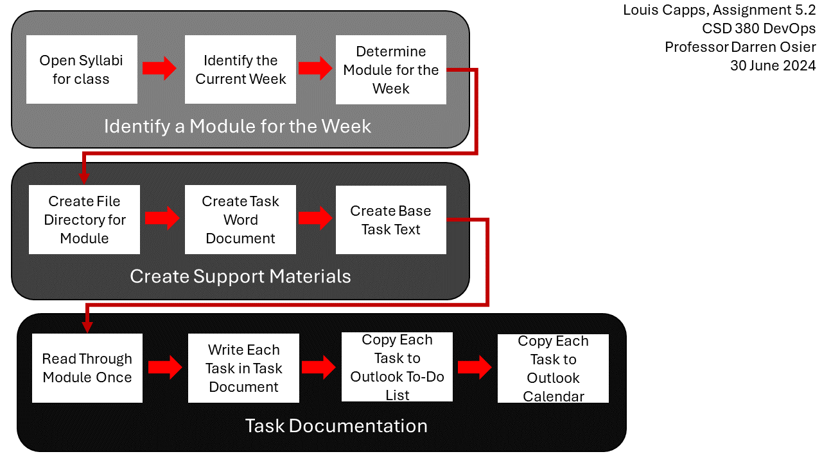

Analyzing Lean Metrics

**Average Flow Time**

|  |  |
| --- | --- |
| Identify a Module for the Week | 5 minutes |
| Create Support Materials | 10 minutes |
| Task Documentation | 50 minutes |

Estimated cycle time = 65 minutes per module, 130-260 minutes total depending on the number of modules, with a minimum of two modules and a maximum of four modules.

**Optimizing Weekly Monday Assignment Planning**

**Combining Module Identification:** By identifying all the modules at once, rather than one at a time, I can eliminate the time needed to recheck the syllabi and identify which modules are being used, saving around 3 minutes per module after the first module. This bulk identification would be a net savings of 3-9 minutes.

**Pre-prepping Create Support Materials:** The base Word document for each module is the same across all classes with that module number until tasks are added to it. By copying that base Word document to the corresponding module in the second class, I can save the time needed to create that Word document, cutting out an estimated half to three-quarters of the time spent creating support modules for that class. This duplication of already created Word documents would net a savings of 6 minutes per module, with a maximum of 12 minutes as only half of the modules could benefit from this duplication.

**Cutting Unused Task Documentation:** After considering how it isn’t used that much after documentation, I can cut out copying each task to an Outlook calendar. This portion of task documentation is by far the most time-consuming part as the Outlook calendar wasn’t designed to easily add many individual notes quickly. By doing so, I estimate that the time taken by the Documenting Tasks portion will be cut in half, down to 25 minutes per module, for a net savings of a minimum of 50 and a maximum of 100 minutes.

By implementing these changes in the process, I estimate the time saved documenting every module for the week to be the following depending on the number of modules:

* 2 Modules: 59 minutes
* 3 Modules: 87 minutes
* 4 Modules: 121 minutes