LineUsage Behavior

The LineUsage element is used to specify how the symbol is used in the context of 1D geometry. This document describes the behavior of the VertexControl and StartOffset / EndOffset / Repeat parameters.

Repeat Parameter

Repeat > 0

When set to a positive value, the Repeat parameter specifies the separation between adjacent symbols on a polyline. To define a continuous line style using a symbol, the Repeat value should be set to the width of the symbol. This is shown in the upper figure below. If the Repeat value is less than the symbol width, then adjacent symbols will overlap each other. If the Repeat value is greater than the symbol width, then adjacent symbols will have gaps in between (which may be what the symbol author wants). The latter case is shown in the lower figure.

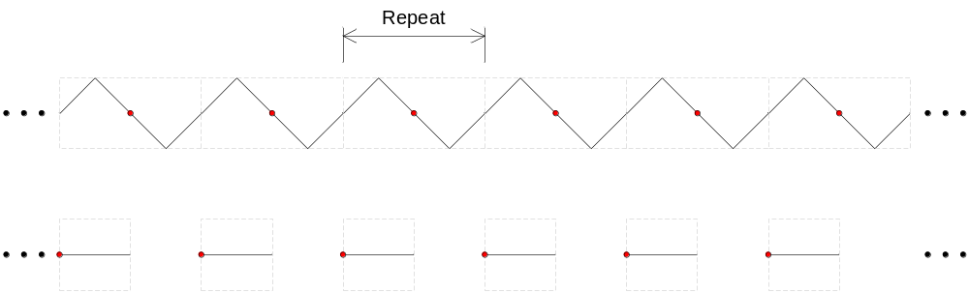

The StartOffset and EndOffset parameters define the start and end locations for the distribution, relative to the start and end of the polyline. For all VertexControl options, no symbols will be positioned between the start of the polyline and the start offset location, and between the end offset location and the end of the polyline. Furthermore, no portion of any symbol will be drawn in these regions for the OverlapNone and OverlapWrap cases. See the individual VertexControl sections below for details.

In general it’s not possible to fit an integral number of symbols along a given polyline while simultaneously satisfying the StartOffset, EndOffset, and Repeat values. To handle this there are a couple of strategies:

- Symbols are repeated according to the Repeat parameter, and are truncated at the start and/or end locations to satisfy the offset requirements.
- An integral number of symbols is distributed within the polyline according to the Repeat parameter, leaving gaps at the start and end locations. To satisfy the offset requirements:
  - symbols can still be drawn at the start and end locations, with the understanding that the initial and final symbol separations will not equal the Repeat value
  - a centerline path can be drawn in these gaps
- The Repeat value is adjusted (and the symbols correspondingly stretched) so that an integral number of symbols can fit along the polyline.

With AutoCAD linetypes, strategies 1 and 2 are used with alignment type “A” while strategy 3 is used with alignment type “S”. For FRED we will only make use of strategies 1 and 2. Strategy 3 can be added for FRED +1.

Repeat <= 0

Setting the Repeat to a non-positive value indicates that symbols will only be drawn at the start and/or end offset locations. This setting is intended to only be used in the context of point symbols, e.g. drawing an arrowhead at the start of the polyline, or drawing filled circles at the start and end points. These symbols will simply be drawn at the offset locations without any wrapping, truncation, or other modification.

For non-positive Repeat values the VertexControl option is ignored, and the following rules apply to the StartOffset and EndOffset parameters:

- if the StartOffset is specified (>=0) then a symbol is drawn at the start offset location
- if the EndOffset is specified (>=0) then a symbol is drawn at the end offset location
- if the StartOffset and EndOffset are both specified but their sum is greater than the polyline length (the EndOffset offset location comes before the StartOffset location) then no symbols are drawn
- if the StartOffset and EndOffset are both unspecified (< 0) then no symbols are drawn

The remainder of the document describes the behavior for the different VertexControl options in the case where the Repeat value is positive.

Vertex Control = OverlapNone

Symbols will be distributed along the polyline according to the offset / repeat parameters, but no symbol will be drawn so that it overlaps a vertex where the feature geometry changes by more than the VertexAngleLimit. The rule is automatically applied at the start and end point. If the VertexAngleLimit is set to zero, this option gives AutoCAD behavior with Linetype Generation (LTG) disabled. If the VertexAngleLimit is set to 180 degrees or larger then this gives AutoCAD behavior for complex linetypes with LTG enabled.

For this option the code computes a symbol distribution within each segment (or group of segments) of the polyline. In the case where the VertexAngleLimit is zero each segment will be treated separately. If the VertexAngleLimit is greater than zero, then adjoining segments for which the limit is not exceeded will be part of the same group for which the distribution is computed. Since the maximum change in angle at a vertex is 180 degrees, setting the VertexAngleLimit to 180 degrees or larger result in the entire polyline being processed as one segment group (equivalent to LTG enabled).

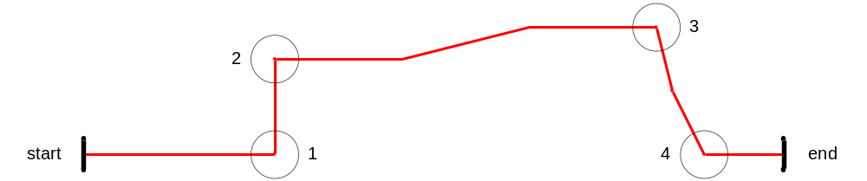

The drawing above gives an example. Assume the VertexAngleLimit is set to 30 degrees. For the given polyline this limit is exceeded at the four circled vertices, resulting in five groups of segments. Note that some of them – like the one going from circle 2 to circle 3 – consist of more than one segment.

For this VertexControl option the default values for the StartOffset and EndOffset are zero. To handle offsets the starting and ending segment groups which contain the offsets are first located. No symbols are distributed in groups before / after the starting / ending groups. The starting group is then adjusted to begin at the start offset location, while the ending group is adjusted to end at the end offset location. In the drawing below, the start and offsets locations are drawn in blue. The starting group goes from 1 to 2, and the ending group goes from 2 to 3. The adjusted groups are drawn in green.
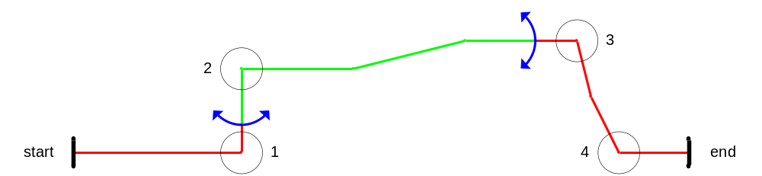

To compute the symbol distribution within a segment group, the code first finds the length of the group and fits the maximum number of symbols into that length based on the repeat value. Any remaining length is then drawn as a centerline path at the start and end of the group. For example, if the segment group is 150 mm long and the repeat value is 20 mm, then 7 complete symbols can fit inside this group, leaving a remainder of 10 mm. This remainder is “used up” by drawing a 5 mm dash at both the start and end of the group. The style of this dash defaults to black with a line weight of zero, but this can be overridden using the DefaultPath element in the LineUsage.

After the symbol distribution for the group has been computed, the symbols are drawn unadulterated at each computed position. No truncation or wrapping is performed. This follows the behavior of AutoCAD with complex linetypes.

The drawing below shows what the final distribution might look like using a symbol like the following: . Only the green portion of the polyline is captured here (scaled up by a factor of two). Two symbols were distributed in the first group, while 13 were distributed in the second group. Black centerline dashes are drawn to fill in the gaps at the start and end of each group.

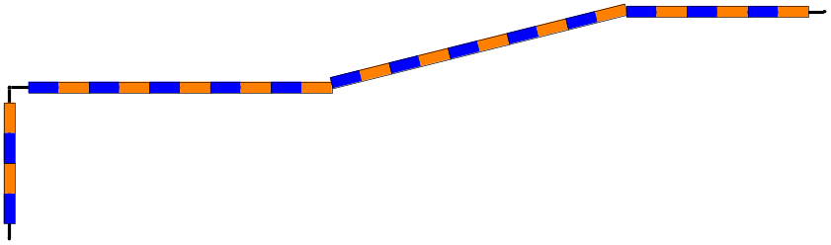

Notice that in the second group the symbols overlap the interior vertices slightly. Symbol wrapping is not done, as mentioned earlier.

TODO: do we need any special offset behavior for closed polylines (e.g. polygon edges)?

Vertex Control = OverlapDirect

The intent of this option is to distribute point symbols along the polyline. No truncation or wrapping of the symbols is performed – they are “stamped” along the polyline according to the StartOffset / EndOffset / Repeat parameters. Furthermore, a symbol will be drawn at each interior vertex where the feature geometry changes by more than the VertexAngleLimit. This behavior can be effectively disabled by setting the VertexAngleLimit to 180 degrees or larger.

As with the OverlapNone VertexControl option, polygon segments are merged into groups based on the VertexAngleLimit. The computation of the distribution within each group is slightly different though.

Case 1: only the StartOffset is specified

A starting symbol is drawn at the start offset location, and the distribution repeats until the end of the polyline.

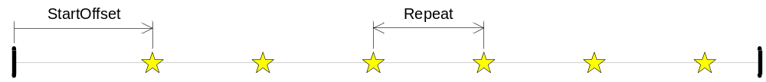

Case 2: only the EndOffset is specified

An ending symbol is drawn at the end offset location, and the distribution repeats until the start of the polyline.

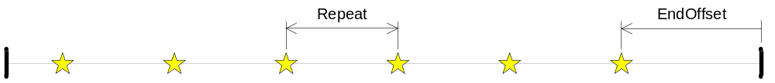

Case 3: both the StartOffset and EndOffset are specified

Starting and ending symbols are drawn at the start and end offset locations. Symbols are then distributed at the Repeat value within the polyline. This distribution is centered within the start / end offset locations, leaving a gap of width Δ on either side of the interior distribution. The number of symbols on the interior is chosen so that 0.5 * Repeat < Δ < 1.5 * Repeat, i.e. the gap is never smaller than half the Repeat value or greater than 1.5 times the Repeat value.

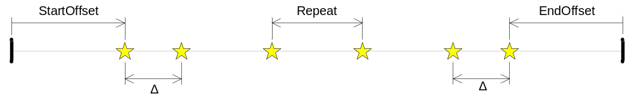

Case 4: neither the StartOffset nor EndOffset is specified

Symbols are not drawn at the start and end offset locations. The interior distribution, however, is the same as in case 3 but with the start and end offsets set to zero.

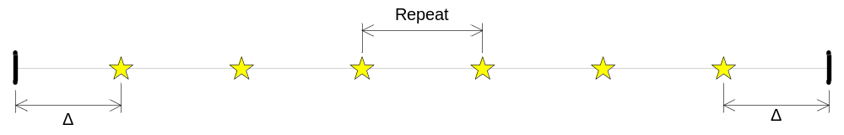

TODO: do we need any special offset behavior for closed polylines (e.g. polygon edges)?

Vertex Control = OverlapNoWrap

This option is no longer required, and should be deprecated. It was originally added to support the case of LTG enabled, but it would differ from the AutoCAD implementation in that centerline dashes would not be drawn at the start and end offset locations. Furthermore, it was noted in the OverlapNone section that the LTG enabled case is handled by simply setting the VertexAngleLimit to 180 degrees or larger.

Vertex Control = OverlapWrap

This is the default VertexControl option. The intent of this option is to produce a clean, continuous, distribution of symbols along the polyline. Symbols will be distributed along the curve according to the offset / repeat parameters, and any symbol which overlaps an interior vertex gets wrapped / bent around the vertex. For Path geometry along the centerline this gives AutoCAD behavior for simple linestyles with LTG enabled. For Path geometry off of the centerline this will be hard to implement cleanly. We could support this for Text by splitting the string into individual characters and having those follow the curve (i.e. the text follows the path). Unless we find a meaningful way to support this for Image we'll just ignore it in that case.

The StartOffset and EndOffset parameters define the start and end locations for the distribution, relative to the start and end of the polyline. The symbols are truncated at these locations – this is the behavior that Topobase requested. The different permutations of StartOffset and EndOffset are now described. The diagrams use the following symbol definition: . The white circle shows the origin of the symbol.

Case 1: neither the StartOffset nor EndOffset is specified

The distribution starts at the beginning of the polyline and repeats until the end of the polyline. The starting and ending symbols are truncated at the start and end of the polyline.

Case 2: only the StartOffset is specified

The origin of the starting symbol is placed at the start offset location, and the distribution repeats until the end of the polyline. The starting symbol is truncated at the start offset location, and the ending symbol is truncated at the end of the polyline.

Case 3: only the EndOffset is specified

The origin of the ending symbol is placed at the end offset location, and the distribution repeats until the start of the polyline. The starting symbol will be truncated at the start of the polyline, and the ending symbol will be truncated at the end offset location.

Case 4: both the StartOffset and EndOffset are specified

The origin of the starting symbol is placed at the start offset location, and the distribution repeats until the end offset location. The starting / ending symbols will be truncated at the start / end offset locations. If the sum of the offsets is greater than the polyline length then no symbols are drawn.

TODO: do we need any special offset behavior for closed polylines (e.g. polygon edges)?

