Pizza Ordering System Use Cases and Diagram

Kiel Hicks, Kyle Avrett

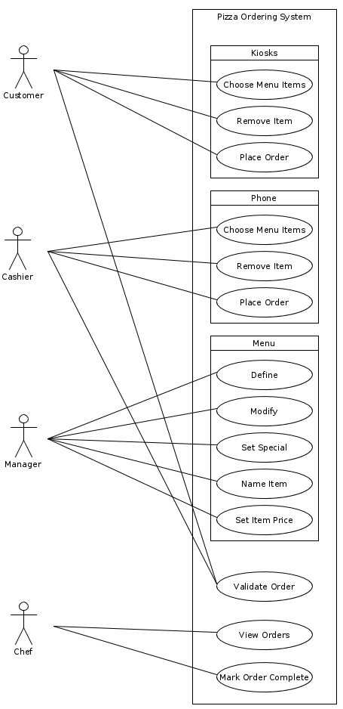

Cashier inputs order from customer in store
Scope: Pizza ordering system
Level: user goal
Primary Actor: cashier
Stakeholders and Interests: cashier, customer
Main Success Scenario:
1; Cashier inputs order from customer in the store.
2; Order is recorded.
Extensions:
- Cashier must be able to change what was ordered
Special Requirements:
- Cashier must be able to input anything on the menu

Cashier inputs order from customer from phone
Scope: Pizza ordering system
Level: user goal
Primary Actor: cashier
Stakeholders and Interests: cashier, customer
Main Success Scenario:
1; Cashier inputs order from customer from the phone
2; Order is recorded
Extensions:
- Cashier must be able to change what was ordered
Special Requirements:
- Cashier must be able to input anything on the menu

Customer inputs order from kiosk
Scope: Pizza ordering system
Level: user goal
Primary Actor: Customer
Stakeholders and Interests: Customer
Main Success Scenario:
1; Customer inputs order from kiosk
2; Order is recorded
Extensions:
- Customer must be able to change what was ordered
Special Requirements:
- Customer must be able to input anything on the menu

Cashier receives payment from customers
Scope: Pizza ordering system
Level: user goal
Primary Actor: cashier
Stakeholders and Interests: cashier, customer
Main Success Scenario:
1; after inputting an order, the application determines what the customer must pay
2; the payment is paid
Extensions:
- application must handle tax

Customer views menu from kiosk
Scope: pizza ordering system
Level: user goal
Primary Actor: customer
Stakeholders and Interests: customer
Main Success Scenario:
1; Customer requests to view menu from the kiosk
2; Customer views the menu from the kiosk
Special Requirements:
- Customer must be able to view entire menu

Customer removes a selection while ordering
Scope: pizza ordering system
Level: user goal
Primary Actor: customer
Stakeholders and Interests: customer
Main Success Scenario:
1; customer removes an item from their order
Extensions:
- Customer must be capable of removing a selection at any time prior to confirming the order.
Special Requirements:
- Customer must be capable of continuing ordering after removing a selection

Cashier removes a selection from an order
Scope: pizza ordering system
Level: user goal
Primary Actor: cashier
Stakeholders and Interests: cashier, customer
Main Success Scenario:
1; Cashier removes an item from an order
Extensions:
- Cashier must be capable of removing a selection at any time prior to confirming the order.
Special Requirements:
- Cashier must be capable of continuing ordering after removing a selection

Cashier validates order
Scope: pizza ordering system
Level: user goal
Primary Actor: cashier
Stakeholders and Interests: cashier, customer
Main Success Scenario:
1; After completing an order, cashier validates that this is the entire, correct order
2; Cashier confirms order

Customer validates order
Scope: pizza ordering system
Level: user goal
Primary Actor: customer
Stakeholders and Interests: customer
Main Success Scenario:
1; After completing an order, customer validates that this is the entire, correct order
2; Customer confirms order

Chef views an order
Scope: pizza ordering system
Level: user goal
Primary Actor: chef
Stakeholders and Interests: chef, customer
Main Success Scenario:
1; Chef views an uncompleted order

Chef marks order as completed
Scope: pizza ordering system
Level: user goal
Primary Actor: chef
Stakeholders and Interests: chef
Main Success Scenario:
1; After an order is finished being made, a chef marks the order as completed

Manager defines a new menu
Scope: Pizza ordering system
Level: user goal
Primary Actor: Manager
Stakeholders and Interests: Manager
Main Success Scenario:
1; A new menu is created by the manager

Manager modifies an existing menu
Scope: Pizza ordering system
Level: user goal
Primary Actor: manager
Stakeholders and Interests: manager
Main Success Scenario:
1; manager is able to change the contense of an already existing menu

Manager sets the special item on an existing menu
Scope: Pizza ordering system
Level: user goal
Primary Actor: manager
Stakeholders and Interests: manager
Main Success Scenario:
1; manager is able to change an item to be the special in an already existing menu

Manager names an item for a menu and adds it to the menu
Scope: Pizza ordering system
Level: user goal
Primary Actor: manager
Stakeholders and Interests: manager
Main Success Scenario:
1; a new item is created with the specified name in the menu

Manager sets the price for an item on a menu
Scope: Pizza ordering system
Level: user goal
Primary Actor: manager
Stakeholders and Interests: manager
Main Success Scenario:
1; the price is set/changed for an item on a menu by the manager

Manager defines a menu
Scope: pizza ordering system
Level: user goal
Primary Actor: manager
Stakeholders and Interests: manager, customer
Main Success Scenario:
1; Manager requests a new menu initialization
2; System displays a new menu with no items

Manager sets an existing item as the special for the day
Scope: pizza ordering system
Level: user goal
Primary Actor: manager
Stakeholders and Interests: manager, customer
Main Success Scenario:
1; Manager sets an item to be the special for the day
Special Requirements:
- Manager may change the price of the item

