Pizza Ordering System: Domain Model, Glossary, and Use Case

Kiel Hicks, Kyle Avrett

Domain Model

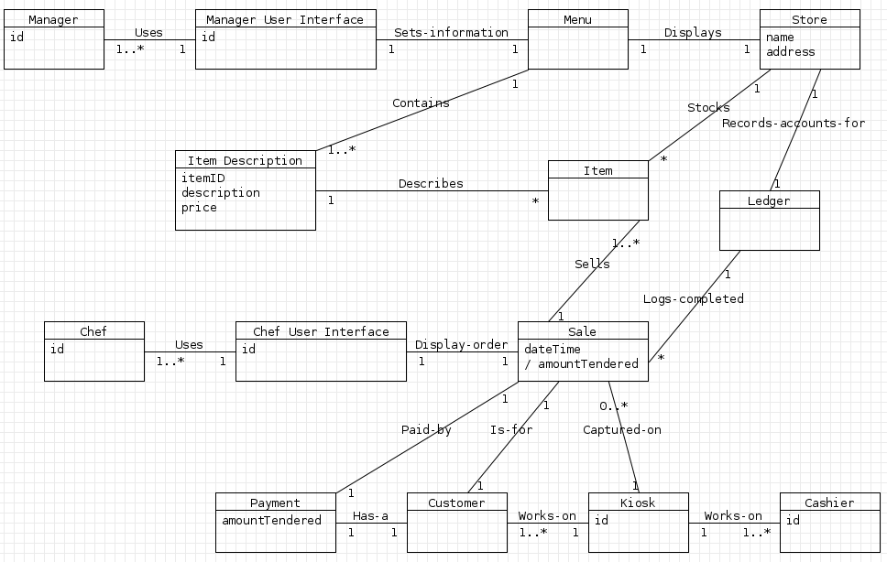

Note: I am sorry that the lines have overlapped the multiplicity/associations in some areas, the tool I use did not like my layout. I tried to make it as readable as possible.
Glossary

Item Description
This is an explanation of what the item is.

Item
A food or drink physical object that is sold by the pizza place

Manager
A person who is in charge of the employees and modifies the pizza place's menu

Manager User Interface
The interface that the Manager uses to accomplish his goals with the system. Similar to the Kiosk with the Cashier.

Menu
A listing of Item Descriptions that is presented to the customer to choose from.

Store
The business itself that the pizza place is.

Ledger
A manner to record the sales/transactions of the pizza place.

Chef
A person who fulfills the sales.

Chef User Interface
The interface that the Chef uses to see what sales need to be filled, and which orders need to be marked as filled

Sale
A customer has bought an item for money.

CashPayment
The payment method of the customer.

Customer
A person who buys items from the pizza place

Kiosk
An interface that the Customer and Cashier use to make a sale of items from the pizza place.

Cashier
A person who takes orders from a Customer over the phone to make a sale and enters them into a Kiosk.

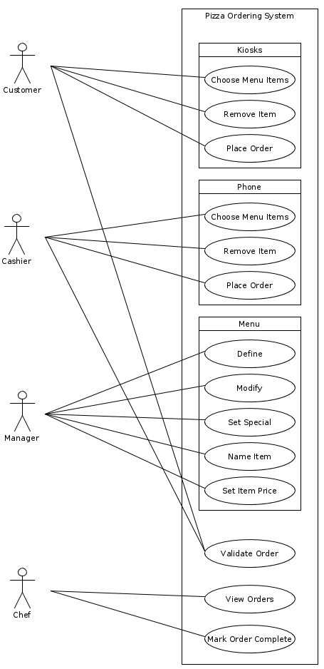
Use Case
Cashier inputs order from customer in store
Scope: Pizza ordering system
Level: user goal
Primary Actor: cashier
Stakeholders and Interests: cashier, customer
Main Success Scenario:
1; Cashier inputs order from customer in the store.
2; Order is recorded.
Extensions:
- Cashier must be able to change what was ordered
Special Requirements:
- Cashier must be able to input anything on the menu

Cashier inputs order from customer from phone
Scope: Pizza ordering system
Level: user goal
Primary Actor: cashier
Stakeholders and Interests: cashier, customer
Main Success Scenario:
1; Cashier inputs order from customer from the phone
2; Order is recorded
Extensions:
- Cashier must be able to change what was ordered
Special Requirements:
- Cashier must be able to input anything on the menu

Customer inputs order from kiosk
Scope: Pizza ordering system
Level: user goal
Primary Actor: Customer
Stakeholders and Interests: Customer
Main Success Scenario:
1; Customer inputs order from kiosk
2; Order is recorded
Extensions:
- Customer must be able to change what was ordered
Special Requirements:
- Customer must be able to input anything on the menu

Cashier receives payment from customers
Scope: Pizza ordering system
Level: user goal
Primary Actor: cashier
Stakeholders and Interests: cashier, customer
Main Success Scenario:
1; after inputting an order, the application determines what the customer must pay
2; the payment is paid
Extensions:
- application must handle tax

Customer views menu from kiosk
Scope: pizza ordering system
Level: user goal
Primary Actor: customer
Stakeholders and Interests: customer
Main Success Scenario:
1; Customer requests to view menu from the kiosk
2; Customer views the menu from the kiosk
Special Requirements:
- Customer must be able to view entire menu

Customer removes a selection while ordering
Scope: pizza ordering system
Level: user goal
Primary Actor: customer
Stakeholders and Interests: customer
Main Success Scenario:
1; customer removes an item from their order
Extensions:
- Customer must be capable of removing a selection at any time prior to confirming the order.
Special Requirements:
- Customer must be capable of continuing ordering after removing a selection

Cashier removes a selection from an order
Scope: pizza ordering system
Level: user goal
Primary Actor: cashier
Stakeholders and Interests: cashier, customer
Main Success Scenario:
1; Cashier removes an item from an order
Extensions:
- Cashier must be capable of removing a selection at any time prior to confirming the order.
Special Requirements:
- Cashier must be capable of continuing ordering after removing a selection

Cashier validates order
Scope: pizza ordering system
Level: user goal
Primary Actor: cashier
Stakeholders and Interests: cashier, customer
Main Success Scenario:
1; After completing an order, cashier validates that this is the entire, correct order
2; Cashier confirms order

Customer validates order
Scope: pizza ordering system
Level: user goal
Primary Actor: customer
Stakeholders and Interests: customer
Main Success Scenario:
1; After completing an order, customer validates that this is the entire, correct order
2; Customer confirms order

Chef views an order
Scope: pizza ordering system
Level: user goal
Primary Actor: chef
Stakeholders and Interests: chef, customer
Main Success Scenario:
1; Chef views an uncompleted order

Chef marks order as completed
Scope: pizza ordering system
Level: user goal
Primary Actor: chef
Stakeholders and Interests: chef
Main Success Scenario:
1; After an order is finished being made, a chef marks the order as completed

Manager defines a new menu
Scope: Pizza ordering system
Level: user goal
Primary Actor: Manager
Stakeholders and Interests: Manager
Main Success Scenario:
1; A new menu is created by the manager

Manager modifies an existing menu
Scope: Pizza ordering system
Level: user goal
Primary Actor: manager
Stakeholders and Interests: manager
Main Success Scenario:
1; manager is able to change the contense of an already existing menu

Manager sets the special item on an existing menu
Scope: Pizza ordering system
Level: user goal
Primary Actor: manager
Stakeholders and Interests: manager
Main Success Scenario:
1; manager is able to change an item to be the special in an already existing menu

Manager names an item for a menu and adds it to the menu
Scope: Pizza ordering system
Level: user goal
Primary Actor: manager
Stakeholders and Interests: manager
Main Success Scenario:
1; a new item is created with the specified name in the menu

Manager sets the price for an item on a menu
Scope: Pizza ordering system
Level: user goal
Primary Actor: manager
Stakeholders and Interests: manager
Main Success Scenario:
1; the price is set/changed for an item on a menu by the manager

Manager defines a menu
Scope: pizza ordering system
Level: user goal
Primary Actor: manager
Stakeholders and Interests: manager, customer
Main Success Scenario:
1; Manager requests a new menu initialization
2; System displays a new menu with no items

Manager sets an existing item as the special for the day
Scope: pizza ordering system
Level: user goal
Primary Actor: manager
Stakeholders and Interests: manager, customer
Main Success Scenario:
1; Manager sets an item to be the special for the day
Special Requirements:
- Manager may change the price of the item

