**ZAAKPAY payment module for VirtueMart**

ZAAKPAY VirtueMart Payment module for a leading Indian online payment

system. A merchant needs to be registered with ZAAKPAY and We provide a ZAAKAPY Merchant account, in order to receive payments via Cards.ZAAKPAY works with the VirtueMart 1.1.2 version.

An installation procedure:

1. Download the Zip File Extract it.

2. There are total four files out of which the payment folder has

two files called ps_zaakpay.php and ps_zaakpay.cfg.php that should be placed inside the administrator/components/com_virtuemart/classes/payment/classes/payment folder

and the file notify_zpay.php should be placed in com-virtumart

folder.

3. Login to Administrator Area - site administrator panel.

Select VirtueMart Store panel in the drop list, then select List

Payment Methods.

Create a new payment method "Zaakpay".

Enter code.

Select ps_zaakpay as Payment class name from the dropdown list.

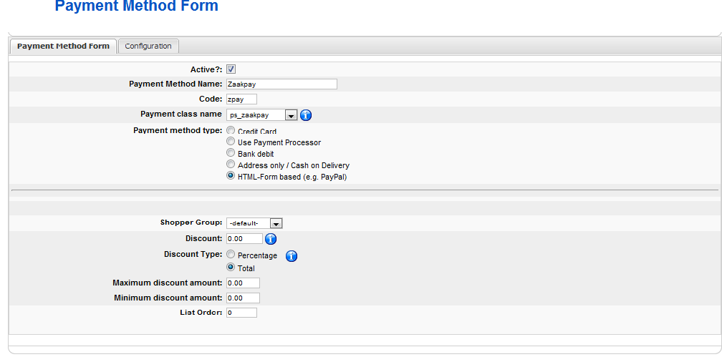

• Open the file ps_zaakpay_info.php and copy the php code

• Move to the “Configuration” tab and paste the copied code into "Payment Extra Info" text area.

• Fill a "Configuration" tab according to payment config data in ZAAKPAY.

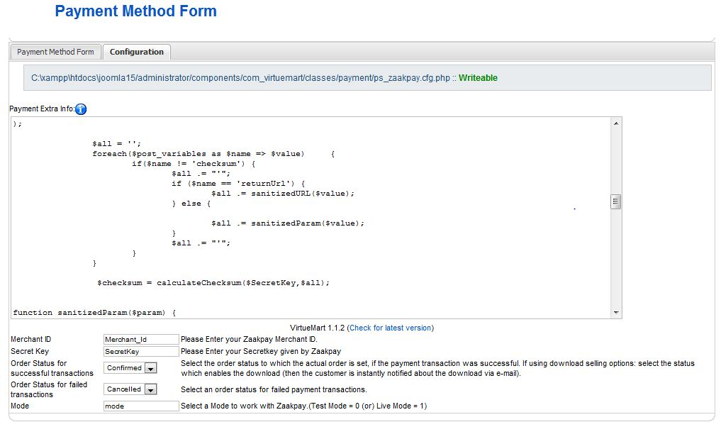

* In the bottom of the configuration tab there are some fields where the merchant needs to enter the merchantId and secretkey given by zaakpay.
* There is a field called Mode where the merchant need to enter 0 or 1 to work in Test mode or Live mode.
* Then click save. You are done. You can see Zaakpay in the Payment method list.

Note : When the response from zaakpay is wrong , in order to see what actually gone wrong ZAAKPAY has provided a new way for the merchants.

The Merchant should add two fields called “zpay_response_code” and “zpay_response_description” to the virtuemart orders table(#__{vm}_orders) to store the responses code and response description from zaakpay.

* Response file is notify_zpay.php