Faculty of Science Conference, Lapai

Author Name ¹, Second D.Author², Third Author³
Affiliations of the Authors^{1, 3}
Specifying the full State and Country
youremail@domain.com¹, fonsac@ibbu.edu.ng², Lapai@yahoo.com³

ABSTRACT
A detailed abstract of the paper should be carefully written. Authors are advised to avoid citations and references in the Abstract section. A brief of the content, problems, issues and the methods used could be a building part of the Abstract. Few lines of the concluding part should be used. Keywords should not be more five with each separated by a comma.

Keywords- Physics, Mathematics, Biology, Biochemistry, Chemistry, Geography, Computer Science.

- Introduction
Basic introduction section should be added. The font size of the entire paper should be 10 points and Times New Roman. Authors should notice that the paper is supposed to be strongly formatted in double-column. All images and figures should be named and captioned appropriately
- SECTION
Other sections can be used and added to the entire paper. The Section area could be all CAPITAL with sub-sections being the Sentence style. The Sections and subsections font sizes are 12 and 10 points for the body respectively (See Subsection 2.1 and 2.1.1 for examples
  - Subsections
Authors are to make sure the format is usable and under stable. All listing sections and enumerations should be well articulated.
- Physics: State and motion.
- Biology: Science of living things and environment.
- Latency: this defines the total response time and the overall turn-around time of a process in a system.

ease
Interrupt wait
Req
Time up
Who child
Main
I/O
child
Interrupt occurs
Idea

Figure 1: Images are to be captioned
The entire paper should be justified and the images should not be blurring. Advisably, authors should use better and standard image editors and high resolution images. Sizes should be moderate to avoid the overshooting in the margins.

    - SubsubSections
The subsections are italic and well placed at the subsection area. It is advisable that all images and figures used in a Text should be referenced. Placing an image without calling or referring to it makes it un-substantial .

- Abbreviations
Define abbreviations and acronyms the first time they are used in the text, even after they have already been defined in the abstract. Abbreviations such as PI, IEEE, SI, ac, and dc do not have to be defined. Abbreviations that incorporate periods should not have spaces: write “C.N.R.S.,” not “C. N. R. S.” Do not use abbreviations in the title unless they are unavoidable) (Access, 2017).
- Math
For the FONSAC editorial considerations, Authors are advice to use either the Microsoft Equation Editor or the MathType add-on (http://www.mathtype.com) for equations in your submission .

- Images and Graphs
Images and figures are all meant to appear in color, or shades of black/gray. It is strongly advisable to authors to use the standard image creating tools such as Edraw, Visio and other tools for better resolution and understanding. Such figures may include photographs, illustrations, multicolor graphs, and flowcharts etc. .
- MANUSCRIPT SUBMISSION TO FONSAC19
Authors are to submit a copy of their manuscript to the editorial board through the email fonsac@ibbu.edu.ng
Upon submission, you will receive an email with specific instructions of either to modify, relate and edit some parts are suggested by the reviewing and the technical committee. Authors are advised to always check their emails and spam sections to avoid the mail being classified as unsolicited message from the selection board.

To avoid any delays in publication, please be sure to follow these instructions. Most journals require that final submissions be uploaded through the fonsac@ibbu.edu.ng with the message subject as “final submissions Paper 123” quoting the id of the paper.
  - CBT Model
Consider J as a job pool containing P processes each process P with its identity i; identification takes values from 1, 2, 3... n each P has an associated burst time δ_{i} . Let a phase in execution be introduced at time t=0 as λ₀
Such that the pool J = {P₁, P₂, P₃… P_{n} }… (1) at λ₀
based on arrival identity 1, 2, 3… n.
Using the LJF concept, sort all processes in descending order of their burst times δ_{i} at a new execution time λ₁ such that
J¹ = { P₁δ₁ , P₂δ₂ , P₃δ₃ … P_{n}δ_{n} } … (2) at λ₁
If and only if P_{i}δ_{i} >= Pi+₁δi+₁.
Since the LJF needs to identify jobs as short and long, the need to calculate job categorization becomes necessary. To get a category, a threshold is set involving all process burst times such that
= … (3)

LJF+CBT Architectural overview

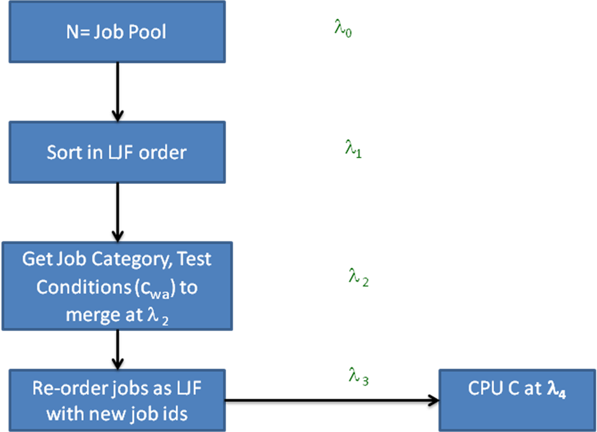
Figure 2: LJF+CBT Architectural overview (Source )
Multipart figures should be combined and labeled before final submission. Labels should appear centered below each subfigure in 8 point Times New Roman font in the format of (a) (b) (c).
- TEST SIMULATION OF THE LJF+CBT MODEL
This Section depicts and present what a model, groups and logics can be presented. A table caption should be placed at the top of the Table (See Table 1).
- Why Poisson?
It is a discrete probability distribution that expresses the probability of a given number of events happening in some intervals independent of time. So it is said that a discrete random variable X is said to have a Poisson distribution with parameters λ > 0, if for x= 0,1,2,…,n the probability mass function of X is given by
F(x;λ) = Pr (X=x)
(7)
Where is the base of the natural log with value = 2.71828,
x! Is the factorial of x, and λ = λT, as number of events occurring will be observed in the time interval T = 1.
This implies the positive real number λ is = E(x) and in Poisson after derivation and proving the Variance
Var (x) = λ
Therefore, E(x) = Var (x) = λ .

For this simulation, the mean was submitted as 10 to simulate and generate 15 random variables along side the random numbers. Numbers were simulated with repeated sequence so as to mimic the processes that could exist with the same burst times.

Table1: Generated Processes and Burst Times
Observation/ process identification | Random Numbers | Random Variables/ Burst times
1 | 0.838 | 13
2 | 0.287 | 8
3 | 0.86 | 13
4 | 0.818 | 13
5 | 0.604 | 11
6 | 0.209 | 7
7 | 0.692 | 11
8 | 0.782 | 12
9 | 0.566 | 10
10 | 0.982 | 17
11 | 0.643 | 11
12 | 0.367 | 9
13 | 0.765 | 12
14 | 0.797 | 13
15 | 0.21 | 7

Computing and analysing the Table makes it brighter. From the results obtained in Table 2, time is of the essence.

Table 2: Comparing LJF+CBT and LJF
Metrics/Algorithm | LJF | LJF+CBT
Average Waiting Time | 88.53 | 62.80
Average Turn around time | 99.67 | 73.93
Context Switch | 14 | 10
ACKNOWLEDGMENT
The preferred spelling of the word “acknowledgment” in American English is without an “e” after the “g.” Use the singular heading even if you have many acknowledgments. In most cases, sponsor and financial support acknowledgments are placed in the unnumbered footnote on the first page, not here (Access 2017)
- CONCLUSION
In conclusion, references should be in the APA 6th Edition format. In line citations should be made clear and nicely referred.
References
Access, (2017). Preparation of Papers for IEEE Access 1(1), 1-6.
Al-Adwan, Ahmad, & Smedley, Jo. (2012). Implementing e-learning in the Jordanian Higher Education System: Factors affecting impact. International Journal of Education and Development using Information and Communication Technology, 8(1), 121.
Albugmi, Ahmed, Walters, Robert, & Wills, Gary. (2016). A framework for cloud computing adoption by Saudi government overseas agencies. Paper presented at the Future Generation Communication Technologies (FGCT), 2016 Fifth International Conference on.
Bryant, Kay, & Campbell, John. (2006). User behaviours associated with password security and management. Australasian Journal of Information Systems, 14(1).
Dublin, Lance. (2008). Success with e-learning.
Lee, Yi-Hsuan, Hsieh, Yi-Chuan, & Hsu, Chia-Ning. (2011). Adding Innovation Diffusion Theory to the Technology Acceptance Model: Supporting Employees' Intentions to use E-Learning Systems. Educational Technology & Society, 14(4), 124-137.
Pan, Jeh-Nan, & Nguyen, Hung Thi Ngoc. (2015). Achieving customer satisfaction through product–service systems. European Journal of Operational Research, 247(1), 179-190.
Rice, PL. (1992). Stress and health. California: Brooks: Cole Publishing Company, Pacific Grove.
Zhao, Ling, Lu, Yaobin, Zhang, Long, & Chau, Patrick YK. (2012). Assessing the effects of service quality and justice on customer satisfaction and the continuance intention of mobile value-added services: An empirical test of a multidimensional model. Decision Support Systems, 52(3), 645-656.
Zhou, Tao. (2013). An empirical examination of continuance intention of mobile payment services. Decision Support Systems, 54(2), 1085-1091.

