MHA-DQN Architecture Diagram
Complete Data Flow: 8 Feature Groups → 8 Attention Heads → 3 Attention Layers
Generated: November 26, 2025 at 12:35 AM

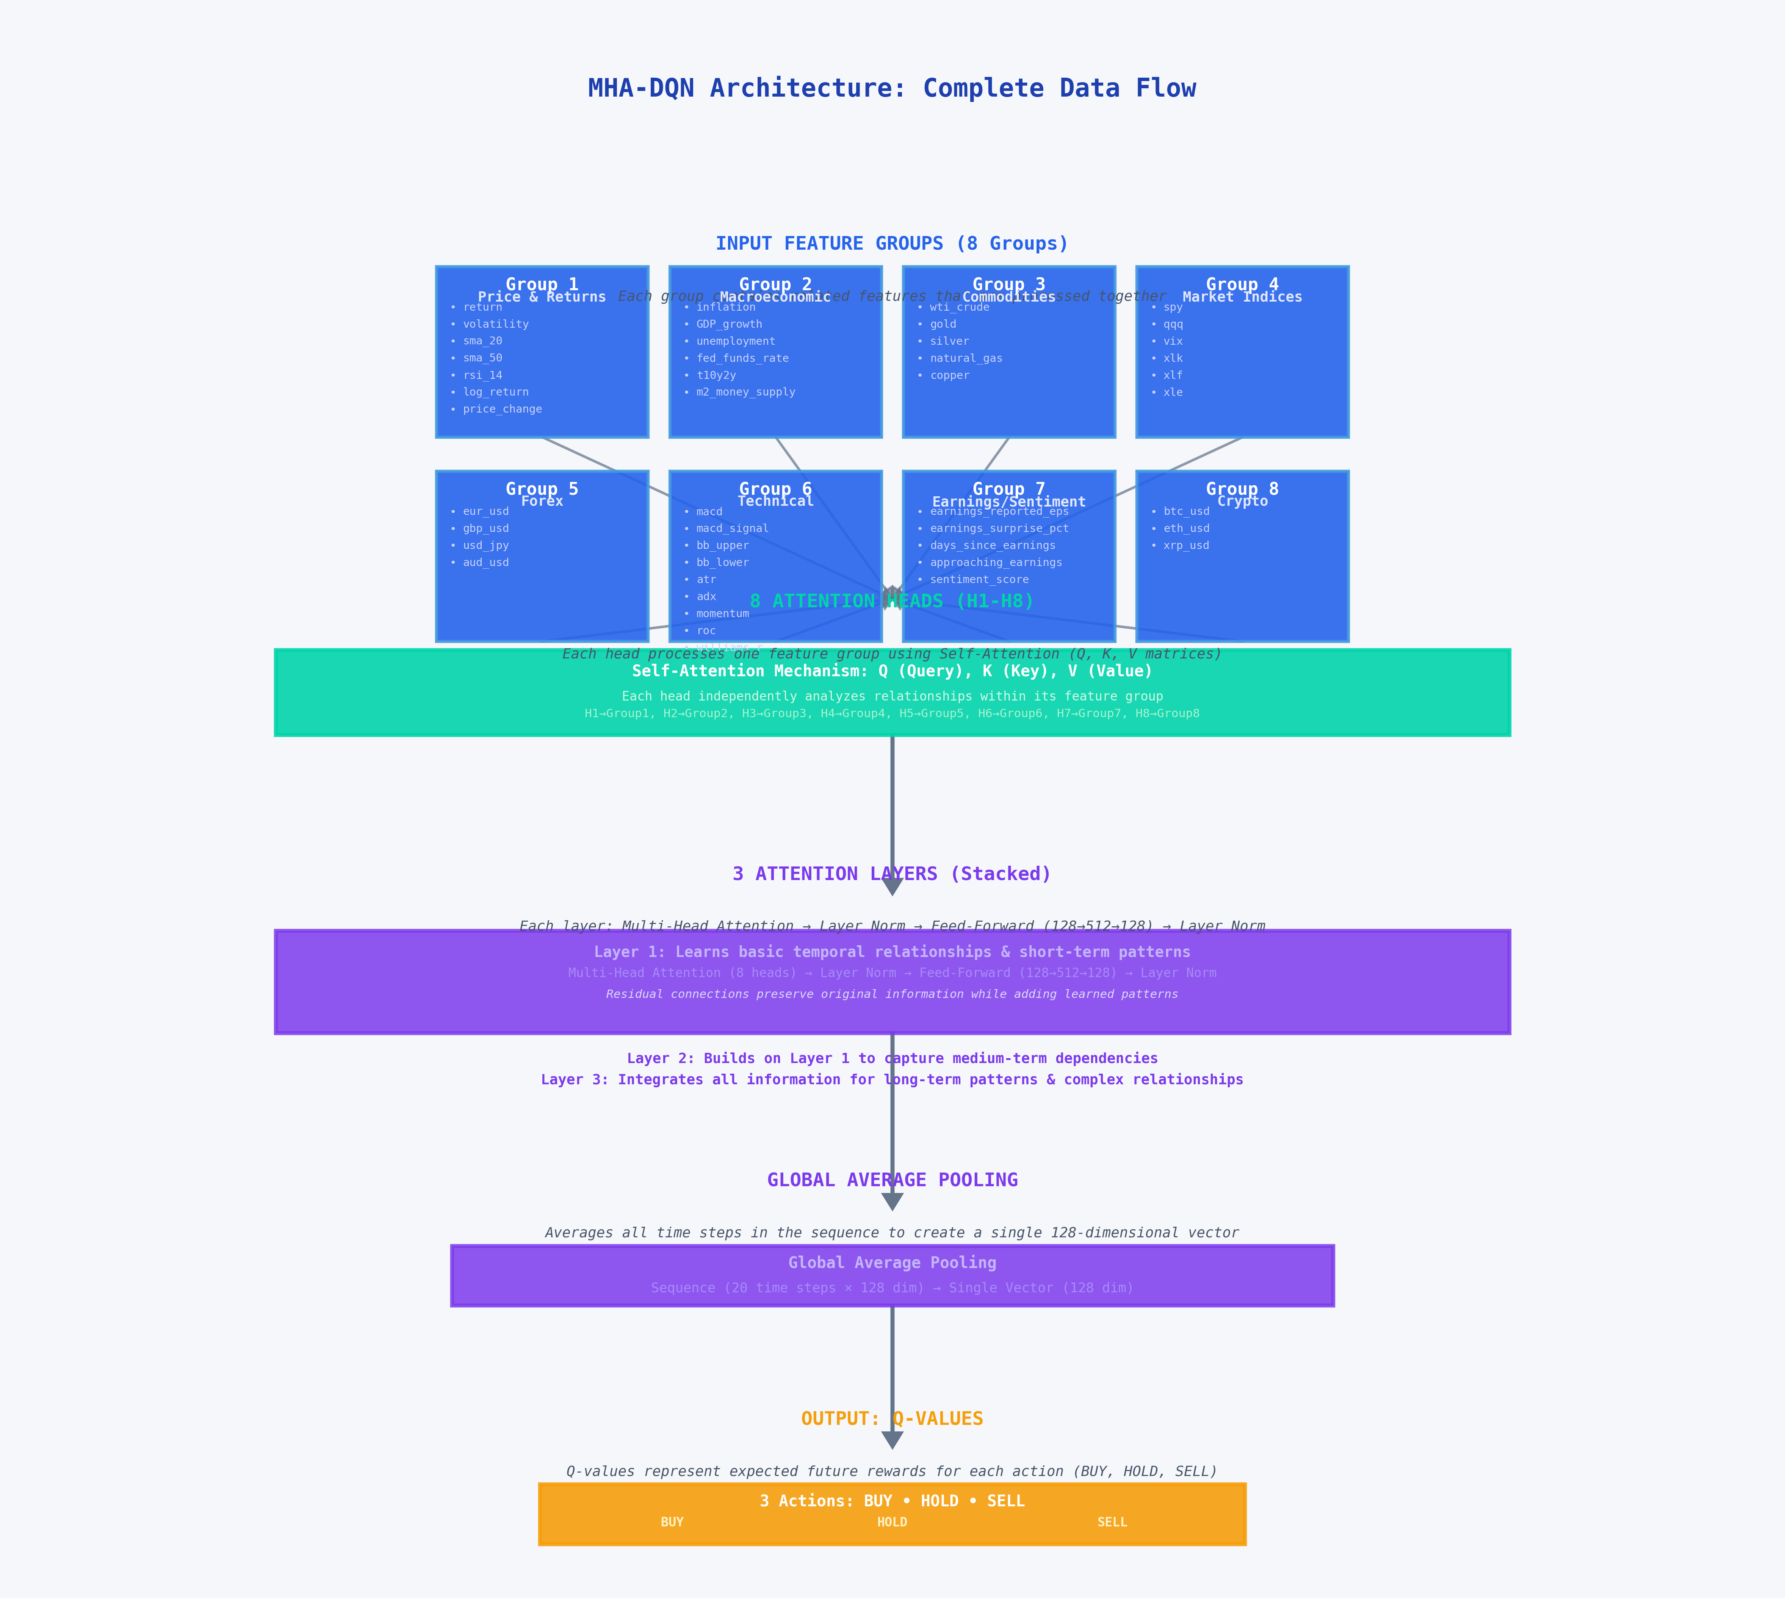

Architecture Explanation

Input Feature Groups (8 Groups)
The architecture starts with 8 feature groups, each containing related financial and market indicators:
- Group 1: Price & Returns: return, volatility, sma_20, sma_50, rsi_14, log_return, price_change
- Group 2: Macroeconomic: inflation, GDP_growth, unemployment, fed_funds_rate, t10y2y, m2_money_supply
- Group 3: Commodities: wti_crude, gold, silver, natural_gas, copper
- Group 4: Market Indices: spy, qqq, vix, xlk, xlf, xle
- Group 5: Forex: eur_usd, gbp_usd, usd_jpy, aud_usd
- Group 6: Technical: macd, macd_signal, bb_upper, bb_lower, atr, adx, momentum, roc, williams_r
- Group 7: Earnings/Sentiment: earnings_reported_eps, earnings_surprise_pct, days_since_earnings, approaching_earnings, sentiment_score
- Group 8: Crypto: btc_usd, eth_usd, xrp_usd

8 Attention Heads (H1-H8)
Each attention head processes one feature group independently using Self-Attention mechanism. The Self-Attention uses Query (Q), Key (K), and Value (V) matrices to analyze relationships between different time steps within each feature group. This allows the model to focus on the most relevant information from the historical sequence.

3 Attention Layers (Stacked)
The three attention layers are stacked to create hierarchical feature learning:
- Layer 1: Learns basic temporal relationships and short-term patterns
- Layer 2: Builds on Layer 1 to capture medium-term dependencies
- Layer 3: Integrates all information for long-term patterns and complex relationships

- Each layer contains:
- 1. Multi-Head Attention: Processes all 8 heads together
- 2. Layer Normalization: Stabilizes training by normalizing activations
- 3. Feed-Forward Network: Expands dimensions (128→512) for complex pattern learning, then compresses back (512→128)
- 4. Layer Normalization: Final normalization before passing to next layer
- Residual connections (skip connections) preserve original information while allowing the network to learn additive improvements.

Global Average Pooling
Converts the sequence of 20 time steps (each with 128 dimensions) into a single 128-dimensional vector. This summarizes all temporal information into a fixed-size representation suitable for final decision-making.

Output: Q-Values
The final output consists of Q-values for three actions: BUY, HOLD, and SELL. Each Q-value represents the expected future reward for taking that action in the current market state. The action with the highest Q-value is selected as the trading recommendation.

