Term project

User Interface

SEG2105C

Prof. Ayman Elsawah

Students:

Jinyang Huang 8078297

Kevin Le 8427204

Mengyun Zheng 7609162

Michael Egbunike 6784143

Saif Zabarah 2359049

Delete Recipe

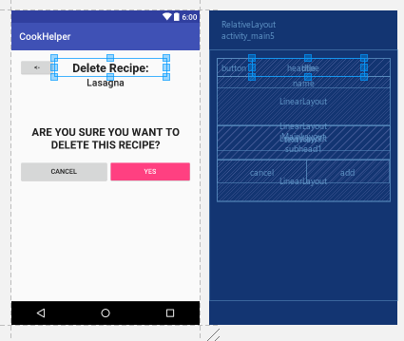

Add recipe

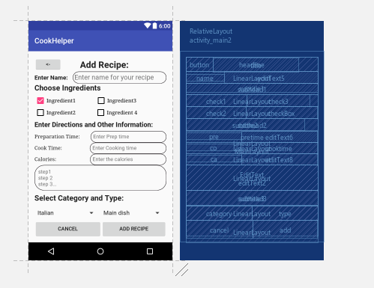

Edit recipe

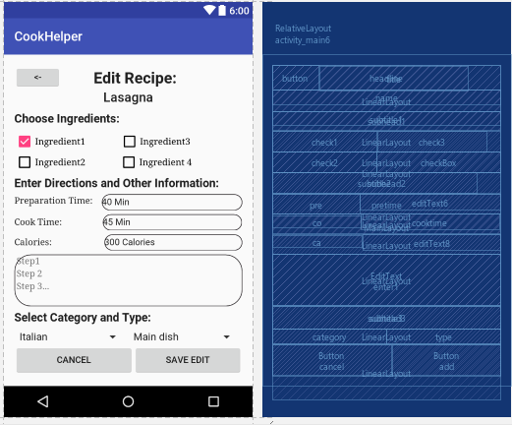

Home page

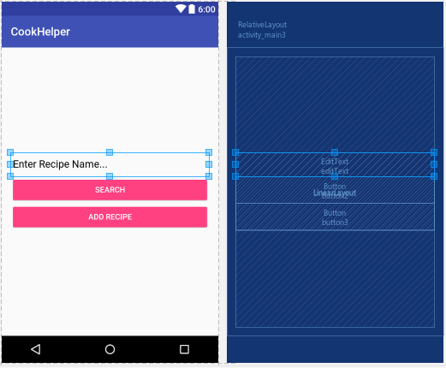

Search page

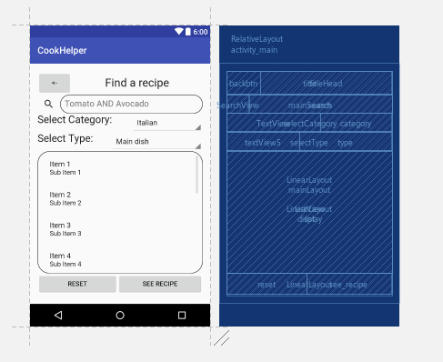

View page

