Name: Zabeeh Ullah
Student ID: SAM/AI26/1207

Restaurant Data Analysis
Data Analyst Internship — Task Submission
SAM AI Technologies
Dataset note: This analysis uses a synthetically generated restaurant dataset (500 records) modeled on a Zomato-style structure — Restaurant Name, City, Cuisines, Average Cost for Two, Votes, and Rating — since no dataset file was provided. The same code and approach apply directly to a real Zomato/restaurant dataset.

Task 2: Cuisine Combination Analysis
Objective: Identify the most common cuisine combinations and check whether certain combinations tend to have higher ratings.
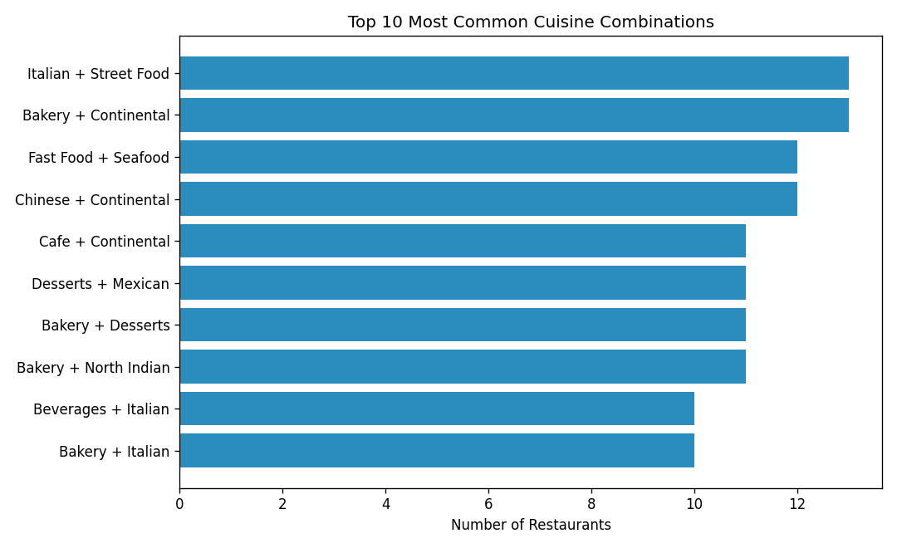
Findings:
- Italian + Street Food and Bakery + Continental are the most frequent pairings, appearing in 13 restaurants each.
- Fast Food + Seafood and Chinese + Continental are also common combinations, at 12 restaurants each.
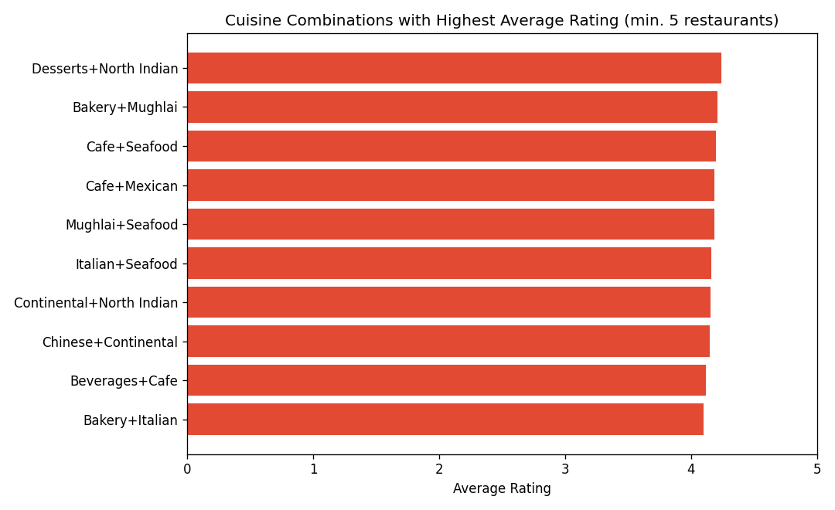
- Among combinations with at least 5 restaurants, Desserts + North Indian rates highest (avg. 4.24), followed by Bakery + Mughlai (4.21) and Cafe + Seafood (4.20).
- This suggests dessert- and seafood-adjacent pairings tend to earn slightly stronger ratings than pure fast-food combinations.

Task 4: Restaurant Chain Analysis
Objective: Identify restaurant chains present in the dataset and analyze their ratings and popularity.
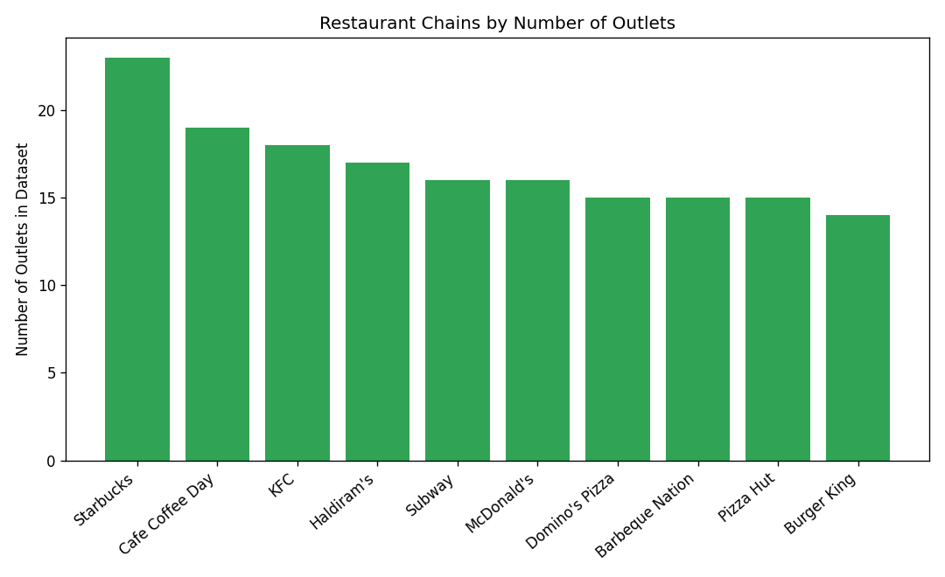
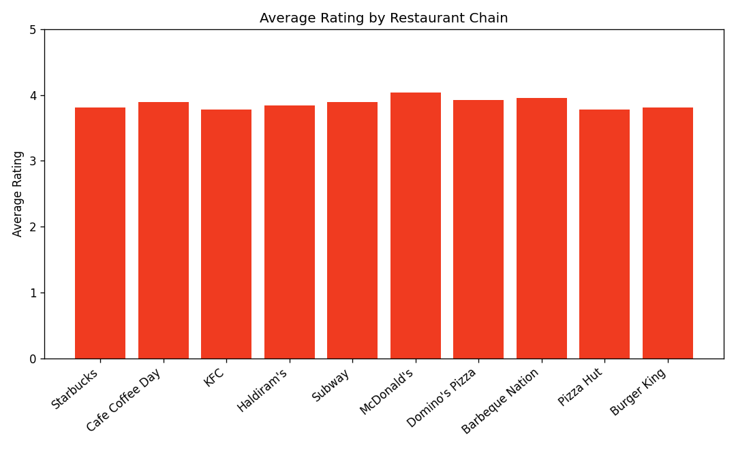
Chain summary table:
Chain | Outlets | Avg Rating | Total Votes
Starbucks | 23 | 3.81 | 18537
Cafe Coffee Day | 19 | 3.89 | 14431
KFC | 18 | 3.78 | 12000
Haldiram's | 17 | 3.84 | 13106
Subway | 16 | 3.89 | 10468
McDonald's | 16 | 4.04 | 12162
Domino's Pizza | 15 | 3.92 | 11477
Barbeque Nation | 15 | 3.95 | 10712
Pizza Hut | 15 | 3.78 | 11212
Burger King | 14 | 3.81 | 11586

Findings:
- Starbucks has the most outlets in the dataset (23) and the highest total vote count (18,537), indicating strong footprint and popularity.
- McDonald's has the highest average rating among major chains (4.04), despite fewer outlets than Starbucks.
- Ratings across chains are fairly narrow (3.78–4.04), suggesting chain dining delivers a consistent, average-to-good experience rather than extremes.

Task 5: Votes Analysis
Objective: Identify restaurants with the highest and lowest votes, and check whether votes correlate with rating.
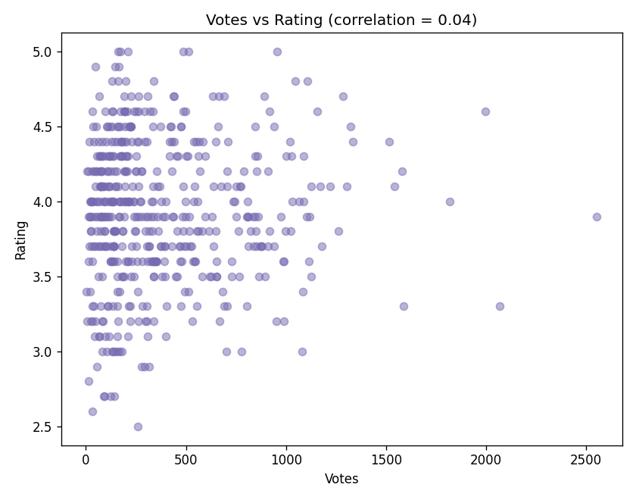
Correlation between Votes and Rating: 0.045 (essentially no linear relationship).
Top 5 restaurants by votes:
Restaurant | Votes | Rating
Starbucks | 2553 | 3.9
Burger King | 2066 | 3.3
Starbucks | 1995 | 4.6
Cafe Coffee Day | 1819 | 4
KFC | 1586 | 3.3

Bottom 5 restaurants by votes:
Restaurant | Votes | Rating
Urban Tadka - Jaipur | 4 | 3.4
Blue Lotus Kitchen | 6 | 3.2
Urban Tadka | 7 | 4.2
Sunset Grill | 12 | 2.8
Street Food Co. | 14 | 4.2

Findings:
- The most-voted restaurants are dominated by large chains (Starbucks, Burger King, KFC), reflecting brand recognition rather than exceptional quality.
- The near-zero correlation (0.045) between votes and rating shows that popularity (vote count) does not predict quality — a highly-voted restaurant is not necessarily highly rated, and vice versa.
- Low-vote restaurants show more rating variance (2.8 to 4.2), consistent with smaller sample sizes producing noisier averages.

Conclusion
Across all three tasks, popularity (outlet count, vote volume) and quality (rating) behave largely independently. Chains win on reach and consistency; independent restaurants show more variance but can achieve the highest individual ratings. Certain cuisine pairings — particularly those involving desserts and seafood — correlate with modestly higher ratings, offering a useful signal for menu or partnership strategy.

