Pocahontas: Ambassador of the New World
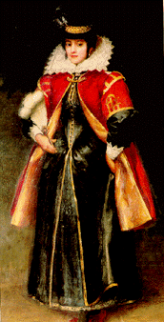
Viewing Guide

- Why did the Indians use a nickname instead of a person’s real name?
- List three examples that show the Powhatan Indians were civilized people, not savages.
- Powhatan was an unusually powerful ruler. Evidence of this is ___.
- What was Powhatan’s attitude toward the British colonists when they first arrived?
- How old was John Smith when he landed at Jamestown?
- According to this video, how might Smith and Pocahontas have bridged the language gap between them?
- Why was Smith condemned to death at Jamestown?
- Why did ships take a cargo of dirt from the New World to England?
- How did King James and the colonists deeply insult Powhatan?
- Why did Pocahontas refuse a reward from Smith?
- How was Smith injured?
- Why did Pocahontas decide to live with the Potomac Indians?
- What did Pocahontas do while she was a captive of the colonists?
- Who suggested that Pocahontas go to London?
- How old was Pocahontas when she died?

