**Problem Statement 1:**

This assignment is for visualization using matplotlib: data to use:

url=https://raw.githubusercontent.com/Geoyi/Cleaning-Titanic-Data/master/titanic_original.csv'

titanic = pd.read_csv(url)

Charts to plot:

1. Create a pie chart presenting the male/female proportion

2. Create a scatterplot with the Fare paid and the Age, differ the plot color by gender

NOTE:​ ​The​ ​solution​ ​shared​ ​through​ ​Github​ ​should​ ​contain​ ​the​ ​source​ ​code​ ​used​ ​and​ ​the​ ​screenshot​ ​of​ ​the​ ​output.

**Solution**

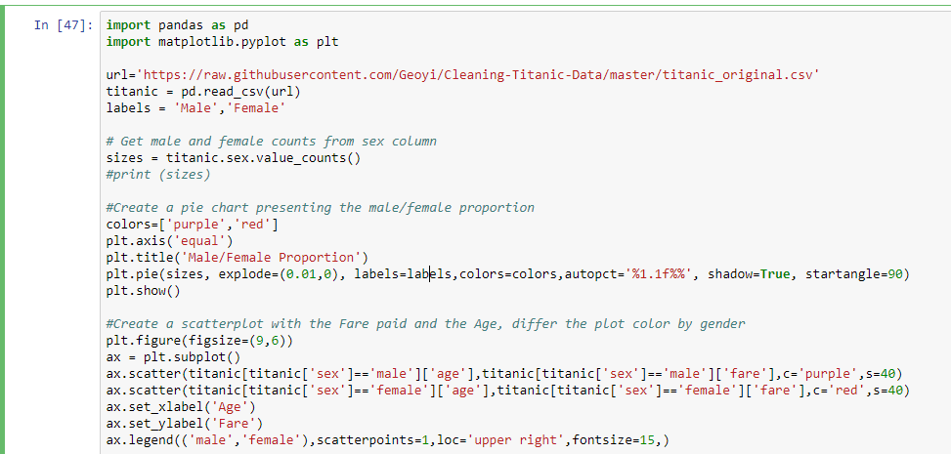

**Output**

