**Install Jupyter notebook and run the first program and share the screenshot of the output.**

1. Jupyter notebook installed and accessible as per below screenshot

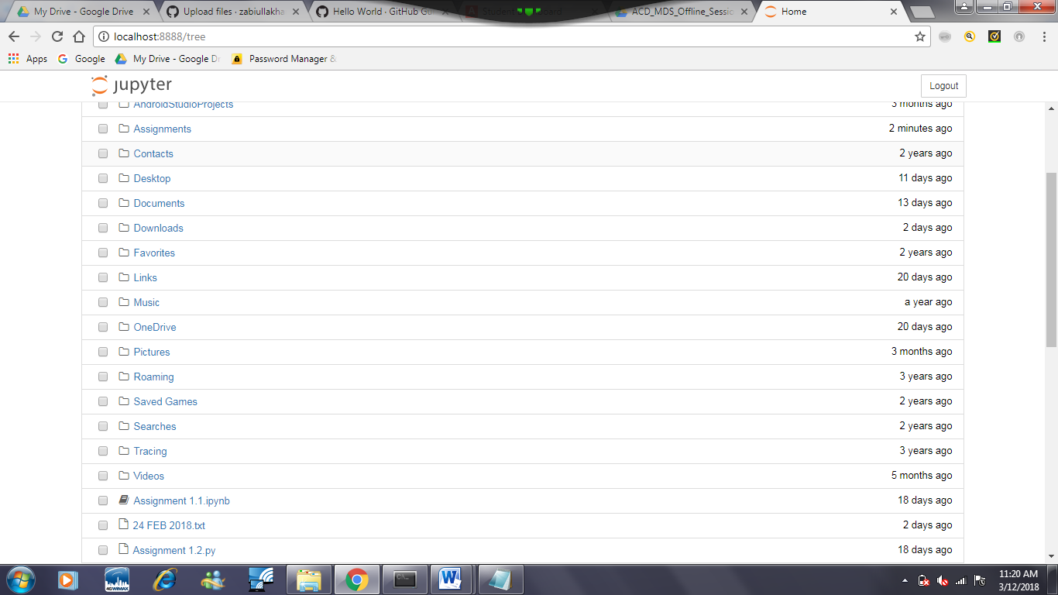

1. List commands Program with output executed in Jupyter notebook

