**Problem Statement 1:**

Is gender independent of education level? A random sample of 395 people was surveyed and each person was asked to report the highest education level they obtained. The data that resulted from the survey is summarized in the following table:

|  |  |  |  |  |  |
| --- | --- | --- | --- | --- | --- |
|  | High School | Bachelors | Masters | Ph.d. | Total |
| Female | 60 | 54 | 46 | 41 | 201 |
| Male | 40 | 44 | 53 | 57 | 194 |
| Total | 100 | 98 | 99 | 98 | 395 |

Question: Are gender and education level dependent at 5% level of significance? In other words, given the data collected above, is there a relationship between the gender of an individual and the level of education that they have obtained?

**Solution**

The chi-square test statistic is calculated by using the formula:

χ2=∑(O−E)2/E

Where, *O* represents the observed frequency.

*E* is the expected frequency under the null hypothesis and computed by:

E = row total **×** column total **/** sample size

We will compare the value of the test statistic to the critical value of χ2α with degree of freedom = (*r* - 1) (*c* - 1), and reject the null hypothesis if χ2>χ2α.

Df = (r-1)(c-1) = (4-1)(2-1) = (3)(1) = 3

Here, sample size = 395

Ef(High School) = 201 * 100/395 = 50.886

Em(High School) = 194*100/395 = 49.114

Ef(Bachelors) = Ef(Ph.d.) = 201*98/395 = 49.868

Em(Bachelors) = Em(Ph.d.) = 194*98/395 = 48.132

Ef(Masters) = 201*99/395 = 50.377

Em(Masters)= 194*99/395 = 48.623

Here's the table of expected frequency counts:

|  |  |  |  |  |  |
| --- | --- | --- | --- | --- | --- |
|  | High School | Bachelors | Masters | Ph.d. | Total |
| Female | 50.886 | 49.868 | 50.377 | 49.868 | 201 |
| Male | 49.114 | 48.132 | 48.623 | 48.132 | 194 |
| Total | 100 | 98 | 99 | 98 | 395 |

So, working this out, χ2= (60−50.886)2/50.886+⋯+ (57−48.132)2/48.132

= (60-50.886)(60-50.886)/50.886 + (54-49.868)(54-49.868)/49.868 +

(46-50.377)(46-50.377)/50.377 + (41-49.868)(41-49.868)/49.868 +

(40-49.114)(40-49.114)/49.114 + (44-48.132)(44-48.132)/48.132 +

(53-48.623)(53-48.623)/48.623 + (57-48.132)(57-48.132)/48.132

= 1.632 + 0.342 + 0.380 + 1.577 + 1.691 + 0.355 + 0.394 + 1.634

= 8.006

The critical value of χ2 with 3 degree of freedom for alpha value of 0.05 is 7.814.

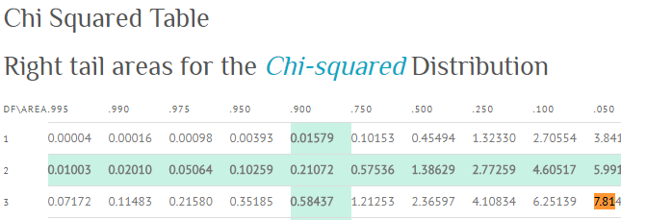

Since 8.006 > 7.815, therefore we reject the null hypothesis and conclude that the education level depends on gender at a 5% level of significance.