A Physics-Interpretable Gated-Imaging Simulation and Anti-Shortcut Validation Framework for 3D Target and Planar False-Target Discrimination
Target journal: Optics & Laser Technology
Draft date: 2026-07-10
Manuscript type: Research article
Highlights
- A Blender-based gated-imaging simulator is built for 3D and planar targets.
- Rectangular pulse-gate overlap models the range-gated echo response.
- Scalar shortcut diagnostics reveal a strong raw third-gate brightness cue.
- Domain-randomized training improves structured-nuisance robustness.
- Full three-gate stacks outperform all single-gate controls after domain mixing.
Submission Notes
Author names, affiliations, corresponding-author details, funding information, acknowledgements, declaration of competing interest, and final data/code availability statements must be confirmed by the authors before submission.
Abstract
Laser range-gated imaging can provide depth-related observations beyond a single two-dimensional intensity image, which is potentially useful for discriminating true 3D targets from planar false targets. However, classifiers trained on simulated gated images may exploit non-physical shortcuts such as black frames, absolute brightness differences, or rendering artifacts. This study presents a physics-interpretable Blender-based gated-imaging simulation and anti-shortcut validation framework for true 3D military target versus planar false-target discrimination. True targets are rendered as three-gate image stacks with visible depth-dependent responses, while planar false targets are generated by camera-depth flattening and rectangular pulse-gate overlap modulation. The framework includes scalar shortcut diagnosis, per-gate maximum normalization, model-level grouped validation, single-gate ablations, structured nuisance tests, and domain-randomized training. Experiments on 44 manually selected military 3D models show that the raw simulation contains a strong scalar shortcut, with gate-2 P99 intensity reaching 0.9886 threshold accuracy. Per-gate maximum normalization reduces the strongest scalar shortcut to 0.7955. On a four-view grouped validation dataset, the full three-gate stack achieves mean accuracies of 0.9848, 0.9811, and 0.9205 under clean, light-noise, and strong-noise evaluation, respectively. Clean/noisy-trained models fail under structured hard-nuisance shifts, whereas domain-mixed training improves the robustness boundary and reaches 0.9394, 0.9242, 0.9091, 0.9394, and 0.7727 under clean, light-noise, strong-noise, mild-nuisance, and strong-nuisance evaluation. These results support gate-stack validation in controlled simulation while emphasizing the need for shortcut diagnostics before robustness claims.
Keywords: laser gated imaging; range-gated imaging; planar false target; 3D target discrimination; Blender simulation; anti-shortcut validation; domain randomization
1. Introduction
Target recognition under active deception remains difficult when a planar false target visually resembles a real object from a given viewpoint. Conventional two-dimensional image recognition mainly depends on texture, contour, and local appearance cues. When the false target preserves a similar visible silhouette, a single image may not provide enough evidence to determine whether the object has real three-dimensional structure.
Laser range-gated imaging offers a physically different observation mechanism. A transmitted laser pulse illuminates the scene, while a receiver gate selects echoes within a controlled time window. Different gates correspond to different range intervals, so a gated image stack contains both spatial appearance and range-dependent response information. For a real 3D target, visible surfaces occupy a range of depths and therefore contribute differently to different gates. For a planar false target located near one depth plane, the visible silhouette should remain more consistent across nonzero gates, with intensity changes governed by the pulse-gate temporal overlap.
The central challenge in simulation-based validation is that a neural network may solve the task for the wrong reason. For example, if a false target appears in only one gate while the other gates are black, a classifier can detect black frames rather than depth structure. If true and false classes differ systematically in brightness, a scalar feature such as maximum intensity or P99 intensity may classify the data without using the intended multi-gate cue. Therefore, simulated gated-image classification requires explicit anti-shortcut validation before accuracy can be interpreted as physical evidence [5,15,16].
This work addresses the following question:
Can a physically interpretable three-gate image stack provide more stable evidence than any individual gate for discriminating true 3D targets from planar false targets, after major simulation shortcuts are diagnosed and controlled?
The main contributions are:
- A Blender-based gated-imaging simulation pipeline for selected military 3D models and corresponding planar false targets.
- A rectangular pulse-gate overlap model for generating interpretable true 3D and planar false-target gate responses.
- An anti-shortcut validation protocol including scalar shortcut diagnosis, per-gate normalization, grouped validation, single-gate ablations, and independent noise evaluation.
- A four-view grouped validation experiment showing that the full three-gate stack outperforms single-gate baselines on average under clean, light-noise, and strong-noise evaluation.
- A hard-nuisance boundary and domain-randomized training analysis showing that structured nuisance variation must be included in the simulation domain before robustness claims are made.
The work is positioned as a simulation and validation framework, not as a deployment-ready military recognition system and not as a new neural architecture.
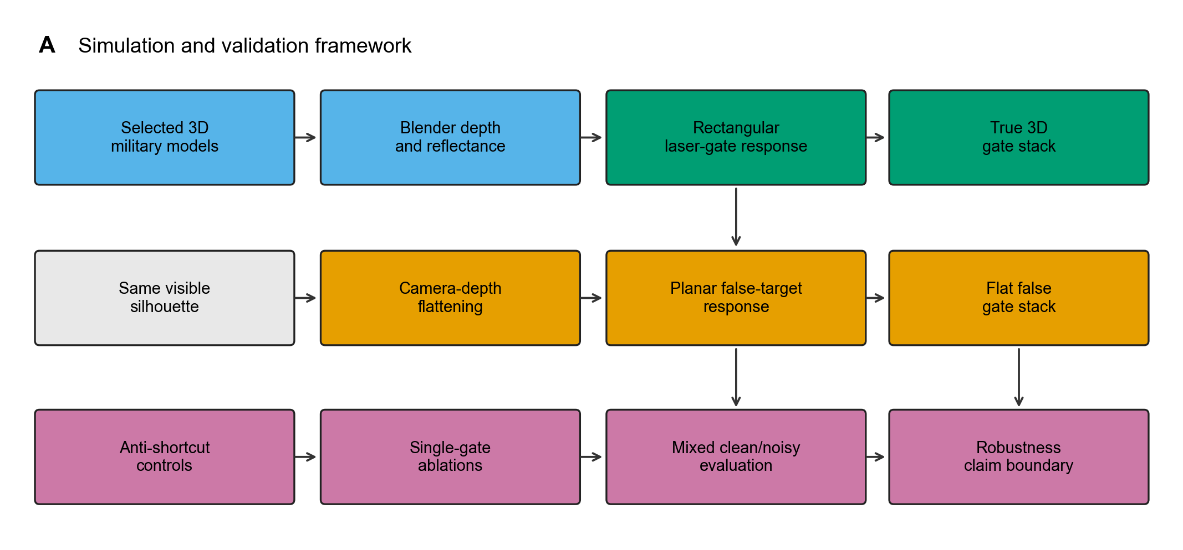
Figure 1. Overview of the proposed simulation and validation framework for gated-imaging-based discrimination between 3D targets and planar false targets. Selected military 3D models are rendered in Blender with depth and reflectance information, followed by a rectangular laser-gate response model to generate true 3D gate stacks. Planar false targets are generated by camera-depth flattening while preserving the visible silhouette, and the resulting gate stacks are evaluated with anti-shortcut controls, single-gate ablations, and independent clean/noisy tests. Source file: `writing/figures/fig1_gated_imaging_framework.png`.
2. Related Work
2.1 Laser range-gated imaging
Laser range-gated imaging uses active pulsed illumination and temporally controlled receiver gates to suppress out-of-gate background and encode range-dependent information. Classical gated viewing and 3D range-gated systems established the practical value of temporal gating for active ranging and imaging, including underwater and long-range scenarios [7,8]. In three-dimensional laser gated range-intensity correlation imaging, the relationship among the transmitted pulse, receiver gate, echo delay, and received intensity can be modeled through range-intensity profiles [1]. Rectangular pulse and gate windows naturally produce triangular or trapezoidal response profiles depending on their relative widths [1,9,10]. Spatial-correlation and multi-pulse super-resolution formulations further show that multi-gate intensity sequences carry recoverable range structure rather than ordinary texture [9,10]. Underwater gated range-intensity imaging has likewise used multi-gate observations for 3D recovery under scattering [11]. These physical principles motivate the rectangular pulse-gate overlap response used in the present simulation.
2.2 Learning-based gated imaging and depth priors
Learning-based methods increasingly treat gated image stacks as structured optical inputs. Gated2Depth recovers dense depth from gated images and demonstrates that temporal gating can support monocular-like depth estimation under night-time and adverse conditions [12]. Gated2Gated further exploits multi-gate consistency for self-supervised depth learning [13]. More recently, transformer-based 3D range-gated imaging with multiple depth priors has argued that pure vision learning underuses the optical principle of range-gated imaging and that gate stacks should be treated as physically related observations [2]. These works motivate multi-gate depth and consistency modeling. However, the present task is different: instead of reconstructing dense depth, this study evaluates whether gate-stack observations can discriminate true 3D targets from planar false targets while avoiding simulation shortcuts.
2.3 Gated cameras and multimodal perception
Gated cameras have also been used in robust perception systems, especially under adverse visibility, low-light, rain, fog, or weather-degraded conditions. Range-gated active short-wave infrared imaging has been studied for rain penetration and improved target visibility in degraded atmospheres [14]. In multimodal object detection, gated near-infrared images can complement RGB, LiDAR, and radar under adverse weather [3]. Recent diffractive optical imaging systems further suggest longer-term routes for optical-neural image formation and projection [4]. This literature motivates the long-term direction of combining gated imaging with multimodal or optical-neural recognition. The present work provides a narrower prerequisite: a controlled simulation and validation protocol for one physically meaningful discrimination task.
2.4 Shortcut learning and simulation-to-real risk
Shortcut learning is a general risk in deep learning: models may exploit cues that correlate with labels in the training data but do not reflect the intended causal or physical mechanism [5]. Related work on Clever Hans predictors and dataset bias further shows that high accuracy can arise from unintended decision rules or collection artifacts rather than the intended concept [15,16]. Synthetic optical imaging adds another risk because simulator artifacts may be easier to learn than real physical structure. Domain randomization is one way to reduce this risk by exposing the model to controlled variation during training, thereby improving transfer from simulation to broader domains [6,17]. In this paper, shortcut diagnostics and domain-randomized simulation are treated as necessary components of the validation chain.
3. Physical Model and Simulation
3.1 Rectangular pulse-gate overlap
Let the transmitted pulse be a rectangular temporal window of width \(T_l\), and let the receiver gate be another rectangular temporal window of width \(T_g\). If the echo from a surface point arrives at time \(\tau\) and the center of gate \(i\) is \(c_i\), the normalized gate response is modeled as the normalized overlap length:
W_i(\tau)= \frac{\left|\mathrm{rect}_{T_l}(t-\tau)\cap \mathrm{rect}_{T_g}(t-c_i)\right|} {\min(T_l,T_g)}.
When \(T_l=T_g\), the response profile is triangular. When one window is wider than the other, the response becomes trapezoidal with a plateau [1,9,10]. In the present rectangular-overlap simulation configuration, the receiver gate is wider than the laser pulse, so a trapezoidal response is used.
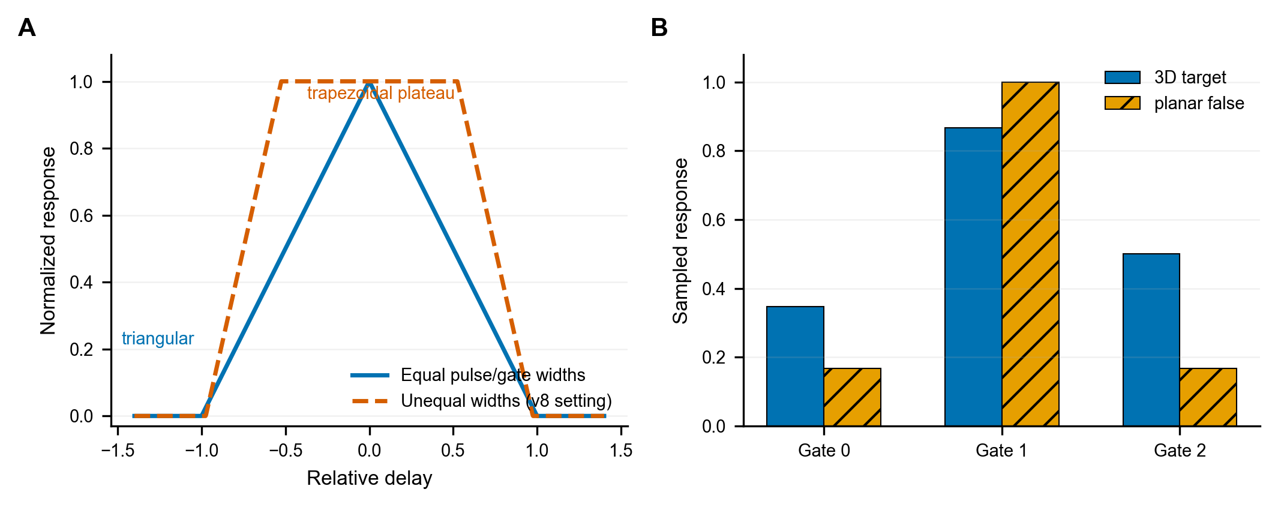
Figure 2. Rectangular pulse-gate overlap model used in the gated-image simulation. The normalized received response is determined by the temporal overlap length between the transmitted laser pulse and the receiver gate. Equal pulse/gate widths produce a triangular response, whereas the rectangular-overlap unequal-width setting produces a trapezoidal response with a plateau. A planar false target samples the same whole-object response across gates, while a true 3D target integrates responses from multiple visible depths. Source file: `writing/figures/fig2_rectangular_overlap_response.png`.
3.2 True 3D target gate-stack generation
For a true 3D target, visible surface points have different camera depths. The \(i\)-th gate image is modeled as:
I_i(x,y)=R(x,y)W_i(\tau(x,y)),
where \(R(x,y)\) is the rendered visible reflectance or intensity and \(\tau(x,y)\) is the depth-dependent echo delay. Because \(\tau(x,y)\) varies over the object surface, different gates emphasize different depth regions. Blender is used to load and render each selected military 3D model, producing a three-gate grayscale stack:
X=[I_0,I_1,I_2].
3.3 Planar false-target construction
The planar false target is generated by flattening the target geometry along the camera-depth direction while preserving the visible silhouette. This construction removes the target's physical depth distribution but avoids the unrealistic behavior of showing only a partial object in each gate. The false target is then modulated by the same rectangular pulse-gate response. Thus, a planar false target should appear as a whole-object silhouette across nonzero gates, with gate intensity controlled by pulse-gate overlap rather than by an arbitrary manual fade.
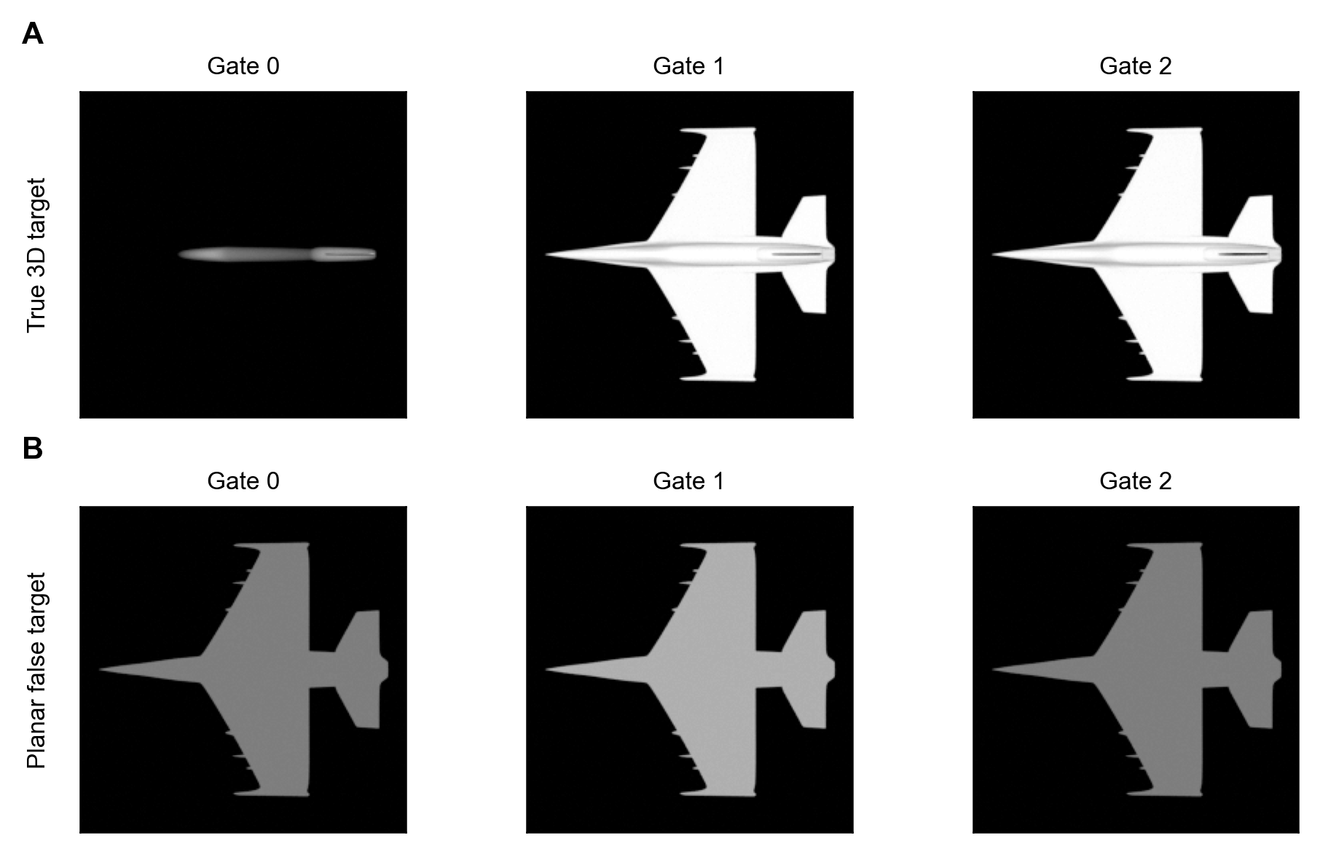
Figure 3. Representative raw gate-stack images generated by the rectangular-overlap gated-image simulation. The true 3D target changes its visible structure across gates because different depth regions contribute to different range windows. In contrast, the planar false target preserves the complete object silhouette across gates, with intensity changes governed by the pulse-gate overlap response. Source file: `writing/figures/fig3_true3d_flatfalse_gate_examples.png`.
4. Dataset and Anti-Shortcut Protocol
4.1 Dataset
The study uses 44 manually selected military 3D models. The selected source models include 12 main battle tank models, 20 fighter jet models, and 12 attack helicopter models. Each model is rendered as a true 3D target and paired with a corresponding planar false target. The single-view dataset contains 88 samples and 264 gate images. The four-view dataset renders each source model under four yaw angles (0, 90, 180, and 270 degrees), producing 352 samples and 1056 gate images.
Throughout the paper, Gate 0/1/2 denote the three ordered range gates of a sample; full stack denotes the joint use of all three gates; and grouped validation means that all views and domain variants of the same source model stay in the same split partition. Internal dataset-generation tags are omitted from the main text.
For the four-view dataset, validation splitting is grouped by the underlying source model. All views and domain variants of the same source object are assigned to the same split partition. This prevents cross-view leakage.
Table 1 summarizes the dataset variants used in the current experiments. A sample denotes one three-gate stack.
dataset variant | role | source groups | true-3D stacks | planar-false stacks | total stacks | gate images | grouped split protocol
single-view normalized rectangular-overlap simulation | early controlled validation | 44 | 44 | 44 | 88 | 264 | 25% source-group validation when trained
four-view normalized rectangular-overlap simulation | clean/noise evaluation domain | 44 | 176 | 176 | 352 | 1056 | 33 train groups and 11 validation groups per seed
four-view mild structured-nuisance domain | structured-nuisance evaluation and domain-mix component | 44 | 176 | 176 | 352 | 1056 | 11 validation groups per seed during evaluation
four-view strong structured-nuisance domain | structured-nuisance stress test | 44 | 176 | 176 | 352 | 1056 | 11 validation groups per seed during evaluation
normal-plus-mild-nuisance domain mixture | final domain-randomized training | 44 | 352 | 352 | 704 | 2112 | 33 train groups and 11 validation groups per seed

4.2 Scalar shortcut diagnosis
Before neural training, simple scalar features extracted from individual gate images are tested with one-dimensional threshold classifiers. Unless otherwise stated, P95 and P99 denote the 95th- and 99th-percentile intensities of a single gate image, maximum intensity is the peak pixel value, and edge density is the fraction of pixels retained by a fixed edge detector. These descriptors are used only for shortcut diagnosis, not as the final recognition model.
The raw rectangular-overlap simulation contains a strong non-structural cue: a threshold on the third-gate P99 intensity already reaches 0.9886 accuracy. This means that the raw dataset cannot be used as direct evidence that a classifier learns depth-gated structure.
Per-gate maximum normalization is therefore applied to reduce absolute brightness differences across samples. After normalization, the strongest scalar shortcut decreases to 0.7955 and shifts mainly toward edge or shape statistics. This does not eliminate all single-gate information, but it weakens the dominant brightness cue and motivates formal single-gate neural ablations.
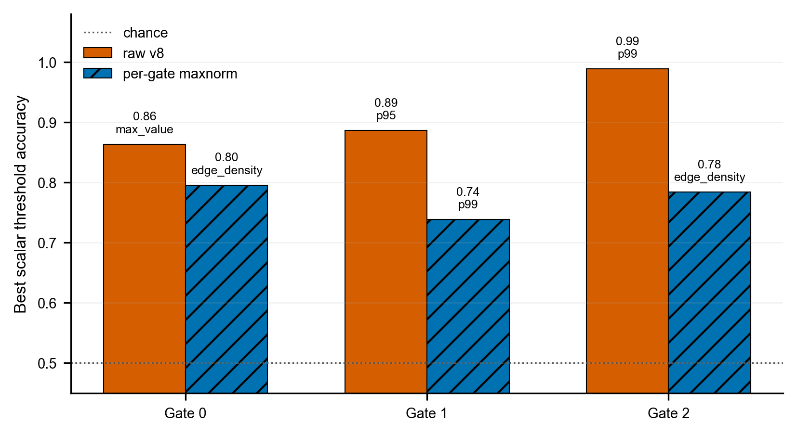
Figure 4. Strongest single-gate scalar shortcut before and after per-gate maximum normalization. In the raw rectangular-overlap simulation, the third gate contains a strong 99th-percentile intensity cue, with a threshold-classification accuracy of 0.9886. After per-gate maximum normalization, the strongest scalar shortcut is reduced to 0.7955 and shifts mainly toward edge or shape statistics, indicating that absolute brightness is no longer the dominant cue. Source file: `writing/figures/fig4_scalar_shortcut_control.png`.
Table 2 reports the strongest scalar threshold classifier found for each gate before and after per-gate maximum normalization.
dataset | gate | strongest scalar feature | threshold accuracy | true-3D mean | planar-false mean | Cohen's d
raw rectangular-overlap simulation | 0 | maximum intensity | 0.8636 | 0.3426 | 0.1440 | -2.041
raw rectangular-overlap simulation | 1 | P95 intensity | 0.8864 | 0.3177 | 0.1597 | -2.291
raw rectangular-overlap simulation | 2 | P99 intensity | 0.9886 | 0.3055 | 0.1103 | -2.886
per-gate max-normalized simulation | 0 | edge density | 0.7955 | 0.3664 | 0.1357 | -1.398
per-gate max-normalized simulation | 1 | P99 intensity | 0.7386 | 0.6874 | 0.6004 | -0.573
per-gate max-normalized simulation | 2 | edge density | 0.7841 | 0.3499 | 0.1559 | -1.194

5. Neural Baseline and Training Setup
The neural model is a lightweight electronic baseline used to test whether the simulated gate stacks contain discriminative information. It is not the main innovation. A shared CNN encoder extracts features from each gate. The full-stack setting fuses all three gate features, while the single-gate baselines use only one selected gate. Fusion modes include mean fusion, attention fusion, and attention-residual fusion. The classifier head outputs logits for two classes, true 3D target and planar false target; softmax probabilities are used only for interpretation, while cross-entropy loss is applied to logits during training.
Main experiments use three random seeds:
42 / 332 / 2026
Independent evaluation conditions are:
condition | gaussian noise std | poisson peak | background scatter
clean | 0.00 | 0 | 0.00
light noise | 0.02 | 80 | 0.02
strong noise | 0.05 | 30 | 0.05

Structured hard-nuisance evaluation additionally introduces low-frequency reflectance variation, weak background scatter, and partial occlusion. Domain-randomized training mixes the normal four-view domain with the mild-nuisance domain and applies strong-noise augmentation during training.
Table 3 lists the main training and evaluation settings for the final domain-mixed experiments.
item | setting
task | binary classification of true 3D versus planar false targets
input | grayscale three-gate stacks resized to 224 x 224 per gate
backbone | shared three-layer CNN encoder with 128-dimensional per-gate features
fusion used for final domain-mixed runs | learned attention over gate features
classifier head | LayerNorm, dropout 0.25, Linear 128 to 64, ReLU, dropout 0.25, Linear 64 to 2 logits
model size | 126,371 trainable parameters for the attention full-stack model
loss | cross-entropy on logits; label smoothing 0.05 for training
optimizer and schedule | AdamW, learning rate 0.001, weight decay 1e-4, cosine annealing to 1e-5
training length | 20 epochs
batch size and workers | batch size 8, `num_workers=0`
random seeds | 42, 332, 2026
split | model-level grouped split, validation ratio 0.25
domain-mixed training set | 704 stacks; per seed, 528 training stacks and 176 validation stacks
training-time degradation | probability 0.5, Gaussian noise std 0.05, Poisson peak 30, background scatter 0.05
clean evaluation | normal four-view dataset, no added degradation
light-noise evaluation | Gaussian noise std 0.02, Poisson peak 80, background scatter 0.02
strong-noise evaluation | Gaussian noise std 0.05, Poisson peak 30, background scatter 0.05
mild-nuisance domain | baked nuisance dataset with reflectance strength 0.08, background strength 3.0, occlusion alpha 0.6, mean occlusion fraction 0.0496
strong-nuisance domain | baked nuisance dataset with reflectance strength 0.18, background strength 9.0, occlusion alpha 0.35, mean occlusion fraction 0.1262
evaluation sample count | 88 grouped validation stacks per seed and condition
software checked locally | Windows 10, Python 3.8.20, PyTorch 2.4.1, CUDA 11.8

6. Results
6.1 Single-view full-stack versus single-gate baselines
On the normalized single-view dataset, the full three-gate stack achieves the highest mean accuracy under clean, light-noise, and strong-noise evaluation. Table 4 reports the independent evaluation accuracies.
Table 4. Single-view full-stack versus single-gate baselines under clean, light-noise, and strong-noise evaluation. Values are mean grouped-validation accuracy over three seeds (42/332/2026).
condition | full stack | Gate 0 | Gate 1 | Gate 2
clean | 0.9697 | 0.9091 | 0.7121 | 0.8636
light noise | 0.9545 | 0.8636 | 0.5151 | 0.7727
strong noise | 0.7424 | 0.6970 | 0.5152 | 0.5152

These results show that the complete gate stack contains useful information beyond any individual gate in the single-view controlled setting.
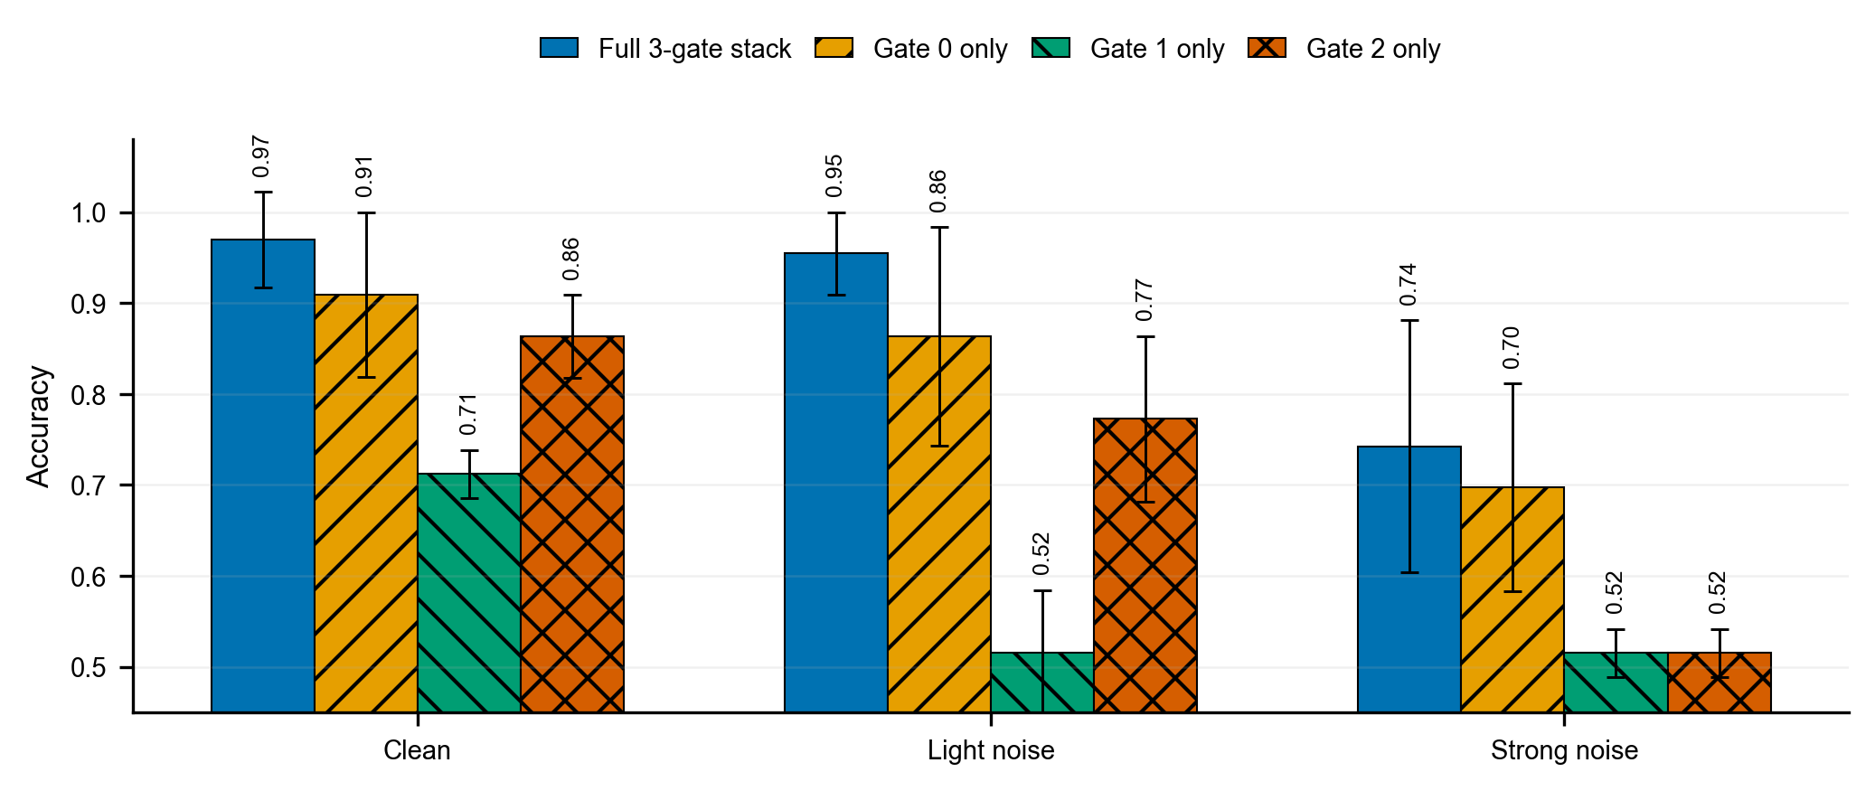
Figure 5. Independent evaluation of the full three-gate stack and single-gate baselines under clean, light-noise, and strong-noise conditions. Bars denote mean accuracy over three random seeds (42/332/2026), and error bars denote standard deviation. The full three-gate stack gives the highest mean accuracy in all three evaluation conditions, supporting the usefulness of multi-gate information beyond a single selected range slice. Source file: `writing/figures/fig5_full_stack_vs_single_gate_robustness.png`.
6.2 Fusion-mode comparison
The fusion comparison shows that the best fusion strategy depends on the evaluation condition. Attention-residual fusion is strong under clean single-view validation, but attention fusion is more stable under strong noise. Therefore, the paper treats the fusion head as a tunable engineering module rather than a claimed architectural breakthrough. Quantitative single-view fusion trends are summarized in Figure 6; the corresponding four-view numerical comparison is reported later in Table 6.
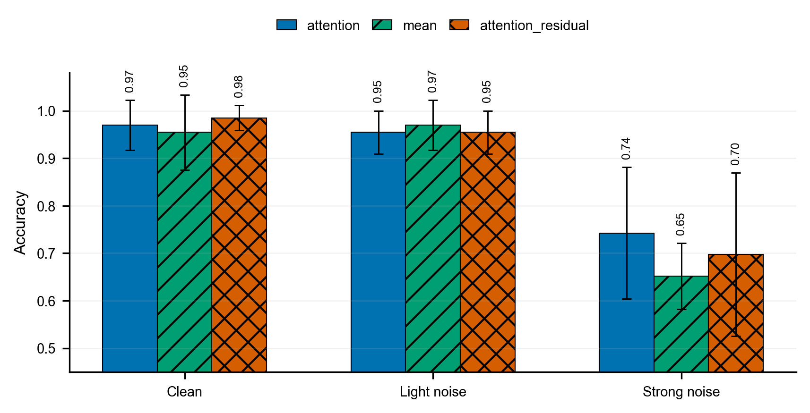
Figure 6. Independent evaluation of three full-stack fusion strategies under clean, light-noise, and strong-noise conditions. Bars denote mean accuracy over three random seeds, and error bars denote standard deviation. The attention-residual head provides the best clean-condition performance, mean fusion is slightly better under light noise, while attention fusion is more robust under strong noise. This indicates that gate-stack fusion is a design variable rather than a solved component. Source file: `writing/figures/fig6_full_stack_fusion_robustness.png`.
6.3 Four-view grouped validation
The four-view dataset tests whether the gate-stack advantage remains when each source model is rendered from four yaw orientations and all views of the same source model are grouped during splitting. The full three-gate stack remains the best mean performer. Table 5 reports the corresponding accuracies.
Table 5. Four-view full-stack versus single-gate baselines under clean, light-noise, and strong-noise evaluation. Values are mean grouped-validation accuracy over three seeds (42/332/2026).
condition | full stack | Gate 0 | Gate 1 | Gate 2
clean | 0.9848 | 0.9697 | 0.9545 | 0.8939
light noise | 0.9811 | 0.9432 | 0.9053 | 0.8750
strong noise | 0.9205 | 0.7462 | 0.5265 | 0.6098

The strong-noise margin is especially important: under stronger degradation, the complete gate stack remains substantially more stable than any single gate.
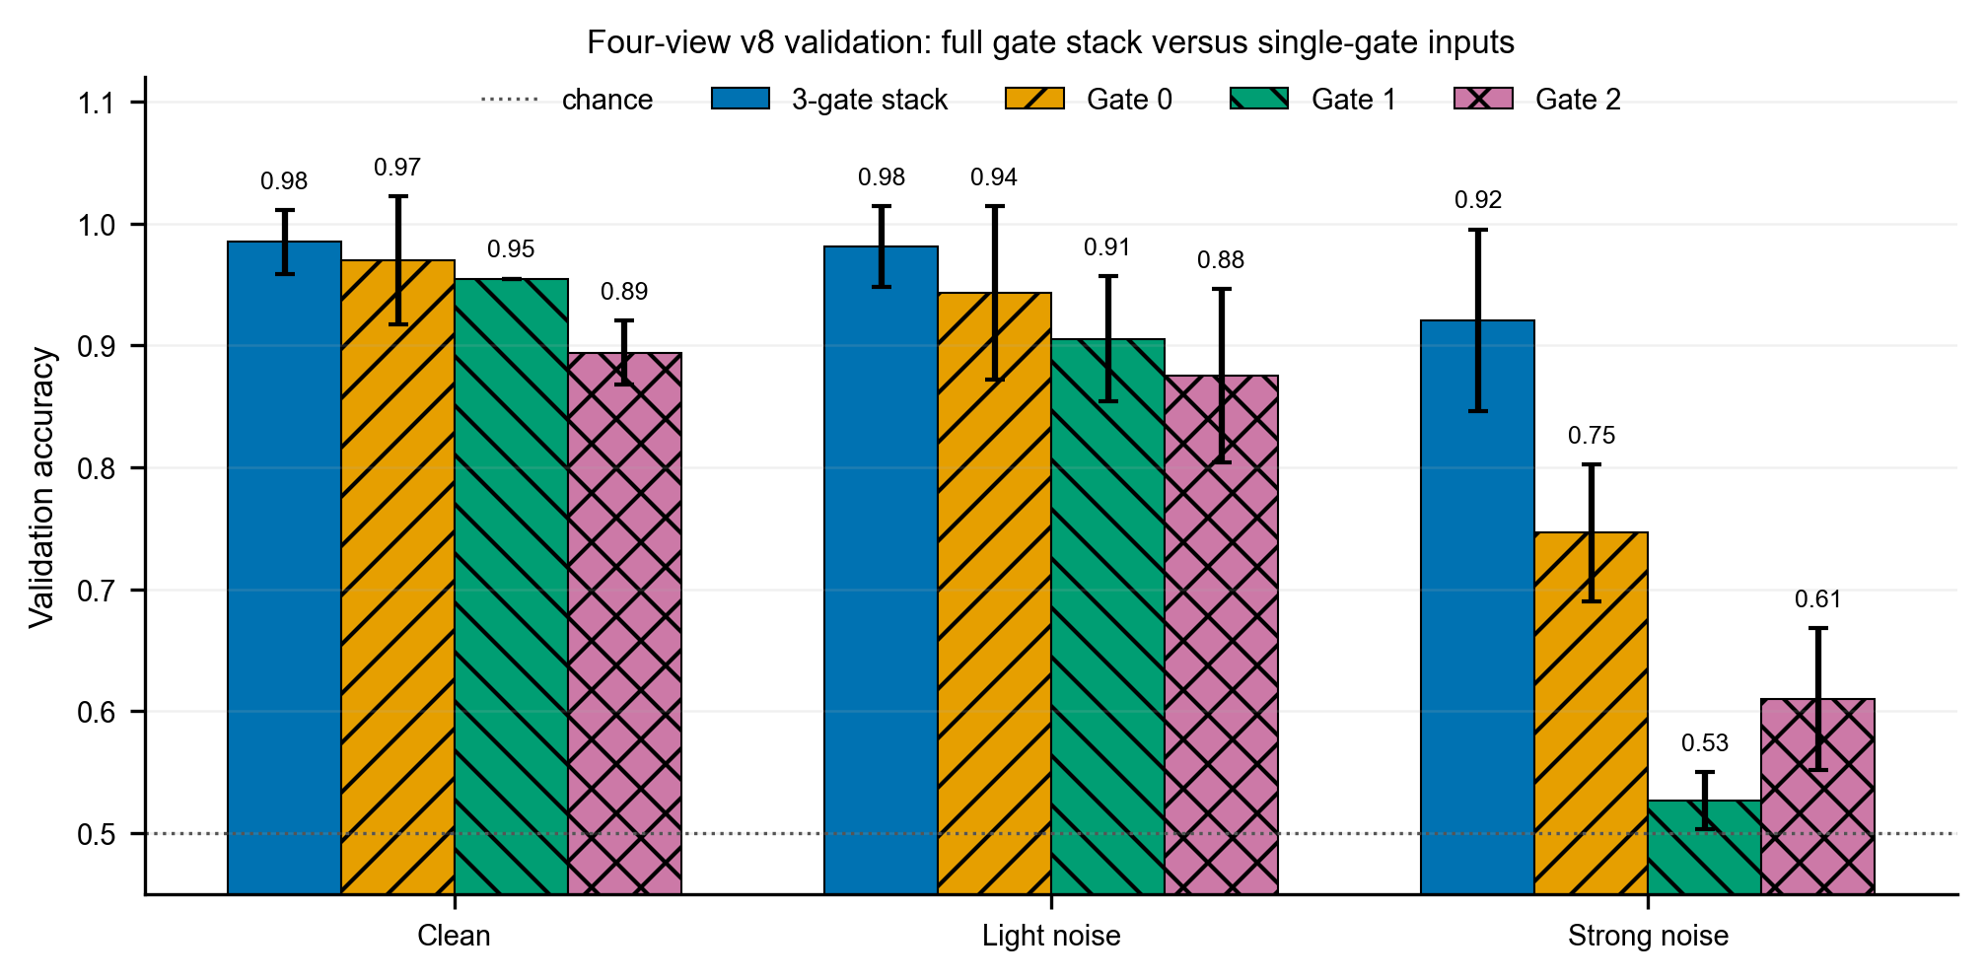
Figure 7. Four-view validation of the full three-gate stack and single-gate baselines under clean, light-noise, and strong-noise conditions. Each source model is rendered at four yaw rotations (0, 90, 180, and 270 degrees), and the validation split keeps all views of the same source model in the same partition. Bars denote mean accuracy over three random seeds, and error bars denote standard deviation. The full gate stack remains the best mean performer in all three evaluation conditions, with a larger margin under strong noise. Source file: `writing/figures/fig7_mv4_full_stack_vs_single_gate_robustness.png`.
6.4 Four-view fusion comparison
Four-view fusion results further support a conservative network claim. Attention, mean, and attention-residual fusion tie under clean evaluation; mean fusion is slightly better under light noise; attention fusion is best under strong noise. Table 6 summarizes these results.
Table 6. Four-view full-stack fusion-mode comparison under clean, light-noise, and strong-noise evaluation. Values are mean grouped-validation accuracy over three seeds (42/332/2026).
condition | attention | mean | attention_residual
clean | 0.9848 | 0.9848 | 0.9848
light noise | 0.9811 | 0.9848 | 0.9394
strong noise | 0.9205 | 0.7197 | 0.7727

This result confirms that the neural fusion head is an engineering variable, while the central contribution remains the simulation and validation framework.
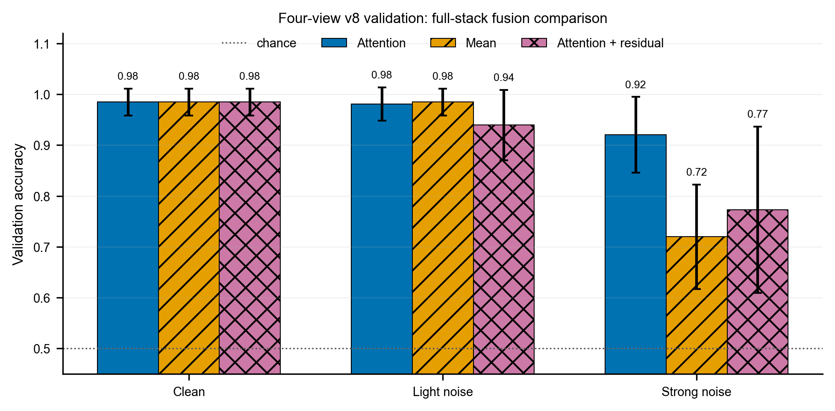
Figure 8. Four-view validation of full-stack fusion modes under clean, light-noise, and strong-noise conditions. Bars denote mean accuracy over three random seeds, and error bars denote standard deviation. The three fusion modes are tied under clean evaluation. Mean fusion is slightly better under light noise, while simple attention is clearly more robust under strong noise. This result indicates that the fusion head is an engineering variable rather than the central contribution of the study. Source file: `writing/figures/fig8_mv4_full_stack_fusion_robustness.png`.
6.5 Hard-nuisance failure boundary
The clean/noisy-trained four-view attention models fail under structured hard-nuisance shifts. Table 7 reports the hard-nuisance failure boundary.
Table 7. Hard-nuisance failure boundary for clean/noisy-trained four-view attention models. Values are mean grouped-validation accuracy over three seeds (42/332/2026).
condition | full stack | Gate 0 | Gate 1 | Gate 2
strong structured nuisance | 0.5000 | 0.4697 | 0.5000 | 0.4545
mild structured nuisance | 0.5000 | 0.4848 | 0.5000 | 0.4545

This is a failure-boundary result, not a negative result to hide. It shows that clean/noisy validation does not imply robustness to structured reflectance, background, and occlusion shifts. Therefore, nuisance-aware simulation must be treated as part of the imaging model.
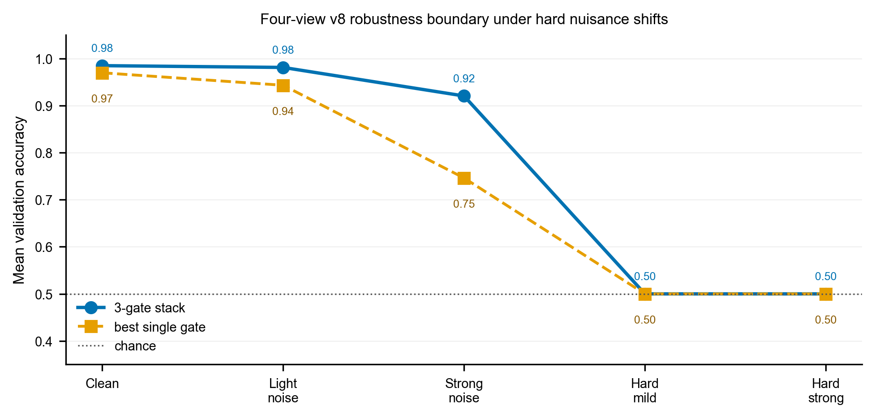
Figure 9. Failure-boundary evaluation under structured nuisance shifts. The four-view attention models are trained on the normalized clean/noisy dataset and evaluated on clean, light-noise, strong-noise, and hard-nuisance datasets. The hard-nuisance datasets introduce low-frequency reflectance texture, weak background scatter, and partial occlusion while preserving per-sample maximum intensity. The full gate stack remains robust under the original clean/noisy protocol but collapses to approximately chance accuracy under structured nuisance shifts, indicating that nuisance-aware simulation and training are required before making realistic robustness claims. Source file: `writing/figures/fig9_hard_nuisance_failure_boundary.png`.
6.6 Domain-randomized training improves the robustness boundary
To address the hard-nuisance failure, a domain-mixed dataset is constructed by combining the normal four-view domain with the mild structured-nuisance domain.
The domain-mixed model is trained with strong-noise augmentation. Compared with normal mixed-noise training and online nuisance augmentation, explicit domain mixing provides the best hard-nuisance robustness. Table 8 summarizes the grouped-validation mean accuracy over three seeds (42/332/2026).
Table 8. Training-strategy comparison under clean/noisy evaluation and structured hard-nuisance shifts. Values are mean grouped-validation accuracy over three seeds (42/332/2026).
strategy | clean | light noise | strong noise | mild nuisance | strong nuisance
mixed-noise training | 0.9848 | 0.9811 | 0.9205 | 0.5000 | 0.5000
online structured-nuisance augmentation | 0.9697 | 0.7879 | 0.5606 | 0.5000 | 0.5000
domain mixture + strong-noise training | 0.9394 | 0.9242 | 0.9091 | 0.9394 | 0.7727

These results show that high clean accuracy alone is insufficient: mixed-noise training reaches 0.9848 on clean data but falls to 0.5000 under both mild-nuisance and strong-nuisance shifts, whereas domain-mixed training retains 0.9394 and 0.7727 under the same conditions. The domain-mixed model therefore sacrifices some clean and light-noise accuracy, but substantially improves the structured-nuisance robustness boundary. This supports a manuscript-safe claim: explicit domain-randomized simulation improves structured-nuisance robustness in the current simulation setting.
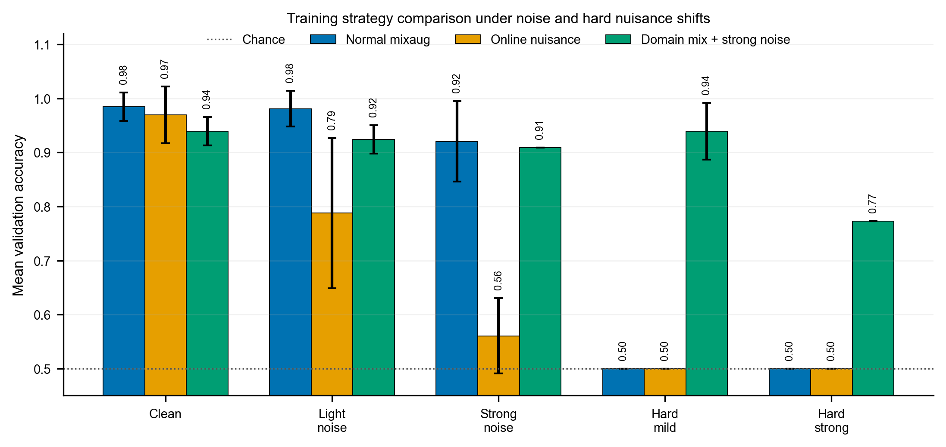
Figure 10. Training strategy comparison under clean/noisy evaluation and structured hard-nuisance shifts. Bars denote mean grouped-validation accuracy over three random seeds, and error bars denote standard deviation. The normal mixed-noise baseline performs best under clean and light-noise conditions but collapses to chance accuracy under the hard-nuisance datasets. Online structured nuisance augmentation does not recover hard-nuisance performance in the current implementation and weakens strong-noise robustness. In contrast, explicit domain mixing between the normal and mild-nuisance simulated domains, combined with strong-noise augmentation, recovers mild-nuisance accuracy to 0.9394 and strong-nuisance accuracy to 0.7727 while preserving 0.9091 strong-noise accuracy. Source file: writing/figures/fig10_domain_randomization_strategy_comparison.png.
6.7 Domain-mixed full-stack versus single-gate ablation
The final domain-mixed single-gate ablation evaluates whether the robustness gain from domain mixing can be reproduced by a single gate alone. All models are trained with the same normal-plus-mild-nuisance mixed domain and strong-noise augmentation. The full-stack model uses all three gates, while the single-gate controls use only gate 0, gate 1, or gate 2. Table 9 reports the five-condition comparison.
Table 9. Domain-mixed full-stack versus single-gate ablation under clean, light-noise, strong-noise, mild-nuisance, and strong-nuisance evaluation. All models use domain-mixed normal-plus-mild-nuisance training with strong-noise degradation. Values are mean grouped-validation accuracy over three seeds (42/332/2026).
condition | full stack | Gate 0 | Gate 1 | Gate 2
clean | 0.9394 | 0.7879 | 0.5758 | 0.7727
light noise | 0.9242 | 0.8295 | 0.5455 | 0.7576
strong noise | 0.9091 | 0.8523 | 0.5909 | 0.7424
mild nuisance | 0.9394 | 0.8485 | 0.5455 | 0.8030
strong nuisance | 0.7727 | 0.7121 | 0.5303 | 0.6667

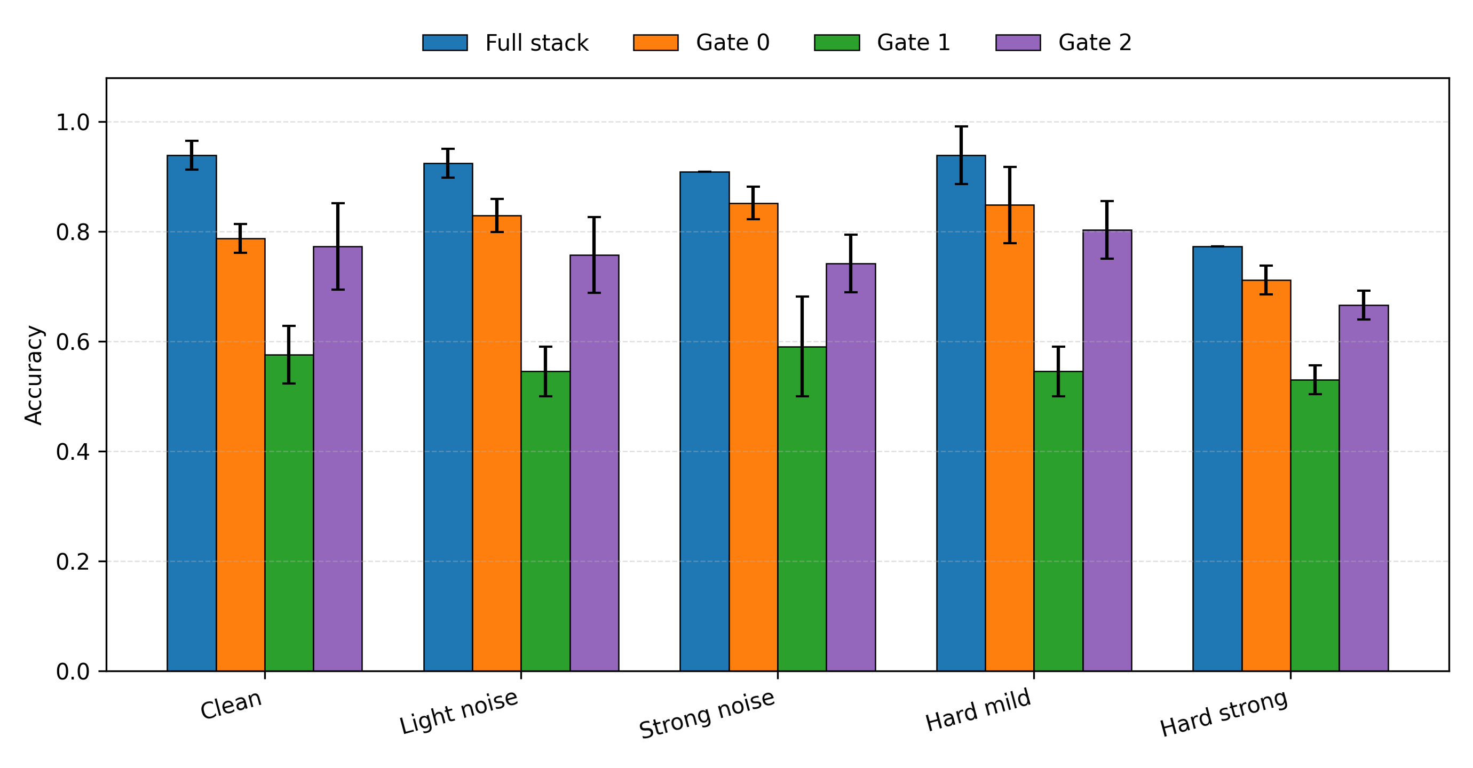
Figure 11. Domain-mixed full-stack versus single-gate ablation under clean, light-noise, strong-noise, mild-nuisance, and strong-nuisance evaluation. All models are trained on the normal-plus-mild-nuisance mixed domain with strong-noise augmentation and evaluated with model-level grouped splits over three seeds. The full three-gate stack is the best mean performer under all five conditions, indicating that the domain-randomized robustness improvement is not reproduced by any individual gate alone. Source file: writing/figures/fig11_domainmix_full_stack_vs_single_gate.png.
After domain-randomized training, the full three-gate stack remains the strongest configuration under every evaluation condition, with the largest absolute gains over the best single gate on clean (+0.1515 versus Gate 0) and mild-nuisance (+0.0909 versus Gate 0) settings. Gate 0 is the strongest single-gate baseline under strong-noise and strong-nuisance evaluation, but it remains below the full stack. Gate 1 is consistently weak in the domain-mixed single-gate setting. This result completes the domain-randomized ablation: the robustness improvement is not explained by a single gate alone, but benefits from the complete gate-stack observation.
7. Discussion
The current evidence supports three main conclusions.
First, the gated-image stack provides more stable evidence than individual gate images in the controlled simulation. This conclusion is supported by both single-view and four-view grouped validation. The four-view result is especially important because it reduces the possibility that a fixed viewpoint alone explains the result.
Second, anti-shortcut validation is necessary [5,15,16]. The raw simulation contains a strong scalar brightness shortcut, and direct classification on such data would be misleading. Per-gate maximum normalization reduces this shortcut, but single-gate images remain informative. Therefore, scalar diagnostics and single-gate neural ablations are both needed.
Third, robustness must be evaluated beyond clean/noisy perturbations. The hard-nuisance boundary shows that normal mixed-noise training collapses under structured reflectance, background, and occlusion shifts. Domain-randomized training improves this boundary [6,17], but the result remains simulation-domain evidence rather than proof of real-world decoy robustness.
The neural model should be interpreted as a lightweight baseline. The experiments show that fusion design affects robustness, but they do not support a claim that a particular attention-residual design is the main innovation. The stronger and more defensible contribution is the physical simulation and validation chain.
8. Limitations
This study remains limited in several ways. The dataset contains only 44 manually selected source models, so the results should be treated as controlled validation rather than large-scale military recognition. The viewpoint protocol includes four yaw rotations but not broad elevation changes or realistic sensor-placement variation. The physical model uses simplified rectangular pulse and gate windows and does not fully model detector response, atmospheric propagation, material BRDF, timing jitter, or real backgrounds. The planar false target is also idealized: it preserves the visible silhouette and removes depth, whereas real decoys may include folds, supports, nonuniform reflectance, deformation, and environmental clutter.
The domain-randomized result improves the simulated robustness boundary but does not prove real-world robustness. The completed domain-mixed single-gate ablation further supports the gate-stack claim, but it remains limited to the current simulated datasets and selected nuisance types.
9. Conclusion
This work presents a physics-interpretable gated-imaging simulation and anti-shortcut validation framework for discriminating true 3D targets from planar false targets. True targets are simulated through depth-dependent three-gate responses, while planar false targets are generated by camera-depth flattening and rectangular pulse-gate overlap modulation. The experiments show that raw simulated images can contain strong brightness shortcuts and that anti-shortcut controls are required before neural accuracy can be interpreted physically. After normalization and grouped validation, the full three-gate stack outperforms single-gate baselines on average under clean, light-noise, and strong-noise evaluation. Structured hard-nuisance tests reveal a failure boundary for clean/noisy-trained models, while explicit domain-randomized simulation improves this boundary. The final domain-mixed single-gate ablation confirms that the full gate stack remains the strongest mean performer across all five evaluation conditions. The current results support the value of gate-stack observations and domain-randomized simulation in a controlled setting, and they provide a foundation for broader viewpoint validation, larger datasets, real-system calibration, and future multimodal optical-neural target recognition.
Declaration of Competing Interest
To be confirmed by all authors before submission.
Funding
To be completed with confirmed funding information before submission. If no external funding supported the study, use: "This research did not receive any specific grant from funding agencies in the public, commercial, or not-for-profit sectors."
Data and Code Availability
The current experiments were generated and evaluated locally using Blender-rendered gate-stack datasets and PyTorch training scripts. A final data/code availability statement should be confirmed before submission, especially because the selected 3D model assets may be subject to third-party license restrictions.
References
[1] Bo Song, Yue Zhang, Xinwei Wang, Liang Sun, Yurun Zhang, and Yan Zhou, "Range precision prediction model for three-dimensional laser gated range-intensity correlation imaging," Optics Express 34(1), 707-717 (2026). DOI: 10.1364/OE.582218.
[2] Xiaoquan Liu, Di Zhang, Jinming Gao, and Xinwei Wang, "Transformer-based 3D range-gated imaging method with multiple depth priors," Optics & Laser Technology 190, 113234 (2025). DOI: 10.1016/j.optlastec.2025.113234.
[3] Edoardo Palladin, Roland Dietze, Praveen Narayanan, Mario Bijelic, and Felix Heide, "SAMFusion: Sensor-Adaptive Multimodal Fusion for 3D Object Detection in Adverse Weather," Computer Vision - ECCV 2024, Lecture Notes in Computer Science, 484-503 (2024). DOI: 10.1007/978-3-031-73030-6_27.
[4] Cagatay Isil, Alexander Chen, Yuhang Li, F. Onuralp Ardic, Shiqi Chen, Che-Yung Shen, and Aydogan Ozcan, "Snapshot 3D image projection using a diffractive decoder," Light: Science & Applications 15, 270 (2026). DOI: 10.1038/s41377-026-02378-3.
[5] Robert Geirhos, Joern-Henrik Jacobsen, Claudio Michaelis, Richard Zemel, Wieland Brendel, Matthias Bethge, and Felix A. Wichmann, "Shortcut learning in deep neural networks," Nature Machine Intelligence 2, 665-673 (2020). DOI: 10.1038/s42256-020-00257-z.
[6] Josh Tobin, Rachel Fong, Alex Ray, Jonas Schneider, Wojciech Zaremba, and Pieter Abbeel, "Domain randomization for transferring deep neural networks from simulation to the real world," 2017 IEEE/RSJ International Conference on Intelligent Robots and Systems (IROS), 23-30 (2017). DOI: 10.1109/IROS.2017.8202133.
[7] Jens Busck, "Underwater 3-D optical imaging with a gated viewing laser radar," Optical Engineering 44(11), 116001 (2005). DOI: 10.1117/1.2127895.
[8] Martin Laurenzis and Emmanuel Bacher, "Image coding for three-dimensional range-gated imaging," Applied Optics 50(21), 3824-3828 (2011). DOI: 10.1364/AO.50.003824.
[9] Xinwei Wang, Youfu Li, and Yan Zhou, "Triangular-range-intensity profile spatial-correlation method for 3D super-resolution range-gated imaging," Applied Optics 52(30), 7399-7406 (2013). DOI: 10.1364/AO.52.007399.
[10] Xinwei Wang, Youfu Li, and Yan Zhou, "Multi-pulse time delay integration method for flexible 3D super-resolution range-gated imaging," Optics Express 23(6), 7820-7831 (2015). DOI: 10.1364/OE.23.007820.
[11] Xinwei Wang, Yinan Cao, Wei Cui, Xiaoquan Liu, Songtao Fan, Yan Zhou, and Youfu Li, "Underwater 3D deblurring-gated range-intensity correlation imaging," Optics Letters 45(4), 969-972 (2020). DOI: 10.1364/OL.385983.
[12] Tobias Gruber, Frank Julca-Aguilar, Mario Bijelic, and Felix Heide, "Gated2Depth: Real-Time Dense Lidar From Gated Images," Proceedings of the IEEE/CVF International Conference on Computer Vision (ICCV), 1506-1516 (2019).
[13] Amanpreet Walia, Stefanie Walz, Mario Bijelic, Fahim Mannan, Frank Julca-Aguilar, Michael Langer, Werner Ritter, and Felix Heide, "Gated2Gated: Self-Supervised Depth Estimation from Gated Images," Proceedings of the IEEE/CVF Conference on Computer Vision and Pattern Recognition (CVPR), 2807-2817 (2022).
[14] Adam Willitsford, Kristin Haubrich, Sean Barry, and C. Russell Philbrick, "Range-gated active short-wave infrared imaging for rain penetration," Optical Engineering 60(1), 013103 (2021). DOI: 10.1117/1.OE.60.1.013103.
[15] Sebastian Lapuschkin, Stephan Waeldchen, Alexander Binder, Gregoire Montavon, Wojciech Samek, and Klaus-Robert Mueller, "Unmasking Clever Hans predictors and assessing what machines really learn," Nature Communications 10, 1096 (2019). DOI: 10.1038/s41467-019-08987-4.
[16] Antonio Torralba and Alexei A. Efros, "Unbiased look at dataset bias," Proceedings of the IEEE Conference on Computer Vision and Pattern Recognition (CVPR), 1521-1528 (2011). DOI: 10.1109/CVPR.2011.5995347.
[17] Jonathan Tremblay, Aayush Prakash, David Acuna, Mark Brophy, Varun Jampani, Cem Anil, Thang To, Eric Cameracci, Shaad Boochoon, and Stan Birchfield, "Training Deep Networks with Synthetic Data: Bridging the Reality Gap by Domain Randomization," Proceedings of the IEEE Conference on Computer Vision and Pattern Recognition Workshops (CVPRW), 969-977 (2018). DOI: 10.1109/CVPRW.2018.00143.
Pre-Submission Checklist
- [x] Fill Table 1 with exact dataset counts and split counts.
- [x] Fill Table 2 with complete scalar shortcut diagnostics.
- [x] Fill Table 3 with exact final hyperparameters and software versions.
- [x] Fill Table 4 with single-view full-stack versus single-gate results.
- [x] Fill Table 5 with four-view full-stack versus single-gate results.
- [x] Fill Table 6 with four-view fusion-mode comparison.
- [x] Fill Table 7 with hard-nuisance failure-boundary results.
- [x] Fill Table 8 with domain-randomized training-strategy comparison.
- [x] Complete Table 9 after 3090 Gate 1/Gate 2 formal runs.
- [x] Generate Fig. 11 after full five-condition single-gate evaluation.
- [x] Expand references to cover classical gated imaging, learning-based multi-gate depth, adverse-weather gated cameras, shortcut learning, and domain randomization.
- [ ] Re-verify newly added references against DOI/CrossRef metadata before submission.
- [x] Convert figure notes into final journal-style figure captions.

