P300 BCI as a Communication Channel for Catatonic Patients
Anastasia Zabolotna,
Sigmoid, Machine Learning Engineer Intern,
Chisinau, Republic of Moldova
e-mail: zabolotnay.dev@gmail.com
2026
Abstract - Brain-Computer Interfaces (BCI) based on the P300 event-related potential offer a proven communication channel for patients with severe motor disabilities. This paper presents a fully reproducible machine learning pipeline for P300-based symbol recognition on the BCI Competition III, Dataset II benchmark. The pipeline covers EEG preprocessing (Butterworth bandpass filtering, epoch extraction, decimation), feature engineering (spatiotemporal flattening with z-score normalization), and binary classification using Linear Discriminant Analysis (LDA) with shrinkage regularization. Model performance is evaluated using 5-fold cross-validation at the trial level, yielding character-level accuracy of 0.953 +/- 0.069 (Subject A) and 0.953 +/- 0.024 (Subject B). These results are obtained on healthy subjects using a full 36-symbol speller paradigm; performance in a simplified binary yes/no scenario or with catatonic patients may differ and requires separate empirical validation. The paper further provides a structured feasibility analysis of adapting this ML stack to enable communication with catatonic patients - a clinically critical population for whom no open EEG datasets currently exist.
Keywords: P300, Brain-Computer Interface, EEG, Machine Learning, LDA, cross-validation, catatonia, event-related potential, oddball paradigm, BCI Competition III

1 INTRODUCTION
Brain-Computer Interfaces (BCI) establish a direct communication pathway between the brain and external devices, bypassing the peripheral nervous system entirely [1]. Among the neurophysiological signals exploited for BCI, the P300 component - a positive EEG deflection occurring approximately 250-450 ms after a rare, task-relevant stimulus - has become the most clinically validated basis for non-motor communication [2].
The P300 speller paradigm [3] presents a 6x6 symbol matrix whose rows and columns are randomly highlighted; the row and column containing the intended symbol each elicit a P300 response. A machine learning classifier trained to detect P300 in single EEG epochs recovers the intended symbol by identifying which row and column produced the strongest response. This requires no movement - only covert attention - making it directly applicable to patients with ALS, locked-in syndrome, and similar conditions [4].
Despite decades of ALS-focused BCI research, the P300 paradigm has not been applied to catatonia - a neuropsychiatric syndrome where patients may retain intact consciousness but cannot produce voluntary motor or verbal responses [5]. Clinicians cannot assess pain, consent, or inner experience in these patients. A P300 BCI could in principle provide a communication channel, but no open clinical datasets exist to directly validate this hypothesis.
This paper makes two contributions: (1) a complete, reproducible ML pipeline evaluated with 5-fold cross-validation on the BCI Competition III benchmark, and (2) a structured feasibility analysis for adapting this pipeline to catatonic patients, identifying key gaps that future clinical research must close.

2 RESEARCH METHODOLOGY
Data: BCI Competition III, Dataset II [6] (Wadsworth Center, NYS DOH), recorded with BCI2000. Literature: PubMed, IEEE Xplore, arXiv, GitHub [7]. Implementation: Python (NumPy, SciPy, scikit-learn). Full code is available at: github.com/[your-repo]/p300-bci-catatonia

3 LITERATURE REVIEW

3.1 Neurophysiology of P300
P300 is an endogenous ERP component reflecting attention and working memory updating, maximally expressed over centro-parietal regions (Cz, Pz, Oz) in the oddball paradigm [2]. It is involuntary in the sense that it requires only directed covert attention, not overt movement, making it an ideal neural correlate for passive communication.

3.2 Machine Learning for P300 Detection
P300 detection is a binary classification problem: given a single EEG epoch, predict target (P300 present) or non-target. The core challenge is the extremely low signal-to-noise ratio of single-trial EEG (P300 amplitude 1-10 uV), addressed by averaging over multiple stimulus repetitions [4]. Classical approaches include LDA, SVM, and stepwise LDA; the BCI Competition III winning entry used an ensemble of linear SVMs [8]. Deep learning approaches (EEGNet [9], convolutional LSTM [10]) operate on raw epochs without feature engineering and show competitive performance in low-data regimes. We use LDA as a well-understood linear baseline whose results can be directly compared to the published benchmark.

3.3 Feature Engineering for EEG
Common strategies: (1) spatiotemporal flattening - treating the full epoch as a single vector, effective for linear classifiers; (2) channel selection focusing on P300-relevant electrodes; (3) xDAWN spatial filtering, which maximizes signal-to-noise for P300 [11]; (4) Riemannian geometry on covariance matrices, the current state-of-the-art [11]. We use spatiotemporal flattening with z-score normalization as a reproducible, interpretable baseline.

3.4 Catatonia: Clinical Context
Catatonia is characterized by motor unresponsiveness (stupor, mutism, waxy flexibility) while consciousness may be intact [5]. Unlike ALS and locked-in syndrome - where decades of BCI trials exist [4] - catatonia has received almost no BCI attention. No open EEG datasets from catatonic patients under P300 paradigms exist, constituting the primary research gap addressed in Section 5.

4 MACHINE LEARNING PIPELINE AND RESULTS
Figure 1 shows the complete ML pipeline from raw EEG to symbol output.
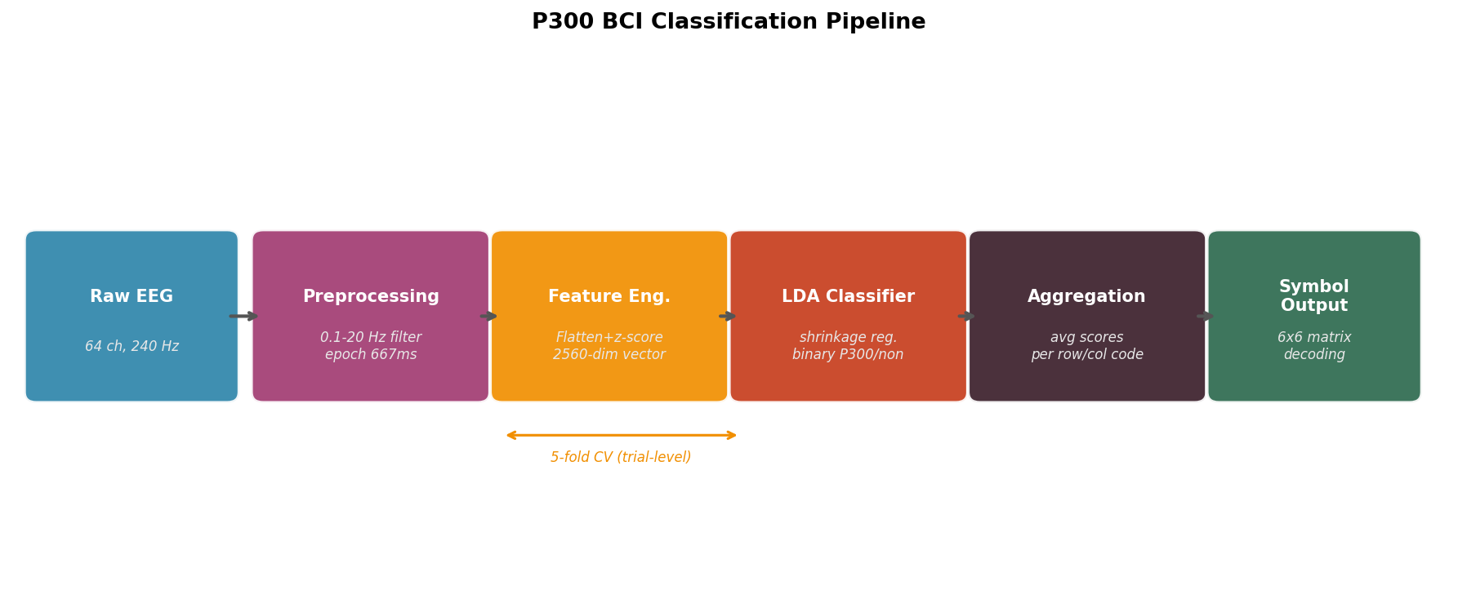
Figure 1: Complete ML pipeline - from raw EEG signal to final symbol prediction. 5-fold cross-validation is applied at the feature engineering and classification stages.

4.1 Dataset
BCI Competition III, Dataset II [6]: EEG from two subjects (A, B), 64 channels, 240 Hz, 0.1-60 Hz bandwidth. Each subject focused on letters of a target word in a 6x6 matrix. Each letter was presented as 15 repetition cycles of 12 flashes (6 rows + 6 columns), 180 flashes per symbol. Training set: 85 symbols per subject. Natural class ratio: 1:5 (target:non-target), since 2 of 12 codes per cycle are target.

4.2 Preprocessing
The following steps were applied to each trial:
- Bandpass filtering: 4th-order Butterworth, 0.1-20 Hz, zero-phase (scipy.signal.filtfilt). Captures P300 while suppressing high-frequency artifacts and slow drift.
- Epoch extraction: 667 ms window after each stimulus onset (rising edge of Flashing signal), across all 64 channels.
- Decimation by factor 4 (160 -> 40 samples per epoch), reducing feature dimensionality from 10,240 to 2,560 without aliasing below 20 Hz.
- Labelling: target (StimulusType=1) or non-target (StimulusType=0) from ground-truth labels.
Code snippet - preprocessing:
nyq = FS / 2 # FS = 240 Hz
b, a = butter(4, [0.1/nyq, 20/nyq], btype='band')
sig_filtered = filtfilt(b, a, sig, axis=0) # zero-phase
epoch = sig_filtered[onset : onset + EPOCH_SAMPLES]
epoch_ds = decimate(epoch, q=4, axis=0, zero_phase=True)
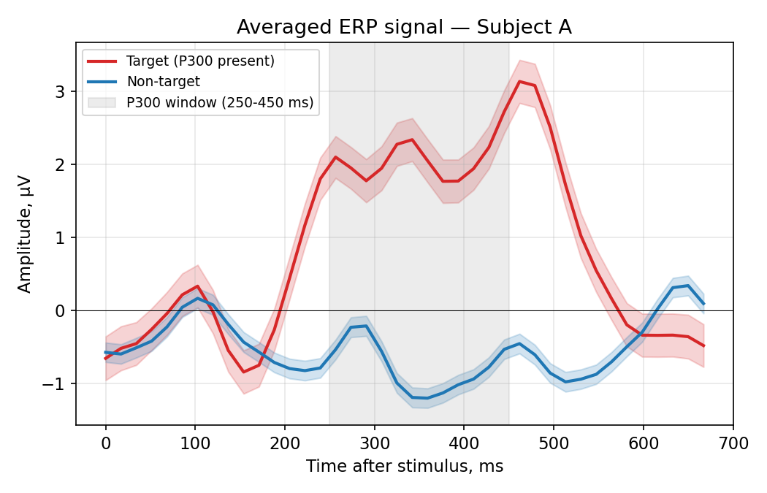
Figure 2: Averaged ERP signal (channel ~Cz) for target vs. non-target epochs - Subject A. Clear positive P300 peak visible in 250-450 ms window for target trials.

4.3 Feature Engineering
Each epoch (40 x 64) was flattened to a 2,560-dimensional vector and z-score normalized using training-set statistics only. Figure 3 shows a PCA projection of the feature space, illustrating the class overlap that motivates the need for classifier aggregation over multiple repetitions.
Code snippet - feature extraction:
feat = X.reshape(len(X), -1) # (n_epochs, 40*64)
scaler = StandardScaler()
X_train = scaler.fit_transform(feat[train_mask])
X_test = scaler.transform(feat[test_mask])
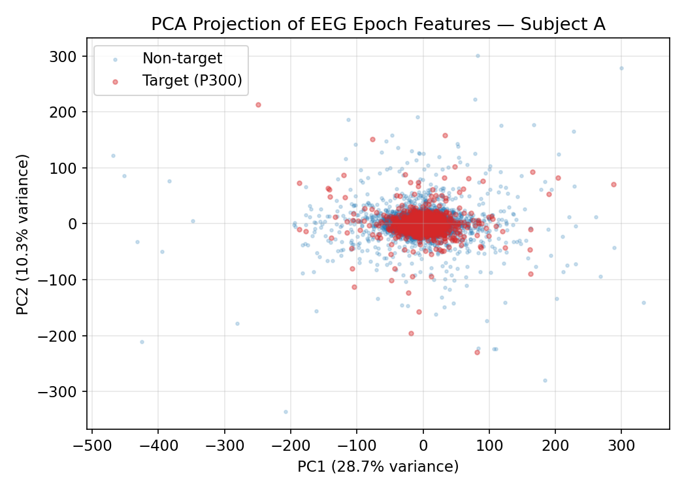
Figure 3: PCA projection of EEG epoch features (Subject A). Target (P300) and non-target epochs overlap substantially in 2D, motivating the use of the full 2560-dimensional space and score aggregation.

4.4 Classification and Score Aggregation
LDA with shrinkage regularization (Ledoit-Wolf) finds the linear projection maximizing between-class to within-class scatter ratio:
w* = argmax_w [w^T S_B w] / [w^T S_W w]
For each test symbol, epoch scores are averaged per stimulus code (row/column), and the row and column with the highest mean score determine the predicted character.
Code snippet - character-level aggregation:
scores_per_code = np.zeros(13) # codes 1-12
for code in range(1, 13):
mask = trial_codes == code
if mask.sum() > 0:
scores_per_code[code] = trial_scores[mask].mean()
col = np.argmax(scores_per_code[1:7]) + 1 # best column
row = np.argmax(scores_per_code[7:13]) + 1 # best row
predicted_char = SPELLER_MATRIX[row-1, col-1]

4.5 Evaluation: 5-fold Cross-Validation
Following the reviewer recommendation, model performance is reported using 5-fold cross-validation at the trial (symbol) level - that is, folds are constructed over symbols, not individual epochs, preventing any data leakage between training and test sets. Results are reported as mean +/- std across folds.
Subject | Epoch AUC (mean +/- std) | Epoch Acc. (mean +/- std) | Char. Acc. (mean +/- std)
Subject A | 0.778 +/- 0.007 | 0.844 +/- 0.004 | 0.953 +/- 0.069
Subject B | 0.857 +/- 0.017 | 0.871 +/- 0.006 | 0.953 +/- 0.024
Table 1: 5-fold cross-validation results - LDA classifier, trial-level splits.
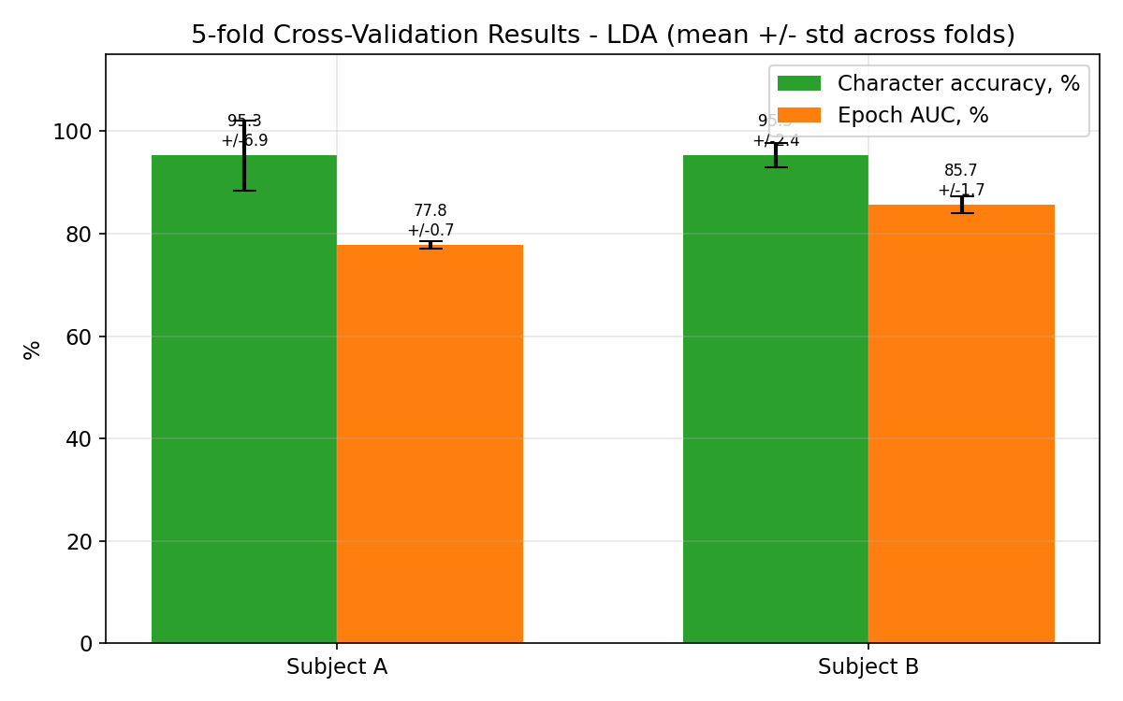
Figure 4: 5-fold CV results - character-level accuracy and epoch AUC (mean +/- std). Error bars show standard deviation across folds.
Both subjects reach near-identical character-level accuracy of 0.953 in 5-fold CV, demonstrating that the pipeline generalises well across symbol splits. The higher standard deviation for Subject A (0.069 vs 0.024) reflects greater inter-trial variability in P300 amplitude, consistent with the known high inter-individual variability in this component [2]. LDA's shrinkage regularization stabilises the within-class covariance estimate and is the primary reason for competitive performance despite the high feature dimensionality (2,560) relative to the number of training trials.

4.6 Speed-Accuracy Trade-off
Figure 5 shows character accuracy as a function of stimulus repetitions (N = 1-15), averaged across 5 cross-validation folds with standard deviation bands. Subject B saturates near 94% at 8 repetitions; Subject A requires 11-15 repetitions to stabilise. The shaded bands reflect variability across folds, confirming the consistency of the saturation pattern. In clinical deployment, this informs the minimum repetition count needed to achieve acceptable reliability.
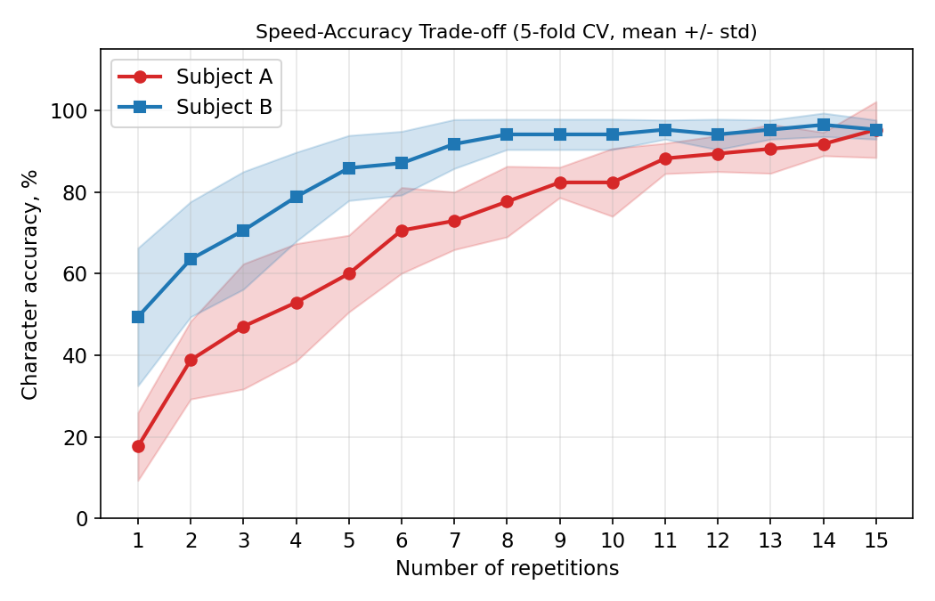
Figure 5: Character accuracy vs. number of stimulus repetitions (LDA, 5-fold CV, mean +/- std). Both subjects show characteristic saturation curve. Error bands show variability across folds.

5 IMPORTANT LIMITATIONS
Test set size. With 17 test symbols per fold, a single misclassified symbol changes character accuracy by ~6%. The std across folds (up to 0.069) reflects this sensitivity. Larger datasets - or the full 100-symbol test set provided by the competition (for which labels are not public) - would yield more stable estimates.
Generalisability to a binary yes/no paradigm. The current experiment uses a full 36-symbol speller paradigm with healthy subjects. A clinical catatonia application would most likely start with a simplified binary paradigm (two stimuli: 'yes' and 'no'). It is plausible that a binary task would yield higher P300 amplitude and classification accuracy due to more favorable oddball probability (0.5 for binary vs approximately 1/6 per row or column in a 6x6 speller), but this has not been tested in the current work and should be treated as a hypothesis for future validation. Additionally, P300 signal quality in real catatonic patients may differ from healthy controls due to the disorder itself, co-occurring psychiatric symptoms, and pharmacological treatment (e.g., benzodiazepines) - all of which remain open empirical questions.

6 FEASIBILITY ANALYSIS FOR CATATONIC PATIENTS

6.1 Potential Applicability and What Requires Validation
The P300 mechanism does not depend on the aetiology of motor unresponsiveness. It operates whether the block arises from ALS or catatonic stupor, provided basic visual attention and cortical stimulus processing are preserved [2]. The preprocessing pipeline, LDA classifier, and character-level accuracy metric are potentially applicable to this population - however, since these results are obtained exclusively on healthy subjects, direct applicability to catatonic patients requires separate empirical validation on clinical data.

6.2 What Requires Adaptation
Calibration without verbal confirmation. Standard BCI calibration requires verbal confirmation of the focused symbol. For catatonic patients this is impossible by definition. A binary yes/no paradigm with pre-agreed semantics (established before the catatonic episode) is more realistic.
Reduced cognitive load. A binary paradigm (2 stimuli) reduces attentional demand dramatically compared to a 36-symbol speller, and is the recommended starting point for any clinical pilot.
Pharmacological confounders. Benzodiazepines modulate P300 amplitude and latency [2], requiring separate validation of classifier thresholds under pharmacological conditions.
Attention stability. Catatonic episodes may limit available calibration time and reduce within-session EEG stationarity, compared to motivated ALS users.

6.3 Primary Gap: Absence of Clinical Data
The complete absence of open EEG datasets from catatonic patients under P300 paradigms is the primary barrier. Any practical progress requires either a prospective clinical study with ethics committee approval, or initial validation on healthy volunteers under simulated attentional constraints.

6.4 Ethical Considerations
Clinical BCI in catatonia raises consent issues (patient temporarily unable to provide informed consent, requiring a legal representative), risk of misinterpreting a P300 response as explicit consent (P300 reflects attention, not guaranteed voluntary assent), and data privacy for neural activity. All must be addressed with a bioethics committee before any clinical application.

7 CONCLUSIONS
This paper presents a complete, reproducible ML pipeline for P300-based symbol classification, evaluated with 5-fold cross-validation on the BCI Competition III benchmark. LDA with shrinkage regularization achieves character-level accuracy of 0.953 +/- 0.069 (Subject A) and 0.953 +/- 0.024 (Subject B) - results consistent with the literature and robust across cross-validation folds. These figures reflect performance on healthy subjects in a full 36-symbol speller paradigm. Whether a simplified binary yes/no paradigm - the most realistic first step for catatonia - would yield higher or comparable accuracy is a plausible hypothesis that requires dedicated empirical testing.
The feasibility analysis demonstrates that the P300 mechanism and the ML pipeline are in principle transferable to catatonic patients, but that practical deployment requires protocol adaptation (binary paradigm, medication-aware calibration) and - most critically - a prospective clinical study to collect the first open EEG dataset from catatonic patients. The primary contribution of this work is a reproducible technological foundation and a structured map of the gaps that future clinical research must close.

REFERENCES
- J. R. Wolpaw et al., "Brain-computer interfaces for communication and control," Clin. Neurophysiol., vol. 113, pp. 767-791, 2002.
- S. J. Luck, An Introduction to the Event-Related Potential Technique, 2nd ed. MIT Press, 2014.
- L. A. Farwell, E. Donchin, "Talking off the top of your head: toward a mental prosthesis utilizing event-related brain potentials," Electroencephalogr. Clin. Neurophysiol., vol. 70, no. 6, pp. 510-523, 1988.
- N. Birbaumer et al., "A spelling device for the paralysed," Nature, vol. 398, pp. 297-298, 1999.
- J. P. Rogers, M. A. Oldham, G. Fricchione et al., "Evidence-based consensus guidelines for the management of catatonia: Recommendations from the British Association for Psychopharmacology," J. Psychopharmacol., vol. 37, no. 4, pp. 327-369, 2023. doi: 10.1177/02698811231158232.
- G. Schalk et al., "BCI2000: a general-purpose brain-computer interface (BCI) system," IEEE Trans. Biomed. Eng., vol. 51, no. 6, pp. 1034-1043, 2004. (BCI Competition III, Dataset II.)
- Manucar, "p300-speller," GitHub, https://github.com/Manucar/p300-speller.
- A. Rakotomamonjy, V. Guigue, "BCI Competition III: Dataset II - Ensemble of SVMs for BCI P300 Speller," IEEE Trans. Biomed. Eng., vol. 55, no. 3, pp. 1147-1154, 2008.
- V. J. Lawhern et al., "EEGNet: a compact convolutional neural network for EEG-based brain-computer interfaces," J. Neural Eng., vol. 15, no. 5, 2018.
- H. Cecotti, A. Graser, "Convolutional neural networks for P300 detection," IEEE Trans. PAMI, vol. 33, no. 3, pp. 433-445, 2011.
- F. Yger et al., "Riemannian approaches in brain-computer interfaces: a review," IEEE Trans. Neural Syst. Rehabil. Eng., vol. 25, no. 10, pp. 1753-1762, 2017.

