Market analysis overview

Competing products
Product | Link | Cost | Key selling points
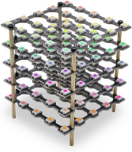 | Treedix Led Cube 5X5X5 Digital Individually Addressable with RGB Full-Colour, Starter Kit for Adults : Amazon.co.uk: Lighting | £21.99
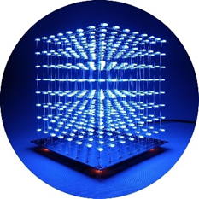 | iCubeSmart 3D Led Cube DIY Electronics Kit Soldering Project Kit (3D8S-BLUE) : Amazon.co.uk: DIY & Tools | £36.00
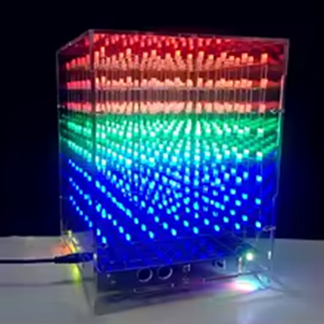 | Cololful Light Cubes DIY Kit 8X8X8 WIFI Mobile Phone APP Change Word 888 LED Flashing Smart Electronic Production | £32.90

