Software – Portfolio
A functional overview and annotated breakdown of code for pattern control, input response, and sensor integrations
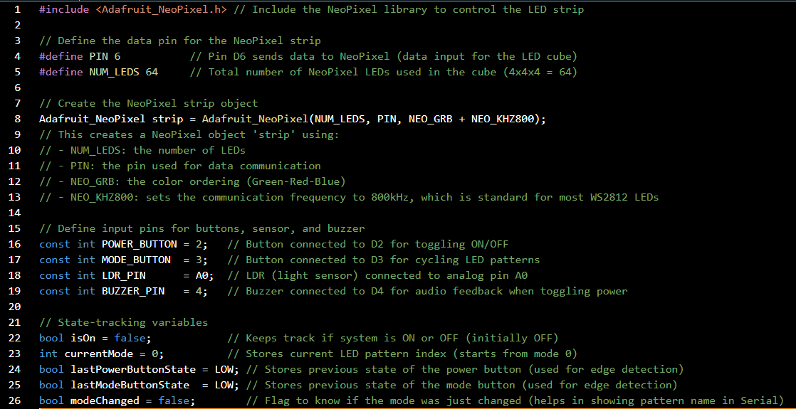
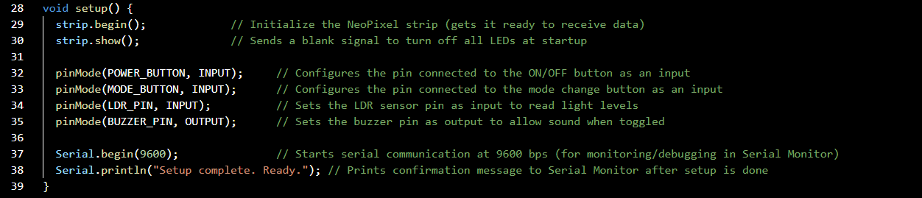
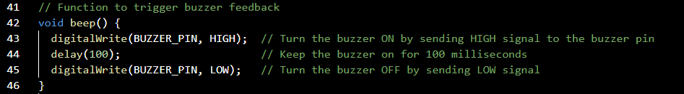
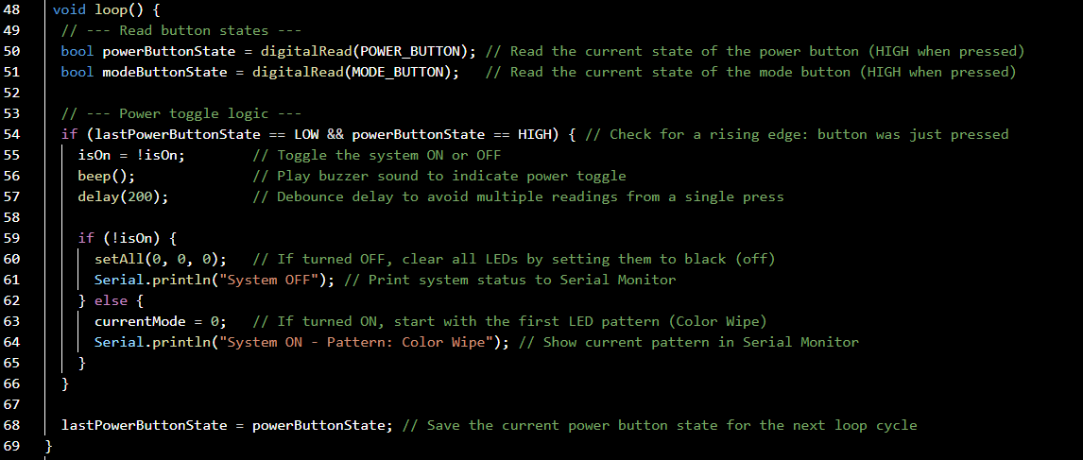
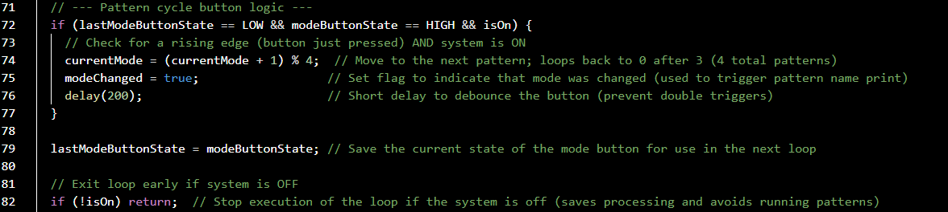
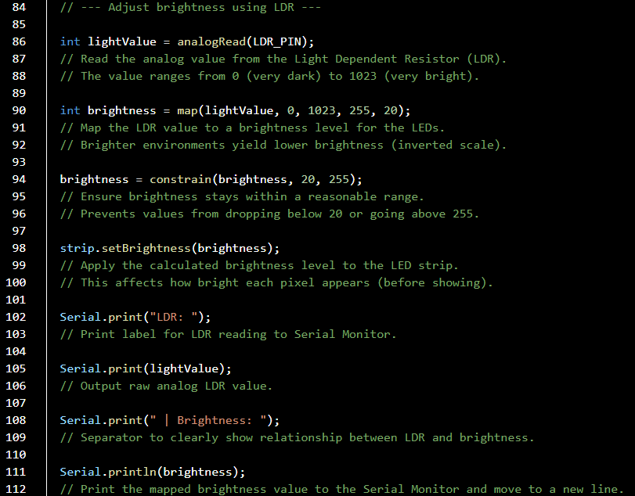
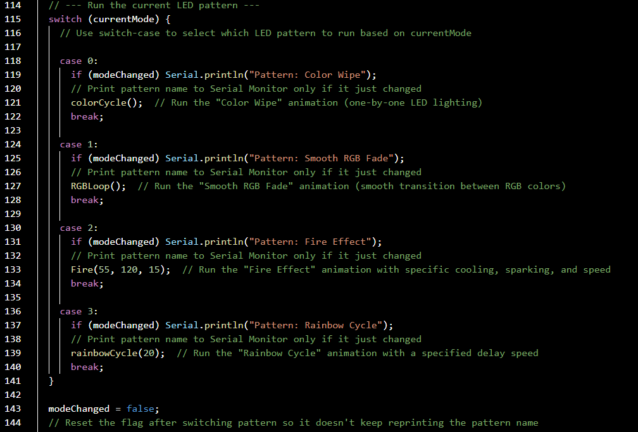
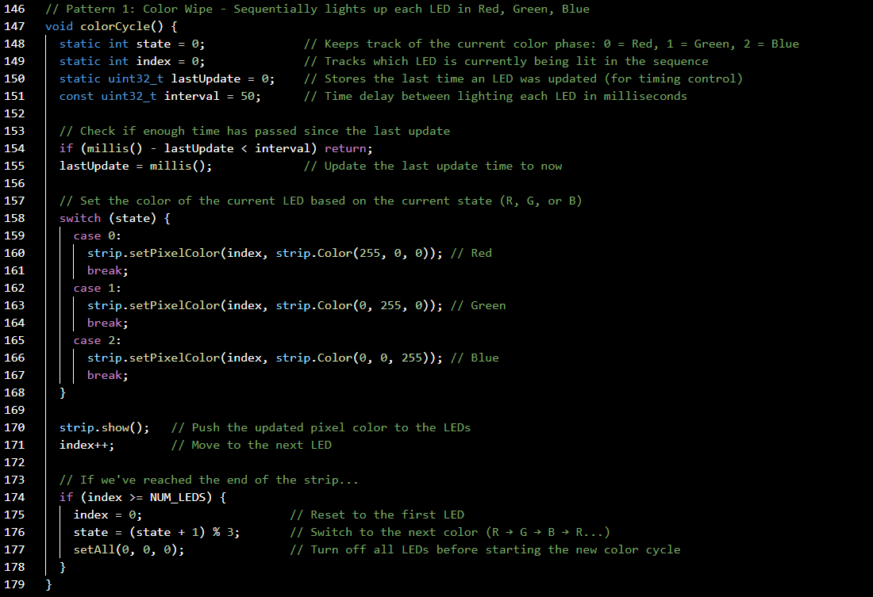
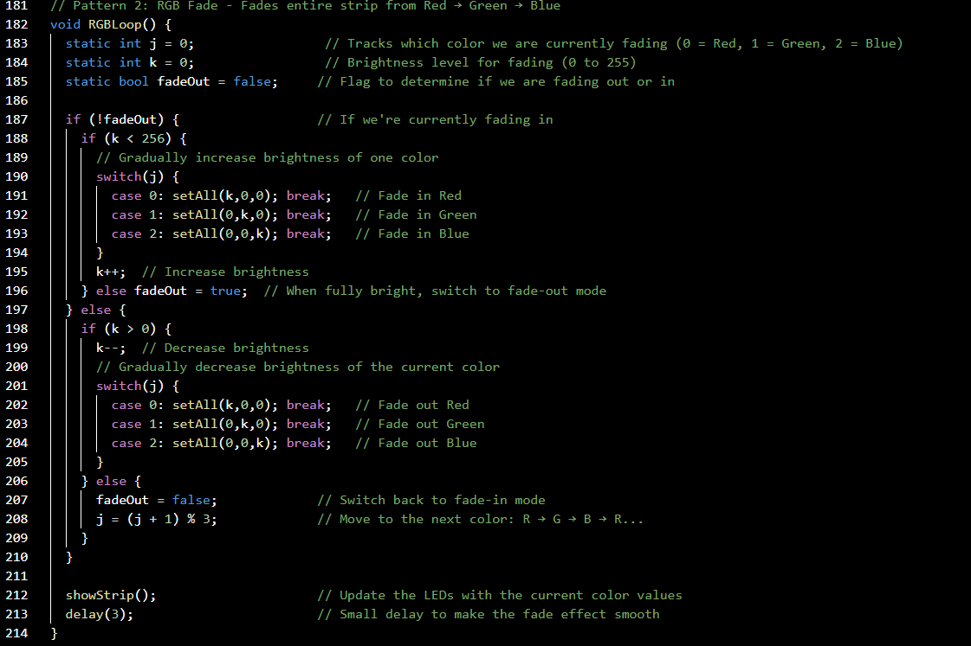
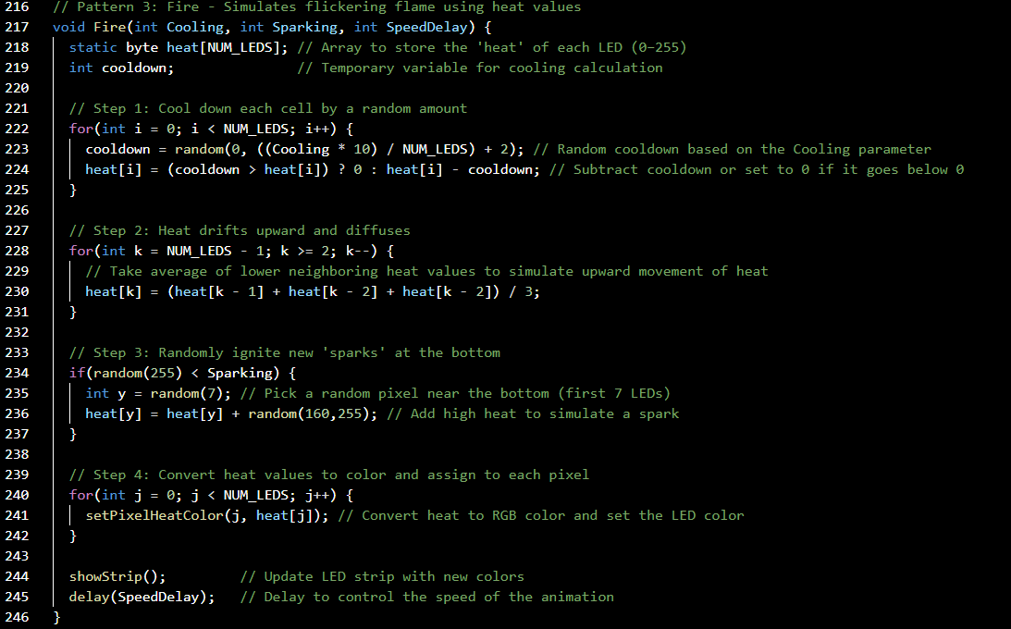
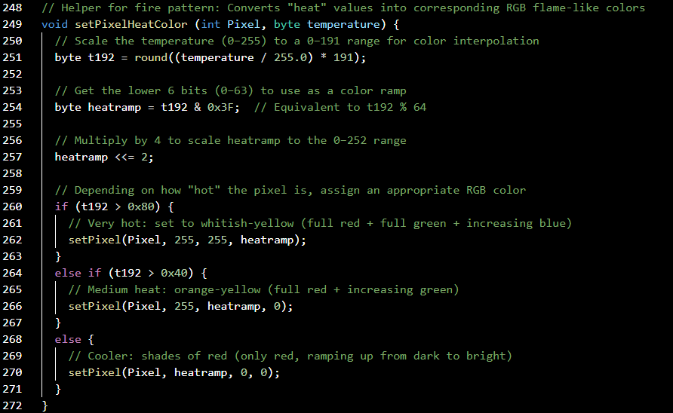
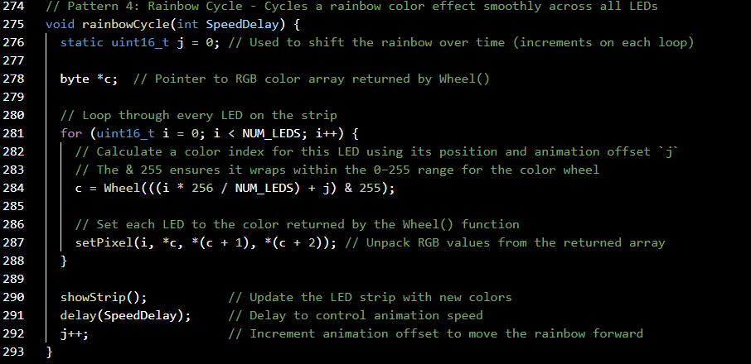
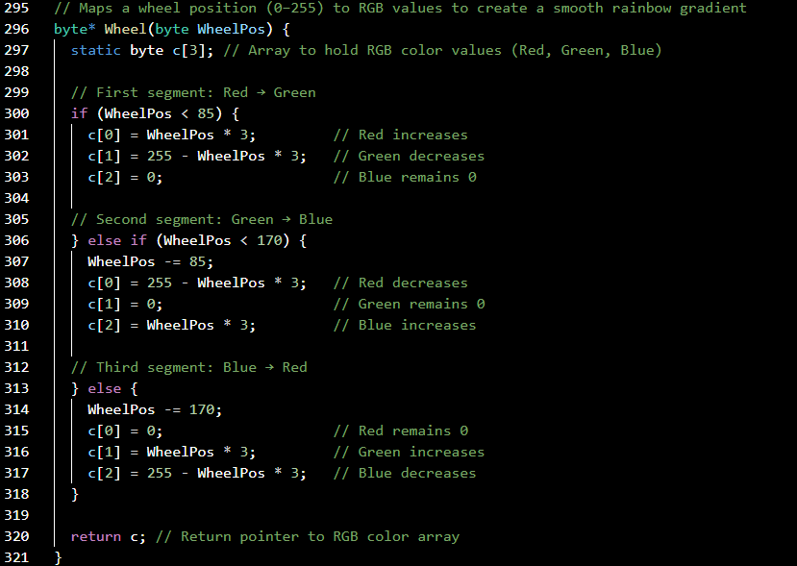
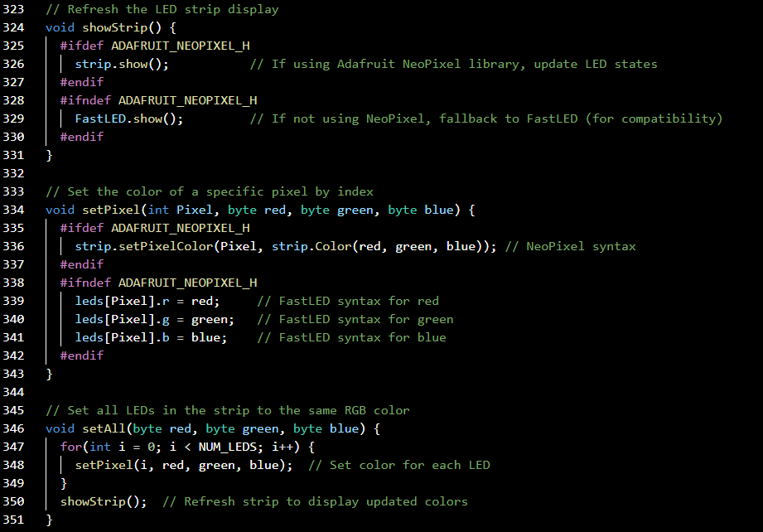

Overall Summary of the Full Code – NeoPixel Cube Project
This Arduino code powers a fully interactive NeoPixel LED Cube system with user-controlled lighting patterns, brightness adjustment via an LDR (light sensor), and audio feedback using a buzzer.
1. Setup and Configuration
The code begins by importing the Adafruit NeoPixel library, which is essential for controlling addressable RGB LEDs. It then defines the data pin for the LED strip (pin 6) and the total number of LEDs (64), which corresponds to a 4×4×4 LED cube.
Input pins are defined for:
POWER_BUTTON: Toggles the cube ON and OFF.
MODE_BUTTON: Cycles through different lighting patterns.
LDR_PIN: Reads ambient light level to adjust LED brightness.
BUZZER_PIN: Sounds a tone when the system is powered ON or OFF.
State-tracking variables (isOn, currentMode, etc.) are initialized to monitor the system's status and respond appropriately to button inputs.

2. Initialization in setup()
Inside the setup() function:
The NeoPixel strip is initialized and cleared.
Pin modes for all inputs and outputs are set.
Serial communication is started for real-time debugging and monitoring.

3. Main Loop – Continuous Checks & Responses
The loop() function runs continuously and checks:
Whether the power button is pressed (to toggle ON/OFF).
Whether the mode button is pressed (to change patterns).
The LDR sensor reading, which is used to calculate and set the LED brightness dynamically.
When ON, the cube executes one of four lighting patterns based on the current mode.

4. Lighting Patterns
There are four different LED animations, each with its own function:
Color Wipe (colorCycle)
Lights up each LED in sequence (red → green → blue), then repeats. Creates a clean flowing transition across the cube.
Smooth RGB Fade (RGBLoop)
All LEDs gradually fade in and out through red, green, and blue. Gives a soft ambient lighting effect.
Fire Effect (Fire)
Simulates realistic flickering flame by creating heat values per LED and converting them into fiery RGB colors.
Rainbow Cycle (rainbowCycle)
Loops a rainbow gradient across the LED strip, shifting colors over time for a vibrant, animated effect.
Each mode can be changed instantly using the mode button, and the active mode is printed to the Serial Monitor.

5. Additional Features
Brightness Control: Uses an LDR sensor to automatically adjust brightness based on ambient light.
Buzzer Feedback: A short tone is played each time the system is powered ON or OFF.
Serial Output: Prints real-time feedback including brightness levels and the active pattern.

Conclusion
This code allows for a fully interactive and responsive LED cube, using simple physical inputs and real-time sensor data. The modular structure makes it easy to understand, modify, and expand—for example, by adding new patterns, remote control, or Bluetooth in the future.
This efficient and well-commented script showcases practical applications of digital input, analog sensing, PWM-based LED control, and real-time logic in embedded systems.

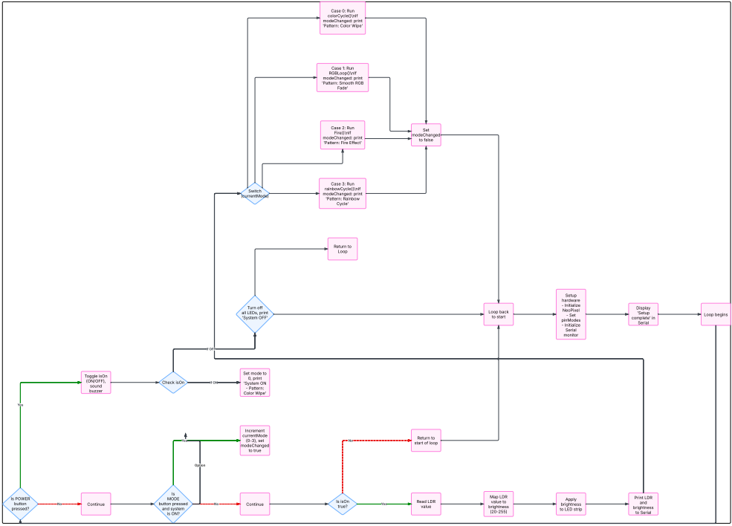
Software Flowchart Summary
This flowchart captures the real-time decision-making process and responses based on user interaction and sensor input.
1. Initialization (setup)
The NeoPixel LED strip is initialized using strip.begin().
All input/output pins are configured (buttons, LDR sensor, and buzzer).
Serial communication is established for debugging and feedback.
A confirmation message is printed to indicate readiness.
2. Main Program Loop (loop)
The core of the program runs continuously and follows this structure:
a. Read Power Button
If pressed (and it’s a new press), the system toggles between ON and OFF.
When turning ON, the first pattern (Color Wipe) is selected by default.
When turning OFF, all LEDs are turned off.
A short beep from the buzzer gives feedback on each toggle.
The system prints status ("System ON"/"System OFF") to the serial monitor.
b. Read Mode Button
If the system is ON and the mode button is pressed, the current LED pattern is changed to the next one in a cycle (total of 4 patterns).
A modeChanged flag is used to detect and print pattern changes.
c. LDR Sensor Brightness Control
The ambient light is read using the LDR sensor via analogRead().
The value is mapped to a brightness range (from dim in dark to bright in light).
This brightness level is applied to the LED strip and printed to the serial monitor.
d. Pattern Execution (based on mode)
A switch statement checks the value of currentMode and runs the corresponding lighting pattern:
Mode 0: Color Wipe – Sequentially lights up LEDs in Red, Green, and Blue.
Mode 1: RGB Fade – All LEDs fade smoothly between red, green, and blue.
Mode 2: Fire Effect – Creates a flickering flame effect using simulated heat values.
Mode 3: Rainbow Cycle – Animates a rainbow effect cycling across the LED strip.
e. Loop Repeats
After each iteration, the program returns to the top of the loop and continuously re-evaluates inputs and runs the selected effect in real-time.

Overall Flow Summary
This software allows control of lighting effects using just two buttons and a light sensor. It responds in real time to user actions and environmental brightness, providing an interactive and adaptive LED display experience. Also allows audible feedback. The flowchart helps visualize how the system makes decisions and executes different parts of the code based on changing inputs.

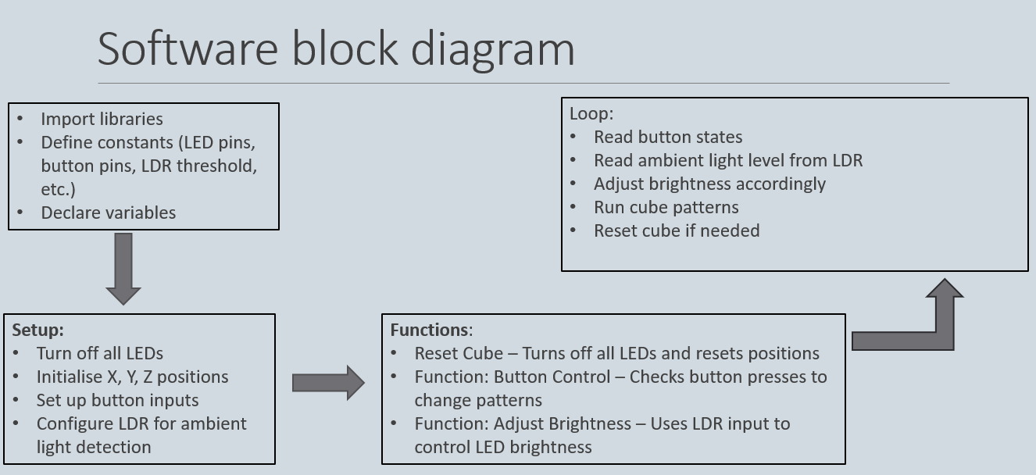


Access the Full Arduino Code
Scan the QR code on the left or visit the link below to view the complete source code for our NeoPixel Cube project
-https://pastebin.com/H5fWksem

