Pilot 1 (single graph on trial, no incentivization)

> completiontimesminutes

[1] 16.61667 26.80000 16.63333 32.35000 38.50000

> wrongaqs

1 2 3 4 5

1 0 8 0 0

> #10 is max wrong

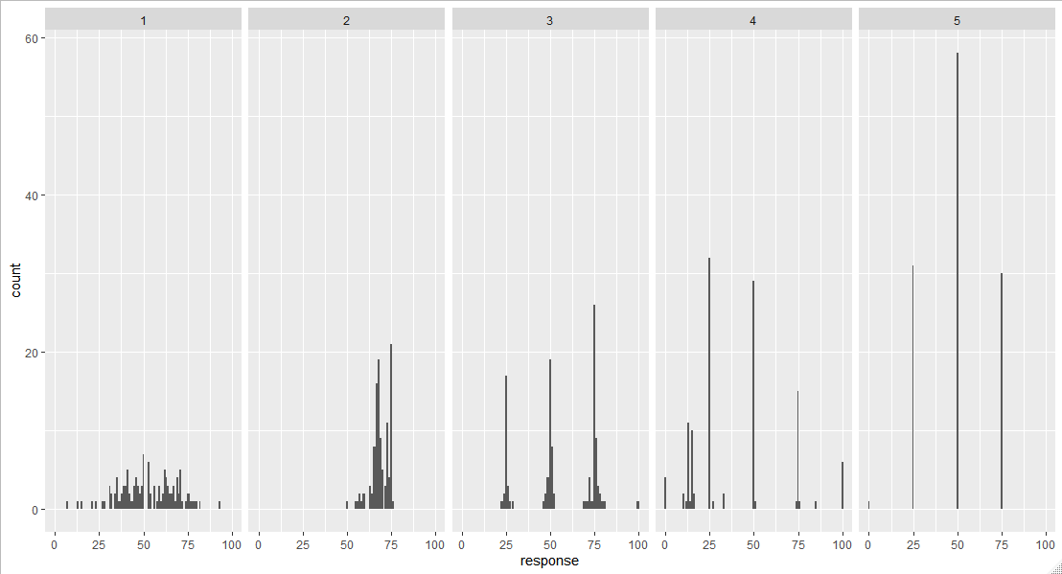

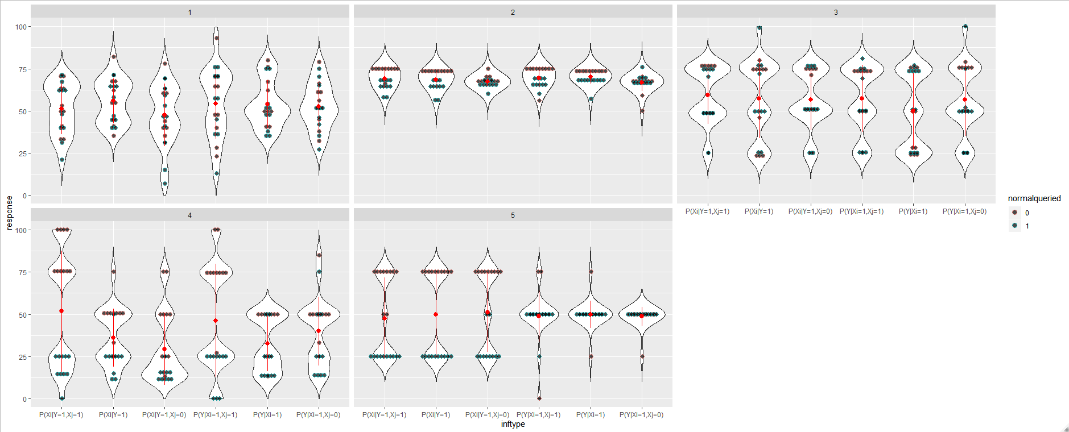

Pilot 2 (double graph on trial, incentivization of inferences)

> completiontimesminutes

[1] 35.96667 52.75000 52.38333 76.83333 45.30000

> wrongaqs

1 2 3 4 5

0 2 1 2 0

> #10 is max wrong

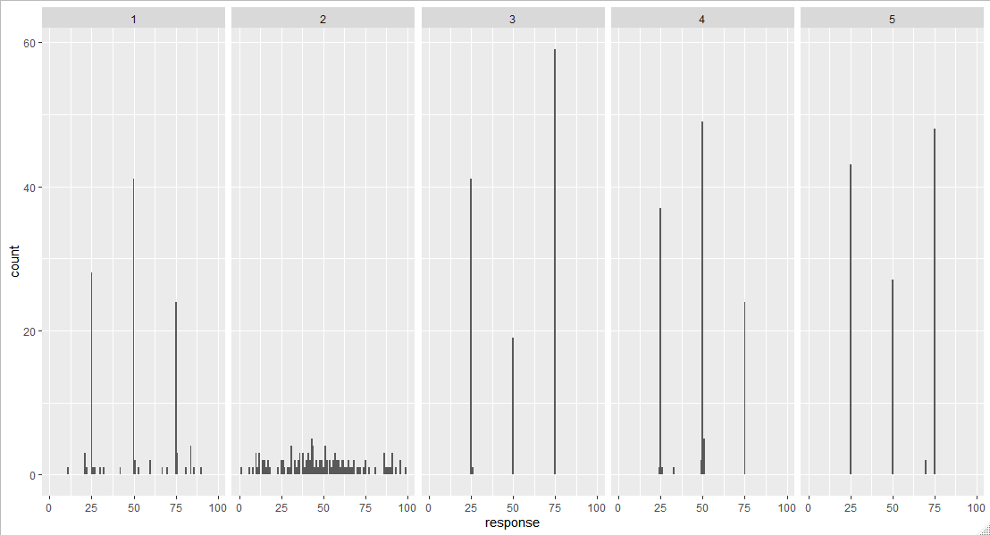

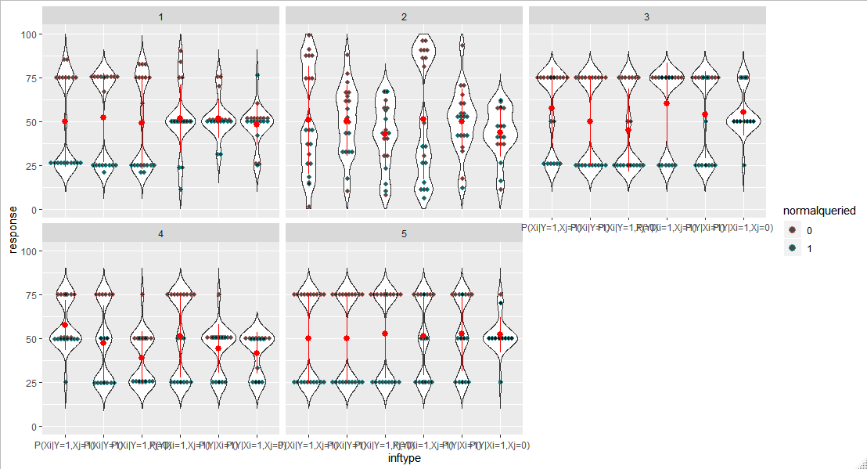

Pilot 3 (double graph on trial, no incentivization)

> completiontimesminutes

[1] 16.61667 20.06667 24.73333 41.03333 54.65000

> wrongaqs

1 2 3 4 5

9 7 9 10 0

> #10 is max wrong

