Hi Scott,

I coded up a simple PI loop charge controller to generate CCCV profiles as part of the batches of input data that I’m using to run through the online parameter identification w/ sensitivity-based data selection. Below I’ve outlined what I’ve done as well as the feedback I’m looking for.

Approach

* I’ve implemented a simple PI loop to compute the current trajectory iteratively at each time step (1s). To deal with integrator windup caused by the max current limitation, I’ve implemented some basic controller-actuator feedback

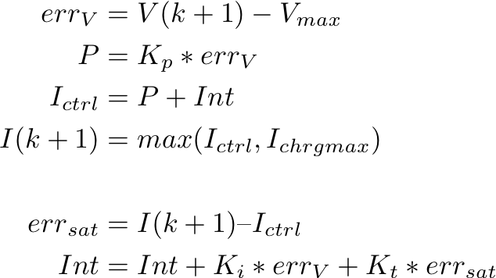

The results have more or less looked like the following:

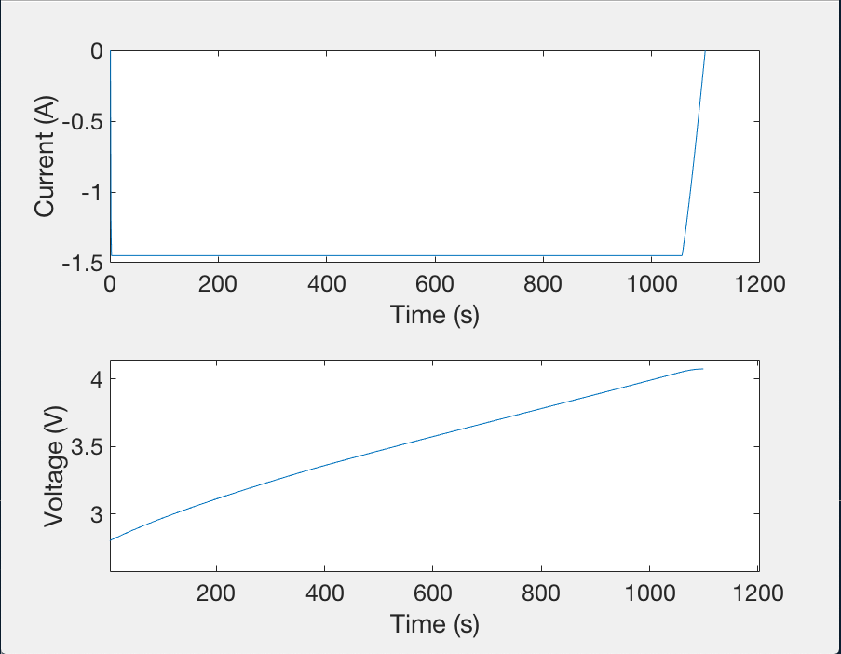

I’ve been adjusting the proportional and integral gains but have yet to find a working solution. In the meantime, I’ll plan to just use the generated charging profile as a stand-in for my input train; eventually I would like to fix this issue and incorporate charging profiles that are closer to what our battery tester generates for CCCV profiles.

Feedback I’m looking for

1. Is it worth spending more time on this? From a sensitivity standpoint does the CV portion even matter?
2. Is this a gain tuning issue or something more fundamental to the approach?