Hi Scott,

I coded up P and PI charge controllers in separate attempts to generate CCCV charging profiles as part of the batches of input data that I’m using to run through the online parameter identification w/ sensitivity-based data selection. Below I’ve outlined what I’ve done, issues I’m running into, and the feedback I’m looking for.

Approach

I’ve tried implementing two approaches: (1) a proportional controller and (2) a PI controller to compute the current trajectory iteratively at each time step (1s). In (2), to deal with integrator windup caused by the max current limitation, I’ve implemented some basic controller-actuator feedback:

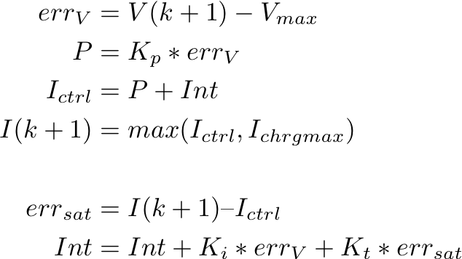

My exit condition for the code is I < I_cutoff = 10mA. For the P-controller, I do the same as above just w/o the Int term. The results have more or less looked like the graphs on the following page for the P-controller and PI-controller.

Issues (See Graphs)

I’ve been adjusting the proportional and integral gains but have yet to generate a reasonable looking CCCV charging profile. The PI-controller looks closer to what I want, but I can’t get the CV portion to look reasonable.

Feedback I’m looking for

1. Is this a gain tuning issue or something more fundamental to the approach?
2. Any alternative approaches I should try to generate more realistic profiles?

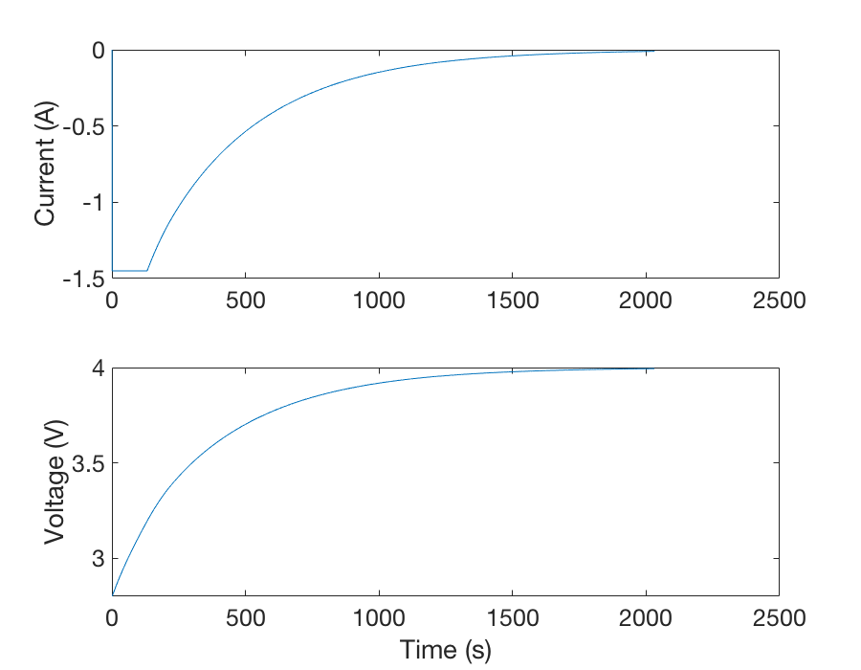

Figure 1: P-controller Current Profile

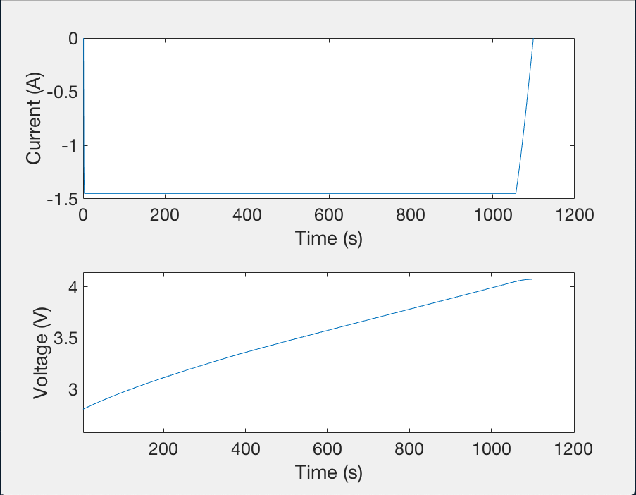

Figure 2: PI-controller Current Profile